95-712 OOP/Java Homework 3 Due: Tuesday, July 1, 2008

Part A. Swing , RSA and the BigInteger class

Write a graphical user interface program in java that allows the user to generate RSA keys. The program will have a screen similar to the following:

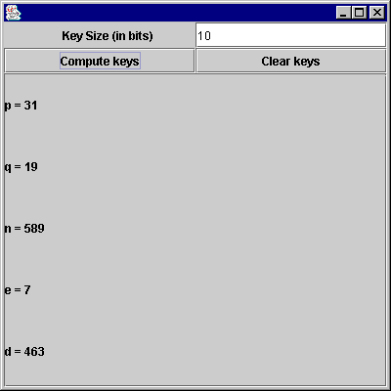

In this case, the user has selected 10 bit keys (determining the size of n) and has hit the “Compute keys” JButton. The keys are displayed in a swing JTextArea component. If the “Clear Keys” JButton is hit the bottom portion of the screen is cleared.

In the example that follows the user has requested a much larger key size. Note that the JTextArea now appears with a scrollbar. The scrollbar can be used to view the entire value of n.

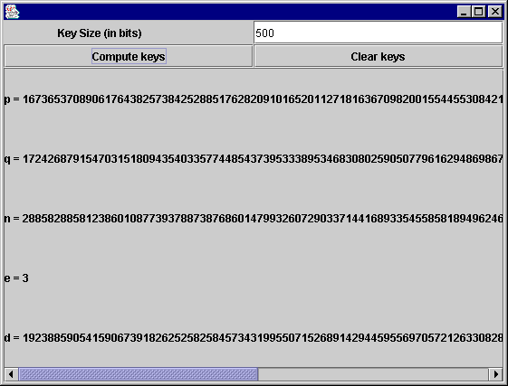

The program will be called KeyGenApp.java and must make use of Java’s BigInteger class.

Part B. Swing and Message Digest Calculations

A message digest algorithm takes as input an arbitrary series of bytes and computes an integer based on these bytes. If the algorithm is good then it is computationally hard to find another series of bytes that generates the same integer. In other words, the resulting value is like a fingerprint of the document. In Java we can use the SHA1 and MD5 algorithms to compute message digests. The following problems are designed to acquaint you with message digests and give you more experience working with Swing.

The program below, MessageDigestApplet.java, computes a message digest from a file or from text entered by the user. Run this program using the appletviewer program. The appletviewer program takes an HTML file as input and loads and runs the class file contained within it.

What is the message digest of the following string. Note that this string has exactly 12 characters. There is no carriage return at the end. The last character is a period. Show your answers in hexadecimal bytes.

Hello World.

a) MD5 Message Digest _____________________________

b) SHA1 Message Digest _____________________________

What is the message digest of the program MessageDigestApplet.java?

a) MD5 Message Digest _____________________________

b) SHA1 Message Digest _____________________________

What is the message digest of the file MessageDigestApplet.class ?

a) MD5 Message Digest _____________________________

b) SHA1 Message Digest _____________________________

Modify the program so that it is a Java application rather than an applet. Also, allow the user to select a file at a URL. You will need to add a button that says “URL Digest”. When that button is clicked a JOptionPane will be displayed that asks the user for the URL. The file will then be fetched from the URL and the digest computed and displayed. Call this program MessageDigestApplication.java .

(5) Use the Java application program that you developed to compute the SHA1 message digest of the file index.html found at http://www.andrew.cmu.edu/~mm6/index.html.

SHA1 Message Digest of index.html ____________________

/*
* Cay S. Horstmann & Gary Cornell, Core Java
* Published By Sun Microsystems Press/Prentice-Hall
* Copyright (C) 1997 Sun Microsystems Inc.
* All Rights Reserved.
*
* Permission to use, copy, modify, and distribute this
* software and its documentation for NON-COMMERCIAL purposes
* and without fee is hereby granted provided that this
* copyright notice appears in all copies.
*
* THE AUTHORS AND PUBLISHER MAKE NO REPRESENTATIONS OR
* WARRANTIES ABOUT THE SUITABILITY OF THE SOFTWARE, EITHER
* EXPRESS OR IMPLIED, INCLUDING BUT NOT LIMITED TO THE
* IMPLIED WARRANTIES OF MERCHANTABILITY, FITNESS FOR A
* PARTICULAR PURPOSE, OR NON-INFRINGEMENT. THE AUTHORS
* AND PUBLISHER SHALL NOT BE LIABLE FOR ANY DAMAGES SUFFERED
* BY LICENSEE AS A RESULT OF USING, MODIFYING OR DISTRIBUTING
* THIS SOFTWARE OR ITS DERIVATIVES.
*/

/**
* @version 1.00 10 Sep 1997
* @author Cay Horstmann
*/

/*
* Modified by M. Gallant 09/12/2000
* - converted to applet (requires digital signature).
* - suitable for IE4+ or JavaPlugin1.2.2+.
* - MessageDigest not implemented in Netscape JVM.
* - modified loadBytes() for faster file reading.
* - modified computeDigest() for local formatting.
* - replaced menu with two buttons; modified actionPerformed()
*/

import java.io.*;
import java.security.*;
import java.awt.*;
import java.awt.event.*;

public final class MessageDigestApplet extends java.applet.Applet
implements ActionListener, ItemListener{

private Button b0, b1, b2 ;
private TextArea message = new TextArea();
private TextField digest = new TextField();
private String filename = null;
private String lastDir = "";
private MessageDigest currentAlgorithm;

public void init(){
this.setLayout(new BorderLayout(7,7)) ;
Panel p = new Panel();
b0 = new Button("Clear text") ;
b0.addActionListener(this) ;
p.add(b0) ;
b1 = new Button("File digest") ;
b1.addActionListener(this) ;
p.add(b1) ;
b2 = new Button("Text digest") ;
b2.addActionListener(this) ;
p.add(b2) ;

CheckboxGroup g = new CheckboxGroup();
addCheckbox(p, "SHA-1", g, true);
addCheckbox(p, "MD5", g, false);
add(p, "North");
add(message, "Center");
add(digest, "South");
add(new Label(" "), "East") ;
add(new Label(" "), "West") ;

digest.setFont(new Font("Courier", Font.PLAIN, 12));

setAlgorithm("SHA-1");
}

public Insets getInsets() {
return new Insets(5,7,7,7) ;
}

private void addCheckbox(Panel p, String name,
CheckboxGroup g, boolean v)
{ Checkbox c = new Checkbox(name, g, v);
c.addItemListener(this);
p.add(c);
}

public void itemStateChanged(ItemEvent evt)
{ if (evt.getStateChange() == ItemEvent.SELECTED)
setAlgorithm((String)evt.getItem());
}

private void setAlgorithm(String alg)
{ try
{ currentAlgorithm = MessageDigest.getInstance(alg);
}
catch(NoSuchAlgorithmException e)
{ digest.setText("" + e);
}
}

public void actionPerformed(ActionEvent evt)
{ String arg = evt.getActionCommand();
if (arg.equals("File digest"))
{ FileDialog d = new FileDialog(new Frame(),
"Open text file", FileDialog.LOAD);
d.setFile("*.txt");
d.setDirectory(lastDir);
d.show();
String f = d.getFile();
lastDir = d.getDirectory();
if (f != null)
{ filename = lastDir + f;
computeDigest(loadBytes(filename));
}
}
else if (arg.equals("Text digest"))
{ String m = message.getText();
computeDigest(m.getBytes());
}
else if (arg.equals("Clear text"))
{ message.setText("");
digest.setText("");
}

}

private byte[] loadBytes(String name)
{ FileInputStream in = null;

try
{ in = new FileInputStream(name);
ByteArrayOutputStream buffer
= new ByteArrayOutputStream();

int bytesread = 0;
byte [] tbuff = new byte[512] ;

while(true) {
bytesread = in.read(tbuff);
if (bytesread == -1) // if EOF
break ;
buffer.write(tbuff,0,bytesread) ;
}
return buffer.toByteArray();
}
catch (IOException e)
{ if (in != null)
{ try { in.close(); } catch (IOException e2) {}
}
return null;
}
}

private void computeDigest(byte[] b)
{ currentAlgorithm.reset();
currentAlgorithm.update(b);
byte[] hash = currentAlgorithm.digest();
String d = " ";
int usbyte = 0; // unsigned byte
for (int i = 0; i < hash.length; i++){
usbyte = hash[i] & 0xFF ; // byte-wise AND converts
// signed byte to
// unsigned.
if(usbyte<16) // pad on left if single
// hex digit.
d += "0" + Integer.toHexString(usbyte) + " "; else
d += Integer.toHexString(usbyte) + " ";
}
digest.setText(d.toUpperCase());
}

public void paint(Graphics g) { // put black border around applet.
g.setColor(Color.black) ;
g.drawRect(0,0,this.getSize().width-1, this.getSize().height- 1) ;
}
}

Part C. Expression Trees

Extend the Arithmetic example from the course notes to include classes Minus, Mult and Divide. Each of these should override the eval() method to perform the correct operations. For each class, including the ones I’ve already provided, write a toString() method that returns a String containing a text version of the part of the arithmetic problem in the subtree rooted at the current node. For example, if the expression tree is

+

*
/

4
1
5
3

calling toString() for the “+” node should produce the String

((3 * 5) + (1 / 4)).

The recommended way to do this is the same as the way the eval() method works: recursively. For example, if the top node is a Plus object, it creates a String with an opening parenthesis “(“, then calls its left child to return a String (which is then concatenated), then concatenates “ + ”, then calls its right child to return a string (which is concatenated), then concatenates “)”. The method toString() returns the resultant String.

Rewrite the TestArithmetic class so that its main() method produces five random arithmetic problems of length four (i.e., having four Consts separated by three operators). Constants should be integers chosen at random in the range [1, 20]. Operators should be chosen randomly from the set {+, -, *, /}. For each arithmetic problem, you should print out the result of your toString()method applied to the root node, then an equals sign, then the result of eval(), producing something like this:

((16.0 / 16.0) - (7.0 * 17.0)) = -118.0
((4.0 + 17.0) / (12.0 / 12.0)) = 21.0
((14.0 - 4.0) + (1.0 / 20.0)) = 10.05
((18.0 + 15.0) / (5.0 / 10.0)) = 66.0
((4.0 / 5.0) + (5.0 * 7.0)) = 35.8

You might find it convenient (as I did) to create methods randOperator() and randConstant() within TestArithmetic.

You should submit all of your .java and .class files to Blackboard, using the submission process you used last time.

