95-702 Organizational Communication and Distributed Object

Technologies Homework 1 Due Tuesday September 20, 2005

Topics: Distributed Systems, Tomcat, Xalan and Axis installation, Servlets, Log Files, SAX Event Handling, RSS news feeds

Part I Installing and Testing Course Software

1. Download and install J2SE 5

a. Visit www.javasoft.com.
b. Select
J2SE Core Desktop,
popular Downloads J2SE 5.0,
and download JDK 5.0 Update 5.
c. Visit http://java.sun.com/j2se/1.5.0/install-windows.html
and follow the instructions to set your path variable.
Mine reads C:\Program Files\Java\jdk1.5.0_05\bin.
d. Test JDK5.0 Runtime:
Open a DOS prompt and check the version as shown below.
C:>java -version
java version "1.5.0_05"
Java(TM) 2 Runtime Environment, Standard Edition (build 1.5.0_05-b05)
Java HotSpot(TM) Client VM (build 1.5.0_05-b05, mixed mode, sharing)
e. Test JDK5.0 compiler:
C:\Documents and Settings\mm6>javac -version
javac 1.5.0_05
javac: no source files
f. Be sure to download and unzip the java documentation from Sun.

2. Download and Install Xalan (for XSLT) from Apache

a. Visit http://apache.cs.utah.edu/xml/xalan-j/ and
download xalan-j_2_7_0-bin.zip.

b. I unzipped mine to C:\xalan.

c. Create a user variable (Start/Settings/Control
panel/System/Advanced/Environment Variables) called XLANCLASSPATH with
the following value (a single string separated by semicolons):

C:\xalan\xalan-j_2_7_0\xalan.jar;
C:\xalan\xalan-j_2_7_0\xercesImpl.jar;
C:\xalan\xalan-j_2_7_0\xml-apis.jar

d. Create another user variable called CLASSPATH and set it to
%XLANCLASSPATH%. That is, dereference the variable you defined in part c.

- Create a batch file (with notepad) called xalan.bat with the following
single line:

java org.apache.xalan.xslt.Process -IN %1 -XSL %2 -OUT %3

Save this file to C:\batch\xalan.bat.

f. Place "C:\batch" in your path variable.

Mine now reads:
C:\Program Files\Java\jdk1.5.0_05\bin;C:\batch

g. Test by typing xalan at any DOS command prompt

C:>xalan

C:>java org.apache.xalan.xslt.Process -IN -XSL -OUT
Missing argument for option: -IN
Missing argument for option: -XSL
Missing argument for option: -OUT

3. Download and install Apache Tomcat

a. Visit http://tomcat.apache.org/
and select Windows Executable from the core Binary Distributions
apache-tomcat-5.5.12.exe

b. I included all features. Be sure to remember the user name and
password of the Tomcat administrator.

c. I installed mine at C:\Tomcat5.5.

- Add a user environment variable called CATALINA_HOME with the path
pointing to Tomcat.

My CATALINA_HOME reads C:\Tomcat 5.5

e. Testing Tomcat:

First, place Tomcat's bin directory in your path.
Mine now reads C:\Program Files\Java\jdk1.5.0_05\bin;C:\batch;
C:\Tomcat 5.5\bin.

From any DOS prompt type tomcat5w.
If Tomcat is started stop it.
If Tomcat is stopped start it.
Start Tomcat with tomcat5w and visit http://localhost:8080.

4. Download and Install Apache Axis

a. Download activation.jar from
http://java.sun.com/products/javabeans/glasgow/jaf.html

b. Download mail.jar from
http://java.sun.com/products/javamail/downloads/index.html

c. Download xml-security-bin-1_2_1.zip from
http://xml.apache.org/security/dist/java-library/

d. Download and unzip axis-bin-1_3.zip from
http://ws.apache.org/axis/

e. Place Axis behind Tomcat.

Copy the directory C:\Axis\axis-1_3\webapps\axis to
C:\Tomcat 5.5\webapps

f. Copy tools.jar, xmlsec-1.2.1.jar, activation.jar and mail.jar to the
C:\Tomcat 5.5\webapps\axis\WEB-INF\lib\ directory.

g. Create a user variable called AXISCLASSPATH and set it to the
following(a single string separated by semicolons):

C:\Tomcat 5.5\webapps\axis\WEB-INF\lib\axis.jar;
C:\Tomcat 5.5\webapps\axis\WEB-INF\lib\axis-ant.jar;
C:\Tomcat 5.5\webapps\axis\WEB-INF\lib\axis-schema.jar;
C:\Tomcat 5.5\webapps\axis\WEB-INF\lib\commons-discovery-0.2.jar;
C:\Tomcat 5.5\webapps\axis\WEB-INF\lib\commons-logging-1.0.4.jar;
C:\Tomcat 5.5\webapps\axis\WEB-INF\lib\jaxrpc.jar;
C:\Tomcat 5.5\webapps\axis\WEB-INF\lib\log4j.jar;
C:\Tomcat 5.5\webapps\axis\WEB-INF\lib\log4j-1.2.8.jar;
C:\Tomcat 5.5\webapps\axis\WEB-INF\lib\saaj.jar;
C:\Tomcat 5.5\webapps\axis\WEB-INF\lib\wsdl4j-1.5.1.jar;
C:\Tomcat 5.5\webapps\axis\WEB-INF\lib\mail.jar;
C:\Tomcat 5.5\webapps\axis\WEB-INF\lib\activation.jar;
C:\Tomcat 5.5\webapps\axis\WEB-INF\lib\xmlsec-1.2.1.jar;
C:\Tomcat 5.5\webapps\axis\WEB-INF\lib\tools.jar

h. Add %AXISCLASSPATH% to your classpath variable. Mine reads %XALANCLASSPATH%;%AXISCLASSPATH%

i. Test Axis
Start Tomcat with the axis directory already present under
C:\Tomcat 5.5\webapps
Visit http://localhost:8080/axis
The Axis happiness should report that all needed and optional
components are found.
You should be able to view two services and their WSDL.

5. Download and install Apache Ant

a. Visit http://ant.apache.org/, download and unzip Ant 1.6.5

b. Add the two environment variables JAVA_HOME and ANT_HOME
My variables read
JAVA_HOME
C:\Program Files\Java\jdk1.5.0_05
ANT_HOME
C:\ApacheAnt\apache-ant-1.6.5

c. Add a pointer to ant in your path variable. Mine
now reads:
C:\Program Files\Java\jdk1.5.0_05\bin;C:\batch;
C:\Tomcat 5.5\bin;%ANT_HOME%\bin

c. Test Ant with
C:\Documents and Settings\mm6>ant
Buildfile: build.xml does not exist!
Build failed

d. Copy "server/lib/catalina-ant.jar" from the Tomcat installation
to the "lib" directory of your Ant installation.

Part II Building a Web Application

- In what follows, we will work under a directory structure away from the Tomcat installation. Let’s begin by creating a new directory called “ANewApp”. Under AnewApp, create the following directories: docs, src, and web. Under “AnewApp/web” create a new file called “index.html” as shown in Figure 1.1. Under the directory “AnewApp/web”, create another directory called “WEB-INF”. Note that WEB-INF must be in caps even though it will not appear to be entirely in upper case in some displays. Within the “AnewApp/src” directory, create a servlet called HandleForm.java as shown in Figure 1.2. Under the “web/WEB-INF” directory, create a deployment descriptor called web.xml as shown in Figure 1.3.

<!-- index.html -->
<html>
<head>
<title>Introductions</title>
</head>
<body>
<form method="get" action="ProcessForm">
Hi, what is your name?
<input type="text" name = "name"> <p>
<input type = "submit">
</form>
</body>
</html>
Figure 1.1

// HandleForm.java
// An introductory servlet

import java.io.*;
import javax.servlet.*;
import javax.servlet.http.*;

public class HandleForm extends HttpServlet {

public void doGet(HttpServletRequest req,
HttpServletResponse response)
throws ServletException,
IOException {

String name = req.getParameter("name");

response.setContentType("text/html");

PrintWriter out = response.getWriter();

String docType = "<!DOCTYPE HTML PUBLIC \"//W3C//DTD HTML 4.0 ";
docType += "Transitional//EN\">\n";

out.println(docType +
"<HTML>\n" +
"<HEAD><TITLE>Hello" + name + "</TITLE></HEAD>\n" +
"<BODY>\n" +
"<H1>Hello "+ name + "</H1>\n" +
"</BODY></HTML>");
}

}
Figure 1.2

<?xml version="1.0" encoding="UTF-8"?>

<!DOCTYPE web-app
PUBLIC "-//Sun Microsystems, Inc.//DTD Web Application 2.2//EN"
"http://java.sun.com/j2ee/dtds/web-app_2.2.dtd">

<web-app>

<servlet>
<servlet-name>TestServlet</servlet-name>
<servlet-class>HandleForm</servlet-class>
</servlet>
<servlet-mapping>
<servlet-name>TestServlet</servlet-name>
<url-pattern>/ProcessForm/*</url-pattern>
</servlet-mapping>
</web-app>

Figure 1.3

- Next we will create a build.properties file with the contents shown in Figure 1.4. Place your own user name and password (you entered these names when you installed Tomcat) in the file as shown and save it directly under the AnewApp directory.

# build.properties
# Context path to install this application on
# The user will visit with http://localhost:8080/MyCoolApp
app.path=/MyCoolApp

# Tomcat 5 installation directory
catalina.home=C:/Tomcat 5.5

# Manager webapp username and password
manager.username=put your user name here with no quotes
manager.password=put your password here with no quotes

Figure 1.4

- Next we will place a file called build.xml directly under the AnewApp directory. This file will contain instructions for ant. Save the file shown in Figure 1.5 as build.xml. If ant does not work after copying this file, try deleting the first few characters of the file and then replacing them. The file should start with the symbols: “less than ! minus minus”.

<!—build.xml
General purpose build script for web applications and web services,
including enhanced support for deploying directly to a Tomcat 5
based server.

This build script assumes that the source code of your web application
is organized into the following subdirectories underneath the source
code directory from which you execute the build script:

docs Static documentation files to be copied to
the "docs" subdirectory of your distribution.

src Java source code (and associated resource files)
to be compiled to the "WEB-INF/classes"
subdirectory of your web applicaiton.

web Static HTML, JSP, and other content (such as
image files), including the WEB-INF subdirectory
and its configuration file contents.

$Id: build.xml.txt,v 1.6 2002/03/09 22:39:19 craigmcc Exp $
-->

<!-- A "project" describes a set of targets that may be requested
when Ant is executed. The "default" attribute defines the
target which is executed if no specific target is requested,
and the "basedir" attribute defines the current working directory
from which Ant executes the requested task. This is normally
set to the current working directory.
-->

<project name="My Project" default="compile" basedir=".">

<!-- ===================== Property Definitions =========================== -->

<!--

Each of the following properties are used in the build script.
Values for these properties are set by the first place they are
defined, from the following list:

* Definitions on the "ant" command line (ant -Dfoo=bar compile).

* Definitions from a "build.properties" file in the top level
source directory of this application.

* Definitions from a "build.properties" file in the developer's
home directory.

* Default definitions in this build.xml file.

You will note below that property values can be composed based on the
contents of previously defined properties. This is a powerful technique
that helps you minimize the number of changes required when your development
environment is modified. Note that property composition is allowed within
"build.properties" files as well as in the "build.xml" script.

-->

<property file="build.properties"/>
<property file="${user.home}/build.properties"/>

<!-- ==================== File and Directory Names ======================== -->

<!--

These properties generally define file and directory names (or paths) that
affect where the build process stores its outputs.

app.name Base name of this application, used to
construct filenames and directories.
Defaults to "myapp".

app.path Context path to which this application should be
deployed (defaults to "/" plus the value of the
"app.name" property).

app.version Version number of this iteration of the application.

build.home The directory into which the "prepare" and
"compile" targets will generate their output.
Defaults to "build".

catalina.home The directory in which you have installed
a binary distribution of Tomcat 5. This will
be used by the "deploy" target.

dist.home The name of the base directory in which
distribution files are created.
Defaults to "dist".

manager.password The login password of a user that is assigned the
"manager" role (so that he or she can execute
commands via the "/manager" web application)

manager.url The URL of the "/manager" web application on the
Tomcat installation to which we will deploy web
applications and web services.

manager.username The login username of a user that is assigned the
"manager" role (so that he or she can execute
commands via the "/manager" web application)

-->

<property name="app.name" value="myapp"/>
<property name="app.path" value="/${app.name}"/>
<property name="app.version" value="0.1-dev"/>
<property name="build.home" value="${basedir}/build"/>
<property name="catalina.home" value="../../../.."/> <!-- UPDATE THIS! -->
<property name="dist.home" value="${basedir}/dist"/>
<property name="docs.home" value="${basedir}/docs"/>
<property name="manager.url" value="http://localhost:8080/manager"/>
<property name="src.home" value="${basedir}/src"/>
<property name="web.home" value="${basedir}/web"/>

<!-- ================== Custom Ant Task Definitions ======================= -->

<!--

These properties define custom tasks for the Ant build tool that interact
with the "/manager" web application installed with Tomcat 5. Before they
can be successfully utilized, you must perform the following steps:

- Copy the file "server/lib/catalina-ant.jar" from your Tomcat 5
installation into the "lib" directory of your Ant installation.

- Create a "build.properties" file in your application's top-level
source directory (or your user login home directory) that defines
appropriate values for the "manager.password", "manager.url", and
"manager.username" properties described above.

For more information about the Manager web application, and the functionality
of these tasks, see <http://localhost:8080/tomcat-docs/manager-howto.html>.

-->

<taskdef name="install" classname="org.apache.catalina.ant.InstallTask"/>
<taskdef name="list" classname="org.apache.catalina.ant.ListTask"/>
<taskdef name="reload" classname="org.apache.catalina.ant.ReloadTask"/>
<taskdef name="remove" classname="org.apache.catalina.ant.RemoveTask"/>

<!-- ==================== Compilation Control Options ==================== -->

<!--

These properties control option settings on the Javac compiler when it
is invoked using the <javac> task.

compile.debug Should compilation include the debug option?

compile.deprecation Should compilation include the deprecation option?

compile.optimize Should compilation include the optimize option?

-->

<property name="compile.debug" value="true"/>
<property name="compile.deprecation" value="false"/>
<property name="compile.optimize" value="true"/>

<!-- ==================== External Dependencies =========================== -->

<!--

Use property values to define the locations of external JAR files on which
your application will depend. In general, these values will be used for
two purposes:
* Inclusion on the classpath that is passed to the Javac compiler
* Being copied into the "/WEB-INF/lib" directory during execution
of the "deploy" target.

Because we will automatically include all of the Java classes that Tomcat 5
exposes to web applications, we will not need to explicitly list any of those
dependencies. You only need to worry about external dependencies for JAR
files that you are going to include inside your "/WEB-INF/lib" directory.

-->

<!-- Dummy external dependency -->
<!--
<property name="foo.jar"
value="/path/to/foo.jar"/>
-->

<!-- ==================== Compilation Classpath =========================== -->

<!--

Rather than relying on the CLASSPATH environment variable, Ant includes
features that makes it easy to dynamically construct the classpath you
need for each compilation. The example below constructs the compile
classpath to include the servlet.jar file, as well as the other components
that Tomcat makes available to web applications automatically, plus anything
that you explicitly added.

-->

<path id="compile.classpath">

<!-- Include all JAR files that will be included in /WEB-INF/lib -->
<!-- *** CUSTOMIZE HERE AS REQUIRED BY YOUR APPLICATION *** -->
<!--
<pathelement location="${foo.jar}"/>
-->

<!-- Include all elements that Tomcat exposes to applications -->
<pathelement location="${catalina.home}/common/classes"/>
<fileset dir="${catalina.home}/common/endorsed">
<include name="*.jar"/>
</fileset>
<fileset dir="${catalina.home}/common/lib">
<include name="*.jar"/>
</fileset>
<pathelement location="${catalina.home}/shared/classes"/>
<fileset dir="${catalina.home}/shared/lib">
<include name="*.jar"/>
</fileset>

</path>

<!-- ==================== All Target ====================================== -->

<!--

The "all" target is a shortcut for running the "clean" target followed
by the "compile" target, to force a complete recompile.

-->

<target name="all" depends="clean,compile"
description="Clean build and dist directories, then compile"/>

<!-- ==================== Clean Target ==================================== -->

<!--

The "clean" target deletes any previous "build" and "dist" directory,
so that you can be ensured the application can be built from scratch.

-->

<target name="clean"
description="Delete old build and dist directories">
<delete dir="${build.home}"/>
<delete dir="${dist.home}"/>
</target>

<!-- ==================== Compile Target ================================== -->

<!--

The "compile" target transforms source files (from your "src" directory)
into object files in the appropriate location in the build directory.
This example assumes that you will be including your classes in an
unpacked directory hierarchy under "/WEB-INF/classes".

-->

<target name="compile" depends="prepare"
description="Compile Java sources">

<!-- Compile Java classes as necessary -->
<mkdir dir="${build.home}/WEB-INF/classes"/>
<javac srcdir="${src.home}"
destdir="${build.home}/WEB-INF/classes"
debug="${compile.debug}"
deprecation="${compile.deprecation}"
optimize="${compile.optimize}">
<classpath refid="compile.classpath"/>
</javac>

<!-- Copy application resources -->
<copy todir="${build.home}/WEB-INF/classes">
<fileset dir="${src.home}" excludes="**/*.java"/>
</copy>

</target>

<!-- ==================== Dist Target ===================================== -->

<!--

The "dist" target creates a binary distribution of your application
in a directory structure ready to be archived in a tar.gz or zip file.
Note that this target depends on two others:

* "compile" so that the entire web application (including external
dependencies) will have been assembled

* "javadoc" so that the application Javadocs will have been created

-->

<target name="dist" depends="compile,javadoc"
description="Create binary distribution">

<!-- Copy documentation subdirectories -->
<mkdir todir="${dist.home}/docs"/>
<copy todir="${dist.home}/docs">
<fileset dir="${docs.home}"/>
</copy>

<!-- Create application JAR file -->
<jar jarfile="${dist.home}/${app.name}-${app.version}.war"
basedir="${build.home}"/>

<!-- Copy additional files to ${dist.home} as necessary -->

</target>

<!-- ==================== Install Target ================================== -->

<!--

The "install" target tells the specified Tomcat 5 installation to dynamically
install this web application and make it available for execution. It does
*not* cause the existence of this web application to be remembered across
Tomcat restarts; if you restart the server, you will need to re-install all
this web application.

If you have already installed this application, and simply want Tomcat to
recognize that you have updated Java classes (or the web.xml file), use the
"reload" target instead.

NOTE: This target will only succeed if it is run from the same server that
Tomcat is running on.

NOTE: This is the logical opposite of the "remove" target.

-->

<target name="install" depends="compile"
description="Install application to servlet container">

<install url="${manager.url}"
username="${manager.username}"
password="${manager.password}"
path="${app.path}"
war="file://${build.home}"/>

</target>

<!-- ==================== Javadoc Target ================================== -->

<!--

The "javadoc" target creates Javadoc API documentation for the Java
classes included in your application. Normally, this is only required
when preparing a distribution release, but is available as a separate
target in case the developer wants to create Javadocs independently.

-->

<target name="javadoc" depends="compile"
description="Create Javadoc API documentation">

<mkdir dir="${dist.home}/docs/api"/>
<javadoc sourcepath="${src.home}"
destdir="${dist.home}/docs/api"
packagenames="*">
<classpath refid="compile.classpath"/>
</javadoc>

</target>

<!-- ====================== List Target =================================== -->

<!--

The "list" target asks the specified Tomcat 5 installation to list the
currently running web applications, either loaded at startup time or
installed dynamically. It is useful to determine whether or not the
application you are currently developing has been installed.

-->

<target name="list"
description="List installed applications on servlet container">

<list url="${manager.url}"
username="${manager.username}"
password="${manager.password}"/>

</target>

<!-- ==================== Prepare Target ================================== -->

<!--

The "prepare" target is used to create the "build" destination directory,
and copy the static contents of your web application to it. If you need
to copy static files from external dependencies, you can customize the
contents of this task.

Normally, this task is executed indirectly when needed.

-->

<target name="prepare">

<!-- Create build directories as needed -->
<mkdir dir="${build.home}"/>
<mkdir dir="${build.home}/WEB-INF"/>
<mkdir dir="${build.home}/WEB-INF/classes"/>

<!-- Copy static content of this web application -->
<copy todir="${build.home}">
<fileset dir="${web.home}"/>
</copy>

<!-- Copy external dependencies as required -->
<!-- *** CUSTOMIZE HERE AS REQUIRED BY YOUR APPLICATION *** -->
<mkdir dir="${build.home}/WEB-INF/lib"/>
<!--
<copy todir="${build.home}/WEB-INF/lib" file="${foo.jar}"/>
-->

<!-- Copy static files from external dependencies as needed -->
<!-- *** CUSTOMIZE HERE AS REQUIRED BY YOUR APPLICATION *** -->

</target>

<!-- ==================== Reload Target =================================== -->

<!--

The "reload" target tells the specified Tomcat 4 installation to dynamically
reload this web application, to reflect changes in the underlying classes or
the "web.xml" deployment descriptor.

-->

<target name="reload" depends="compile"
description="Reload application on servlet container">

<reload url="${manager.url}"
username="${manager.username}"
password="${manager.password}"
path="${app.path}"/>

</target>

<!-- ==================== Remove Target =================================== -->

<!--

The "remove" target tells the specified Tomcat 4 installation to dynamically
remove this web application from service.

NOTE: This is the logical opposite of the "install" target.

-->

<target name="remove"
description="Remove application on servlet container">

<remove url="${manager.url}"
username="${manager.username}"
password="${manager.password}"
path="${app.path}"/>

</target>

</project>

Figure 1.5

The directory that we have built has the following structure:

D:.
└───ANewApp
│ build.properties
│ build.xml
│
├───docs
├───src
│ HandleForm.java
│
└───web
│ index.html
│
└───WEB-INF
web.xml

We must place our web applications under Tomcat’s webapps directory. Ant will do this for us. If you examine Tomcat’s webapp directory you will see ROOT, axis, and in a little bit, our new application “MyCoolApp”. ROOT is expanded and shown below.

C:\Tomcat 5.5
|
conf
|
--- server.xml this is a serverwide configuration file
|
|
webapps the directory holding web applications
|
ROOT a web application whose contents are publicly | accessible
|
--- index.html home page for this web application (JSP pages go here too)
|
WEB-INF contents not served directly to clients but
| contains classes and configuration information
---web.xml deployment descriptor containing configuration
information for this web application
|
classes this directory contains servlet classes (built by ant in this homework)
|
--- someservlet.class
|
lib this directory holds classes held in jar files
|
--- my.jar

- We need to install our application under Tomcat. So, if Tomcat is not yet running, launch the tomcat5w GUI and select start. Then run ant (as a DOS command) from within the AnewApp directory. Ant will automatically find the build.xml file. What you need to do is tell ant what target activity you would like to execute. For now, let’s run the command

ant compile

You should see something like the following:

C:\AnewApp>ant compile
Buildfile: build.xml

prepare:
[mkdir] Created dir: C:\AnewApp\build
[mkdir] Created dir: C:\AnewApp\build\WEB-INF
[mkdir] Created dir: C:\AnewApp\build\WEB-INF\classes
[copy] Copying 2 files to C:\AnewApp\build
[mkdir] Created dir: C:\AnewApp\build\WEB-INF\lib

compile:
[javac] Compiling 1 source file to C:\AnewApp\build\WEB-INF\classes

BUILD SUCCESSFUL

Total time: 27 seconds

- Now, you should attempt to install the application under Tomcat. Enter the command
ant install

If things went well, you will see something like the following:

C:\AnewApp>ant install note: if it can’t find ant check your path variables
Buildfile: build.xml

prepare:

compile:

install:
[install] OK - Installed application at context path /MyCoolApp
[install]

BUILD SUCCESSFUL

Total time: 1 minute 40 seconds
C:\AnewApp>

- We can now visit our web application by entering the URL http://localhost:8080/MyCoolApp into out favorite browser. After entering your name and hitting the submit button you should see a browser like the following:

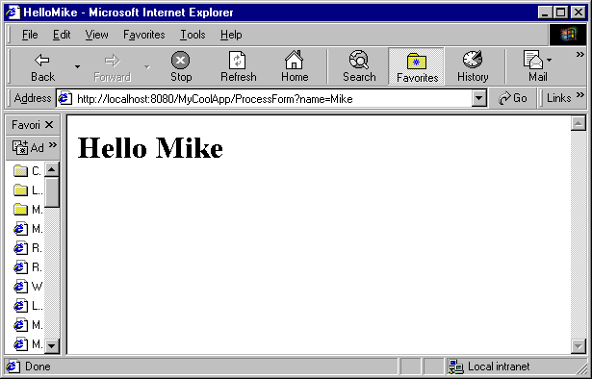

(7) It is very important that you examine the directory C:\Tomcat 5.5\logs. This directory will contain valuable feedback for you when you are debugging. System.out.println statements, executed from within your servlets, will write to the file C:\Tomcat 5.5\logs\stdout_date.

(8) Edit the HandleForm.java servlet so that the doGet() method begins with the line System.out.println(“The servlet has been executed “);

(9) Save the new servlet and run the following ant tasks:
ant compile
ant remove
ant install

Note, “ant reload” does not yet appear to be working correctly.

(10) Visit the servlet again several times and then examine the output found in
C:\Tomcat 5.5\logs\stdout_date. At the bottom of this file should be the output of the System.out.println statement.

PART III REQUIRED ACTIVITIES

Directions: Complete the activities listed on this sheet and type or paste your answers directly in the space provided. The Activities Sheet must be submitted in your envelope as a single Microsoft Word document called Lab1Submission.doc. Only turn in the Part III Required Activities portion of this document. Please don’t submit Part I or Part II. Also, you must submit printouts of all your java code as well as copies of these files on CD (or disk).

To capture a screen shot, hit Alt+PrtScreen on the window you want to copy. You can paste the screen shot into the Word document with the Edit/Paste menu. To capture the entire screen, use Ctrl+PrtScreen. Please only paste a screen shot when and where you are asked to do so.

Note: Points will be deducted if the submission is not neat, organized, and easy to grade. In addition, your Java code will be documented with comments describing the code.

Note: after you make any changes to the servlet you will need to build a new war file and redeploy it to the application server as shown above.

1) Many HTTP request headers sent by the client are only used by web servers and not by servlets(such as HandleForm). On occasion servlets are interested in the values of various HTTP headers. The Accept header, for example, specifies the media types the client prefers to accept. Each media type is represented by a type/subtype pair with “*” used as a wild card. If not passed by the client to the server the server may assume the client accepts all media types. We can access the Accept header from within a servlet by calling the getHeader() method of the HttpServletRequest object. The result is a java String.

fromClient = req.getHeader("Accept") + "<p>";

Add code to the HandleForm.java servlet so that it displays the contents of the Accept header on the browser.

The User-Agent header gives information about the client software. A servlet can use this information to keep statistics or customize its response based on the type of the client browser.

fromClient += req.getHeader("User-Agent") + "<p>";

Add code to the HandleForm.java servlet so that it displays the contents of the User-Agent header on the browser.

The Referer header gives the URL of the document that refers to the requested URL.

fromClient += req.getHeader("Referer") + "<p>";

Add code to the HandleForm.java servlet so that it displays the contents of the Referer header on the browser.

Post a screen shot here showing the browser after making the above three modifications.

2) Continue to make modifications to the web application so that the html page requests the user’s name and credit card number. After the Submit button is pressed the location bar (which lists the current URL) on the top of the browser contains a query string representing the user’s name and credit number. Paste the contents of the location bar, including the query string generated. (You need not do an entire screen shot for this question.)

3) Modify the html file from question (2) so that a Post method is used rather than a Get method. Do not change the servlet at this time. When you click the submit button in the html file you will receive an error message. Paste the error message generated from the Netscape browser. If you don’t have access to Netscape then show what IE5 does. Different browsers behave differently and we will take that into account. You’ll receive points either way.

4) Continuing from question (3), add a doPost() method to your servlet. It should contain the same parameters as doGet() and should throw the same exceptions. Have your doPost() method call doGet(). Paste the contents of the location bar after hitting the submit button. (You need not do an entire screen shot for this question.)

5) Continue to modify the servlet so that it displays on the browser screen the number of times this particular servlet has been visited. You will need to add an integer member to the HandleForm class. You need not use Session objects unless you want to. Paste a screen shot of the output generated by this new servlet after five visits.

6) Continue to modify the servlet so that it displays the time in seconds that has elapsed since the last visit by any browser. Use the Date class in java.util. Or, if you prefer, use the Calendar class. Paste a screen shot of the output generated by this new servlet.

7) Continue to modify the servlet so that it sets the content type to text/plain on the response object. Does this servlet still keep track of the time since the last visit (it’s OK if it does)? Explain what you see?

Question 8 is designed so that you get a chance to review some of what we have done in the previous questions. Please resist the temptation to simply make modifications to the servlet we worked on above. Take some time and build a new directory structure.

8) Write a new web application (a servlet called ReadRSS.java with a new index.html file) that allows the user to enter the name of an RSS feed (URL) in a browser. Your servlet will then read the RSS feed and send it back to the browser as text/xml. There is no need to parse the XML with a parser. We will do that in the next question. You may assume that your user is friendly and that the URL is correct. Paste at least three screen shots showing the browser displaying different user selected RSS documents.

In order to read the RSS feed, you may use the following Java code from within the servlet:

URL u = new URL(RSSName);
URLConnection uc = u.openConnection();
InputStream raw = uc.getInputStream();
InputStream buffer = new BufferedInputStream(raw);
Reader r = new InputStreamReader(buffer);
int c;
while((c = r.read()) != -1) {
fromRSS = fromRSS + ((char)c);
}

The RSSName string will come from the browser’s http request. The browser must prompt the user for an RSS URL rather than a name of a person (as we did in the previous questions). Below are a few RSS feeds that you might try:

http://rss.pcworld.com/rss/latestnews.rss
http://rss.pcworld.com/rss/downloads.rss?period=week
http://servlet.java.sun.com/syndication/rss_java_highlights-PARTNER-20.xml
http://dublincore.org/news.rss
http://news.bbc.co.uk/rss/newsonline_uk_edition/front_page/rss.xml

Here is a screen shot showing an initial visit:

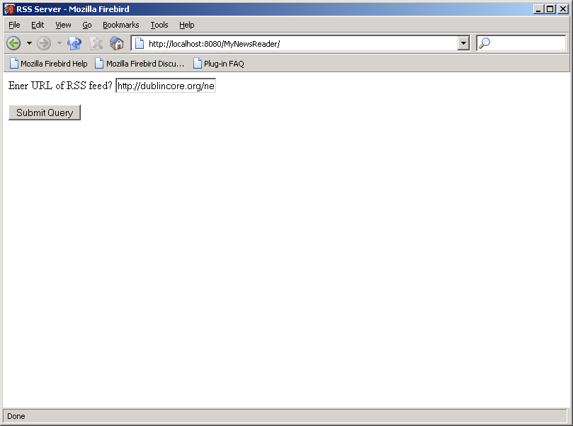

Here is a screen shot showing the results of the visit:

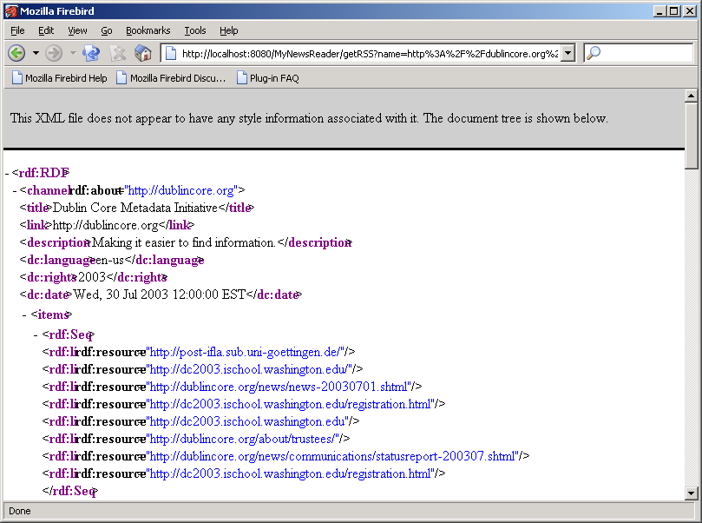

9) In question 8 we are reading the RSS feed and displaying it to the browser as raw XML. Many web sites are beginning to describe their content using RSS but raw XML is not typically what browsers like to display. For this question you will write a web application that allows a user to register her interest in a set of several RSS feeds. After the registration step, the user will be able to visit the web application and receive a list of news items and links (pointing to those items) on her browser. Many users (with different email addresses) may use the same application concurrently. All the data sent to the browser for display will be in HTML (not XML). If the user enters a URL that does not actually address an RSS feed then the program will report that fact to the user without crashing.

Required files:

Register.html When Register.html is accessed it displays an HTML form on the browser. The form allows the user to enter a complete email address and a URL of an RSS news feed. When the submit button is hit, Register.html sends an HTTP request to a servlet called SetRSS.java. This servlet collects the email address and the URL and places the pair in a shared object called UserLists.java. UserLists.java is a modified version of the VisitTracker.java program we studied in class. UserLists holds a hash table of linked lists. Each hash table cell holds a list of URL’s that a particular user is interested in. The hash table is indexed with an email address.

SetRSS.java SetRSS is a servlet that is called by Register.html. It reads the URL and email address and passes both of these data items to UserLists.java. It then makes a request on UserLists for a list of all URL’s that the email address is associated with. SetRSS collects this list of RSS URL’s and sends them back to the browser.

UserLists.java UserLists.java is a singleton. There is only one object of this class and can be used for servlet collaboration. It makes use of the java.util package. This package contains various collection classes. The UserLists object needs to associate a list of RSS URL’s with each registered email address. The number of email addresses may grow over time and so may the number of URL’s associated with each email address.

Access.html When Access.html is accessed it displays an HTML form on the browser. The form allows the user to enter an email address. When the submit button is hit, Access.html sends an HTTP request to a servlet called ReadRSS.java.

ReadRSS.java The ReadRSS servlet collects the email address from the HTTP request and passes it to the UserLists object. The UserLists object returns a list of RSS URL’s associated with the email address. ReadRSS iterates over each URL and creates an InputSource object for each. The InputSource objects are passed, one at a time, to the RSSHandler class. ReadRSS reads the results made available by RSSHandler. ReadRSS returns an HTML document to the browser. This document contains a set of anchor elements. Each anchor element has an attribute containing a URL. Each anchor element has the title of the news item as its content. So, the user sees a list of news items with links. The source of the RSS feed and the current date and time will be displayed around each list of news feed items.

RSSHandler.java The RSSHandler class is a SAX handler and it extends the ContentHandler class. Its constructor takes an InputSource object as a parameter. The class handles SAX events from an RSS news feed. As a simplification, the RSSHandler class looks for any <item> element containing a <title> and a <link> element. It assumes that a <title> and a <link> element will always be found within an <item> element. It does not assume that <link> and <title> are in any particular order. Nor does it assume that there are no additional children of the <item> element. It ignores all elements that are not found within an <item> element. To model the behavior of the SAX handler you might consider using a finite state machine as discussed in class. For each RSS feed, the RSSHandler class makes available a list of title and link pairs.

RSSTitleAndLink.java This is a very simple class that holds one title and link pair as two Java String objects. If you write your solution without this file that is fine.

The directory structure for my solution looks like the following:

D:\McCarthy\www\95-702\examples\GetAnRSSFeedServlet>tree /f
Folder PATH listing
Volume serial number is 71FAE346 BA17:BF69
D:.
│ build.properties
│ build.xml
│
├───build
│ │ Access.html
│ │ Register.html
│ │
│ └───WEB-INF
│ │ web.xml
│ │
│ ├───classes
│ │ ReadRSS.class
│ │ RSSHandler.class
│ │ RSSTitleAndLink.class
│ │ SetRSS.class
│ │ UserLists.class
│ │
│ └───lib
├───docs
├───src
│
│ ReadRSS.java
│ RSSHandler.java
│ RSSTitleAndLink.java
│ SetRSS.java
│ UserLists.java
│
└───web
│ Access.html
│ Register.html
│
└───WEB-INF
web.xml

Paste here several screen shots showing users registering. At least one of the users should be shown registering for multiple news feeds.

Paste here several screen shots that show a browser displaying a list of links that the user is interested in.

Submission requirements:

Submit an otherwise blank CD (or floppy) holding three separate web applications in three separate directories.

Submit printouts of a well documented Handleform.java and its associated index.html file.

Submit printouts of a well documented ReadRSS.java and its associated index.html file.

Submit printouts of the files Register.html ,SetRSS.java (a documented servlet), UserLists.java (a documented singleton), Access.html , ReadRSS.java (a documented servlet), and RSSHandler.java (a documented SAX handler)

Submit a Microsoft word document with all of the screen shots mentioned above (Lab1Submission.doc).

Place all of this in one large envelope with your name, course number and homework number.

Helpful Readings:

On XML and SAX see http://www.ibiblio.org/xml/

If you are having trouble don’t panic. Start early and see me or a TA if you can’t resolve the issue on your own. Use the discussion board.

Grading Guidelines:

Question/Points
- 5 Pts.
- 5 Pts.
- 5 Pts.
- 5 Pts.
- 5 Pts.
- 10 Pts.
- 5 Pts.
- 30 Pts.
- 30 Pts.

