95-702 Organizational Communication and Distributed Object

Technologies Homework 1 Due Thursday, September 16, 2004

Application Server Installation and Servlets

Topics: Distributed Systems, Application Server Installation and deployment, Servlets, Log Files, SAX Event Handling, RSS news feeds

In this lab we will be using Sun’s Java System Application Server Platform Edition 8 to build several web applications. In Part I, we will present the details associated with the installation and basic configuration of Sun’s Application Server running under Windows NT or Windows 2000 (you may also use Linux). In Part II we will experiment with servlets. In Part III you will be asked to complete work for submission.

Part I Installing Sun’s Application Server

Remove J2SDK and JRE (if any)
Remove JWSDP (if any)

Download and unzip j2eesdk-1_4_01-windows
-- I chose D:\Sun\AppServer
-- I chose to prompt for admin user name
-- Many students change the port from 8080 to 7070 so as not to conflict
with a pre-installed Tomcat. You might change the HTTPS port as well.
-- I checked Add bin directory to path, create samples server, and create
desktop shortcut to autodeploy

Download and unzip j2ee-1_4-doc-tutorial_2 from http://java.sun.com/j2ee/1.4/download.html#tutorial

-- I unzipped mine to D:\
producing D:\j2eetutorial14

Set your environment up so that you can use JAXP (for DOM or SAX) from within the application Server or from stand alone Java:

My application server is located at D:\Sun\AppServer
My JDK is located at D:\Sun\AppServer\jdk

The libraries are stored in D:\Sun\AppServer\lib\endorsed and are automatically available to the Application server.

To run stand alone java programs that use JAXP, copy the .jar files in
D:\Sun\AppServer\lib\endorsed to a new directory called D:\Sun\AppServer\jdk\jre\lib\endorsed (within the JDK).

My path variable contains D:\Sun\AppServer\jdk\bin;D:\Sun\AppServer\bin;

Download and unzip the Java 2 SDK, Standard Edition Documentation Version 1.4.2. The zip file is called j2sdk-1_4_2-doc and is found at
http://java.sun.com/j2se/1.4.2/download.html

After unzipping the documentation I have a directory called
D:\Sun\AppServer\jdk\docs that holds documentation for all the standard Java API’s.

TESTING THE INSTALLATION
Test java with

d:\mccarthy>java -version
java version "1.4.2_04"
Java(TM) 2 Runtime Environment, Standard Edition (build 1.4.2_04-b04)
Java HotSpot(TM) Client VM (build 1.4.2_04-b04, mixed mode)

Test J2EE startup with

d:\mccarthy>cd D:\Sun\AppServer\domains
D:\Sun\AppServer\domains>asadmin start-domain domain1
Starting Domain domain1, please wait.
Log redirected to D:\Sun\AppServer\domains\domain1\logs\server.log.
Domain domain1 started.

Visit with browser at

http://localhost:8080/

Visit admin console at

http://localhost:4848/asadmin
Use log-in ID and password
View the log file at Application Server->Logging->Open Log Viewer

The help files are very good and are located at Application Console
Admin Server Help.

Say "hello" to Duke

-- copy D:\Sun\AppServer\samples\quickstart\hello.war to
D:\Sun\AppServer\domains\domain1\autodeploy
-- visit http://localhost:8080/hello

Test J2EE shutdown with

d:\mccarthy>cd D:\Sun\AppServer\domains
D:\Sun\AppServer\domains>asadmin stop-domain domain1
Domain domain1 stopped.

Test PointBase database with

D:\Sun\AppServer\pointbase\tools\serveroption>startserver
Server started, listening on port 9092, display level: 0 ...
>quit
PointBase Server Stopped. Good Bye!

Examine server log with

D:\Sun\AppServer\domains\domain1\logs>type server.log | more

Some Notes from Application Server Admin Console Help (not needed for this lab):

To start a domain called domain1 asadmin start-domain domain1

Starting a domain starts the domain's application server and
administration server instance

Stopping a domain shuts down its administration server and application server instance

To stop domain1 asadmin stop-domain domain1

The deployment life-cycle:

Applications or modules are installed in specific domains.
Applications and modules are contained in JAR files.
Deployment survives domain shutdown.
You need not restart a domain to redeploy an application.
An application or module may be enabled or disabled within a domain.
To replace an application or module simply redeploy it.

Types of J2EE JAR Files:

WAR files are Web Application Archives (.war)
EJB JAR files hold EJB's (.jar)
J2EE Application Client JAR's access enterprise beans via RMI/IIOP
(.jar)
Resource Adapter Archive (.rar)
An Enterprise Application Archive file holds one or more of the above
(.ear)

Deployment is through the admin console, the deploytool or through
asadmin command.

Sun implements the JMS API with the Sun Java System Message Queue
(formerly Sun ONE Message Queue)

The J2EE architecture includes standard resources, such as JDBC, JMS,
and JavaMail resources.

Custom resources may be built by the developer.

When you create a new resource, a new name-object binding is entered
into the JNDI repository. Each resource object is identified by a
unique, people-friendly name: the JNDI name. A resource object and its
JNDI name are bound together by the naming and directory service, which
is included with the Application Server.

JNDI names are organized hierarchically, much like a file system. In a
file system, you can organize your files into subdirectories. In JNDI,
resource names are organized into subcontexts. For example, all JDBC
resource names must be in java:comp/env/jdbc subcontext. The JNDI name
for the resource of a payroll database could be
java:comp/env/jdbc/payrolldb.

Part II Packaging Web Applications

Example I Package and deploy hello1.war
=======================================

Packaging a web application

0 Start the application server (Start->Programs->SUN Micro->J2EE1.4 SDK->Start
Default Server)
1 Start deploytool using Start->Programs etc.
2 Create a Web application called hello1 by running the New Web Component
wizard. Select FileNewWeb Component.
3 In the New Web Component wizard:
a. Select the Create New Stand-Alone WAR Module radio button.
b. In the WAR Location field,
enter <INSTALL>/j2eetutorial14/examples/web/hello1/hello1.war.
c. In the WAR Name field, enter hello1 (probably already there).
d. Click Edit Contents to add the content files.
e. In the Edit Contents dialog box, navigate to
<INSTALL>/j2eetutorial14/examples/web/hello1.
Select duke.waving.gif, index.jsp, and response.jsp and click Add. Click
OK.
f. Click Next.
g. Select the No Component radio button.
h. Click Next.
i. Click Finish.
j. Select hello1 in the tree on the left and select the General tab
k. In the context root(Sun-specific) enter /MyFirstWebApp
l. Click the deploy button. Log onto server and view deployment status.
m. Visit http://localhost:8080/MyFirstWebApp

Example II Package and deploy an HTML file and a servlet
========================================================

1. Create a directory called example2.
2. Place index.html in example2. Note that it calls a servlet called
HandleForm.

<!-- index.html -->
<html>
<head>
<title>Introductions</title>
</head>
<body>
<form method="get" action="HandleForm">
Hi, what is your name?
<input type="text" name = "name"> <p>
<input type = "submit">
</form>
</body>
</html>

3. Place HandleForm.java in example2.

// HandleForm.java
// An introductory servlet

import java.io.*;
import javax.servlet.*;
import javax.servlet.http.*;

public class HandleForm extends HttpServlet {

public void doGet(HttpServletRequest req,
HttpServletResponse response)
throws ServletException,
IOException {

String name = req.getParameter("name");

response.setContentType("text/html");
PrintWriter out = response.getWriter();

String docType = "<!DOCTYPE HTML PUBLIC \"//W3C//DTD HTML 4.0 ";
docType += "Transitional//EN\">\n";

out.println(docType +
"<HTML>\n" +
"<HEAD><TITLE>Hello" + name + "</TITLE></HEAD>\n" +
"<BODY>\n" +
"<H1>Hello "+ name + "</H1>\n" +
"</BODY></HTML>");
}

}

4. Set your classpath to "D:\Sun\AppServer\lib\j2ee.jar;."
and compile the servlet with "javac HandleForm.java".

5. Run deploytool. We need to build a J2EE directory structure and collapse it
into a ".war" file and deploy the ".war" to the application server. The
deploytool program does this for us.

a. Run the New Web Application Wizard with File->New->Web Component and
choose next.
b. Under WAR naming browse to the example2 directory and enter example2.war
c. Under Context-Root (Sun specific) enter /WayCool
d. Click edit contents and browse to example2.
e. Move the ".class" file and the ".html" file to the bottom frame
(building the directory structure for the WAR.)You do this by selecting
in the top screen and clicking add to the bottom screen.
f. Choose No Component and finish. We built the WAR and the html is
available.
g. Select the new .WAR and run the wizard again. Select Add to existing WAR
module.
h. Select HandleForm.class in the contents box and click next.
i. Select servlet and select next.
j. Select servlet class HandleForm from the drop down list. Click next.
Click finish.
k. Select the servlet from the tree and add an alias using the tabs. The
alias will be /HandleForm.

l. Select example2 and then choose to deploy. (The application server must
be running.)
m. If you get Tab errors you probably have too many rows in your alias
box.
n. With a browser visit "http://localhost:8080/WayCool".

(6) Edit the HandleForm.java servlet so that the doGet() method begins with
the line System.out.println(“The servlet has been executed “);

(7) Save the new servlet and recompile with javac HandleForm.java.

(8) We need to regenerate the .war file (containing the new HandleForm.class)
and redeploy the .war file. To do this, click the update modules button
and then redeploy the war file. Visit the new web application in a
browser.Run the administration server (localhost:4848) and view the log files for the output of the System.out.println statements. This can be handy when debugging.

PART III REQUIRED ACTIVITIES

Directions: Complete the activities listed on this sheet and type or paste your answers directly in the space provided. The Activities Sheet must be submitted in your envelope as a single Microsoft Word document called Lab1Submission.doc. Only turn in the Part III Required Activities portion of this document. Please don’t submit Part I or Part II. Also, you must submit printouts of all your java code as well as copies of these files on CD (or disk).

To capture a screen shot, hit Alt+PrtScreen on the window you want to copy. You can paste the screen shot into the Word document with the Edit/Paste menu. To capture the entire screen, use Ctrl+PrtScreen. Please only paste a screen shot when and where you are asked to do so.

Note: Points will be deducted if the submission is not neat, organized, and easy to grade. In addition, your Java code will be documented with comments describing the code.

Note: after you make any changes to the servlet you will need to build a new war file and redeploy it to the application server as shown above.

1) Many HTTP request headers sent by the client are only used by servers (such as Tomcat) and not by servlets (such as HandleForm). On occasion servlets are interested in the values of various HTTP headers. The Accept header, for example, specifies the media types the client prefers to accept. Each media type is represented by a type/subtype pair with “*” used as a wild card. If not passed by the client to the server the server may assume the client accepts all media types. We can access the Accept header from within a servlet by calling the getHeader() method of the HttpServletRequest object. The result is a java String.

fromClient = req.getHeader("Accept") + "<p>";

Add code to the HandleForm.java servlet so that it displays the contents of the Accept header on the browser.

The User-Agent header gives information about the client software. A servlet can use this information to keep statistics or customize its response based on the type of the client browser.

fromClient += req.getHeader("User-Agent") + "<p>";

Add code to the HandleForm.java servlet so that it displays the contents of the User-Agent header on the browser.

The Referer header gives the URL of the document that refers to the requested URL.

fromClient += req.getHeader("Referer") + "<p>";

Add code to the HandleForm.java servlet so that it displays the contents of the Referer header on the browser.

Post a screen shot here showing the browser after making the above three modifications.

2) Continue to make modifications to the web application so that the html page requests the user’s name and credit card number. After the Submit button is pressed the location bar (which lists the current URL) on the top of the browser contains a query string representing the user’s name and credit number. Paste the contents of the location bar, including the query string generated. (You need not do an entire screen shot for this question.)

3) Modify the html file from question (2) so that a Post method is used rather than a Get method. Do not change the servlet at this time. When you click the submit button in the html file you will receive an error message. Paste the error message generated from the Netscape browser. If you don’t have access to Netscape then show what IE5 does. Different browsers behave differently and we will take that into account.

4) Continuing from question (3), add a doPost() method to your servlet. It should contain the same parameters as doGet() and should throw the same exceptions. Have your doPost() method call doGet(). Paste the contents of the location bar after hitting the submit button. (You need not do an entire screen shot for this question.)

5) Continue to modify the servlet so that it displays on the browser screen the number of times this particular servlet has been visited. You will need to add an integer member to the HandleForm class. Paste a screen shot of the output generated by this new servlet after five visits.

6) Continue to modify the servlet so that it displays the time in seconds that has elapsed since the last visit. Use the Date class in java.util. Or, if you prefer, use the Calendar class. Paste a screen shot of the output generated by this new servlet.

7) Continue to modify the servlet so that it sets the content type to text/plain on the response object. Does this servlet still keep track of the time since the last visit (it’s OK if it does)? Explain what you see?

Question 8 is designed so that you get a chance to review some of what we have done in the previous questions. Please resist the temptation to simply make modifications to the servlet we worked on above. Take some time and build a new WAR file and deploy your new web application from a new place.

8) Write a new web application (a servlet called ReadRSS.java with a new index.html file) that allows the user to enter the name of an RSS feed (URL) in a browser. Your servlet will then read the RSS feed and send it back to the browser as text/xml. There is no need to parse the XML with a parser. We will do that in the next question. You may assume that your user is friendly and that the URL is correct. Paste at least three screen shots showing the browser displaying different user selected RSS documents.

In order to read the RSS feed, you may use the following Java code from within the servlet:

URL u = new URL(RSSName);
URLConnection uc = u.openConnection();
InputStream raw = uc.getInputStream();
InputStream buffer = new BufferedInputStream(raw);
Reader r = new InputStreamReader(buffer);
int c;
while((c = r.read()) != -1) {
fromRSS = fromRSS + ((char)c);
}

The RSSName string will come from the browser’s http request. The browser must prompt the user for an RSS URL rather than a name of a person (as we did in the previous questions). Below are a few RSS feeds that you might try:

http://rss.pcworld.com/rss/latestnews.rss
http://rss.pcworld.com/rss/downloads.rss?period=week
http://servlet.java.sun.com/syndication/rss_java_highlights-PARTNER-20.xml
http://dublincore.org/news.rss

Here is a screen shot showing an initial visit:

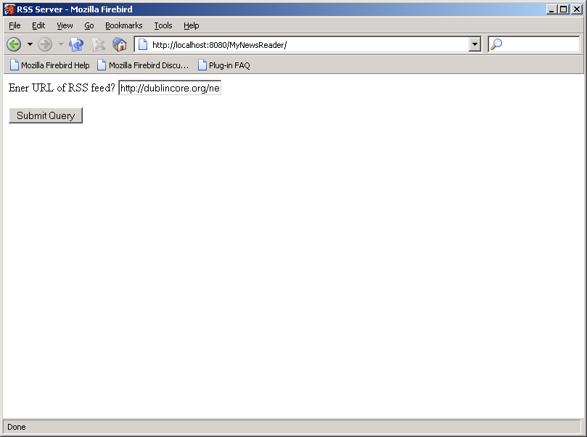

Here is a screen shot showing the results of the visit:

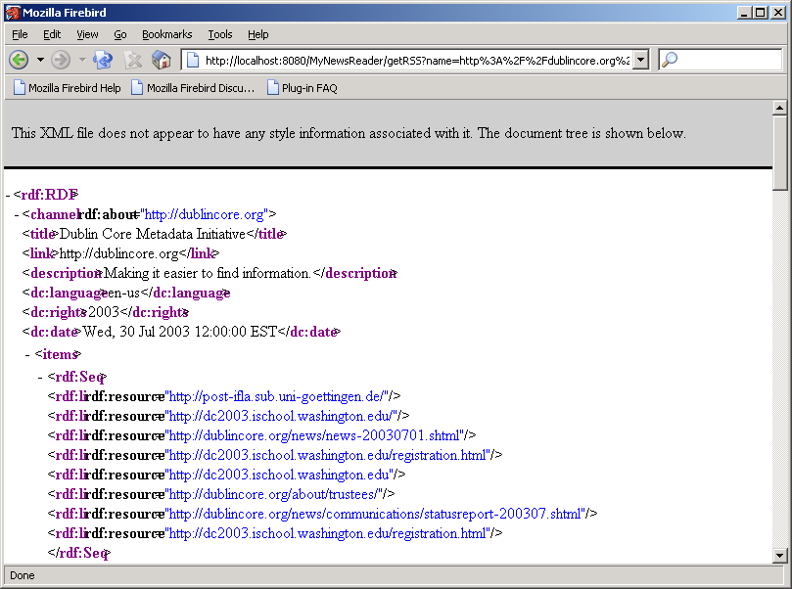

9) In question 8 we are reading the RSS feed and displaying it to the browser as raw XML. Many web sites are beginning to describe their content using RSS but raw XML is not typically what browsers like to display. For this question you will write a web application that allows a user to register her interest in a set of several RSS feeds. After the registration step, the user will be able to visit the web application and receive a list of news items and links (pointing to those items) on her browser. Many users (with different email addresses) may use the same application concurrently. All the data sent to the browser for display will be in HTML (not XML).

Required files:

Register.html When Register.html is accessed it displays an HTML form on the browser. The form allows the user to enter a complete email address and a URL of an RSS news feed. When the submit button is hit, Register.html sends an HTTP request to a servlet called SetRSS.java. This servlet collects the email address and the URL and places the pair in a shared object called UserLists.java. UserLists.java is a modified version of the VisitTracker.java program we studied in class. UserLists holds a hash table of linked lists. Each hash table cell holds a list of URL’s that a particular user is interested in. The hash table is indexed with an email address.

SetRSS.java SetRSS is a servlet that is called by Register.html. It reads the URL and email address and passes both of these data items to UserLists.java. It then makes a request on UserLists for a list of all URL’s that the email address is associated with. SetRSS collects this list of RSS URL’s and sends them back to the browser.

UserLists.java UserLists.java is a singleton. There is only one object of this class and can be used for servlet collaboration. It makes use of the java.util package. This package contains various collection classes. The UserLists object needs to associate a list of RSS URL’s with each registered email address. The number of email addresses may grow over time and so may the number of URL’s associated with each email address.

Access.html When Access.html is accessed it displays an HTML form on the browser. The form allows the user to enter an email address. When the submit button is hit, Access.html sends an HTTP request to a servlet called ReadRSS.java.

ReadRSS.java The ReadRSS servlet collects the email address from the HTTP request and passes it to the UserLists object. The UserLists object returns a list of RSS URL’s associated with the email address. ReadRSS iterates over each URL and creates an InputSource object for each. The InputSource objects are passed, one at a time, to the RSSHandler class. ReadRSS reads the results made available by RSSHandler. ReadRSS returns an HTML document to the browser. This document contains a set of anchor elements. Each anchor element has an attribute containing a URL. Each anchor element has the title of the news item as its content. So, the user sees a list of news items with links. The source of the RSS feed and the current date and time will be displayed around each list of news feed items.

RSSHandler.java The RSSHandler class is a SAX handler and it extends the ContentHandler class. Its constructor takes an InputSource object as a parameter. The class handles SAX events from an RSS news feed. As a simplification, the RSSHandler class looks for any <item> element containing a <title> and a <link> element. It assumes that a <title> and a <link> element will always be found within an <item> element. It does not assume that <link> and <title> are in any particular order. Nor does it assume that there are no additional children of the <item> element. It ignores all elements that are not found within an <item> element. To model the behavior of the SAX handler you might consider using a finite state machine as discussed in class. For each RSS feed, the RSSHandler class makes available a list of title and link pairs.

RSSTitleAndLink.java This is a very simple class that holds one title and link pair as two Java String objects. If you write your solution without this file that is fine.

Paste here several screen shots showing users registering. At least one of the users should be shown registering for multiple news feeds.

Paste here several screen shots that show a browser displaying a list of links that the user is interested in.

Submission requirements:

Submit an otherwise blank CD (or floppy) holding three separate web applications in three separate directories.

Submit printouts of a well documented Handleform.java and its associated index.html file.

Submit printouts of a well documented ReadRSS.java and its associated index.html file.

Submit printouts of the files Register.html ,SetRSS.java (a documented servlet), UserLists.java (a documented singleton), Access.html , ReadRSS.java (a documented servlet), and RSSHandler.java (a documented SAX handler)

Submit a Microsoft word document with all of the screen shots mentioned above (Lab1Submission.doc).

Place all of this in one large envelope with your name, course number and homework number.

Helpful Readings:

The J2EE Tutorial Second Edition Chapter 5 Simple API for XML (SAX)
The J2EE Tutorial Second Edition Chapter 11 Java Servlet Technology

If you are having trouble please don’t panic. Start early and see me if you can’t resolve the issue on your own.

Grading Guidelines:

Question/Points
- 5 Pts.
- 5 Pts.
- 5 Pts.
- 5 Pts.
- 5 Pts.
- 10 Pts.
- 5 Pts.
- 30 Pts.
- 30 Pts.

