Lab 1

Jigsaw Installation and Servlets

In this lab we will be using an HTTP server called Jigsaw available from the World Wide Web Consortium (W3C). In Part 1, we will present the details associated with the installation and basic configuration of Jigsaw running under either Windows ’95 or Windows NT. In Part 2 we will experiment with servlets.

Part I Installing Jigsaw on Windows 95/Windows NT

1) If you have not already done so, you need to install the Java programming language on your system. Obtain a copy of the JDK1.3.0 (Java 2 SDK) compiler. This compiler is available from Sun Microsystem’s web site at http://java.sun.com/j2se/1.3/download-windows.html. You should also download and install the Java documentation. This is available from Sun at http://java.sun.com/j2se/1.3/docs.html. Choose the Browse and Download documentation option and then download one large bundle in HTML format. These files arrive in a compressed format. You can use winzip to expand them. You can download an evaluation copy of winzip from http://www.winzip.com/winzip/download.html. Be sure to set your path variable (so that the Java compiler and Java interpreter can be run from any directory using simple commands). Also be sure to set your classpath variable (so that javac and java can find the locations of the classes that your programs will use). The following web site contains directions on how to set the path and classpath variables: http://java.sun.com/j2se/1.3/install-windows.html.

2) Visit the World Wide Web Consortium (W3C) at http://www.w3.org. Choose Jigsaw from the left hand column. Read the installation instructions carefully. Download and expand the most recent stable version - Jigsaw 2.0.5. The file that you should download is called Jigsaw_2.0.5.zip. Use winzip to exapand this file and place the contents into a new directory called Jigsaw.When you expand this file using winzip, place the extracted files in this new directory.

Using the MyComputer icon, look over the files in the new directory. You should see a directory tree that looks like the following:

C:\Jigsaw\Jigsaw\Jigsaw\Www

The following directions will assume that you have such a directory tree.

3) Next, we want to run the Install.class file under the name C:\Jigsaw\Jigsaw\Jigsaw\Install.class. Before we do so, we must set the CLASSPATH variable. On an NT machine, we can set our CLASSPATH by choosing start/settings/control panel/system/environment and changing the user-variable CLASSPATH to

c:\Jigsaw\Jigsaw\classes\jigsaw.zip;c:\Jigsaw\Jigsaw\classes\servletjar;.;C:\Jigsaw\Jigsaw\classes\jigadmin.jar

The ‘.’ is important so that the current directory is in the classpath. Jigadmin.jar is needed to use the administration server.

Run the Install.class as shown below:

C:\Jigsaw\Jigsaw\Jigsaw>java Install
Jigsaw/2.0.5 setup.

updating C:\Jigsaw\Jigsaw\Jigsaw\config\http-server.props ... done.
updating C:\Jigsaw\Jigsaw\Jigsaw\config\admin-server.props ...done.

Installation complete with 0 warning.

type 'java org.w3c.jigsaw.Main -root C:\Jigsaw\Jigsaw\Jigsaw' to launch Jigsaw.

type 'java org.w3c.jigadmin.Main -root C:\Jigsaw\Jigsaw\Jigsaw http://localhost:
8009' to launch the new JigAdmin tool.
type 'java org.w3c.jigadm.Main -root C:\Jigsaw\Jigsaw\Jigsaw http://localhost:80
09' to launch the old JigAdmin tool (If you do not have JDK1.2)

4) We need to create batch files so that we can type simple commands like ‘jigsaw’ and ‘jigadmin’.
Place the following files (Jigsaw.bat and Jigadmin.bat) in a directory called c:\batch.

Jigsaw.bat
java org.w3c.jigsaw.Main -root c:\Jigsaw\Jigsaw\Jigsaw

Jigadmin.bat
java org.w3c.jigadmin.Main -root c:\Jigsaw\Jigsaw\Jigsaw http://localhost:8009

Place the new directory, c:\batch, in the path variable so that the command interpreter knows where to look for DOS commands. This can be done on an NT machine by choosing start/settings/control panel/system/environment and changing the system variable path to include c:\batch.

Note: If you are planning to run Jigsaw on a Windows ’95 machine, you may have to establish an internet connection before attempting to run Jigsaw. (This may even be true if you are using localhost as your server and do not plan on actually using the network.) Contact your TA or your instructor if you are having problems with the installation.

3) Run Jigsaw. Be sure to open a new DOS screen so that the system is aware of the new classpath and path settings. Your screen should appear as shown below:

C:\Jigsaw\Jigsaw\Jigsaw>jigsaw

C:\Jigsaw\Jigsaw\Jigsaw>java org.w3c.jigsaw.Main -root c:\Jigsaw\Jigsaw\Jigsaw
loading properties from: c:\Jigsaw\Jigsaw\Jigsaw\config\server.props
Jigsaw[2.0.5]: serving at http://heinz-mm6ky:8001/
*** Warning : JigAdmin[2.0.5]: no logger specified, not logging.
JigAdmin[2.0.5]: serving at http://heinz-mm6ky:8009/

4) Run Jigadmin. Be sure to open a new DOS window. Your screen should appear as shown below:

C:\users>jigadmin

C:\users>java org.w3c.jigadmin.Main -root c:\Jigsaw\Jigsaw\Jigsaw http://localhost:8009

5)Change your password. The Jigsaw documentation states that your initial administrative login ID is admin and your initial password is also admin. We would like to change our password using jigadmin. Follow the steps as shown on the following screens:

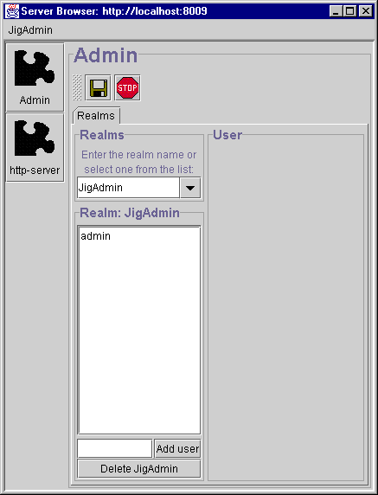
1. Hit return here to see the user name admin.
2. Click admin to see user admin’s properties.

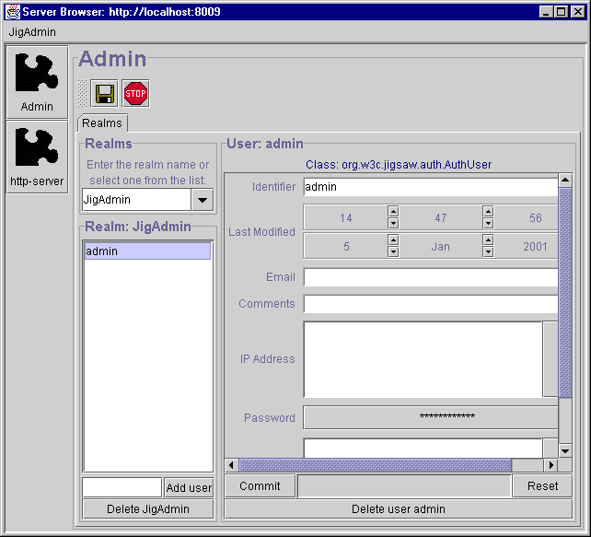
3. Enter a new password by clicking on these asterisks

4. Commit the change.
The JigAdmin realm now has a user named admin with the password that you assigned.

4) If you have a copy of the Adobe Acrobat Reader, you may view Jigsaw’s documentation at http://jigsaw.w3.org/Doc/JigsawDoc.pdf. You may want to bookmark this page or save a file to your computer so that you may more easily refer to the documentation. Please be aware that the documentation is not always complete and up to date, so you may also want to look at the various readme files on your computer if you find that following the documentation does not lead you to the desired result.

Part II Experimenting with HTTP, Servlets and Jigsaw

1) Under the directory Jigsaw/WWW create a new directory called html. Within this new directory, create a file called getnameform.html with the contents as shown in Figure 1.1. Under the directory Jigsaw/WWW/servlet (which should exist after the installation of Jigsaw) create the Java file as shown in Figure 1.2. Name the file HandleForm.java. Compile this program with javac. Load the html file into your browser with: http://localhost:8001/html/getnameform.html

<!-- getnameform.html -->
<html>
<head>
<title>Introductions</title>
</head>
<body>
<form method="get" action="/servlet/HandleForm">
Hi, what is your name?
<input type="text" name = "name"> <p>
<input type = "submit">
</form>
</body>
</html>
Figure 1.1

// HandleForm.java
// An introductory servlet

import java.io.*;
import javax.servlet.*;
import javax.servlet.http.*;

public class HandleForm extends HttpServlet {

public void doGet(HttpServletRequest req,
HttpServletResponse response)
throws ServletException,
IOException {

String name = req.getParameter("name");

response.setContentType("text/html");

PrintWriter out = response.getWriter();

String docType = "<!DOCTYPE HTML PUBLIC \"//W3C//DTD HTML 4.0 ";
docType += "Transitional//EN\">\n";

out.println(docType +
"<HTML>\n" +
"<HEAD><TITLE>Hello" + name + "</TITLE></HEAD>\n" +
"<BODY>\n" +
"<H1>Hello "+ name + "</H1>\n" +
"</BODY></HTML>");
}

}
Figure 1.2

Lab 1 Activities Sheet

Directions: Complete the activities listed on this sheet and type or paste your answers on the Lab 1 Answer Sheet that follows it. The Answer Sheet must be submitted (via email) as a single Microsoft Word document. Only turn in the Lab 1 Answer Sheet portion of this document. Please don’t submit Part I, Part II, or the Activities Sheet.

To capture a screen shot, hit Alt+PrtScreen on the window you want to copy. You can paste the screen shot into the Word document with the Edit/Paste menu. To capture the entire screen, use Ctrl+PrtScreen.

Note: Each question counts for 1 point. One point will be deducted if the submission is not neat, organized, and easy to grade.

1) Most request headers sent by the client are only used by servers and not by servlets. Some are, however, of use by servlets. The Accept header, for example, specifies the media types the client prefers to accept. Each media type is represented by a type/subtype pair with “*” used as a wild card. If not passed by the client to the server the server may assume the client accepts all media types. We can access the Accept header from within a servlet by calling the getHeader() method of the HttpServletRequest object. The result is a java String.

fromClient = req.getHeader("Accept") + "<p>";

Add code to the servlet in Figure 1.1 so that it displays the contents of the Accept header on the browser. Write or paste the resulting data.

2) The User-Agent header gives information about the client software. A servlet can use this information to keep statistics or customize its response based on the type of the client browser.

fromClient += req.getHeader("User-Agent") + "<p>";

Add code to the servlet in Figure 1.1 so that it displays the contents of the User-Agent header on the browser. Write or paste the resulting data.

3) The Referer header gives the URL of the document that refers to the requested URL.

fromClient += req.getHeader("Referer") + "<p>";

Add code to the servlet in Figure 1.1 so that it displays the contents of the Referer header on the browser. Write or paste the resulting data.

4) We would like to add a user name and a password to our servlet. Using Jigadmin, select the http puzzle piece (we want to configure the HTTP server). Then choose the Docs space tab and expand the servlet directory by clicking the little toggle to the left of the servlet icon. Double click on the HandleForm. Then, double click on the ServletWrapperFrame and choose Resource/AddFrameToSelectedResource from the Resource menu. Choose GenericAuthFilter from the drop down list. Add the realm admin in the white rectangle as shown below. Then, commit the change.

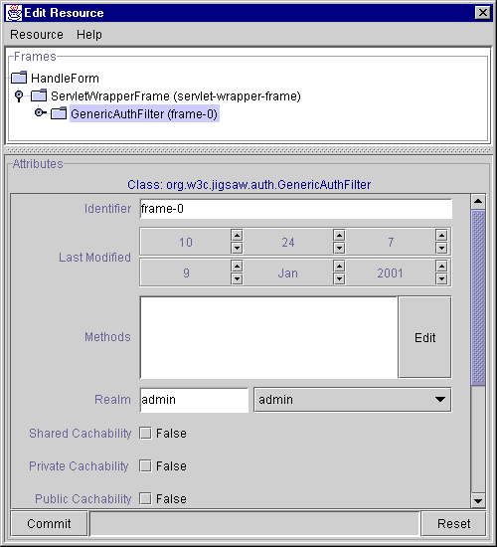

Show a screen shot of your browser requesting a user name and password. This screen shot should show that the html file was available prior to running the protected servlet. Your screen should be similar to the following, except that it should be your screen shot with your name.

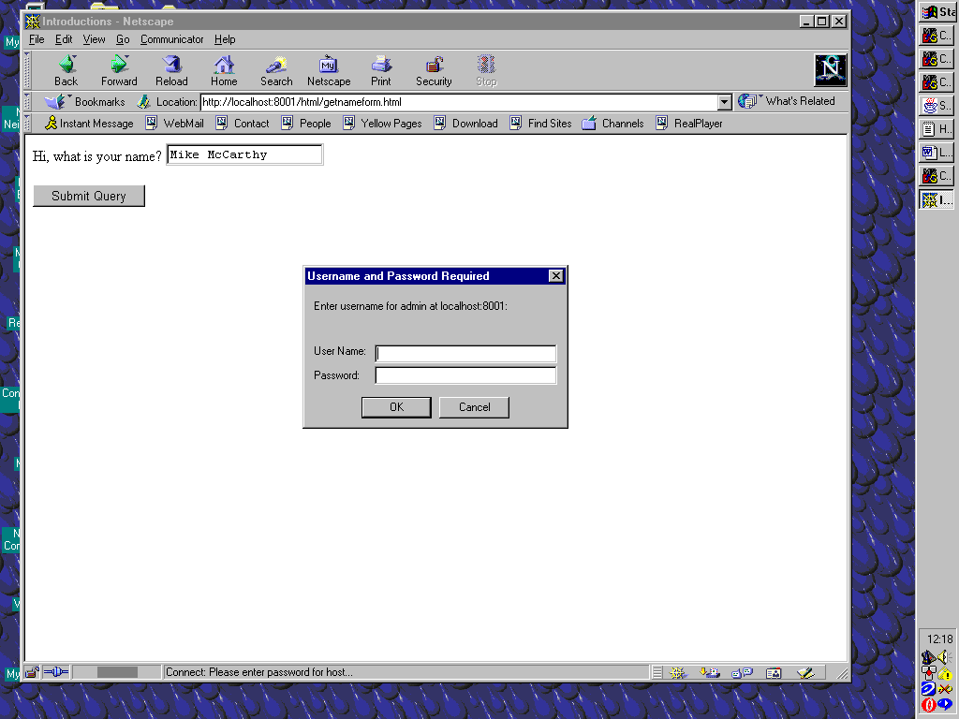

5) After we place the servlet within a realm the Authorization header will contain data that is available to the servlet. It will contain a Base64 encoding of the string "username:password". Include the following code in your servlet and copy a screen shot of the result.

// Display authorization data from the server
String auth = "";
auth = req.getHeader("Authorization");
String userPassEncoded = auth.substring(6);

sun.misc.BASE64Decoder dec = new sun.misc.BASE64Decoder();
String userPassDecoded = new String(dec.decodeBuffer(userPassEncoded));

fromClient += auth + "<p>";
fromClient += userPassDecoded + "<p>";

6) Make the necessary modifications to Figure 1.1 so that the html page requests the user’s name and credit card number. After the Submit button is pressed the location bar (which lists the current URL) on the top of the browser contains a query string representing the user’s name and credit number. Paste the contents of the location bar, including the query string generated.

7) Modify the html file from question (6) so that a Post method is used rather than a Get method. Do not change the servlet at this time. When you click the submit button in the html file you will receive an error message. Paste that error message.

8) Continuing from question (7), add a doPost() method to your servlet. It should contain the same parameters as doGet() and should throw the same exceptions. Have your doPost() call doGet(). Paste the contents of the location bar after hitting the submit button.

9) Modify the servlet in Figure 1.1 so that it displays on the browser screen the number of times it has been visited. Paste a screen shot of the output generated by this new servlet.

10) Modify the servlet in Figure 1.1 so that it displays the number of times it has been visited but this time using System.out.println(). What happened? Type your answer.

Lab 1 Answer Sheet

Name____________________________ Date _____________________________

1) Write or paste the resulting data below this line.

2) Write or paste the resulting data below this line.

3) Write or paste the resulting data below this line.

4) Show a screen shot of your browser requesting a user name and password.

5) Copy a screen shot to this location.

6) Paste the contents of the location bar, including the query string generated here.

7) Paste the error message here.

8) Paste the contents of the location bar here after hitting the submit button.

9) Paste a screen shot of the output generated by this new servlet here.

10) Type your answer here.

