Topics: .NET, Console Applications, GUI Applications, Financial Web Services, Bond pricing, Black-Scholes option pricing

(1) 20 Points. Write a C# class that provides the following three static methods:

// prompt for and read a table of treasury zero rates from
// a user at the DOS screen. See page 95 of Hull (5Th Ed.)
// for an example table.
static double[,] getZeroes(int numRows)

// compute the theoretical price of a bond
static double TheoreticalBondPrice(int yearsToMature,
double principal,
double couponRate,
double[,]zeroes)

// test the two routines above
static void Main(string[] args)

Your TheoreticalBondPrice method will compute the theoretical price of a bond. According to Hull, “the theoretical price of a bond can be calculated as the present value of the cash flows received by the owner of the bond using the appropriate zero-coupon interest rates as discount rates”.

The price of the bond can be computed as the sum

n
B_{fix} =( Σ k * e^{-r}_{i}^{t}_{i} ) + (L * e^{-r}_{n}^{t}_{n})
i = 1

where k is the fixed coupon payment, t_{i} is the time until the i^{th} payment is received ( 1 <= i<= n), r_{i} is the treasury zero rate for a maturity at t_{i}, L is the principal.

In order to compute this sum, you will need to read a table of treasury zero rates to compute the values for r_{i}. See page 95 of Hull. An example execution of this console application follows:

Enter bond maturity (in years):
2
Enter principal:
100
Enter coupon rate % per annum semiannually:
6
Enter treasury zero rates %:
0.5 years:
5.0
1 years:
5.8
1.5 years:
6.4
2 years:
6.8
Theoretical bond price =
98.3850627729396

In this example, the theoretical price of the bond was computed with

3e^{-0.05 * 0.5} + 3e^{-0.058 * 1.0} + 3e^{-0.064 * 1..5} + 103e ^{-0.068*2.0} = 98.39

Submission:

Paste two files to blackboard. The first will be a ".cs"
file containing the C# code of your documented solution. The
second will be a Microsoft Word document contain displays of several DOS screens showing your program running. Use ALT-PRTSCR to take snapshots of the active DOS screen.

(2) 40 Points. Using Visual Studio .NET, write a bond calculator with a graphical user interface. The computations will be the same as in problem 1.

The calculator will provide the user with a single menu showing three options: “load interest rates from file”, “enter bond parameters” and “exit”.

When the user chooses to load interest rates from a file, the application will use an OpenFileDialog object to allow the user to browse to a file containing interest rates. The interest rate file will be a simple text file holding the maturity (in years) and the associated continuously compounded zero rates. Working from Table 5.1 of the Hull book, one of your interest rate files will contain data in the following format: 0.5 5.0 1.0 5.8 1.5 6.4 2.0 6.8. This is the same input data you used in question 1. After the data is loaded by the application, it will appear in a TextBox on the face of the calculator. At any time the user may choose to load a different set of interest rates from a different file. If the bond parameters - coupon rate, principal and maturity are already loaded at the time the user selects an interest rate file, be sure to compute (or re-compute) the theoretical price of the bond.

When the user chooses to enter the bond parameters, the application will display three labeled Text boxes and one button. The text boxes will allow the user to enter the maturity, principle and coupon rate. The button will be labeled “Price Bond” and may be hit at any time. If it is hit before the interest rates have been loaded the user will see a MesaageBox explaining that interest rates must be loaded first. If the button is hit with illegal data in any of the input fields then the user will receive an error message in the result box. When the computation goes smoothly, the result box will display the theoretical price of the bond. Use “try catch” blocks to handle user input errors.

The first picture below is a snapshot of the calculator before the user has selected an option from the menu. The second picture below is a snapshot of how the calculator will look after the user has entered the bond parameters but before loading the interest rates. The third picture shows how the calculator looks with the interest rates loaded and the price of the bond computed. The fourth picture shows how the calculator responds when illegal data has been entered.

Submission:

Paste two files to blackboard. The first will be a ".cs"
file containing the C# code of your documented solution. The
second will be a Microsoft Word document contain displays of several screen showing your program running. Use CTRL-PRTSCR to take snapshots of your entire screen.

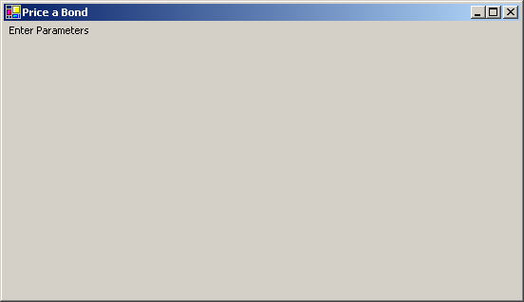

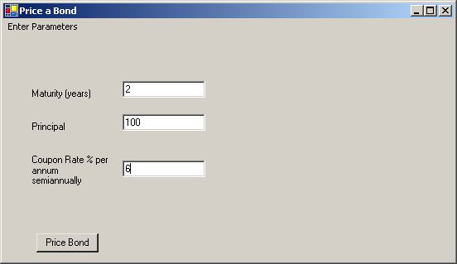

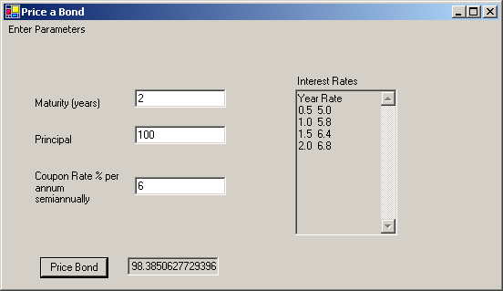

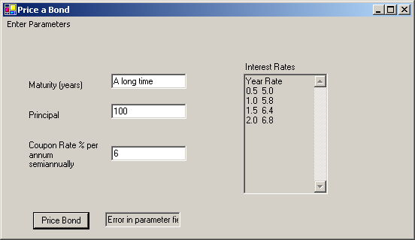

(3) 20 Points. Add a fourth option to the calculator’s menu. This option will permit the interest rates to be fetched from a web service located at:

http://heinz-dewdney.heinz.cmu.edu/InterestRateWebService/Service1.asmx

From the web site you can retrieve a WSDL document encoding a machine readable description of the web service. Run the DOS command “wsdl” with a command line parameter pointing at the WSDL document found at this site. This will generate a C# proxy on the client. Add the proxy (C# file) to your graphical user interface project and use the method in the proxy class to retrieve a one dimensional array of doubles. A reference to a .dll file can be added to a Visual .NET project by choosing Project/Add Reference.

Add a menu item to your GUI and add a menu event handler accordingly.

Submission:

Paste two files to blackboard. The first will be a ".cs"
file containing the C# code of your documented solution. The
second will be a Microsoft Word document contain displays of several screen showing your program running. The screen shots will show the interest rates retrieved from Heinz-dewdney. Use CTRL-PRTSCR to take snapshots of your entire screen.

(4) 20 Points. Visit http://www.xignite.com/xOptions.asmx?op=GetBlackScholesOptionValue
and retrieve the WSDL document associated with this web service. Run the wsdl command with the WSDL document as input and generate a web service proxy called XigniteOptions.cs. Compile this file to XigniteOptions.dll (use –t:library). Write a C# console application called PriceOptionUsingBlackScholes.cs that makes use of the Xignite web service via the generated proxy. The output of your program will look like the following:

D:\McCarthy\www\46-690\examples\blackscholeswebservice>PriceOptionUsingBlackScholes.exe

Enter option type (Put,Call)
Call
Enter stock price:
20
Enter strike price:
22
Enter years to maturity:
.6
Enter risk free rate:
.03
Enter volatility:
.25
Black Scholes Value = 0.926650218708528

Submission:

Paste three files to blackboard. The first will be PriceOptionUsingBlackScholes.cs and the second will be XigniteOptions.cs. The third will be a Microsoft Word document containing displays of several screen showing your program running. Use CTRL-PRTSCR to take snapshots of your entire screen.

