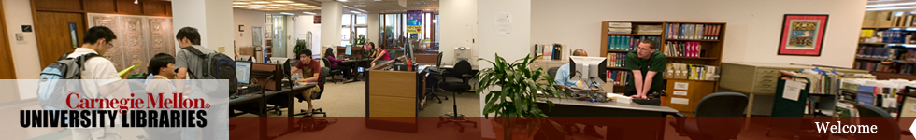
Library Tours

Welcome to Carnegie Mellon University! Come meet library staff, tour the building, and find out how to use library resources on the web. Each tour lasts 30-40 minutes.

All tours begin on the main floor of Hunt Library. Meet at the Information Desk.

DATE | TIMES | NOTE
Tuesday, August 18 | 3:30 & 4:15 | Option to tour Engineering & Science Library (Wean Hall)
Friday, August 21 | 1:00, 2:00, & 3:00 | Option to tour Engineering & Science Library (Wean Hall)
Sunday, August 23 | 1:00, 2:00, & 3:00

