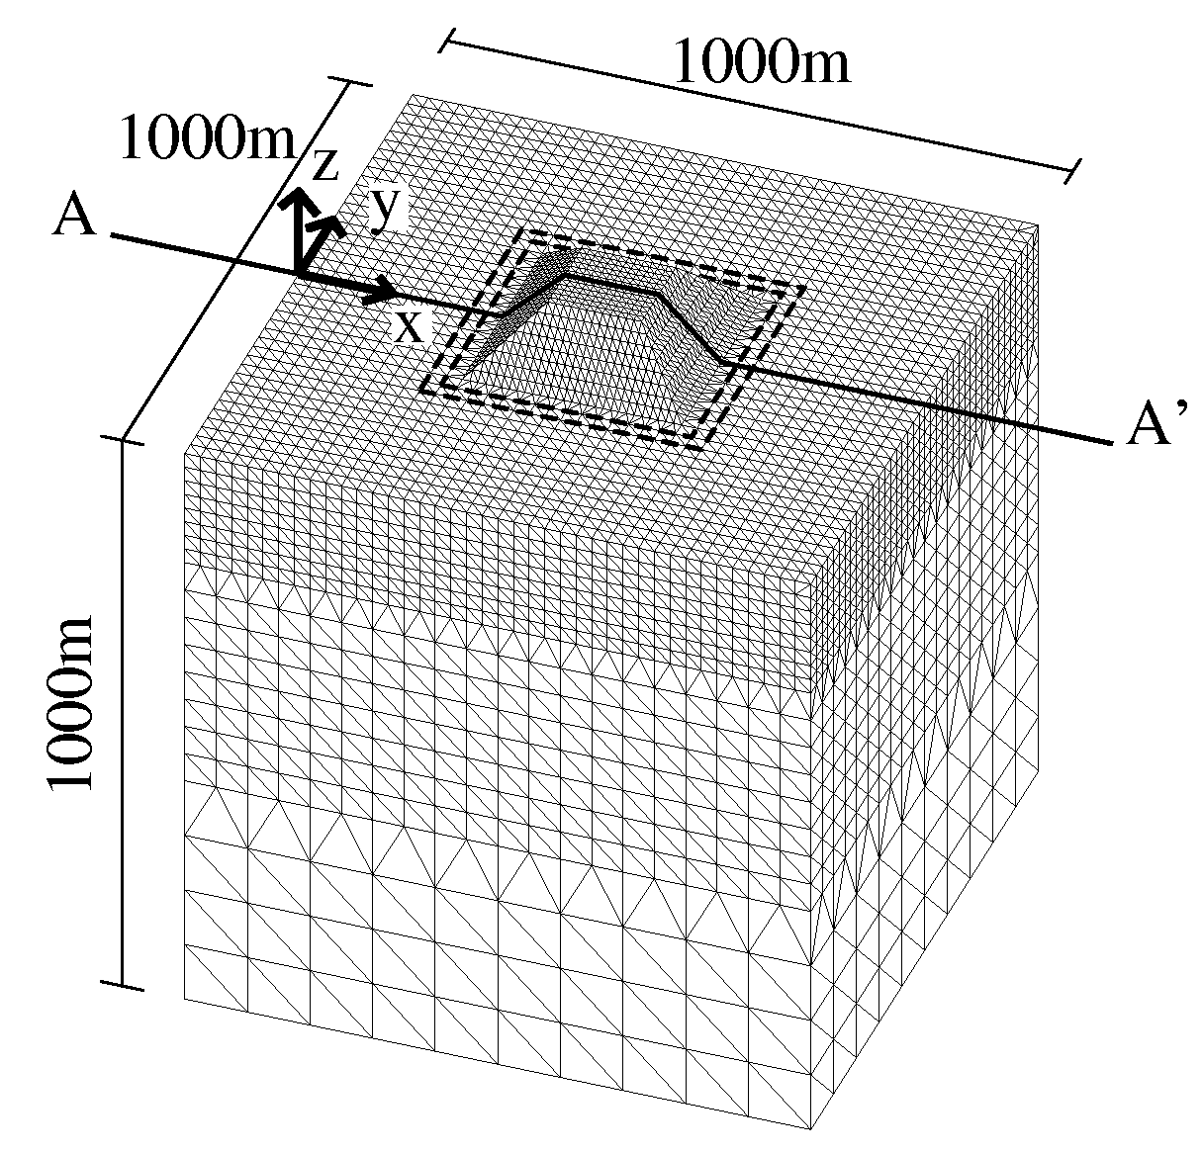
(a)
(b)
Figure 12
Figure 13
Figure 14

