Three-Dimensional Simulation of Long-Period (>1.5 sec) Earthquake Ground Motion in the Valley of Mexico: BASIN EFFECTs
Leonardo RAMIREZ-GUZMAN , Moises CONTRERAS, Jacobo BIELAK and Jorge AGUIRRE
ABSTRACT
Three-dimensional simulations of earthquake ground motion in sedimentary valleys have led to a deeper understanding of wave propagation and site effects in urban regions. In this paper we present a preliminary study of the ground motion and resulting amplification in the Mexico City Basin due to strong earthquakes in the Pacific Coast of Mexico. Three variables control our model: material properties, underground topography, and seismic source. Based on the available literature, we propose an initial coarse approximation of Mexico City’s basin, using as background a regional model similar to the one proposed by Furumura and Singh (2002). The seismic excitation is the 14 September 1995 Copala earthquake (Mw=7.3). Our 3D simulation, with a maximum resolution of 0.66 Hz, reproduces qualitatively the amplifications and long durations observed during the actual earthquake. The computation is performed using HERCULES, an octree-based finite element method code (Tu et al, 2006).

Keywords: Mexico City, 3D Simulation, Finite Elements, Strong Ground Motion.

introduction

Interaction between material properties, topography, and seismic source introduces an increase in amplitude as well as in duration of the ground motion due to earthquakes. As a consequence of such effect, constructed facilities undergo large excitations, threatening their ability to resist, and posing a seismic hazard to the population. Identifying the range of variability in the magnitude of this increment will allow us to improve seismic provisions in codes, in order to build safer structures. That is the long term goal of the current research with the specific target of Mexico City.

Following the 1985 Michoacan earthquake, many research groups have studied the soil motion amplifications and long durations in the lakebed zone in Mexico City compared to rock. Although there is no consensus about the exact mechanism, a fairly good level of understanding has been reached through several studies, see e.g. Singh and Ordaz (1993), Cardenas et al (1997), Furumura and Keneth (1998), Iida (1999) and Chavez-Garcia and Salazar (2002). More recently, Furumura and Singh (2002) explained, based on 2D and 3D simulations, the effect of source location. Energy might be trapped above the Moho (Lg phase), inducing large amplifications in shallow events, in contrast to deeper earthquakes which do not show anomalous behavior. Based on recorded data and a 3D simulation, Iida and Kawase (2004) confirmed a previously suggested observation by Barker et al (1996) of the importance of the trans-Mexican Volcanic Belt (TVB) on ground motion amplification.

In the present study we analyze the influence of the basin excited by the 1995 Copala earthquake, comparing two three-dimensional simulations: the first includes a shallow soft structure, similar in shape to the Valley of Mexico, and the second excludes such region. In both cases we ignore above ground topography. We confirm the amplification due to the TVB and we observe in the horizontal components a large amplification in the basin around the 0.2-0.4Hz frequency band. Previous 3D studies have considered either only the background material or a very high-velocity basin (Furumura and Singh, 2004). To our knowledge, this is the first time that the Mexico City basin has been simulated in a three-dimensional regional simulation with a realistic S-wave velocity, Vs, within the basin.

Material properties: Central Mexico Model

The structural Central Mexico Model (CMM) considered here is a 500km x 500km x 100 km box, similar to the one proposed by Furumura and Singh (2002), with one important difference. In contrast to the latter model, the current one includes a soft structure whose shape resembles the Mexico City basin (MCB) at the surface, with a Vs of 160 m/s and a maximum depth of 120 m. The region of interest, and the plan view and a typical cross-sectional view of it are displayed in Figures 1 and 2, respectively. Table 1 summarizes the properties. Intrinsic attenuation is also included, as explained later.

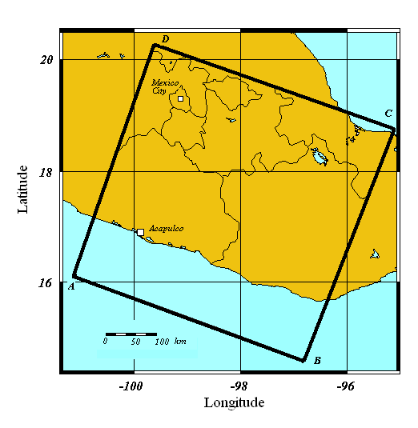
Figure 1. Simulated Region. A 500 km x 500 km x 100 km box.

THE SOURCE: 1995 Copala Earthquake

We used the 14 September 1995 Copala Earthquake as the seismic source, with strike=289°, dip=11° and rake=75°, as per the inversion by Courboulex et al (1997). Since the source was far from the MCB, we ignored the finite fault effect and represented the fault as a double couple with Mw=7.3 located at latitude=16.48°, longitude = -98.76° and depth=16 km. The slip rate source time function is an isosceles triangle with rise time of 2 seconds.

Table 1. Properties of the Structural Model

 | V_{p} ( km/s) | V_{s} ( km/s) | ρ( T/m3)
Mexico City Basin (MCB) | 400 | 160 | 1500
Trans-Mexican Volcanic Belt (TVB) | 4000 | 2000 | 2000
Layer A | 5200 | 3000 | 2500
Upper crust | 5700 | 3300 | 2450
Lower crust | 6750 | 3900 | 2800
Upper Mantle | 8300 | 4700 | 3200
Oceanic Crust | 6000 | 3350 | 2450
Oceanic Basalt | 6950 | 3800 | 2850
Oceanic Mantle | 8400 | 4800 | 3250
Sea | 1531 | 10 | 1000

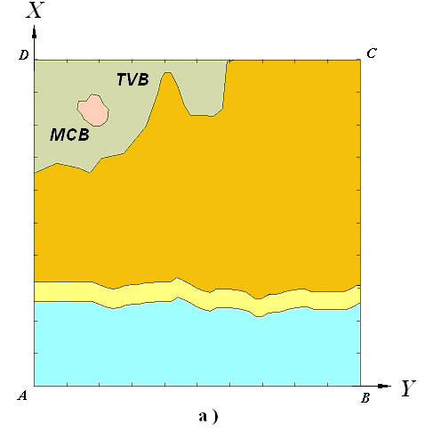
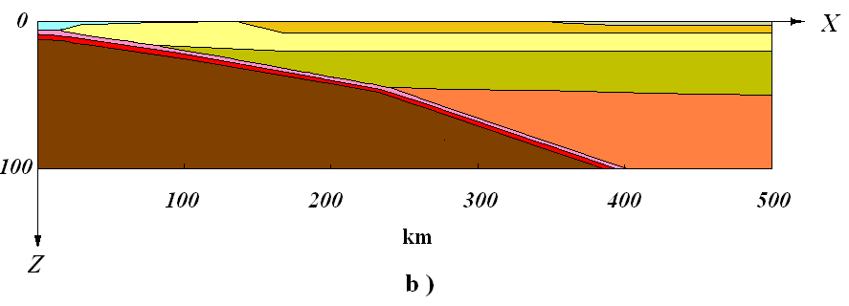
Figure 2. Structural model. a)Top View of the structural model. b) Cross-section.
Simulation

We calculated the ground motion using HERCULES (Tu et al, 2006), an octree-based finite element code, on Lemieux, an HP Alphaserver Cluster at the Pittsburgh Supercomputing Center. We present results of two simulations in order to examine the effects of the basin presence on the ground motion. One simulation includes a simple idealization of the Mexico City Basin (MCB), while the other comprises exclusively the Central Mexico Regional model (CMR), without the basin, to serve as a baseline. In both cases we used six points per S-wavelength to mesh the regional model, except for the water where we used the P wavelength and introduced a small value for the S waves. Our code models only linear anelastic solids. The quality factor Q was taken as 0.1Vs with a mass proportional attenuation. We used 4 points per wavelength in the MCB. This sampling did not have a large impact in the central part of the basin. A summary of the grid size and wall clock time is presented in Table 2. It is important to point out that in previous attempts to simulate the response with uniform grids, as was done, e.g. by Furumura and Kennett (1998) and Furumura and Singh (2002), using realistic values of V_{S} within the basin would have required an extremely large grid due to the presence of the low velocity layers. To avoid such a large mesh, the lower threshold for V_{S} within the basin was taken to be equal to 1.6 km/s in Furumura and Kennett (1998). This unrealistically large value leads to an underestimation of the amplifications within the basin and possibly of the duration of the motion.

Table 2. Computational Performance

Simulation | Number of Elements | Processors | Running Time (hr)
CMR | 83 millions | 400 | 5
MCB | 88 millions | 500 | 10

results and discussion

We obtained the three components of the displacements for a set of stations in a regular grid at the free surface of the model, with a spacing of 2 km. For this discussion we selected only a small set of receivers to show the long duration and the amplifications. We also computed the strong motion duration at a given site as the time it took for the Arias Intensity at that site to increase from 5% to 95% of the corresponding maximum value.

Figure 3, in which absolute velocity is plotted in the MCB model provides some insight into the wave propagation. It represents four different stages of the wave propagation in Central Mexico: a) Waves spread towards the TVB and the sea. The energy in the water is small compared to that traveling into the TVB; b) The motion reaches the volcanic region and undergoes an increase in amplitude due to the Layer A to TVB impedance ratio; c) The soft layer within the MCB causes a dramatic increase of the velocity amplitude; d) Some energy remains trapped in the valley.

In order to have a qualitative idea of the amplification introduced by the valley, we plotted the X and Z components of the velocity from the two simulations in three distinct regions: outside (black) and inside (green) the Volcanic Belt, and inside the basin (red), see Figures 4, 5 and 6. These figures confirm the observation by Baker et al (1996) that the amplitude of both components increases as the waves enter the Volcanic Belt. The X component has an extra amplification due to the presence of the valley in a very specific frequency band. High frequencies are especially important for stations near the basin edges. By contrast, the amplification of the Z component is hardly affected by the presence of the soft basin. We did not run any simulation for a longer period of time, but we can recognize in Figures 5.b and 6.b that the duration of the earthquake increased, at least in some stations, as an effect of the presence of the basin.

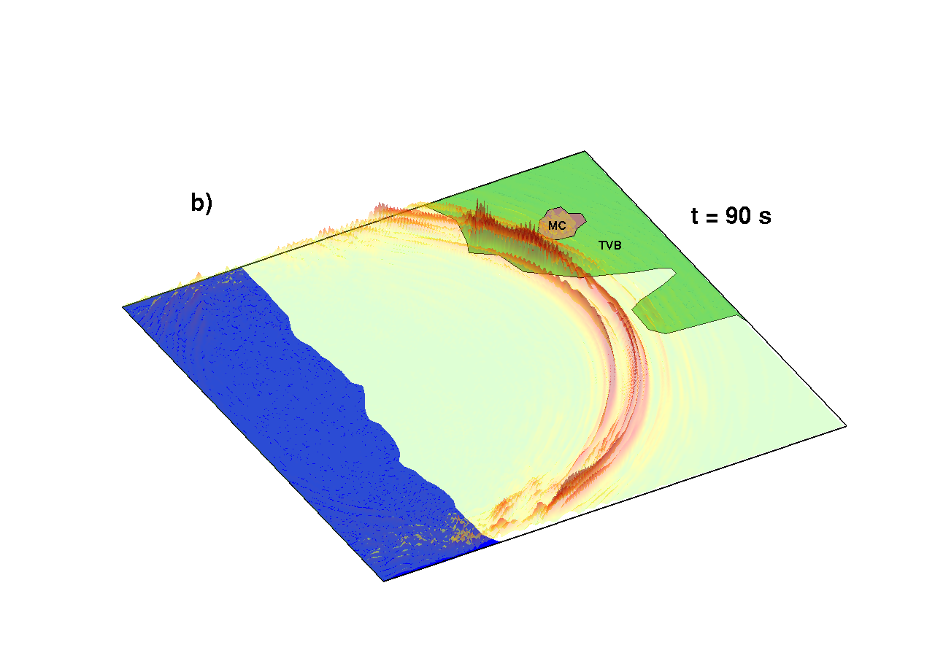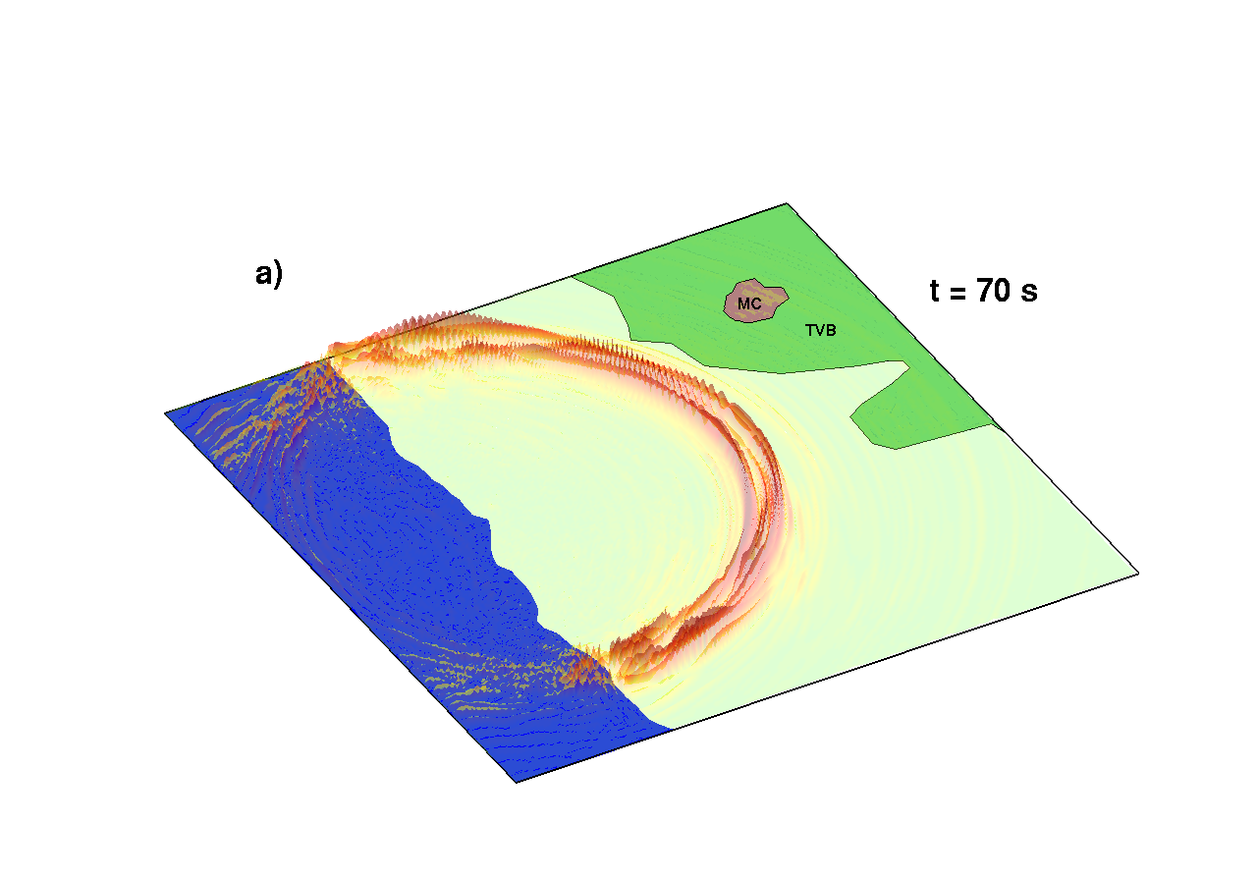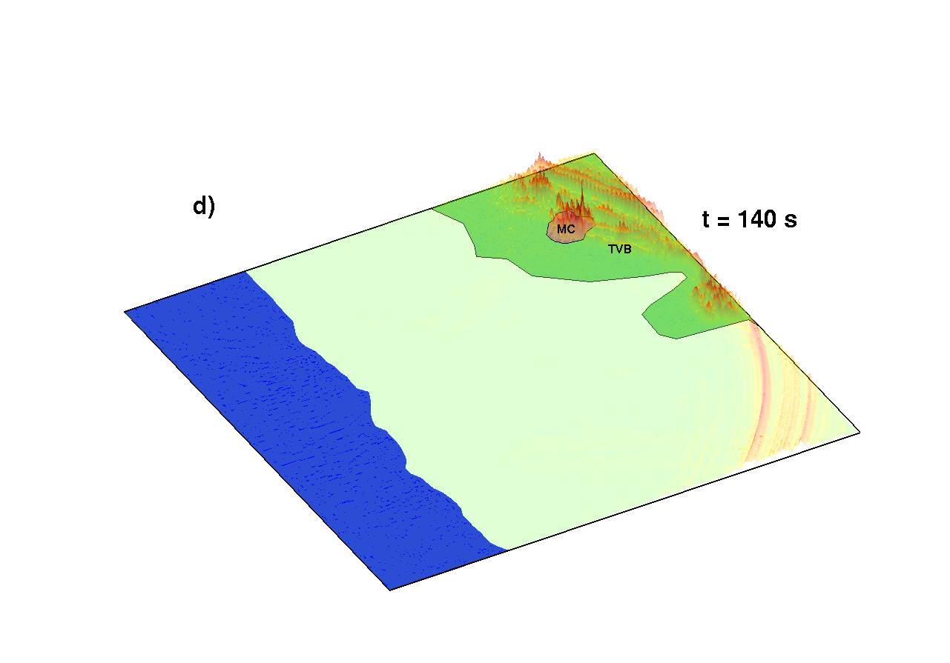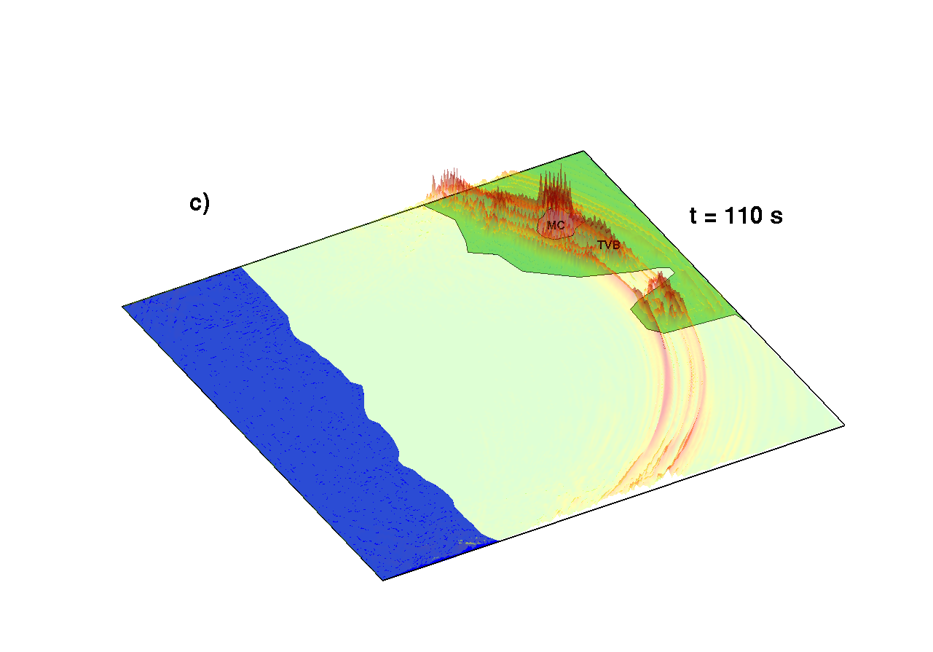

Figure 3. Snapshots of velocity magnitude. a) The earthquake spreads towards the TVB and onto the sea. b) It goes through the TVB and the amplitude increases. c) The waves undergo an extra amplification when it crosses the valley. d) Finally, some energy remains in the basin while outside of the basin the motion has finished.

In order to assist in the interpretation, we plotted the Fourier spectrum amplitude of the two simulations in frequency-space for a line segment going from station 1 to 30, see Figure 7. It is clear that the energy in the valley for the vertical component is spread over the spectrum; it explains why the amplitudes do not change dramatically in time. In the horizontal component, we found an important increase in the amplitude within the frequency band 0.2-0.4Hz. This result is not surprising. The equivalent 1D layer model for a basin, with the characteristics shown in Table 1, would be amplified in a band around 0.3Hz. Nonetheless, there are considerably large differences between the 1D model (layer over a half space under vertical incidence) and our simulation. In Figure 8, we depict the one-dimensional solution, the envelope and the magnitude average of the transfer functions, along a line segment inside the valley, computed as the ratio of the response for the CMB to the corresponding response for the RCM. We assumed that the displacements at depths 0 m and 120 m for the RCM would be very similar. We can see that on average, a simple 1D modeling is a poor approximation and the response can be under- or over-estimated by up to an order of magnitude.

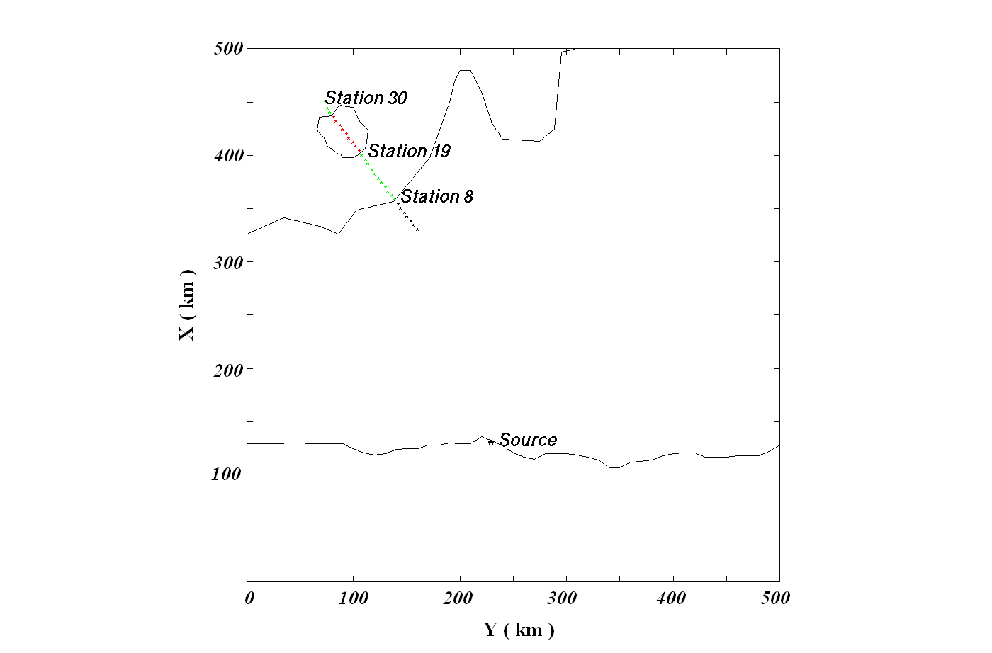
Figure 4. Domain and receiver locations.
As pointed out earlier, the duration also seems to be affected by the presence of the valley. To explore this point, we examined the duration in relation to the energy of the ground motion. We defined the strong ground motion duration as the time interval between the instants at which the 5 % and 95 % of the acceleration energy, or the Arias intensity, has been reached. We plotted in Figures 9 and 10 a normalized energy and the duration, both as a function of the epicentral distance, for the CMR and the MCB simulations. Two main observations can be made from this figure:
1.-There are areas within the basin where the duration compared to the simulation without valley is increased up to 20 % and 50 % for the X and Z components, respectively.
2.-The presence of surface waves introduces a significant elongation in the duration of the Z component.

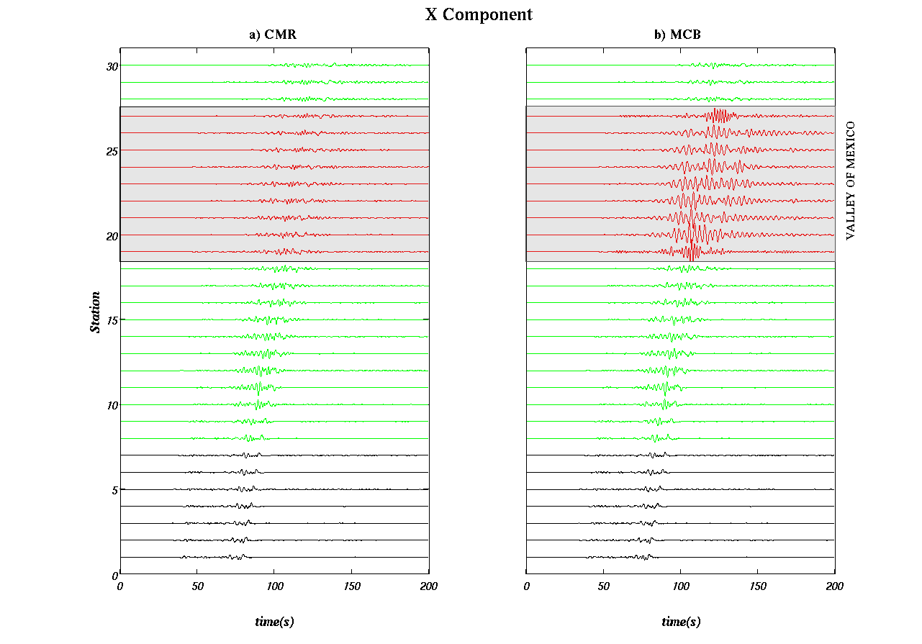
Figure 5. Horizontal X velocity for receivers in Figure 4. Outside (black) and inside (green) the Volcanic Belt, and inside the basin (red).

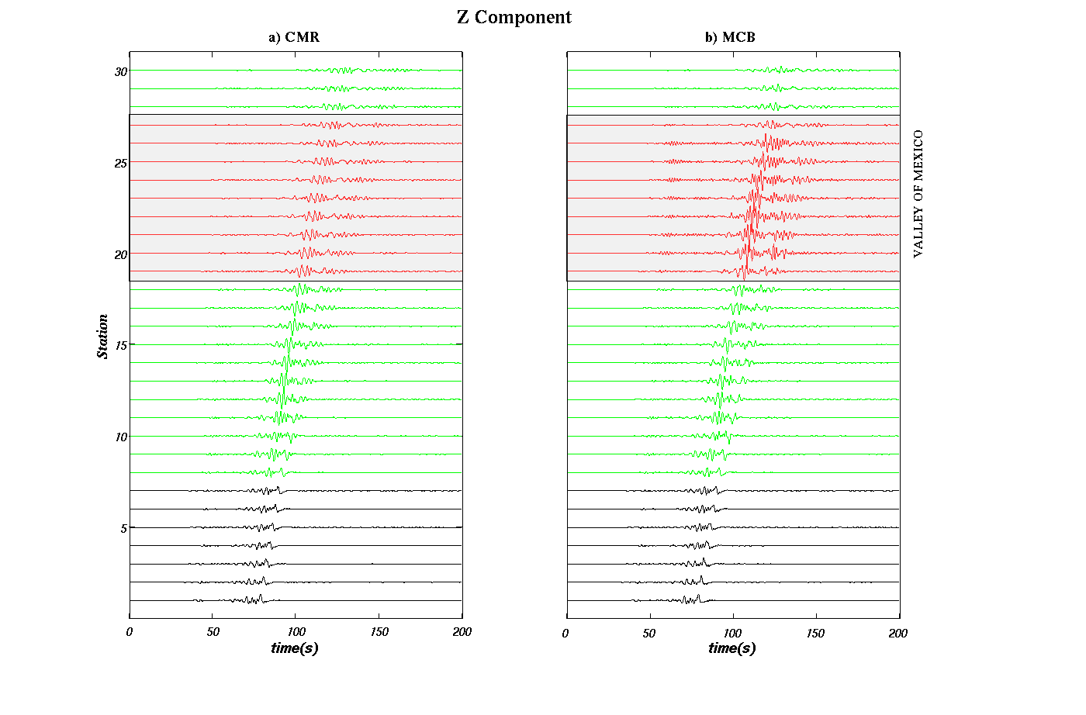
Figure 6. Horizontal Z velocity for receivers in Figure 4. Outside (black) and inside (green) the Volcanic Belt, and inside the basin (red).

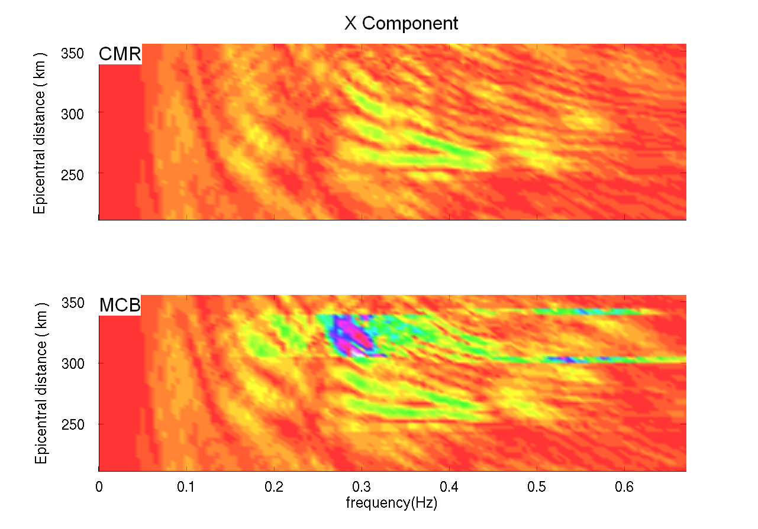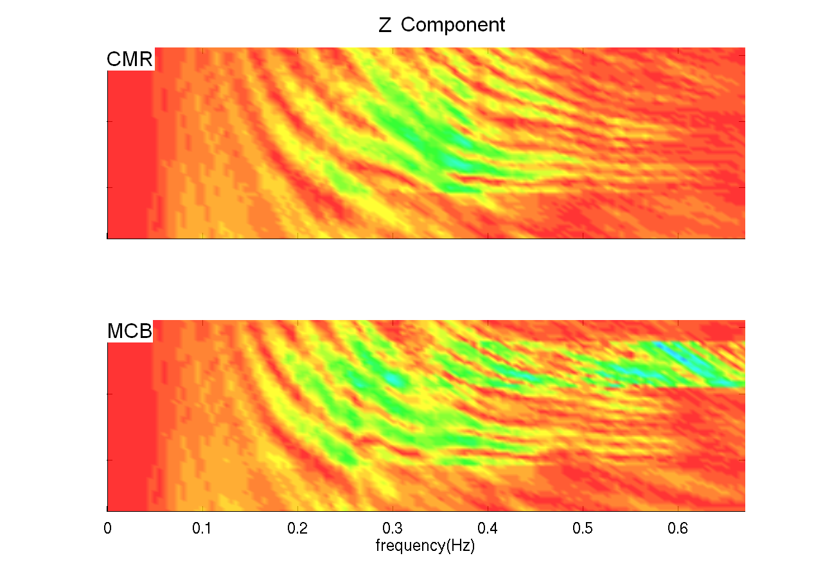
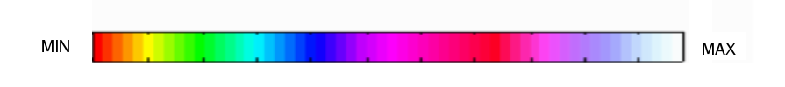

Figure 7. Amplitude of velocity in frequency-space domain ( f- epicentral distance) for a) horizontal X and b) vertical components for the CMR and MCB models.

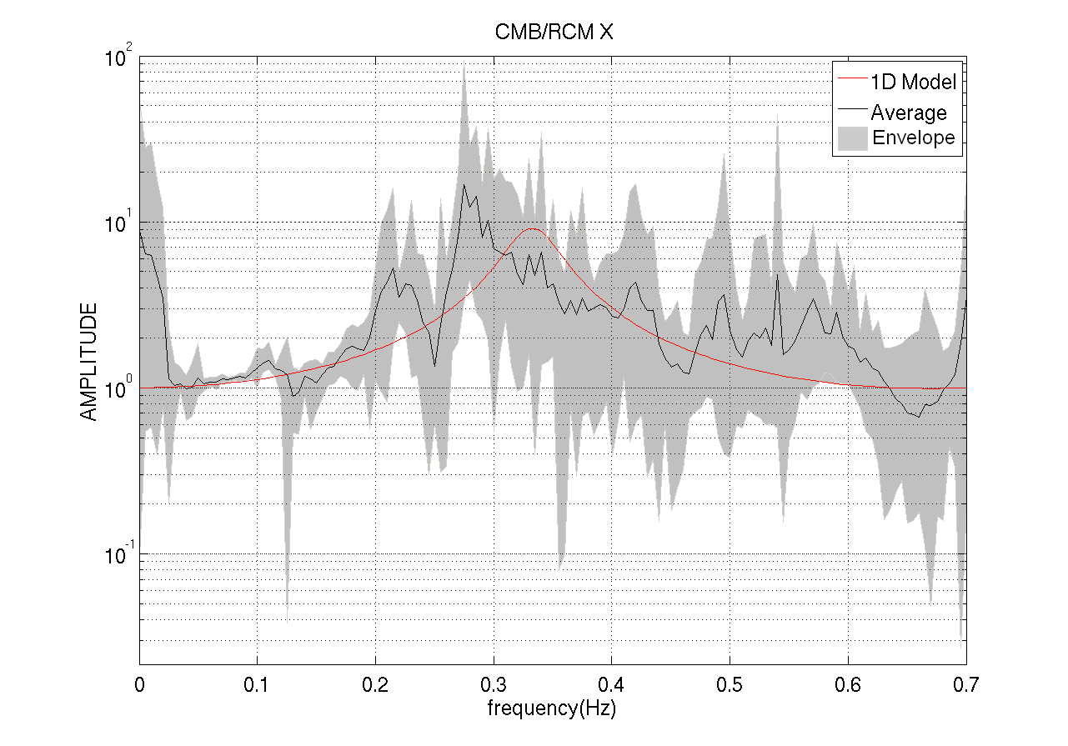

Figure 8. Transfer function for 3D simulation and for corresponding 1D problem

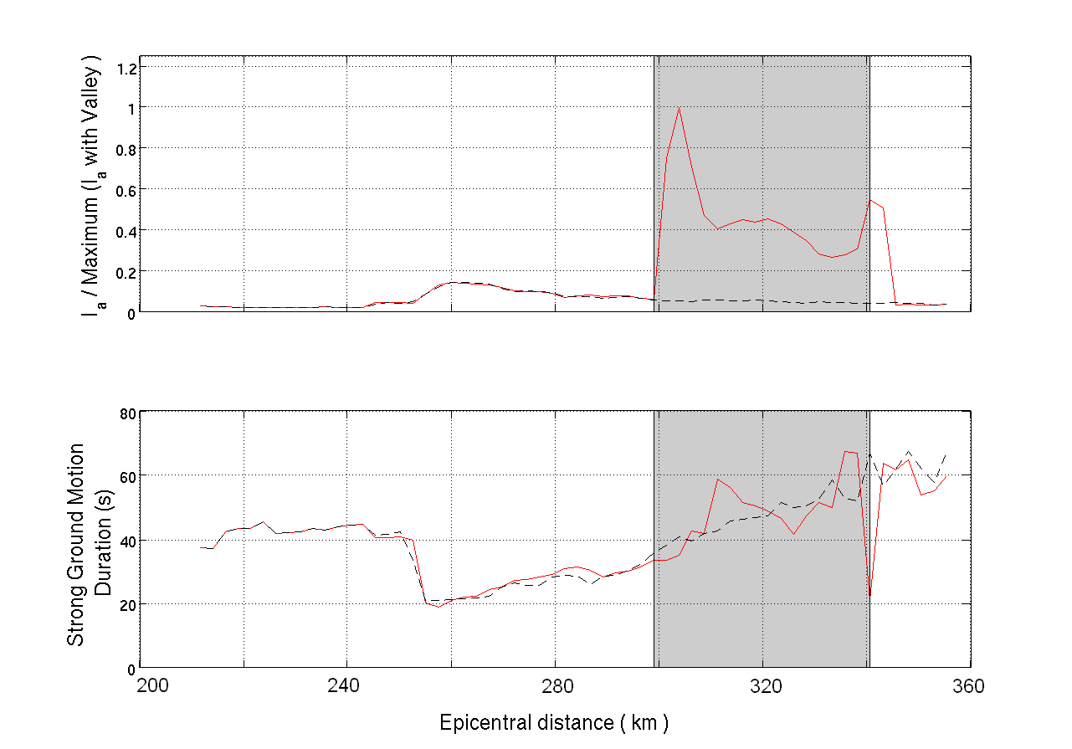
Figure 9. Arias intensity and Strong Ground Motion duration. Horizontal Component. Continuous red-MCB and dashed black-CMR.

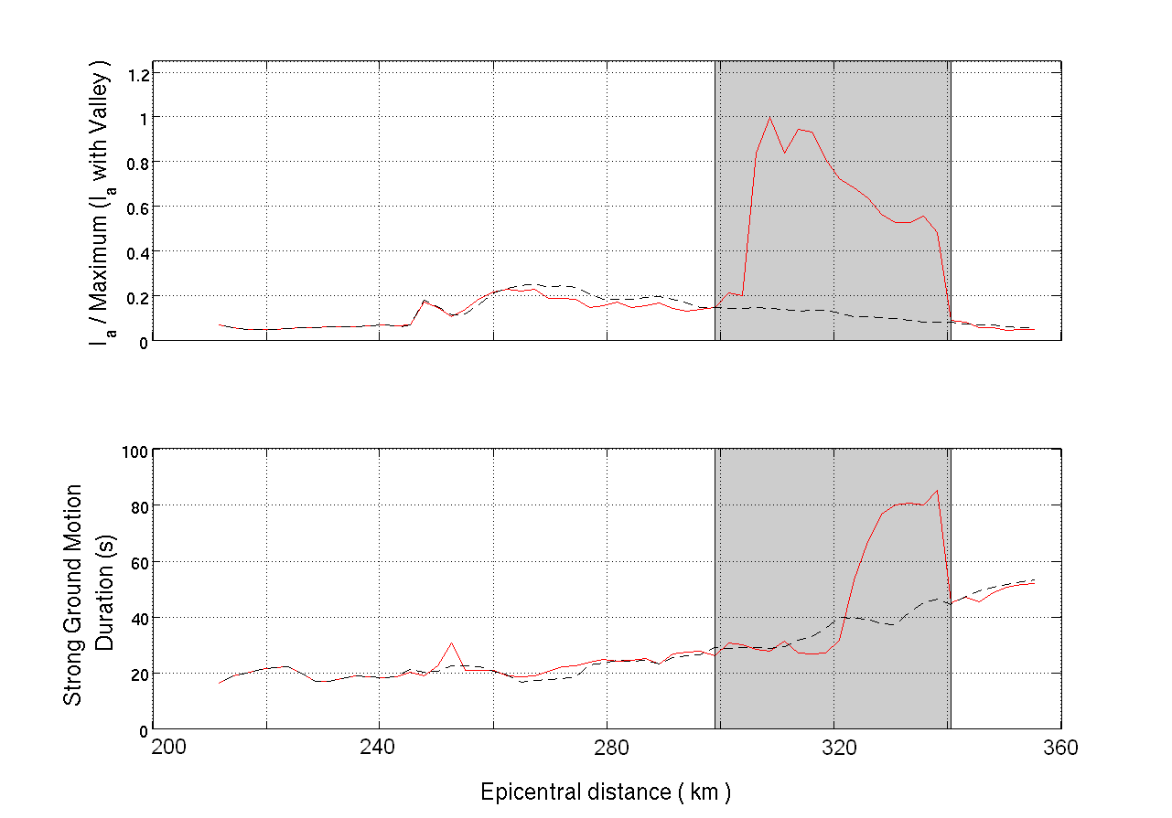
Figure 10. Same as Figure 9 for vertical component.

In addition, we calculated the duration in the vertical component for all the synthetic time histories on the surface, and at ten seismographic stations using records of the Copala earthquake. We filtered the data in order to have consistent accelerations. We selected records from the Mexican Strong Ground Motion Data Base that clearly show the P-wave arrival, as well as a clear coda information. We discarded those stations in which an aftershock overlapped the coda waves. The locations of the stations are showed in Table 3. Using this information we plotted Figure 11.a, where we compare the observed and synthetic strong motion durations at the free surface. A pointwise comparison is shown in Figure 11.b. From among the selected stations,the duration values computed with the simulation and with records, is maximum at ESTS. We see in stations CHIL and OAXM quite similar values. Although, the difference in station IGUA is greater than in CHIL and OAXM, it is still acceptable. In general, if we compare the durations qualitatively, we identify a similar behavior between the synthetic and observed motion. The differences in stations OCLL and ACAJ may be due to the finite fault effect, which was not considered in the simulation. Station TE07 is on compacted soils. Quite likely, it contains local site effects, which could increase the duration of the ground motion. Stations CUER and CUP4 suggest the necessity to improve the basin model. Overall, the estimated durations are shorter than the observed ones. To explain this difference, future simulations should model the rupture on the extended fault in order to capture more accurately the source mechanism.

Table 3. Location of Stations

Name of Station | Latitude | Longitude
ACAJ | 16.8731 | -99.8769
CHIL | 17.4660 | -99.4520
CUER | 18.9841 | -99.2371
CUP4 | 19.3300 | -99.1830
ESTS | 19.4916 | -99.1111
IGUA | 18.3912 | -99.5038
OAXM | 17.0840 | -96.7160
OCLL | 17.0380 | -99.8750
TE07 | 19.4270 | -99.2220
TXCR | 19.5180 | -98.8050

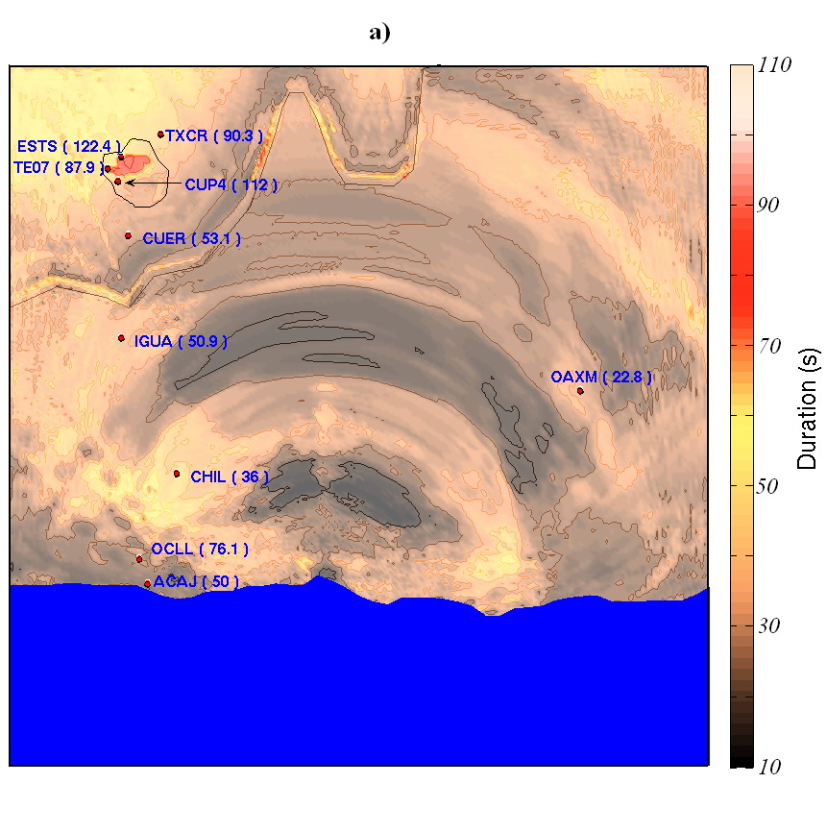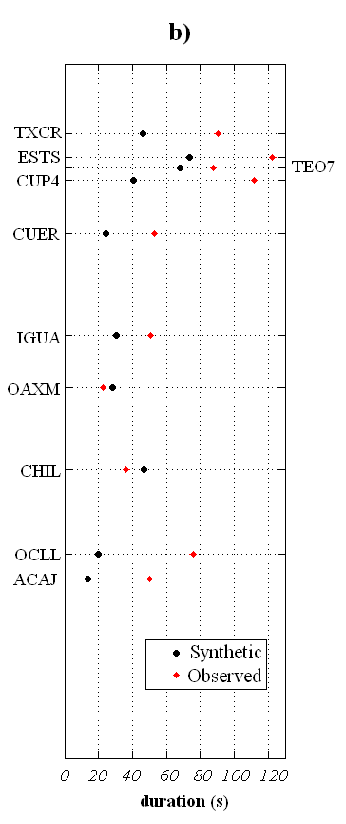
Figure 11. Comparison of the strong motion duration obtained from synthetic records and observed data. a) Computed values using the simulated time histories. In red the location of selected stations that recorded the Copala earthquake, their duration in seconds is shown in parenthesis. b) Comparison at selected stations. In red and black dots the values computed with observed and computed accelerograms, respectively.
Conclusion

Based on the preliminary analysis of a numerical simulation of the Central Mexico Region, we confirmed observations previously supported by data, regarding the impact of the trans-Mexican Volcanic Belt as an efficient mechanism of amplification. We speculated on the long durations of the records in Mexico City as a local effect. And we observed a strong amplification of the response and a significant elongation in the duration of the event in stations within the basin, especially in the frequency range 0.2-0.4Hz as a consequence of the presence of the valley.

The comparison of the synthetic durations with the observed ones was encouraging for some stations but not for others. Further analysis needs to be done on the extensive synthetic seismograms we have generated, but leave this task for future research, along with the development of a more realistic velocity model for Mexico City.

aknowledgements

This research was supported partially by the Mexican National Council of Science and Technology (Scholarship program), by the National Science Foundation through an ITR grant, No. EAR-0326449, and by the Southern California Earthquake Center. SCEC is funded by NSF Cooperative Agreement EAR-0106924 and USGS Cooperative Agreement 02HQAG0008. The SCEC contribution number for this paper is 1068. Supercomputing time at the Pittsburgh Supercomputing Center is provided under NSF TeraGrid grant MCA04N026P. Special thanks to John Urbanic at the PSC for his outstanding technical support.

REFERENCES

Barker JS, Campillo M, Sánchez-Sesma FJ, Jongmans D, and Singh SK. “Analysis of wave propagation in the Valley of Mexico from a dense array of seismometers”, Bulletin of the Seismological Society of America, 86, 1667-1680, 1996.

Cardenas M, Chavez-Garcia FJ, and Gusev A. “Regional amplification of ground motion in central Mexico. Results from coda-length magnitude data and preliminary modeling”, Journal of Seismology, 1, 341-355, 1997.

Chávez-García FJ, and Salazar L. “Strong Motion in Central Mexico: A Model Based on Data Analysis and Simple Modeling”, Bulletin of the Seismological Society of America, 92, 3087-3101, 2002.

Courboulex F, Santoyo MA, Pacheco JF and Singh SK. “The 14 September 1995 (M = 7.3) Copala,
Mexico, earthquake: A source study using teleseismic, regional, and local data”, Bulletin of the Seismological Society of America, 87, 999 -1010, 1997.

Furumura, T, & Kennett, BLN. “On the nature of regional seismic phases - III. The influence of crustal heterogeneity on the wavefield for subduction earthquakes: the 1985 Michoacan and 1995 Copala, Guerrero, Mexico earthquakes”, Geophys. J. Int., 135, 1060-1084, 1989.

Furumura T, and Singh SK. “Regional Wave Propagation from Mexican Subduction Zone Earthquakes: The Attenuation Functions for Interplate and Inslab Events”, Bulletin of the Seismological Society of America, 92, 2110-2125, 2002.

Iida M. “Excitation of high-frequency surface waves with long duration in the Valley of Mexico”, J. Geophys. Res., 104, 7329-7345, 1999.

Iida M, and Kawase H. “A Comprehensive Interpretation of Strong Motions in the Mexican Volcanic Belt”, Bulletin of the Seismological Society of America, 598-618, 2004.

Singh SK, and Ordaz M. “On the origin of long coda observed in the lake-bed strong-motion records of Mexico City”, Bulletin of the Seismological Society of America, 83, 1298-1306, 1993.

Tu T, Yu H, Ramirez-Guzman L, Bielak J, Ghattas O, Ma KL, and O'Hallaron D. “From Mesh Generation to Scientific Visualization: An End-to-End Approach to Parallel Supercomputing”, Proc. ACM/IEEE SC2006, Tampa, FL, 2006.

Graduate Student, Carnegie Mellon University, Computational Seismology Laboratory, Department of Civil and Environmental Engineering, USA, Email: lramirez@andrew.cmu.edu.
Graduate Student, Universidad Nacional Autónoma de Mexico, Instituto de Ingeniería, Coordinación de Ingeniería Sismológica, Mexico, Email: moy@servidor.unam.mx,
Professor, Carnegie Mellon University, Computational Seismology Laboratory, Department of Civil and Environmental Engineering, USA, Email: jbielak@cmu.edu.
Research Associate Professor, Universidad Nacional Autónoma de Mexico, Instituto de Ingeniería, Coordinación de Ingeniería Sismológica, Mexico, Email: joagg@pumas.iingen.unam.mx

