Surface functionalization of carbon nanotubes: Fabrication and applications

Shadpour Mallakpour ^{∗ 1, 2, 3} and Samaneh Soltanian ¹

¹Organic Polymer Chemistry Research Laboratory, Department of Chemistry, Isfahan University of Technology, Isfahan, 84156-83111, Islamic Republic of Iran
²Nanotechnology and Advanced Materials Institute, Isfahan University of Technology, Isfahan, 84156-83111, Islamic Republic of Iran
³Center of Excellence in Sensors and Green Chemistry, Department of Chemistry, Isfahan University of Technology, Isfahan, 84156-83111, Islamic Republic of Iran

Abstract
Carbon nanotubes (CNT)s show exceptional one-dimensional π-electron conjugation, mechanical strength, high chemical and thermal stability, which make them very attractive for use in many applications. CNTs intrinsically tend to hold together as ropes and bundles due to Van der Waals interactions. The prevention of such behavior has been investigated by testing a variety of surface modification methods. The functionalized CNTs present enhanced properties enabling facile production of novel nanomaterials and nanodevices. The functionalizations of CNTs could improve their chemical compatibility and dissolution properties, which enable both a more wide characterization and consequent chemical reactivity. This review aims to provide a brief synopsis about CNT functionalization and highlights recent development in functionalization of CNTs and their applications.

Keywords: Carbon nanotubes . Surface functionalization . Polymer composites.

Table of contents
1. Introduction 7
2. Functionalization of carbon nanotube 8
2.1. Covalent functionalization 8
2.2. Non-covalent functionalization 10
2.3. Polymer functionalized carbon nanotube 11
2.4. Functionalization with biomolecules 14
2.5. Nanopaticle decorated carbon nanotube 18
2.6. Surfactants functionalized carbon nanotube 21
3. Applications 23
3.1. Sensor 23
3.2. Catalyst 25
3.3. Polymer composites 27
3.4. Biological applications 32
4. Conclusions 36
Acknowledgments 37
References 44

List of abbreviations
Chemical names
3APTES 3-aminopropyltriethoxisilane
APPI amphiphilic poly(propyleneimine) dendrimer
BSA bovine serum albumin
CDI N,Nʹ-carbonyldiimidazole
CNTs carbon nanotubes
CPC cetylpyridinium chloride
CSCF CNT grown short carbon fibers
CTAB hexadecyltrimethylammonium bromide
CTVB cetyltrimethylammounium 4-vinylbenzoate
DMF N,N-dimethylformamide
DNA deoxyribonucleic acid
DOX doxorubicin
DTAB dodecyl tri-methyl ammoniumbromide
EDC N-(3-dimethylaminopropyl)-Nʹ-ethylcarbodiimide hydrochloride
FITC fluorescein isothiocyanate
LCP liquid crystalline polymer
mAb monoclonal antibody
MGP macromer-grafted polymer
MWCNT multi-walled carbon nanotubes
NC nanocomposite
NHS N-hydroxysuccinimide
NP nanoparticle
PAI poly(amide-imide)
PEI poly(ethyleneimine)
PIPA poly(N-isopropyl acrylamide)
PLA polylactic acid
PLL poly-L-lysine
PP polypropylene
PS polystyrene
PSCA prostate stem cell antigen
PU Polyurethane
PVA poly(vinyl alcohol)
RF riboflavin
SDBS sodium dodecyl benzene sulphonate
SDS sodium dodecyl sulfate
SOCT sodium octanoate
SWCNT single-walled carbon nanotubes

Other abbreviations
CVD chemical vapor deposition
DBD dielectric barrier discharge
DSC differential scanning calorimetry
EDX energy dispersion X-ray
FE-SEM field emission scanning electron microscopy
f-MWCNT functionalized-MWCNT
MIC minimal inhibitory concentration
RIGP radiation-induced graft polymerization
SEM scanning electron microscopy
TEM transmission electron microscopy
TGA thermogravimetric analysis

1. Introduction
Since carbon nanotubes (CNTs) discovery by Iijima in 1991, they have increasingly drawn the attention of research because of their interesting properties such as excellent mechanical and physical properties, low density, tunable semiconductivity, high modulus and high electrical/thermal properties [1-4]. These outstanding properties make them useful materials for applications in electronic devices, sensors, catalysis, energy storage, superconductors and field-emission devices [5].
CNTs are made of one or more graphene sheets rolled-up to form tubes. Single-walled CNTs (SWCNT)s comprise a single graphene layer seamlessly wrapped into a cylindrical tube. Multi-walled CNTs (MWCNT)s comprise an array of concentric cylinders coaxially arranged around a central hollow core with Van der Waals forces between adjacent layers. The cylindrical nanotubes generally have at least one end capped with a hemisphere of fullerene structure. The graphene layers could be wrapped to form various geometries. According to the rolling angle of the graphene sheet, the tubes may be of armchair, zigzag or chiral form. Current synthetic techniques produce a mixture of the different forms of MWCNTs or SWCNTs, with each single graphene layer having a different geometry [6-8].
However, CNTs tend to aggregate and form clusters owing to high Van der Waals force between the tubes, so the solubility in common solvents and interaction between CNTs and other compounds such as polymeric matrix or molecules is very limited. Functionalization of the CNT surface is a promising means of overcoming these problems and takes an important place for the purpose of application of CNTs [9]. Here, we provide an overview of recent progress and advances that have been made on the functionalization of CNTs and related applications.
2. Functionalization of CNT
CNTs have a tendency to agglomerate uncontrollably, as a result of high surface energy and the stabilization by numerous of π–π electron interactions among the tubes. Weak dispersibility and their insolubility in solvents and matrix have limited their applications. The potential applications of CNTs need an extensive functionalization of the nanotubes to make them processable and to tune their properties [10]. To overcome this drawback, two different strategies are used to disperse CNTs namely mechanical and chemical techniques. The mechanical methods involve high shear mixing, high impact mixing, grinding and rubbing, ultrasonication, and so on. These methods can separate nanotubes from each other, but can also break up nanotubes, decreasing their aspect ratio during processing, and these are time-consuming and ineffective approaches.
Chemical methods are designed to alter the surface energy of the CNTs, improving their wetting or adhesion characteristics and their dispersion stability. These methods are aimed to modify the surface chemistry of the CNTs either non-covalently (adsorption) or covalently (functionalization). Functionalized CNTs might have electrical, optical or mechanical properties that are different from those of the original nanotubes. Thus, it is an appealing area to functionalize CNTs for all kinds of applications [11, 12].

2.1. Covalent functionalization
Covalent functionalization is based on the formation of a covalent bonding between functional entities and the carbon skeleton of CNTs which is stronger than non-covalent interactions. Covalent functionalizations are employed to enhance CNTs dispersion in the target medium (polymer or solvent), which improve wetting or adhesion characteristics and reduce the agglomeration of CNTs [13, 14]. Covalently modifying CNTs could be summarized in two categories, direct covalent sidewall functionalization and indirect chemical modification with carboxylic groups on the surface of CNTs [12]. A considerable disadvantage for covalent functionalization is the disruption of the surface conjugated π network, which leads to deteriorate electrical conductivity. The impact of disrupted π conjugation on mechanical and maybe thermal properties is limited, while the impact on electrical properties is anticipated to be intense since each covalent functionalization site scatters electrons [15].
Mariatti and co-workers functionalized MWCNTs by diphenylcarbinol and silanization processes using 3-aminopropyltriethoxisilane (3APTES). The effects of functionalized MWCNTs (f-MWCNTs) on the mechanical properties and curing behavior of epoxy-based composites have been investigated. The results indicated that the introduction of MWCNTs decreased the activation energy of the reaction and promoted the cure reaction [16].
Li et al. introduced three types of chemical functional groups, aminophenyl (C₆H₄NH₂), nitrophenyl (C₆H₄NO₂) and benzoic acid (C₆H₄COOH), on the sidewalls of MWCNTs in order to find the optimal functionalization of MWCNTs for make MWCNTs more compatible with the liquid crystalline polymer (LCP). The effects of the electron donating and withdrawing groups attached to the f-MWCNTs on the dispersion of MWCNTs in the LCP matrix and their interaction with the LCP were investigated. The results showed that the –C₆H₄NH₂ f-MWCNTs demonstrated the highest intermolecular interaction between MWCNTs and LCP, which led to the considerable changes in mechanical and rheological properties [17].
Covalent functionalization of SWCNTs with anthracene in molten urea through an environmentally friendly green chemistry approach was reported by Ravichandran’s group. The temperature dependent magnetization and electrical resistivity were determined for both functionalized SWCNTs and SWCNTs. The result showed a 300 fold increase in conductivity at room temperature for functionalized SWCNTs when compared to SWCNTs [18].
2.2. Non-covalent functionalization
Non-covalent functionalization is an alternative approach for adjustment the interfacial properties of nanotubes. It is based on supramolecular complexation using different adsorption forces, such as hydrogen bonds, Van der Waals force, electrostatic force and π-stacking interactions. Non-covalent surface functionalization frequently introduces fewer defects to the graphitic structure and does not destroy the conjugated system of the CNT sidewalls, which is important to maintain pristine structure and properties of CNTs [12, 15]. The main drawback of non-covalent attachment is that the forces between the wrapping molecule and the nanotube might be weak, and the efficiency of the load transfer might be low [19]. He et al. achieved non-covalently amino-f-MWCNTs (MWCNTs-NH₂) by adsorption of H₂NCH₂CH₂ONa to MWCNTs wall. Investigation of electrical and thermal mechanical properties on their epoxy composites exhibited non-covalently f-MWCNTs-NH₂ were promising filler for developing electrical conductive MWCNT/epoxy composites with enhanced mechanical properties whereas maintaining the electrical properties of as-prepared MWCNT/epoxy [20].
Zhang and coworkers reported non-covalent modification of MWCNTs by the amino molecules of tetrazine compound. Tetrazine molecules could produce π-stacking with the graphitic sidewalls of MWCNTs. The introduction of amino groups on the surface of MWCNTs could help MWCNTs to disperse homogeneously in epoxy matrix. The results demonstrated that the conductivity of the amino coated MWCNTs/EP composites was considerable higher than that of pristine MWCNTs/EP composites [21].

2.3. Polymer functionalized carbon nanotube
Functionalization of CNTs with polymer molecules is usually used to improve their dispersion and fabricate CNT-based composites to investigate new properties. The main techniques for the modification of CNTs with polymers are covalent attachment (‘‘grafting to’’and ‘‘grafting from’’) and non-covalent attachment (polymer wrapping and absorption) [19].
In the “grafting from” method, the polymer is attached to the CNT surface by in-situ polymerization of monomers in presence of reactive CNTs or CNT supported initiators. It is the reaction between the reactive groups on the surfaces of CNTs and monomers. The benefit of this method is that polymer brushes with high grafting density can be simply produced [22].
Hua et al. introduced styryl (polymerizable groups) onto the surfaces of the MWCNTs by esterification based on the carboxylate salt of carbon nanotubes and p-chloromethylstyrene in toluene. Then the styryl-modified MWCNTs were used as macro-comonomers for in situ radical copolymerization with styrene and composites of styryl-f-MWCNTs and polystyrene were prepared. Based on the comparison between the scanning electron microscopy (SEM) and transmission electron microscopy (TEM) images of polystyrene/MWCNTs nanocomposites (NCs) synthesized with styryl-grafted MWCNTs and raw MWCNTs, the styryl-grafted MWCNTs provided enhanced compatibility with polystyrene matrix than raw MWCNTs. The results of differential scanning calorimetry (DSC) and thermogravimetric analysis (TGA) showed the improved thermal conductivity and T_{g} owing to the uniform dispersion of MWCNTs in polystyrene matrix and covalently bond between them [23].
The “grafting to” method is based on attachment of polymer molecules on the CNT surface by chemical reactions for instance esterification, amidation, radical coupling, etc. It is the reaction between functional groups on the nanotube surfaces and readymade polymers [19, 22].
Kitano et al. used azo-type radical initiator carrying poly(2-methacryloyloxyethyl D-glucopyranoside) blocks (PMEGlc-initiator) for the modification of SWCNT. The radicals from the macro-initiator were trapped by SWCNT giving the SWCNT covalently modified with the cloven macro-initiator (Fig. 1). Furthermore, the SWCNT covalently functionalized with terminal-aminated poly(N-isopropyl acrylamide) (PIPA) through a condensation reaction between carboxylated SWCNT and PIPA. The terminal-aminated PIPA, 1-hydroxybenzotriazole monohydrate (HOBt) and 1-ethyl-3-(3-dimethylaminopropyl)carbodiimide HCl (WSC) were added to the carboxylated SWCNT dispersion (10.0 mg in 30 mL H₂O) at pH 5.5 for 3 days. The SWCNT was washed thoroughly with water by the centrifugeand consequent ultrafiltration (Fig. 2). The functionalized SWCNT could stably be dispersed in aqueous solutions while maintaining the stimuli-responsive and bio-related functions attributed to the introduced polymer chains [24].

Figure 1
Figure 2
Gao and co-workers reported functionalization of MWCNT by poly(ethyleneimine) (PEI) to prepare CNT/epoxy matrix composite for the potential of thermal performance improvement. In comparison with non-functionalized CNTs, the PEI functionalized CNTs demonstrated better dispersion in epoxy matrix and higher thermal conductivity. A 660% improvement in thermal conductivity could be attained in the CNT/epoxy matrix composite when the containing of PEI functionalized CNTs was as high as 8 vol.% [25].
Park et al. described covalent functionalization of CNTs by surface-initiated ring-opening polymerization of epoxides. TEM and SEM micrographs of functionalized CNTs showed that the nanotubes were enwrapped by polymer chains. The amount of grafted polymer varied from 14 to 74 wt% with rising reaction temperature. The O/C ratio of CNTs increased considerably from 5.1% to 29.8% after surface modification of CNTs [26].
Famá et al. reported a methodology to link covalently MWCNTs with biodegradable polylactic acid (PLA) in order to ensure good stress transfer and therefore good mechanical response. PLA was modified with benzoyl chloride and MWCNTs functionalized by Fenton reaction and both modified materials were bounded covalently by esterification reaction. It was observed that the addition of f-MWCNTs improved Young’s modulus and strength without losing deformation [27].
Non-covalent functionalization is an alternate technique for tuning the interfacial properties of CNTs. Morishita et al. achieved non-covalent functionalization of MWCNTs using macromer-grafted polymers (MGPs). MGP (1) was designed to have polymer side chains to improve the MWCNT solubilization in desirable solvents and pyrene moieties to enhance physical adsorption of MGPs on MWCNT surfaces, consequential from π–π stacking between the MWCNT surface and pyrene units. Fig. 3 demonstrates a schematic illustration of physical adsorption of MGP 1 on MWCNT surface. MGP 1 was prepared by radical copolymerization of macromer 2 with appropriate polymer side chains, 1-pyrenyl butyl methyl methacrylate 3 as the pyrene unit, and methyl methacrylate 4 as a spacer unit (Scheme. 1). These MGPs showed strong physical adsorption on the MWCNT surfaces and act as solubilizers that improve solubility of MWCNTs in both chloroform and hexane, which is usually a poor solvent for MWCNTs [28].

Figure 3
Scheme. 1

2.4. Functionalization with biomolecules
CNTs functionalized with biological molecules exhibit great potential for application in nanotechnology and bioengineering. The studies of CNTs interfacing with biology were generally focused on the interactions of CNTs and biological molecules, for instance nucleic acids, proteins and peptides [29-31].
Direct contact with pristine CNT aggregates destroys the cell membrane and leads to cell death [32]. Functionalization with various groups could improve the antimicrobial activity of CNTs. Shanbedi and co-workers functionalized MWCNTs with lysine under microwave irradiation. Antimicrobial activity of pristine and functionalized CNTs was investigated by minimal inhibitory concentration (MIC). The MIC results revealed that functionalized CNTs with lysine were more effective than pristine CNTs against all studied bacteria. The more efficient antimicrobial of CNT-Lysine was related to electrostatic adsorption of bacteria membrane, because of positive charges of the lysine groups on CNTs [33].
In another study, Zou’s group synthesized poly-L-lysine (PLL) using lysine as raw material by N-carboxyanhydride polymerization. MWCNTs were functionalized with PLL by non-convalent method in order to prepare MWCNTs-PLL composite. TGA curve revealed that mass percent of PLL in MWCNTs-PLL composite was about 5%. The obtained MWCNTs-PLL composite could disperse steadily in water as a result of the hydrophilicity of PLL and electrostatic repulsion between MWCNTs-PLL composites [34].
Wu et al. reported the immobilization of a natural pigment, riboflavin (RF), onto MWCNTs by a non-covalent method. RF is a flavoprotein and essential coenzyme in many biological transformations. It is necessary for growth, reproduction and repair hair, skin, nails and joints and is significant for the safety of the body against disease protection [35]. RF and MWCNT mixtures were mulled in agate mortar to prepare an exfoliative solid. This solid was washed and centrifuged to remove the non-immobilized RF (Scheme. 2). ¹H NMR analysis showed π-π stacking interaction by observing the resonance peaks’ shifts. Unlike the insoluble pristine MWCNTs, the RF/MWCNTs demonstrated good water solubility and could be stored in the dark for weeks without precipitation [36].
Scheme. 2

Mallakpour et al. reported a convenient strategy to functionalize CNTs with ascorbic acid under microwave irradiation and presented evidences for the attachment between MWCNTs and ascorbic acid molecule. Functionalization was followed by a condensation reaction between the primary hydroxyl group of ascorbic acid and carboxylic acid group of the MWCNT’s surface. F-MWCNTs was employed as a means of improving the state of dispersion of MWCNTs in the poly(amide-imide) (PAI) matrix. The results of the tensile mechanical tests revealed that the tensile strength significantly increased from 75 to 102.2 MPa for the sample with 5 wt% f-MWCNTs loading and it was 36.3% higher than that of the neat PAI [37].
Mallakpour and co-worker have also investigated functionalization of MWCNTs with glucose using a covalent, non-specific functionalization approach. An esterification reaction, catalyzed by N,N′-carbonyldiimidazole (CDI), occurred between the carboxylic acid group of the acidified MWCNT’s surface and the glucose molecule. Carboxylated MWCNTs were reacted with CDI to form MWCNT-imidazolide. The MWCNT-imidazolide was reacted with glucose dissolved in water solvent system. The grafting was confirmed by TGA, FT-IR spectroscopy, and electron microscopic techniques such as TEM and field emission scanning electron microscopy (FE-SEM) [38].
In another study by Mallakpour et al. MWCNTs were functionalized with seven different amino acids (S-valine, L-alanine , L-leucine, L-isoleucine , S-methionine, L-phenylalanine , and L-tyrosine ) under microwave irradiation. The carboxylic acid groups at the CNT surface were converted into amide by a condensation reaction between the amino groups of amino acid and carboxylic acid group. Also, a diazonium reaction could be occurred between amino acid molecules and uncarboxylated areas on MWCNT, resulting in the attachment of amino acids to these sites. The procedure is fast, simple and resulted in a high degree of functionalization as well as dispersibility in organic solvents. The amino acid-modified CNTs will grant improvement of compatibility and could promise multipurpose in bionanomaterials and biomedical systems. It could be important precursors for design and preparation of NCs and fibers, targeted drug delivery, and other biomedical and engineering applications [39].
An effective technique for the attachment of biomolecules [bovine serum albumin (BSA) protein and deoxyribonucleic acid (DNA)] to amino-group-f-MWCNTs was reported by Awasthi and coworkers. The MWCNTs were functionalized with carboxylic groups by acid oxidation treatments using ultrasonication bath and further treated with ethylenediamine (NH₂ (CH₂)₂ NH₂) to introduce amino groups on the side walls and ends of MWCNTs by amide formation. Then the amino f-MWCNTs were treated with BSA protein and DNA. The TEM observations obviously confirmed the attachment of BSA protein and DNA to the amino f-MWCNTs. The chemical linkage of BSA protein and DNA was verified by the shift of the C=O (amide bond) peak in the amino f-MWCNTs-BSA protein/DNA samples [40].
Polysaccharides are among the best candidates for chemical modification of CNTs. They can combine the properties of additional synthetic counterparts with their inherent biocompatibility. Xanthan gum is a polysaccharide and water-soluble biopolymers secreted by the bacterium Xanthomonas campestris, used as a food additive and rheology modifier. Flahaut et al. synthesized hydrophobically modified Xanthan with three derivatives (Diphenylmaleic anhydride, Phtalic anhydride, Epichlorhydrin-Phenol) and studied how such derivatives of Xanthan should prevent the agglomeration of double-walled CNTs in water and therefore consequence in improved dispersibility of suspensions. Results indicated that the obtained suspensions of double-walled CNTs have e a high stability against agglomeration through steric stabilization resulting from the high hydrophobic interaction between the benzene ring of modified Xanthan and the CNTs through π–π stacking [41].

2.5. Nanoparticle decorated carbon nanotube
Many studies have been interested to production of metal nanoparticle (NPs)-decorated CNTs for exceptional optical, magnetic and electrical properties. The combination of two materials is useful to associate the properties of two components in hybrid materials.
Li and Xin decorated CNTs with silver (Ag–CNTs) using N,N-dimethylformamide (DMF) as a reductant. TEM images confirmed that the silver NPs were uniformly decorated and attached tightly onto CNTs surface without aggregation. The average diameter of the Ag particles is several nanometers (Fig. 4). Two thermoplastic polymers, polypropylene (PP) and polystyrene (PS), containing Ag–CNTs and pristine CNTs were prepared by two different methods: melt mixing and solution mixing. It was found that the solution mixing could result in a better dispersion of CNTs than the melt mixing, leading to better electrical conductivity and mechanical properties. The electrical conductivity and mechanical properties of composites containing Ag–CNTs was considerably improved as compared to composites containing pristine CNTs, confirming the benefit of the Ag–CNTs as efficient conductive fillers. Both Ag–CNTs and pristine CNTs could increase tensile modulus and strength, but the Ag–CNTs had a better effect than pristine CNTs because of the silver NPs could help improving the dispersion of CNTs due to the reduced surface energy and Van der Waals forces between CNTs [42].
Figure 4
Kim’s group reported a simple approach to decorate CNT with silver NPs to enhance the electrical conductivity of CNT and reduce the contact resistance of CNT junctions in a polymer matrix. CNTs were functionalized by ball milling in the presence of ammonium bicarbonate (NH₄HCO₃.), followed by reduction of silver ions in DMF, preparation silver decorated CNTs (Ag-CNTs). The pH value of the reaction had a significant role for distribution of Ag-NPs on CNTs. Well dispersed Ag-NPs were attained at a pH value about 6. The degree of interactions between CNTs and Ag was estimated with and without ball milling functionalization. When pristine CNTs were used for Ag decoration, most Ag-NPs were deposited onto the carbon film of the copper grid used for TEM characterization (Fig. 5a). The high resolution TEM (HRTEM) image revealed that the CNT surface was comparatively clean without any evidence of Ag-NPs on it. A number of Ag-NPs were introduced inside the CNTs because of the capillary effect (Fig. 5b). When the CNTs were functionalized in the presence of NH₄HCO₃, several Ag-NPs attached to the CNT surface. Fig. 5c and 5d indicated that the Ag-NPs were uniformly distributed without agglomeration. The strong signal at about 3 keV of the energy dispersion X-ray (EDX) spectrum was a testament to the decoration of Ag-NPs on CNT surface (Fig. 5e). The Ag-CNTs were incorporated into an epoxy resin as conducting fillers to produce electrically conducting composites. The electrical conductivity of composites containing 0.10 wt% of Ag-CNTs was more than four orders of magnitude higher than those containing same content of pristine and functionalized CNTs [43].
Figure 5

In another study by Murugan and Vimala, MWCNTs functionalized with amphiphilic poly(propyleneimine) dendrimer (MWCNTs-APPI), and the f-MWCNTs were decorated with silver NPs (MWCNTs-APPI-AgNPs). TGA results showed that the relative content of covalently attached APPI to the surface of MWCNT was about 67%. The stability of dispersed MWCNTs-APPI in organic solvents such as toluene, chloroform, ethanol, THF, DMSO, and water were investigated keeping the solution for more than 6 months. It could be observed that the solution was stable without forming precipitate at the bottom of the vials. Thus, APPI acts as a dispersing agent for MWCNTs. The dispersability in organic solvents was attained as a result of attraction between the alkyl groups of the APPI dendrimer and the hydrophobic surface of MWCNTs. The MWCNTs-APPI-AgNPs hybrid was prepared by deposition of Ag-NPs onto the MWCNTs-APPI and characterized with spectroscopy and microscopy techniques. The antimicrobial activities of MWCNTs-APPI and MWCNTs-APPI-AgNPs against three different representative microorganism, Staphylococcus aureus, Bacillus subtilis, and Escheriachia coli demonstrated excellent activity. The order of activity in terms of percentage of kill was MWCNTs-APPIAgNPs> MWCNTS-APPI > MWCNTS-COOH [44].
Cveticanin et al. used poly(vinyl alcohol) (PVA) as a source to reduce silver metal ions without having any additional reducing agents to achieve Ag-NPs on SWCNTs and MWCNTs. The decoration of CNTs with Ag-NPs takes place by anchoring of PVA to the surface of CNTs and simultaneous reduction of Ag⁺ ions under the γ-irradiation. It was shown that the decoration of CNTs with Ag-NPs was much better when Ag/PVA/CNTs were prepared only with PVA• radicals as a reduction species, both for SWCNTs and MWCNTs [45].
In another study, Jeong synthesized suspended SWCNT networks by thermal chemical vapor deposition (CVD) and directly functionalized them with amine group and subsequently functionalized with Au NPs. By measuring the electric properties after each functionalization procedure, it was found that Au NPs performed as electron acceptor to the amine-f-SWCNTs [46].
2.6. Surfactants functionalized carbon nanotube
A wide variety of surfactants have been investigated for dispersion of CNTs include:
(1) non-ionic surfactants, such as octyl phenol ethoxylate (Triton X-100) [47], polyoxyethylene (23) lauryl ether [48], octylphenoxypolyethoxyethanol (Nonidet-P40) [49]; (2) anionic surfactants, such as sodium dodecyl sulfate (SDS) [50], sodium dodecyl benzene sulphonate (SDBS) [51]; (3) cationic surfactants, such as hexadecyltrimethylammonium bromide (CTAB) [52, 53], dodecyl tri-methyl ammoniumbromide (DTAB) [54], cetyltrimethylammounium 4-vinylbenzoate (CTVB) [55].
Kim et al. developed a novel method to prepare highly dispersed MWCNTs by cationic surfactant dodecyl trimethylammonium bromide (DTAB), anionic surfactant sodium octanoate (SOCT) and their mixture (1:1). The surfactants were anchored onto the surface of the as-received MWCNTs by a physical interaction using an easy ultrasonic method. Different surfactant concentration levels containing 0.01 wt % MWCNTs were prepared. The samples were ultrasonicated for 2 h to get the surfactant-coated MWCNTs. Both dispersion of MWCNT bundles and functionalization are attained in a single step. The surfactants used individually were unable to make stable suspensions of MWCNTs, whereas in comparison, a mixture of two surfactants exhibited excellent stability at low total surfactant concentration [56].
Nguyen and coworkers prepared stable aqueous suspensions of CNTs in water using a zwitterionic surfactant, 3-(N,N-dimethylstearylammonio)-propanesulfonate (ZW). Cu_{47.5}Zr_{47.5}Al₅ (CZA) and Cu₅₀Zr₅₀ (CZ) (at.%) powders were submersed in the ZW-CNT suspensions with dwell time from 1 to 6 h in an ultrasonic bath in order to understand the adhesion-debonding behavior of CNTs onto-from metal powder surfaces. The ZW-CNT metal powder suspensions were dried, and CNT-metal composite powders were obtained after decomposition of the surfactant by calcination. ZW surfactants suffer a self-assembly process onto CNT surfaces forming monolayers, which form an electrostatic double layer. Hydrolysis of metal ions into aqueous suspension generates a net positive charge on the metallic powder surfaces. Adhesion of ZW functionalized CNTs (net negative charge) onto the metallic powder particles is supposed to occur through interaction of hydrolyzed metallic powder particles (net positive charge) with the electrical double layer [57].
Lin et al. prepared CNT suspensions stabilized by SDBS, Triton X-100 and cetylpyridinium chloride (CPC) and laboratory column experiments were conducted to investigate mobility of MWCNTs suspended by these surfactants in four disturbed soil samples with certain particle sizes. Direct interaction of the soil grains with the surfactants-stabilized MWCNTs was studied. Results demonstrated that the positively-charged CPC-CNT was completely maintained in the columns whereas the negatively-charged SDBS-CNT and TX-100-CNT more or less broke through the columns [58].
In another study, Chen et al. introduced SDBS to the impregnation solution to promote boron nitride formation on MWCNTs through a dip-coating method based on the reaction of the CNTs with H₃BO₃ and CO(NH₂)₂ at 1000 ºC. The surfactant showed a key function in forming thick boron nitride layers on the MWCNT surface. The coated CNTs revealed controlled electrical property, which offer good possibilities and directions for further preparation of devices and composites [59].

3. Applications
3.1. Sensor
CNTs, among different nano-materials used for design of the nanosensors, have attracted much interest due to their excellent electrical and mechanical properties [60]. Surface functionalization is one of the most important steps for CNT based sensors and biosensors. The surface of CNTs is functionalized for generally two purposes: First, to solubilize and isolate them, second to make them biocompatible or functional for a specific application [61]. CNTs sensitivity to the existence of different molecules in their surrounding chemical environment is a problem owing to interference from these molecules. Since CNTs are sensitive to several substances, it is necessary to functionalize and protect them so that they are selective to the selected target molecule [62].
CNTs have been broadly used as electrode material because of their top surface, considerable mechanical strength, high electrical conduction and significant ability to mediate fast electron transfer kinetics for a wide variety of electroactive species. Various organic and inorganic molecules have been effectively decorated on CNTs by different techniques. Titanium oxide (TiO₂) has become an excellent electrode material for electrochemical sensors and biosensors applications, owing to its high conductivity, low cost, nontoxicity, good biocompatibility and high efficient photocatalytic properties. Arvand and Palizkar prepared MWCNTs coated by a layer of TiO₂ by sol-gel process. The hydroxyl groups on the surface of the TiO₂ could respond to 3-aminopropyl-(diethoxy)-methylsilane as a silane coupling factor to generate the amine functional groups at the surface under mild conditions. The amine-functionalized TiO₂/ MWCNTs (NH₂-TiO₂-MWCNTs) were used for modification of glassy carbon electrode. The modified electrode was applied for determination of olanzapine in human blood serum and in commercial tablet to demonstrate the applicability of this electrode for analysis of olanzapine in real samples. Due to the exceptional properties of NH₂-TiO₂-MWCNTs NC such as numerous active sites, large surface area and stable electronic properties, the modified electrode exhibited considerable surface improvement effects on the electrochemical behavior of olanzapine [63].
Kumar and Nellaiappan prepared riboflavin (vitamin B₂) immobilized MWCNTs modified electrode. It was demonstrated as a selective and sensitive electrocatalytic flow injection analysis electrochemical sensor for iodate detection. Good electrocatalysis toward iodate was observed with a distinctive cyclic voltammetry profile and outstanding stability, reproducibility, and workability in hydrodynamic flow injection analysis conditions [64].
Ghourchian and coworkers produced amine-functionalized MWCNTs using the process of dielectric barrier discharge (DBD) plasma treatment. MWCNTs were treated in a DBD plasma reactor in helium atmosphere for 8 min, and then introducing ammonia gas at 200 ºC for 1 h. The skeleton structure of the MWCNTs was preserved during this process. The amine-functionalized MWCNTs were then fixed on glassy carbon electrode and glucose oxidase as a model enzyme was immobilized on the modified glassy carbon electrode. The negatively charged glucose oxidase was electrostatically adsorbed to the positively charged amine-functionalized MWCNTs, removing the disadvantages of the poor adsorptive capacity of enzymes. The obtained modified electrode was used as a glucose biosensor. The amine functional groups increased the biocompatibility of MWCNTs and supplied an appropriate microenvironment for the enzyme to preserve its biological activity [65].
Radiation-induced graft polymerization (RIGP) is a useful technique for the introduction of functional groups into various polymer materials by specially selected monomers. It can be used to functionalize the surface of MWCNTs to achieve the desired hydrophilic properties. Choi et al. described the functionalization of MWCNTs through RIGP of different vinyl monomers with desired functional groups using γ-irradiation. The used vinyl monomers were maleic anhydride, acrylic acid, methacrylic acid, glycidyl methacrylate, and 4-vinylphenyl- boronic acid (Fig. 6). After that, an electrode for glucose sensing without enzymes based on boronic acid-modified MWCNTs was prepared and the application of these f-MWCNTs in enzyme-free biosensors was investigated. As shown in Fig. 7, the boronic acids on the surface of the MWCNTs can be prepared to react with diol groups on the glucose. 10 Mm glucose was measured in 10mM phosphate buffer solution, using the glass carbon electrode (a), MWCNTs-Nafion electrode (b), and f-MWCNTs-Nafion electrode (c). As can be seen from Fig. 8(a) and (b), no redox peaks were observed for glucose on the glass carbon electrode or the MWCNTs-Nafion electrode. Nevertheless, the redox peaks for glucose on the f-MWNTs-Nafion electrode were clearly salient, as shown in Fig. 8(c). This revealed the interaction of boronic acid in the f-MWCNTs with the diol groups on the glucose [66].

Figures 6, 7 and 8

3.2. Catalyst
Due to the remarkable properties of CNTs, it has been receiving a great deal of attention as a support in heterogeneous catalysis. Transition metal NPs supported on CNTs-catalyzed reactions offers the benefits of simplified isolation of product, high atom efficiency, and simple recovery and recyclability of the catalyst [67].
Kim and coworkers decorated copper oxide NPs (CuONPs) on acid treated MWCNTs using copper acetate precursor through a simple ‘‘mix and heat’’ technique without the use of any solvent, reducing agent, or electric current. Before mix-and-heat, MWCNTs were treated with a 3:1 mixture of conc. H₂SO₄ and HNO₃, and sonicated in an ultrasonic bath to obtain f-MWCNTs. The resultant solid was filtrated and washed with deionized water and then dried. After that, Cu(OAc)₂ was added into f-MWCNTs and mixed homogeneously by a mortar and pestle. Then the mixture was calcinated under argon atmosphere at 350ºC. Schematic illustration for the preparation of CuO/MWCNT are shown in Fig. 9.
Figure 9

MWCNTs supported CuONPs behaved as efficient nanocatalyst for N-arylation of imidazole with various aryl halides. The proposed catalyst was chemically and physically very stable, reusable and heterogenous in nature. After the catalytic reaction, MWCNTs were effectively separated from the used CuO/MWCNT and could be used for any further applications [68].
Daletou et al. functionalized MWCNTs with pyridine or hydroxypyridine moieties through the solvent-free functionalization by the use of isoamyl nitrite and 3-aminopyridine or 2-amino-3-hydroxypyridine, respectively. Modified CNTs were used as the support. Platinum was deposited on the new carbon supports and the functionalized CNTs Pt supported catalysts were prepared. Platinum deposition on the new carbon supports was carried out using the polyol synthetic process, through the reduction of the Pt salt in ethylene glycol solution. Polyol procedure is a versatile chemical method, which provides a high-boiling solvent and reducing agent to reduce metal salts to metal particles. Measurements of the catalytic activity towards oxygen reduction were also carried out to estimate the potential use of these materials as catalytic layers in polymer electrolyte membrane fuel cells [69].
Liu et al. fabricated sulfonated magnetic CNT arrays and used as magnetic solid acid catalysts for hydrolyses of polysaccharides in crop stalks into sugars. To determine the catalytic performance, the synthesized sulfonated magnetic CNT arrays were applied to the hydrolysis of wheat, maize, rice and bean stalks. The results show the as-prepared sulfonated magnetic CNT arrays revealed high selectivity and activity, good magnetic property and stability, indicating a good potential application for efficient hydrolyses of polysaccharides in crop stalks in the future [70].

3.3. Polymer composites
CNT has been receiving the spotlight as a filler material for polymers due to its extraordinary properties [71]. The reinforcement efficiency of CNT in a matrix depends on dispersion morphology, types of bonding with surrounding polymer, content fraction of fillers, aspect ratio and waviness of CNTs [6]. There are various techniques for the dispersion of CNTs in the polymer matrix for instance melt mixing, solution mixing, electrospinning, in-situ polymerization and chemical modification of the CNTs [22]. The chemically modified CNTs can enhance the homogeneity and dispersion of the CNTs within a polymer matrix and can effectively increase the interfacial interaction between CNTs and polymer chains, leading to high load-transfer ability and high mechanical strength of the composites [17].
Yan et al. illustrated a facile synthetic method of amine-grafted MWCNTs using silane coupling agent. 1 eq of carboxylated MWCNTs were dispersed in DMF, 1eq of HOBt and EDC•HCl and 1.2 eq of triethylamine and silane coupling agent KH550 were added to this solution, stirring at room temperature for 2h. After the reaction, the solid was washed with anhydrous ethanol for several times to eliminate residual silane. The obtained MWCNTs were added to ammonia for hydrolysis reaction and ultrasonic vibration for 3h. After that the MWCNTs was washed with anhydrous ethanol for several times until PH=7 and dried in vacuum at 80 ºC. The results showed that the amine groups were grafted onto the surface of MWCNTs and symmetry of MWCNTs was not destroyed. The resulting amine f-MWCNTs were well dispersed in resin matrix and their distribution was comparatively homogenous. They present large polar forces between nanotubes and strong interaction with resin matrix. The effective interaction between amine grafted MWCNTs increased the crosslink density and the values of glass transition temperature which confirmed the good compatibility with resin matrix. The addition of thermally conductive fillers improved the coefficient of thermal conductivity compared with neat epoxy [72].
Suraya and coworker incorporated CNT and short carbon fibers into an epoxy matrix to produce a high performance multiscale composite through low filler contents of both micro and nano reinforcements. Epoxy resin was chosen as matrix since it is an attractive resin in the composite industry because of its excellent strength, stiffness, chemical resistance and dimensional stability. To enhance the stress transfer between epoxy and carbon fibers, CNT were also grown on fibers through CVD method to prepare CNT grown short carbon fibers (CSCF). Conventional CSCF-epoxy and CNT-epoxy composites were prepared and compared with CSCF-CNT-epoxy. Mechanical characterization of composites was carried out to study the synergy effects of CNT and CSCF in the epoxy matrix. Incorporation of 1 wt.% CSCF with CNT-epoxy led to preparation of multiscale composites which demonstrated a considerable increase of both strength and modulus compared to the baseline epoxy. Modulus and strength of 0.2%CNT-1%CSCF composite were increased to 2.37 GPa and 75.49 MPa respectively in comparison with 1.75 GPa and 55 MPa for the baseline epoxy [73].
Polymer foams are a class of cellular materials that have excellent physical, thermal and mechanical properties and are thus desirable engineering materials. Polyurethane (PU) foams are fabricated on an industrial scale finding wide use in transportation, structural and building applications. With the aim of developing a new class of lightweight materials with improved properties, much interest has been focused on polymer NC foams [74]. It is probable to produce a class of materials with promising characteristics, by addition just a little amount of NPs to the polymer matrix. In a study by Pyrz et al. the effect of different concentrations of montmorillonite–CNT hybrids on the final properties of PU NC foams was investigated and compared to pure PU foam. The hybrids were produced by CVD and dispersed in PU foam by an in situ polymerization procedure. The incorporation of the hybrids into PU foam improved the compressive properties of the obtained PU NC foams making it appropriate for different applications. The NC foams showed a decrease in the cell size with a rising amount of particles and an increase in cell density. The incorporation of montmorillonite–CNT hybrids seems to increase the viscosity which hinders the cell growth and results in smaller cell sizes. The microstructures of the pure PU foam and the different types of PU NC foams produced with 0.25%, 0.5% and 1% of montmorillonite–CNT hybrids are shown in Figs. 10 [75].
Figure 10

Mallakpour et al. [76-80] have incorporated carboxylated-MWCNTs into various PAI and poly(easter–imide) matrixes by a simple ultrasonication-assisted solution blending process. The high compatibility of polymer matrixes for acid-modified MWCNTs was discussed. The carboxyl-functionalized MWCNT appeared to facilitate the dispersion state of MWCNT in the polymer matrix. The homogenous dispersion of MWCNTs and the effective improvement performance of the polymer were because of the stronger interfacial adhesion between the polymer matrix and the sidewall of MWCNTs–COOH which altered the morphological structure of composites as confirmed by FE-SEM and TEM. The reinforcing effect of the content of MWCNTs on the thermal and mechanical properties of the NCs has been examined. NC films were prepared by casting a solution of precursor polymer containing MWCNTs into a thin film, and its tensile properties were studied. It is found that the addition of acid-modified MWCNTs polymer matrix led to obvious improvements in the Young’s modulus, tensile strength and thermal stability of polymers.
In another study by Mallakpour and Soltanian [81, 82], carboxylated-MWCNT was covalently functionalized with 5-aminoisophthalic acid through microwave assisted method in order to achieve increased solubility and dispersability. The carboxylic acid groups could be reacted with the NH₂ functional group of 5-aminoisophthalic acid to form an amide covalent bond by a condensation reaction under microwave irradiation. Modified MWCNTs were incorporated into a chiral and biodegradable poly (ester-imide) matrix using solution mixing and ultrasonic dispersion technique. Ultrasonic irradiation was used to break the agglomerate of the CNTs and achieve the fine dispersion of CNTs in polymer. To make MWCNTs more compatible with the polymer, 5-aminoisophthalic acid was introduced to the sidewalls of MWCNTs. The chemical modification of MWCNT reduced the tendency of CNTs to aggregate, leading to improved interaction of the polymer chains with MWCNTs and effective load transfer from the polymer matrix to the CNTs. TGA results revealed that thermal decomposition temperature of the poly (ester-imide) gradually increased as more f-MWCNTs were incorporated into the composite, demonstrating that an improvement was attained due to the presence of f-MWCNTs as reinforcement.
Mallakpour and zadehnazari [83] have also investigated PAI composites containing p-aminophenol f-MWCNTs through ultrasonically assisted process. The MWCNTs were modified with p-aminophenol under microwave irradiation to ensure proper dispersion and appropriate interfacial adhesion between the CNTs and polymer matrix. The procedure was simple, fast, one-pot and results in a high degree of functionalization and dispersibility in organic solvents. The p-aminophenol functionalities on MWCNTs were able to undergo additional reactions, while the structure of the MWCNTs remains comparatively intact. With the intention of development of synthetic methodologies by eliminating toxic, flammable, or carcinogenic organic solvents, PAI were synthesized by step-growth polymerization using a molten ionic salt, TBAB, as a green chemical medium and rapid microwave activation as a nonconventional energy source in organic chemistry. The introduction of various functional groups into the backbone of the aromatic polymer resulted in hydrogen bonding with modified MWCNTs, and PAI chains were strongly attached to the surface of MWCNTs. The mechanical properties and heat-stabilization of NCs were much improved with incorporation of f-MWCNTs and non-covalent bonding between CNTs and polymer chains.
Mallakpour et al. reported covalently attachment of S-valine amino acid to carboxylated MWCNTs by an amide bond and effectively dispersed in various aromatic polymer such as poly(ester–imide), poly(amide-thioester-imide) and PAI as a continuous medium to prepare MWCNTs reinforced composites. The results indicated that thermal and mechanical properties of the composites were improved, in comparison with those of pure polymers [84-88].

3.4. Biological applications
CNTs have been explored for various biomedical applications such as therapeutic drug delivery systems, diagnostic and imaging tools, biosensors, anti-cancer, gene therapy, tissue engineering scaffolds, photo-thermal therapy and neuron prosthesis [89-90]. One of the main beneficial features of CNTs in biological applications is the ability to link a variety of species for instance cells, sugars, proteins and DNA. These biological or non-biological molecules can improve solubility, electrical properties and biocompatibility to interact with other biological specimens in the micro-environment [89].
CNT can achieve entry into cells efficiently and perform as “nano-needles” which penetrate cells by a diffusion-like mechanism. The form, dimensions of CNT and the technique in which they are functionalized can determine the mechanism of cellular entry [91]. The probable mechanisms suggested for CNT–drug interaction are: (1) the absorption of active components of drug within the CNT mesh, (2) covalent or non-covalent linkage of drug molecules, nucleic acids and peptides to the outside walls of the CNTs, and (3) the utilize of CNT channels as catheters [92]. Different therapeutic agents, ranging from small molecules like antimicrobials [93], and anti-inflammatory agents [94], to more complicated biologics such as antibodies [95], peptide-based vaccines [96] have been effectively delivered with CNTs by different strategies, indicating superior efficacy and reduced toxicity.
Both SWCNTs and MWCNTs are investigated as a drug delivery nanocarrier. They can be covalently attached to drug molecules and carry them throughout the body in a biocompatible approach. They are exhibited to cross cell membranes and show blood circulation half-lives of the order of hours [92]. The loaded dose of the drug in direct attachment to CNT is moderately limited; thus high concentrations of CNT are required for delivery of an adequate amount of drug. In this respect, liposomes are employed as drug carriers such as doxorubicin (DOX). They are biocompatible and biodegradable and can be loaded with a great quantity of drug.
Drug-loaded liposomes were covalently attached to CNT to form a CNT-liposomes conjugate by Regev’s group. Pristine MWCNT were treated with nitric acid, resulting in carboxyl groups' decoration of the MWCNT surface. The liposomes were covalently attached to the carboxylated-MWCNT by an amide bond between the carboxylic groups of CNTs surface and the amine groups, which are part of the liposome's membrane. The benefit of this approach is the high transported dose of drug that can be delivered by the CNT through the covalently attached liposomes (10000–15000 DOX molecules per single liposome), consequently avoiding potential unfavorable systemic effects of CNT when administered at high doses [97].
CNTs are emerging as promising delivery vehicles for chemotherapies and cancer diagnostics. The intention of chemotherapy is to destroy cancer cells while minimizing side effects to healthy tissue [98]. McFadden and coworkers designed a drug delivery system for the anti-cancer drugs DOX and mitoxantrone based on CNTs, affording high chemical and biological stability, high drug loading and selective cancer treatment through an active targeting scheme. The therapeutic efficiency of the system in cell viability assays was studied and found that whilst drug-loaded CNTs were less effective than the free drugs, attachment of the targeting agent folic acid considerably improved the efficiency and selectivity of the system. Free mitoxantrone and DOX are both very efficient in vitro experiments owing to their aqueous solubility and membrane permeability. The targeted, drug loaded CNTs are selective in contrast to the free drugs and furthermore allow for sustained release, which is probable to decrease drug-related side effects in animal models and clinical studies [99].
Yang’s group functionalized shortened MWCNTs with PEI for further covalent conjugation to fluorescein isothiocyanate (FITC) and prostate stem cell antigen (PSCA) monoclonal antibody (mAb). At first, the MWCNTs were oxidized and shortened to introduce carboxylic acid groups onto the side walls of CNTs. The PEI was covalently attached on the CNTs via the formation of amides between the carboxylic acid of MWCNT-COOH and the amine of PEI. For prepare of CNT-PEI(FITC), N-(3-dimethylaminopropyl)-N′-ethylcarbodiimide hydrochloride (EDC) and N-hydroxysuccinimide (NHS) were added to a methanol suspension of MWCNT-COOH to activate the carboxylic acid groups of MWCNT-COOH. The mixture was stirred at room temperature and the PEI was added to this solution, followed by stirring for 24h. The obtained MWCNT-PEI was separated by centrifugation. The amine moiety in MWCNT-PEI is desirable for further conjugating the functional groups and biomolecules. A portion of the primary amine groups was utilized to react with FITC to introduce the fluorescein chromophore. The residual amine groups of CNT-PEI(FITC) were allowed to react with glutaraldehyde for further covalent immobilization of mAbPSCA (Fig. 11). The CNT-PEI(FITC)-mAb demonstrated good biocompatibility, and the attachment of antibody increased the cellular uptake ability of the material by PSCA-overexpressed cancer cells. DOX was used as a model drug to investigate the targeted drug delivery of CNT-PEI(FITC)-mAb and chemotherapy effects of PC-3 tumor-bearing mice intravenously injected with CNT-PEI(FITC)-mAb/DOX. Based on the obtained results, CNT-PEI(FITC)-mAb/DOX could selectively accumulate in the malignant tumor issues and reduce the tumor growth [100].
Figure 11

Functionalized CNTs were also appeared as significant class of vectors for delivery of DNA and other biomolecules into various cells. In a study by Abnous et al. SWCNTs were functionalized through non-covalent binding of branched PEIs by two techniques involving hydrophobic interactions with long alkyl chains covalently attached to PEI and through a phospholipid-polyethyleneglycol linker. Functionalized CNTs exhibited good dispersion characteristics in various biological media, presumably due to hydrophobic interactions between the hydrophobic domains on PEIs and CNTs walls. The obtained functionalized CNTs were studied with respect to several properties significant for transfection activity, and their gene delivery potency was examined in vitro and in vivo. PEI-functionalized CNTs showed increased transfection efficiency compared to underivatized PEIs. Furthermore, they were efficient gene delivery vectors in vivo following tail vein injection in mice with the largest expression occurring with the vector PEI-functionalized by a polyethyleneglycol linker [101].

Conclusions
The discovery of CNTs presents exciting opportunities for the development of novel excellent property materials. The outstanding mechanical and physical properties combined with unique transport properties along with other multi-functional characteristics provide a broad potential application for CNTs. Since CNTs tend to self-associate into micro-scale aggregates, disaggregation and uniform dispersion of CNT in different media are critical for successful employment of nanotube properties and developing practical applications of CNTs. The significant challenge is the development of techniques to decrease the nanotube agglomeration. This review provide an overview of the research in functionalization of CNTs with emphases on the introducing various functional groups or surface modifier molecules onto the surface of CNTs. The functionalized CNTs show enhanced properties enabling facile production of novel nanodevices and nanomaterials. Most of the functionalization methods could be classified into the non-covalent adsorption of various functional molecules and the covalent attachment of functional groups onto the surface of CNTs. These methods promote the practical applications of CNTs in many fields. Surface functionalization of CNTs is one of the important steps in the selective detection of molecules. Different inorganic and organic molecules were decorated on CNTs by various methods depending on the molecule to be coupled. The modified CNTs were used for design of sensor and biosensor to the selected target molecule. Also, they are remarkable materials as solid supports for heterogeneous catalysts. CNT-supported metallic NPs exhibit a new class of efficient and recyclable catalysts for chemical reactions. Studies on the outstanding potential of CNTs as reinforcements in polymer composites indicate that these composites not only demonstrate unique intrinsic properties, such as mechanical, electronic and thermal properties but also exhibit cooperative or synergetic effects. The use of CNTs for delivery of drugs and biomolecules is a substantial development in the field of therapeutic nanomedicine. Aattachment of different biomolecules to CNTs generate novel conjugates that are considered noteworthy vehicles for the delivery of drugs, genes and vaccines. Functionalized CNTs have been considered biocompatible and safe for biomolecular delivery applications since functionalization makes the CNTs more hydrophilic and, as such, more water soluble and biocompatible. CNT-based delivery systems are undeniably very promising in terms of their various benefits over the existing technologies.

Acknowledgements
The authors wish to express our gratitude to the Research Affairs Division Isfahan University of Technology (IUT), Isfahan, for partial financial support. Further financial support from National Elite Foundation (NEF), Iran Nanotechnology Initiative Council (INIC) and Center of Excellency in Sensors and Green Chemistry Research (IUT) is gratefully acknowledged.

Legends for Figures
Figure 1. Susceptible processes of radical trap on SWCNT surface.
Figure 2. The condensation reaction between carboxyl groups on SWCNT and amino groups of PIPA.
Figure 3. Schematic illustration of physical adsorption of MGP 1 on an MWCNT surface.
Figure 4. TEM images of Ag–CNTs.
Figure 5. TEM images of the Ag-CNTs without (a) and with (c) functionalization and the corresponding HRTEM (b, d) and (e) EDX spectrum (spot A in d).
Figure 6. RIGP of the vinyl monomers on the surface of MWCNTs.
Figure7. Preparation procedure of glucose sensor using f-MWCNT prepared by radiation-induced graft polymerization.
Figure 8. Cyclic voltammograms of 10 mM glucose in 0.1M phosphate buffer solution (pH7) at a bare glassy carbon electrode (a), MWCNTs-Nafion electrode (b), and F-MWCNTs-Nafion electrode (c) with a scan rate of 50mV/s.
Figure 9. Schematic illustration for the preparation of CuO/MWCNT.
Figure 10. (a) SEM micrograph of pure PU. (b) SEM micrograph of PU-0.25%. (c) SEM micrograph of PU-0.5%. (d) SEM micrograph of PU-1%.
Figure 11. Schematic diagram of the synthesis process for CNT-PEI(FITC)-mAb.

Legends for Schemes
Scheme. 1. Synthesis of MGP 1 by radical copolymerization.
Scheme. 2. Illustration of noncovalently modified MWCNTs with RF via a π-π stacking interaction.

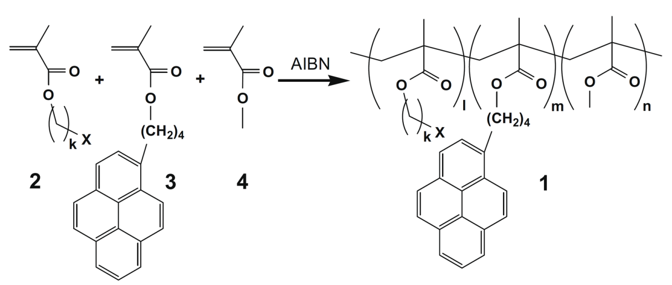
Scheme. 1

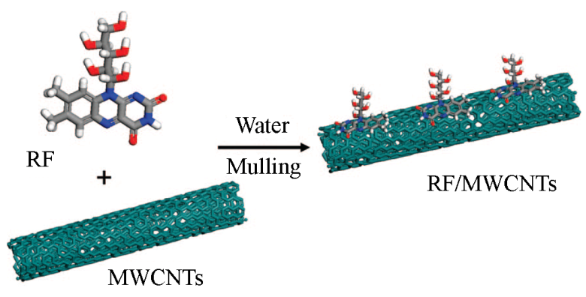
Scheme. 2

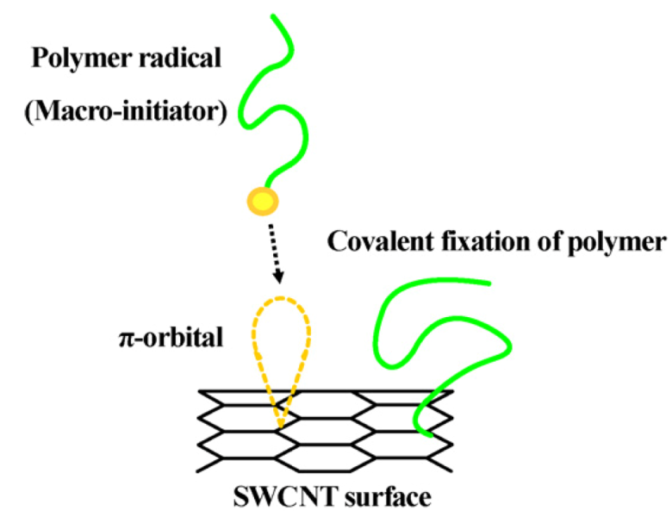
Fig. 1
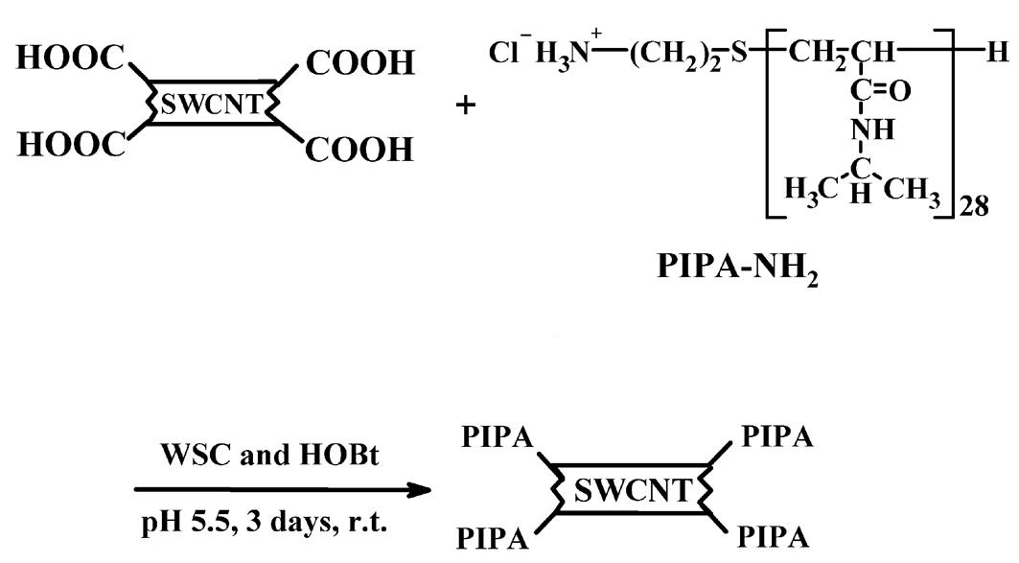
Fig. 2
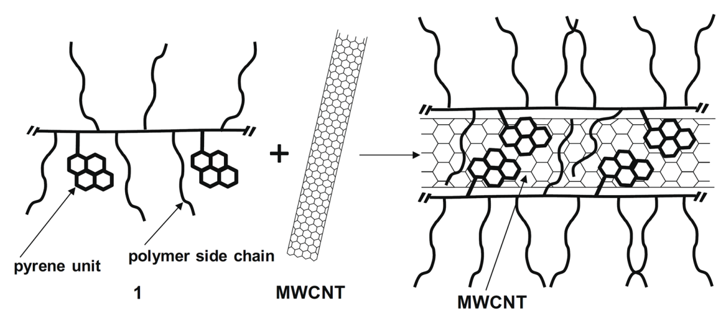
Fig. 3
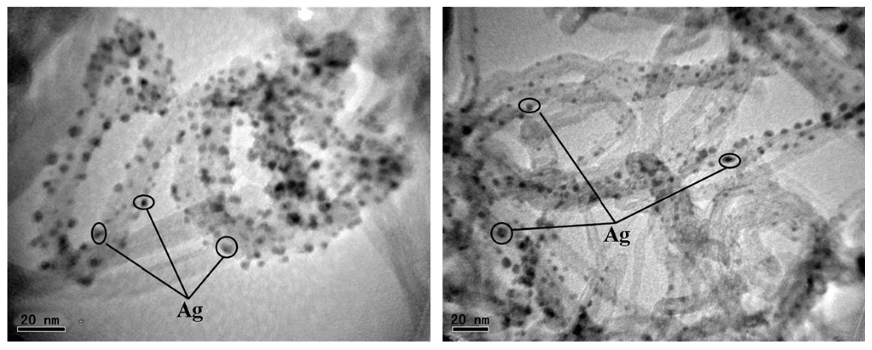
Fig. 4

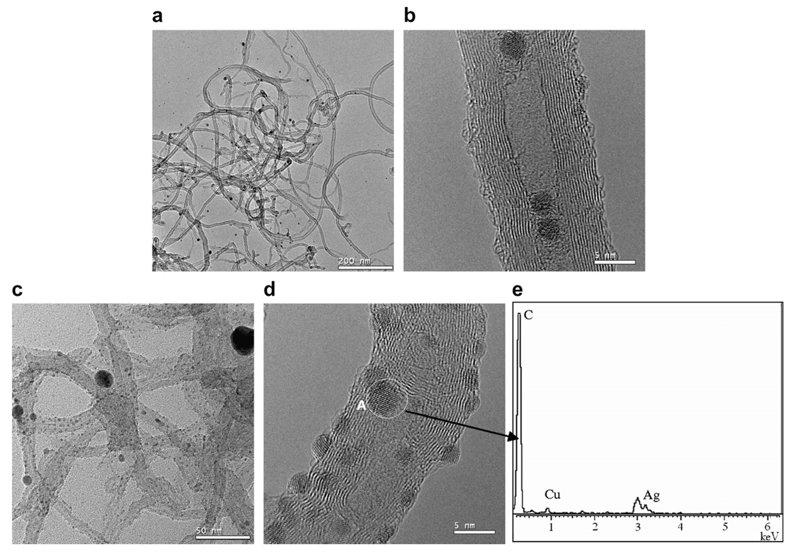
Fig. 5
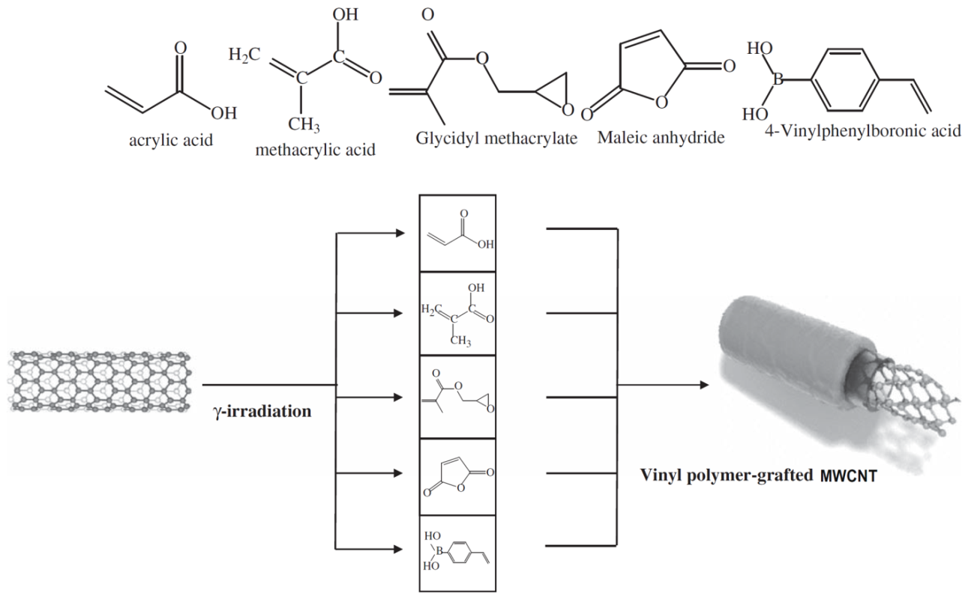
Fig. 6

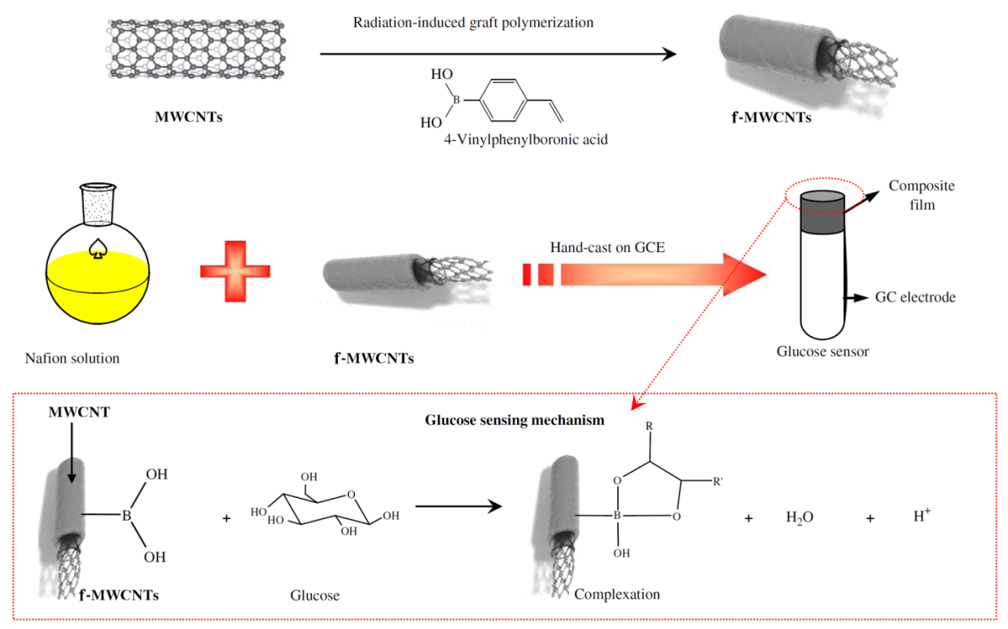
Fig. 7

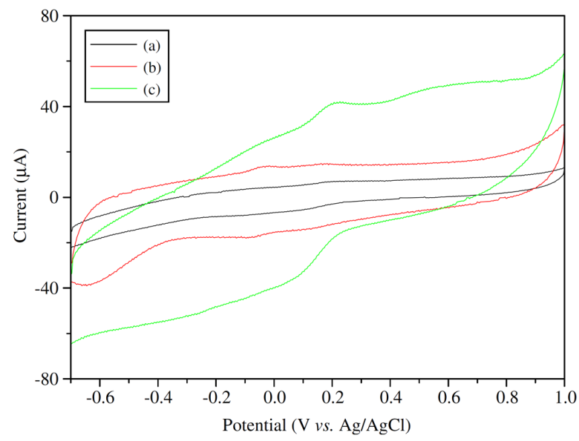
Fig. 8

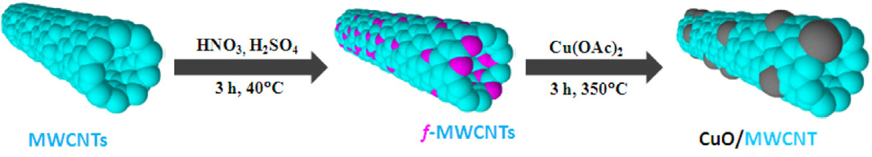
Fig. 9

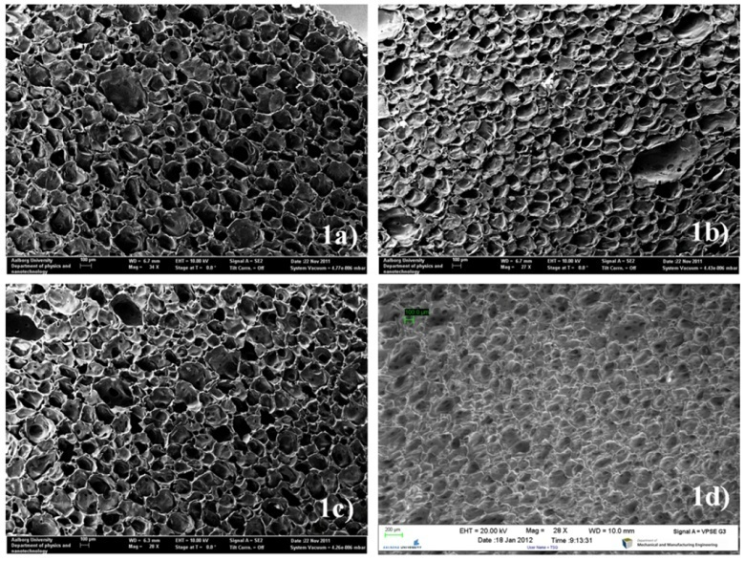
Fig. 10
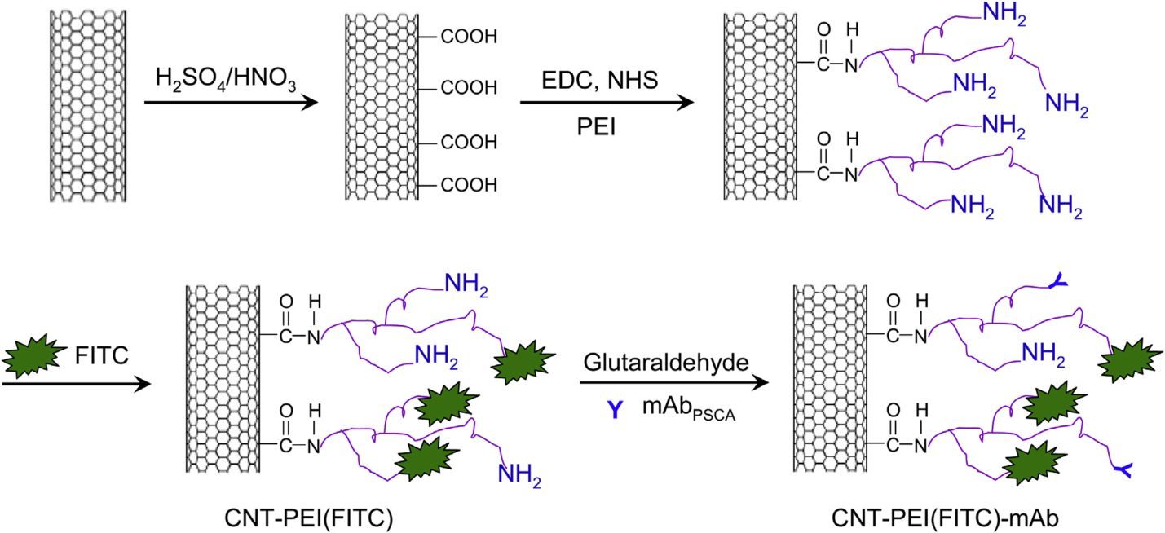
Fig. 11

References
[1] Raja M, Shanmugharaj A, Ryu SH. Influence of surface functionalized carbon nanotubes on the properties of polyurethane nanocomposites. Soft Materials. 2008;6:65-74.
[2] Spitalsky Z, Tasis D, Papagelis K, Galiotis C. Carbon nanotube–polymer composites: chemistry, processing, mechanical and electrical properties. Prog polym sci 2010;35:357-401.
[3] Tasis D, Tagmatarchis N, Bianco A, Prato M. Chemistry of carbon nanotubes. Chem rev 2006;106:1105-36.
[4] Njuguna J, Pielichowski K, Zhu H. Health and Environmental Safety of Nanomaterials: Polymer Nancomposites and Other Materials Containing Nanoparticles: Elsevier; 2014.
[5] Hernández-Fernández P, Montiel M, Ocón P, de la Fuente J, García-Rodríguez S, Rojas S, et al. Functionalization of multi-walled carbon nanotubes and application as supports for electrocatalysts in proton-exchange membrane fuel cell. Appl Catal B Environ 2010;99:343-52.
[6] Ma P-C, Siddiqui NA, Marom G, Kim J-K. Dispersion and functionalization of carbon nanotubes for polymer-based nanocomposites: a review. Compos Part A-Appl S 2010;41:1345-67.
[7] Qu L, Lee KM, Dai L. Functionalization and applications of carbon nanotubes. Carbon Nanotechnology L Dai, editor Elsevier, Amsterdam. 2006:191-234.
[8] Schulz M, Shanov V, Yin Z. Carbon nanotube sheet: processing, characterization and applications. In: Nanotube superfiber materials: changing engineering design: William Andrew; 2014, p. 349-387.
[9] Liu J, Vigolo B, Dossot M, Fort Y, Ehrhardt J-J, McRae E. Efficient microwave-assisted radical functionalization of single-wall carbon nanotubes. Carbon. 2007;45:885-91.
[10] Huang Z, Xi L, Subhani Q, Yan W, Guo W, Zhu Y. Covalent functionalization of multi-walled carbon nanotubes with quaternary ammonium groups and its application in ion chromatography. Carbon. 2013;62:127-34.
[11] Andrews R, Jacques D, Minot M, Rantell T. Fabrication of carbon multiwall nanotube/polymer composites by shear mixing. Macromol Mater Eng 2002;287:395-403.
[12] Meng L, Fu C, Lu Q. Advanced technology for functionalization of carbon nanotubes. Prog Nat Sci 2009;19:801-10.
[13] Koval’chuk AA, Shevchenko VG, Shchegolikhin AN, Nedorezova PM, Klyamkina AN, Aladyshev AM. Effect of carbon nanotube functionalization on the structural and mechanical properties of polypropylene/MWCNT composites. Macromolecules 2008;41:7536-42.
[14] Amiri A, Maghrebi M, Baniadam M, Zeinali Heris S. One-pot, efficient functionalization of multi-walled carbon nanotubes with diamines by microwave method. Appl Surf Sci 2011;257:10261-6.
[15] Moniruzzaman M, Winey KI. Polymer nanocomposites containing carbon nanotubes. Macromolecules 2006;39:5194-205.
[16] Chua T, Mariatti M, Azizan A, Rashid AA. Effects of surface-functionalized multi-walled carbon nanotubes on the properties of poly (dimethyl siloxane) nanocomposites. Compos Sci Technol 2010;70:671-7.
[17] Sahoo NG, Cheng HKF, Bao H, Pan Y, Li L, Chan SH. Covalent functionalization of carbon nanotubes for ultimate interfacial adhesion to liquid crystalline polymer. Soft Matter 2011;7:9505-14.
[18] Hariharasubramanian A, Dominic Ravichandran Y, Rajesh R, Rajendra Kumar K, Kanagaraj M, Arumugam S. Covalent functionalization of single-walled carbon nanotubes with anthracene by green chemical approach and their temperature dependent magnetic and electrical conductivity studies. Mater Chem Phys 2014;143:838-44.
[19] Liu P. Modifications of carbon nanotubes with polymers. Eur Polym J 2005;41:2693-703.
[20] Li X, Wong SY, Tjiu WC, Lyons BP, Oh SA, He CB. Non-covalent functionalization of multi walled carbon nanotubes and their application for conductive composites. Carbon 2008;46:829-31.
[21] Zhang A, Luan J, Zheng Y, Sun L, Tang M. Effect of percolation on the electrical conductivity of amino molecules non-covalently coated multi-walled carbon nanotubes/epoxy composites. Appl Surf Sci 2012;258:8492-7.
[22] Sahoo NG, Rana S, Cho JW, Li L, Chan SH. Polymer nanocomposites based on functionalized carbon nanotubes. Prog polym sci 2010;35:837-67.
[23] Hua J, Wang Z, Xu L, Wang X, Zhao J, Li F. Preparation polystyrene/multiwalled carbon nanotubes nanocomposites by copolymerization of styrene and styryl-functionalized multiwalled carbon nanotubes. Mater Chem Phys 2013;137:694-8.
[24] Kitano H, Tachimoto K, Anraku Y. Functionalization of single-walled carbon nanotube by the covalent modification with polymer chains. J colloid interf sci 2007;306:28-33.
[25] Huang J, Gao M, Pan T, Zhang Y, Lin Y. Effective thermal conductivity of epoxy matrix filled with poly (ethyleneimine) functionalized carbon nanotubes. Compos Sci Technol 2014;95:16-20.
[26] Jin F-L, Yop Rhee K, Park S-J. Functionalization of multi-walled carbon nanotubes by epoxide ring-opening polymerization. J Solid State Chem 2011;184:3253-6.
[27] Seligra PG, Nuevo F, Lamanna M, Famá L. Covalent grafting of carbon nanotubes to PLA in order to improve compatibility. Compos Part B-Eng 2013;46:61-8.
[28] Morishita T, Matsushita M, Katagiri Y, Fukumori K. Synthesis and properties of macromer-grafted polymers for noncovalent functionalization of multiwalled carbon nanotubes. Carbon 2009;47:2716-26.
[29] Li Z, Wu Z, Li K. The high dispersion of DNA–multiwalled carbon nanotubes and their properties. Anal biochem 2009;387:267-70.
[30] Mu Q, Liu W, Xing Y, Zhou H, Li Z, Zhang Y, et al. Protein binding by functionalized multiwalled carbon nanotubes is governed by the surface chemistry of both parties and the nanotube diameter. J Phys Chem C. 2008;112:3300-7.
[31] Sheikholeslam M, Pritzker M, Chen P. Dispersion of multiwalled carbon nanotubes in water using ionic-complementary peptides. Langmuir 2012;28:12550-6.
[32] Aslan S, Loebick CZ, Kang S, Elimelech M, Pfefferle LD, Van Tassel PR. Antimicrobial biomaterials based on carbon nanotubes dispersed in poly (lactic-co-glycolic acid). Nanoscale 2010;2:1789-94.
[33] Amiri A, Zardini HZ, Shanbedi M, Maghrebi M, Baniadam M, Tolueinia B. Efficient method for functionalization of carbon nanotubes by lysine and improved antimicrobial activity and water-dispersion. Mater Lett 2012;72:153-6.
[34] Ling X, Wei Y, Zou L, Xu S. Functionalization and dispersion of multiwalled carbon nanotubes modified with poly-l-lysine. Colloid Surface A 2014;443:19-26.
[35] Vadi M, Hadipour I. Adsorption isotherm study of vitamin B2 on carbon nanotube. Orient J Chem 2011;27:1037.
[36] Long D, Wu G, Wu A. Photoinduced Charge Separation in Riboflavin/Carbon Nanotubes Superstructures. J Phys Chem C 2008;112:13000-3.
[37] Mallakpour S, Zadehnazari A. A convenient strategy to functionalize carbon nanotubes with ascorbic acid and its effect on the physical and thermomechanical properties of poly (amide–imide) composites. J Solid State Chem 2014;211:136-45.
[38] Mallakpour S, Zadehnazari A. One-pot synthesis of glucose functionalized multi-walled carbon nanotubes: Dispersion in hydroxylated poly (amide-imide) composites and their thermo-mechanical properties. Polymer 2013;54:6329-38.
[39] Mallakpour S, Zadehnazari A. A facile, efficient, and rapid covalent functionalization of multi-walled carbon nanotubes with natural amino acids under microwave irradiation. Prog Org Coat 2014;77:679-84.
[40] Awasthi K, Singh D, Singh SK, Dash D, Srivastava O. Attachment of biomolecules (protein and DNA) to amino-functionalized carbon nanotubes. New Carbon Mater 2009;24:301-6.
[41] Skender A, Hadj-Ziane-Zafour A, Flahaut E. Chemical functionalization of Xanthan gum for the dispersion of double-walled carbon nanotubes in water. Carbon 2013;62:149-56.
[42] Xin F, Li L. Decoration of carbon nanotubes with silver nanoparticles for advanced CNT/polymer nanocomposites. Compos Part A-Appl S 2011;42:961-7.
[43] Ma PC, Tang BZ, Kim J-K. Effect of CNT decoration with silver nanoparticles on electrical conductivity of CNT-polymer composites. Carbon 2008;46:1497-505.
[44] Murugan E, Vimala G. Effective functionalization of multiwalled carbon nanotube with amphiphilic poly (propyleneimine) dendrimer carrying silver nanoparticles for better dispersability and antimicrobial activity. J colloid interf sci 2011;357:354-65.
[45] Cveticanin J, Krkljes A, Kacarevic-Popovic Z, Mitric M, Rakocevic Z, Trpkov D, et al. Functionalization of carbon nanotubes with silver clusters. Appl Surf Sci 2010;256:7048-55.
[46] Jeong G-H. Surface functionalization of single-walled carbon nanotubes using metal nanoparticles. Trans Nonferrous Met Soc China 2009;19:1009-12.
[47] Geng Y, Liu MY, Li J, Shi XM, Kim JK. Effects of surfactant treatment on mechanical and electrical properties of CNT/epoxy nanocomposites. Compos Part A-Appl S 2008;39:1876-83.
[48] Sobolkina A, Mechtcherine V, Khavrus V, Maier D, Mende M, Ritschel M, et al. Dispersion of carbon nanotubes and its influence on the mechanical properties of the cement matrix. Cem Concr Compos 2012;34:1104-13.
[49] Naik RB, Jagtap S, Naik R, Malvankar N, Ratna D. Effect of non-ionic surfactants on thermomechanical properties of epoxy/multiwall carbon nanotubes composites. Prog Org Coat 2014;77:1883-9.
[50] Blanch AJ, Quinton JS, Shapter JG. The role of sodium dodecyl sulfate concentration in the separation of carbon nanotubes using gel chromatography. Carbon 2013;60:471-80.
[51] Preetha Nair K, Thomas P, Joseph R. Latex stage blending of multiwalled carbon nanotube in carboxylated acrylonitrile butadiene rubber: Mechanical and electrical properties. Mater Des 2012;41:23-30.
[52] Gao L, Yin H, Zhu H, Mao X, Gan F, Wang D. Separation of dispersed carbon nanotubes from water: Effect of pH and surfactants on the aggregation at oil/water interface. Sep Purif Technol 2014;129:113-20.
[53] Ghorabi S, Rajabi L, Madaeni SS, Zinadini S, Derakhshan AA. Effects of three surfactant types of anionic, cationic and non-ionic on tensile properties and fracture surface morphology of epoxy/MWCNT nanocomposites. Iran Polym J 2012;21:121-30.
[54] Whitsitt EA, Barron AR. Silica coated single walled carbon nanotubes. Nano lett 2003;3:775-8.
[55] Kim TH, Doe C, Kline SR, Choi SM. Water‐Redispersible Isolated Single‐Walled Carbon Nanotubes Fabricated by In Situ Polymerization of Micelles. Adv Mater 2007;19:929-33.
[56] Madni I, Hwang C-Y, Park S-D, Choa Y-H, Kim H-T. Mixed surfactant system for stable suspension of multiwalled carbon nanotubes. Colloid Surface A 2010;358:101-7.
[57] Nguyen J, Wen H, Zhang Z, Yaghmaie F, Lavernia E. Surfactant Assisted Dispersion and Adhesion Behavior of Carbon Nanotubes on Cu–Zr and Cu–Zr–Al Amorphous Powders. J Mater Sci Technol 2014;30:847-53.
[58] Lu Y, Yang K, Lin D. Transport of surfactant-facilitated multiwalled carbon nanotube suspensions in columns packed with sized soil particles. Environ Pollut 2014;192:36-43.
[59] Li X, Li Q, Chen G-X. Alkali metal surfactant-facilitated formation of thick boron nitride layers on carbon nanotubes by dip-coating. Mater Lett 2014;134:38-41.
[60] Wang Q, Arash B. A review on applications of carbon nanotubes and graphenes as nano-resonator sensors. Comp Mater Sci 2014;82:350-60.
[61] Kruss S, Hilmer AJ, Zhang J, Reuel NF, Mu B, Strano MS. Carbon nanotubes as optical biomedical sensors. Adv Drug Deliver Rev 2013;65:1933-50.
[62] Blondeau P, Xavier Rius-Ruiz F, Düzgün A, Riu J, Xavier Rius F. Covalent functionalization of single-walled carbon nanotubes with adenosine monophosphate: Towards the synthesis of SWCNT–Aptamer hybrids. Mater Sci Eng C 2011;31:1363-8.
[63] Arvand M, Palizkar B. Development of a modified electrode with amine-functionalized TiO₂/multi-walled carbon nanotubes nanocomposite for electrochemical sensing of the atypical neuroleptic drug olanzapine. Mater Sci Eng C 2013;33:4876-83.
[64] Nellaiappan S, Kumar AS. Selective flow injection analysis of iodate in iodized table salts by riboflavin immobilized multiwalled carbon nanotubes chemically modified electrode. Electrochim Acta 2013;109:59-66.
[65] Khodadadei F, Ghourchian H, Soltanieh M, Hosseinalipour M, Mortazavi Y. Rapid and clean amine functionalization of carbon nanotubes in a dielectric barrier discharge reactor for biosensor development. Electrochim Acta 2014;115:378-85.
[66] Yang D-S, Jung D-J, Choi S-H. One-step functionalization of multi-walled carbon nanotubes by radiation-induced graft polymerization and their application as enzyme-free biosensors. Radiat Phys Chem 2010;79:434-40.
[67] Yoon B, Pan H-B, Wai CM. Relative catalytic activities of carbon nanotube-supported metallic nanoparticles for room-temperature hydrogenation of benzene. J Phys Chem C 2009;113:1520-5.
[68] Gopiraman M, Ganesh Babu S, Khatri Z, Kai W, Kim YA, Endo M, et al. An efficient, reusable copper-oxide/carbon-nanotube catalyst for N-arylation of imidazole. Carbon 2013;62:135-48.
[69] Orfanidi A, Daletou M, Neophytides S. Preparation and characterization of Pt on modified multi-wall carbon nanotubes to be used as electrocatalysts for high temperature fuel cell applications. Appl Catal B-Environ 2011;106:379-89.
[70] Liu Z, Fu X, Tang S, Cheng Y, Zhu L, Xing L, et al. Sulfonated magnetic carbon nanotube arrays as effective solid acid catalysts for the hydrolyses of polysaccharides in crop stalks. Catal Commun 2014;56:1-4.
[71] Ha H, Kim SC, Ha K. Morphology and properties of polyamide/multi-walled carbon nanotube composites. Macromol Res 2010;18:660-7.
[72] Wang J, Yan S, Bao R, Yang K, Feng Z. Facile fabrication of multi-walled carbon nanotubes and its enhancement on thermally conductive adhesive applied in heat dissipation devices. Mater Des 2013;51:598-604.
[73] Rahmanian S, Suraya A, Shazed M, Zahari R, Zainudin E. Mechanical characterization of epoxy composite with multiscale reinforcements: Carbon nanotubes and short carbon fibers. Mater Des 2014;60:34-40.
[74] Zeng C, Hossieny N, Zhang C, Wang B. Synthesis and processing of PMMA carbon nanotube nanocomposite foams. Polymer 2010;51:655-64.
[75] Madaleno L, Pyrz R, Crosky A, Jensen LR, Rauhe JCM, Dolomanova V, et al. Processing and characterization of polyurethane nanocomposite foam reinforced with montmorillonite–carbon nanotube hybrids. Compos Part A-Appl S 2013;44:1-7.
[76] Mallakpour S, Zadehnazari A. Chiral poly (Amide-Imide)/carbon nanotube bionanocomposites containing hydroxyl pendant groups and L-phenylalanine amino acid: synthesis, preparation of thin films, and thermomechanical behavior. Soft Materials 2013;11:494-502.
[77] Mallakpour S, Zadehnazari A. Synthesize procedures, mechanical and thermal properties of thiazole bearing poly (amid-imide) composite thin films containing multiwalled carbon nanotubes. Colloid Polym Sci 2013;291:1525-34.
[78] Mallakpour S, Zadehnazari A. The production of functionalized multiwall carbon nanotube/amino acid-based poly (amide–imide) composites containing a pendant dopamine moiety. Carbon 2013;56:27-37.
[79] Mallakpour S, Soltanian S. Investigation on production and characterization of bionanocomposites based on surface functionalized multi-walled carbon nanotubes and optically active poly (ester-imide) having L-isoleucine units. Prog Org Coat 2014;77:1023-9.
[80] Mallakpour S, Soltanian S. Functionalized multi-wall carbon nanotube reinforced poly (ester-imide) bionanocomposites containing L-leucine amino acid units. J Polym Res 2014;21:335-342.
[81] Mallakpour S, Soltanian S. Microwave assisted functionalization of carboxylated‐multiwalled carbon nanotubes with 5‐aminoisophthalic acid and its application for the preparation of chiral poly (ester‐imide)/CNT nanocomposites. Polym Compos 2014: DOI: 10.1002/pc.23241.
[82] Mallakpour S, Soltanian S. Chemical modification of MWCNTs with 5-aminoisophthalic acid and its effects on the thermal and morphological properties of chiral poly (ester-imide)/MWCNT nanocomposites having N-trimellitylimido-L-isoleucine moieties. J Polym Res 2014;21:553-561.
[83] Mallakpour S, Zadehnazari A. Efficient functionalization of multi‐walled carbon nanotubes with p‐aminophenol and their application in the fabrication of poly (amide‐imide)‐matrix composites. Polym Int 2014;63:1203-1211.
[84] Mallakpour S, Zadehnazari A. Functionalization of multi-wall carbon nanotubes with amino acid and its influence on the properties of thiadiazol bearing poly (amide-thioester-imide) composites. Synth Met 2013;169:1-11.
[85] Mallakpour S, Soltanian S. Synthesis and properties of chiral poly (ester–imide)/multiwalled carbon nanotube nanocomposites containing 4, 4′-thiobis (2-tert-butyl-5-methylphenol) and s-valine amino acid moieties. High Perform Polym 2014: DOI: 10.1177/0954008314544385.
[86] Mallakpour S, Soltanian S. Studies on Preparation and Microstructure Characterization of Novel Composites Based on Functionalized Multiwalled Carbon Nanotubes and Chiral Poly (ester-imide) Containing S-Valine Linkages. Polym-Plast Technol 2014;53:1583-9.
[87] Mallakpour S, Abdolmaleki A, Rostami M. Hybrid S-valine functionalized multi-walled carbon nanotubes/poly (amid-imide) nanocomposites containing trimellitimidobenzene and 4-hydroxyphenyl benzamide moieties: preparation, processing, and thermal properties. J Mater Sci 2014;49:7445-53.
[88] Mallakpour S, Abdolmaleki A, Rostami M. Influence of biosafe amino acid-functionalized multiwalled carbon nanotubes on the morphology and thermal properties of the poly (amide–imide) nanocomposites containing N, N′-(pyromellitoyl)-bis-S-valine segments. High Perform Polym 2014: DOI: 10.1177/0954008314552536.
[89] Han ZJ, Rider AE, Fisher C, Laan T, Kumar S, Levchenko I, Ostrikov K. Biological Application of Carbon Nanotubes and Graphene. In: Carbon Nanotubes and Graphene, Elsevier, 2014, p. 279-312.
[90] Peretz S, Regev O. Carbon nanotubes as nanocarriers in medicine. Curr Opin Colloid Interface Sci 2012;17:360-8.
[91] Siu KS, Chen D, Zheng X, Zhang X, Johnston N, Liu Y, et al. Non-covalently functionalized single-walled carbon nanotube for topical siRNA delivery into melanoma. Biomaterials 2014;35:3435-42.
[92] Huang H, Yuan Q, Shah J, Misra R. A new family of folate-decorated and carbon nanotube-mediated drug delivery system: synthesis and drug delivery response. Adv Drug Deliver Rev 2011;63:1332-9.
[93] Benincasa M, Pacor S, Wu W, Prato M, Bianco A, Gennaro R. Antifungal activity of amphotericin B conjugated to carbon nanotubes. ACS nano 2011;5:199-208.
[94] Luo X, Matranga C, Tan S, Alba N, Cui XT. Carbon nanotube nanoreservior for controlled release of anti-inflammatory dexamethasone. Biomaterials 2011;32:6316-23.
[95] McDevitt MR, Chattopadhyay D, Kappel BJ, Jaggi JS, Schiffman SR, Antczak C, et al. Tumor targeting with antibody-functionalized, radiolabeled carbon nanotubes. J Nucl Med 2007;48:1180-9.
[96] Pantarotto D, Partidos CD, Graff R, Hoebeke J, Briand J-P, Prato M, et al. Synthesis, structural characterization, and immunological properties of carbon nanotubes functionalized with peptides. J Am Chem Soc 2003;125:6160-4.
[97] Karchemski F, Zucker D, Barenholz Y, Regev O. Carbon nanotubes-liposomes conjugate as a platform for drug delivery into cells. J Controlled Release. 2012;160:339-45.
[98] Meng L, Zhang X, Lu Q, Fei Z, Dyson PJ. Single walled carbon nanotubes as drug delivery vehicles: targeting doxorubicin to tumors. Biomaterials 2012;33:1689-98.
[99] Heister E, Neves V, Lamprecht C, Silva SRP, Coley HM, McFadden J. Drug loading, dispersion stability, and therapeutic efficacy in targeted drug delivery with carbon nanotubes. Carbon 2012;50:622-32.
[100] Wu H, Shi H, Zhang H, Wang X, Yang Y, Yu C, et al. Prostate stem cell antigen antibody-conjugated multiwalled carbon nanotubes for targeted ultrasound imaging and drug delivery. Biomaterials 2014;35:5369-80.
[101] Behnam B, Shier WT, Nia AH, Abnous K, Ramezani M. Non-covalent functionalization of single-walled carbon nanotubes with modified polyethyleneimines for efficient gene delivery. Int J Pharm 2013;454:204-15.

* Corresponding author. Tel.: +98-31-3391-3267. FAX: +98-31-3391-2350. E-mail address: mallak@cc.iut.ac.ir, mallak777@yahoo.com, mallakpour84@alumni.ufl.edu. (S. Mallakpour)

