Carnegie Mellon University Alumni Network Event

The Undergraduate Finance Association along with The Career Center, The Tepper School of Business, The Carnegie Mellon Alumni Association, and The Department of Mathematical Sciences would be honored to invite you to our biggest alumni network event in New York City. Please join us for an unforgettable happy hour at the 3 West Club!
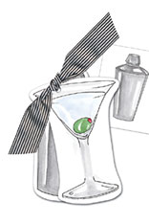
When? Thursday, July 22, 6:30-9 p.m.
Where? 3 West 51st Street

New York City, NY 10019

Between 5th Avenue and Avenue of the Americas
Subway? 51st Street-E, F and walk to 5th Avenue
Or 7TH AVE-B, D, E and walk to 51st Street and 5th Avenue
Cost? Entrance & appetizers are free! There will be a cash bar. Voluntary contributions to help defray overhead of offering this event would be gratefully accepted.
Dress Code? Business casual

We look forward to seeing you there!

Please RSVP on or before Tuesday July 20 to finance@andrew.cmu.edu

Regards,



Carolina Carvalho
President,
Undergraduate Finance Association
www.andrew.cmu.edu/~finance

