Innocence Under Siege is a travelling exhibit containing 50 touching pieces
of artwork, illustrating children's experiences of living under Israeli occupation,
as well as their views of the world around them.

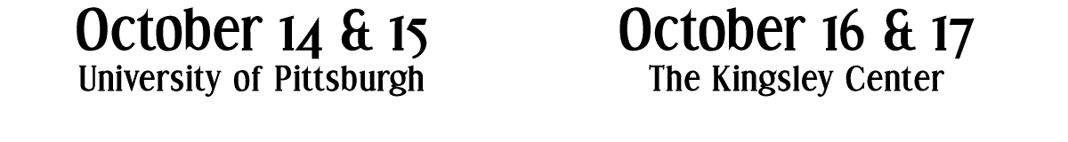
Kimbo Art Gallery  William Pitt Union  3959 Fifth Ave., Oakland  Opening Reception October 14, 6:30pm  Featuring guest speaker Neil Boothby  (Director of Save the Children’s Children in Crisis office  and former Senior Coordinator for Refugee Children  under UN Commissioner for Refugees)  speaking on "Children in Crisis" | Selma Burke Gallery  6118 Penn Circle So.  East Liberty  Opening Reception October 16, 6:30 pm  Featuring guest speaker Saly Fayez  Palestinian-American  (Juvenile Court Advocacy Supervisor,  The Center for Victims of Violent Crime)
FOUR DAYS ONLY!
The exhibit is produced by Al-Phan, a Chicago-based not-for-profit organization dedicated to promoting Palestinian arts, and has also appeared at Harvard University, University of Pennsylvania, American University,
Indiana University, University of Wisconsin, and University of Memphis.

