Summary of Capital Raising and Investments in Israeli Hi-Tech Companies During 1999

IVC-Online, a member of Giza Group is pleased to present you with highlights from its 1999 survey of the Israeli hi-tech and venture capital industries.
- During 1999, private Israeli hi-tech companies raised a total of $1.003 billion from both Israeli venture capital funds and other investors. This represents a new record for capital raised by Israeli companies in a single year, shattering the $600 million raised in 1998 with a 67% increase this year. Just two-years ago, in 1997 only $430 million was raised
- Of the $1.003 billion raised by Israeli hi-tech private companies, local venture capital funds invested $432 million, 43% of the total amount raised by companies for the year. This marks a 27% rise from 1998's figure of $340 million. In 1997 Israeli venture funds invested $240 million.
- The remaining $571 million invested in Israeli hi-tech companies came from non Israeli venture funds such as, foreign venture capital funds and companies, Israeli and non-Israeli institutional investors and angel investors.
- Throughout 1999, Israeli venture capital funds increased their level of investments from quarter to quarter. During Q4/99 Israeli funds invested $134 million, 77% more than they invested during Q1/99.
- The capital invested in Israeli hi-tech companies by non Israeli venture funds also increased from quarter to quarter, from $100 million in Q1/99 to $200 million in Q4/99, a 100% increase.
- 330 companies raised capital from VC funds during 1999. 70 companies raised capital from VCs during Q1/99 and 104 companies raised money from VCs in Q4/99 showing the steady increase over the year.
- The most active sector in 1999 for Israeli hi-tech companies was the Internet. The Israeli Internet sector raised a total of $328 million. During Q4/99, Internet companies raised $115.1 million, similar to the level of investment in Internet companies during Q3/99.
- The Communications sector raised a total of $290.5 million during 1999. During Q4/99, $94.4 million was invested in Israeli Communications companies, a 28% increase from the level of investment in the sector during Q3/99.
- There was a sharp increase in the Israeli Software sector during Q4/99 with $62.4 million invested in Israeli software companies. The figure represents a 136% increase over Q3/99 figures when only $26.6 million was invested in Israeli software companies.
- The Israeli Life Sciences sector was characterized as having been relatively stable during 1999. Investments in this sector ranged between $26-$40 million each quarter. Israeli Life Sciences companies raised a total of $134.7 million during the year.
- 10 Israeli venture funds invested over $15 million over the course of the year. Of these ten funds, eight of them invested even over $20 million during 1999. The combined investments of these 10 funds for the year was $258 million which comprises 60% of the total amount Israeli venture capital funds invested during 1999.

Additional Information
Initial estimates show that Israeli venture capital funds raised $900 million during 1999, a 35% increase from 1998 when $668 million was raised. In 1997 $712 million was raised.
The survey is based on the figures reported by 58 Israeli venture capital funds, managed by their 50 management companies, as well as the IVC-Online databases.

Summary of the survey is represented by the following graphs:

Total Amount Raised by Israeli Hi-tech Companies 1997-1999* ($M)
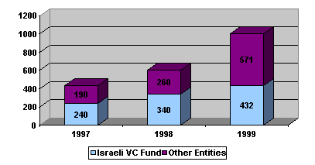
The data for 99', as well as the rest of the data in this file, is based on the survey conducted by IVC-Online with the participation of Israeli's VC funds. The data regarding 97-98' is based on IVC-Online's databases.

Total Amount Ivensted by Israeli VC Funds by Quarter ($M)

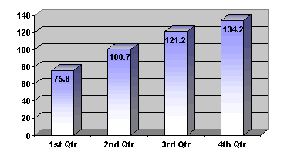

Total Amount: $432 million

Total Amount Raised by Companies in 1999 by Quarter ($M)
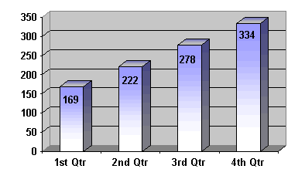
Total Amount: $1,003 million

Distribution of 1999 Investment by Sector
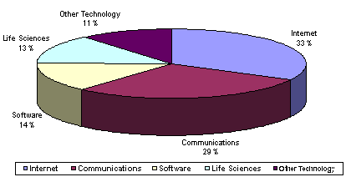
Sector | Amount Raised ($M)
Internet | 328.1
Communications | 290.3
Software | 137.7
Life Sciences | 134.7
Other Technology | 111.9
Total | 1002.7

Amount Raised by the Internet & Communication Sectors by
Quarter 1999 ($M)

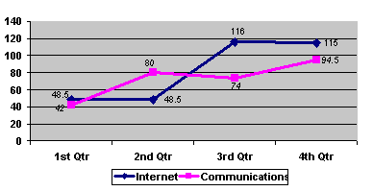

Data Summary Table:

 | Q1/99 | Q2/99 | Q3/99 | Q4/99 | Total
# of Israeli hi-tech companies who raised $ | 70 | 67 | 89 | 104 | 330
Israeli VC Investments ($M) | 75.8 | 100.7 | 121.2 | 134.2 | 431.9
Investments of Other Entities ($M) | 93.2 | 121.3 | 156.8 | 199.8 | 571.1
Total Amount raised by Israeli hi-tech companies ($M) | 169 | 222 | 278 | 334 | 1,003
Investments by Israeli VCs as a % of Total Investments | 45% | 45% | 44% | 40% | 43%
Investments by Other Entities as a % of Total Investments | 55% | 55% | 56% | 60% | 57%

