Workshop 4: Applying the Concepts and Rules

Descriptive Statistics

Central Tendency:
Sample Mean $\overline{x}=\frac{1}{n}\sum_{i=1}^{n}{x_{i}}$
Median Half of x${}_{i}$<=median and half of x${}_{i}$>=median
Mode is the one in x${}_{i}$ that has the maximum frequency.

Measures of Dispersion:
Range = Max – Min
Standard Deviation = S
Where S${}^{2}$=$\frac{\sum{\left(\text{xi}−\overline{x}\right)}}{n−1}$
Ex1: For the following data set, compute mean, median, range and sample standard deviation. 13,1,10,3,3

Mean=(13+1+10+3+3)/5=6
Median=3
Range=13-1=12
Standard Deviation=5.20

Basic Probabilities

Addition Law: P(A or B)=P(A)+P(B)-P(A and B)
Note: if mutually exclusive, P(A and B)=0; if A and B are independent, P(A and B)=P(A)P(B)

Conditional Probability: P(A|B)=$\frac{P(A∩B)}{P(B)}$
Multiplication Law: P(A and B) = P(A B) = P(A)P(B|A) = P(A|B)P(B)

Bayes Rule

Bayes Rule P(A | B) = P(A) P(B | A)/P(B)

Total Probability Rule: P(A)=$\sum{P(A}$and $B_{i}$)=P(A|B${}_{i}$)P(B${}_{i}$)

Ex2 Chapter 3 Question 42 Page 146

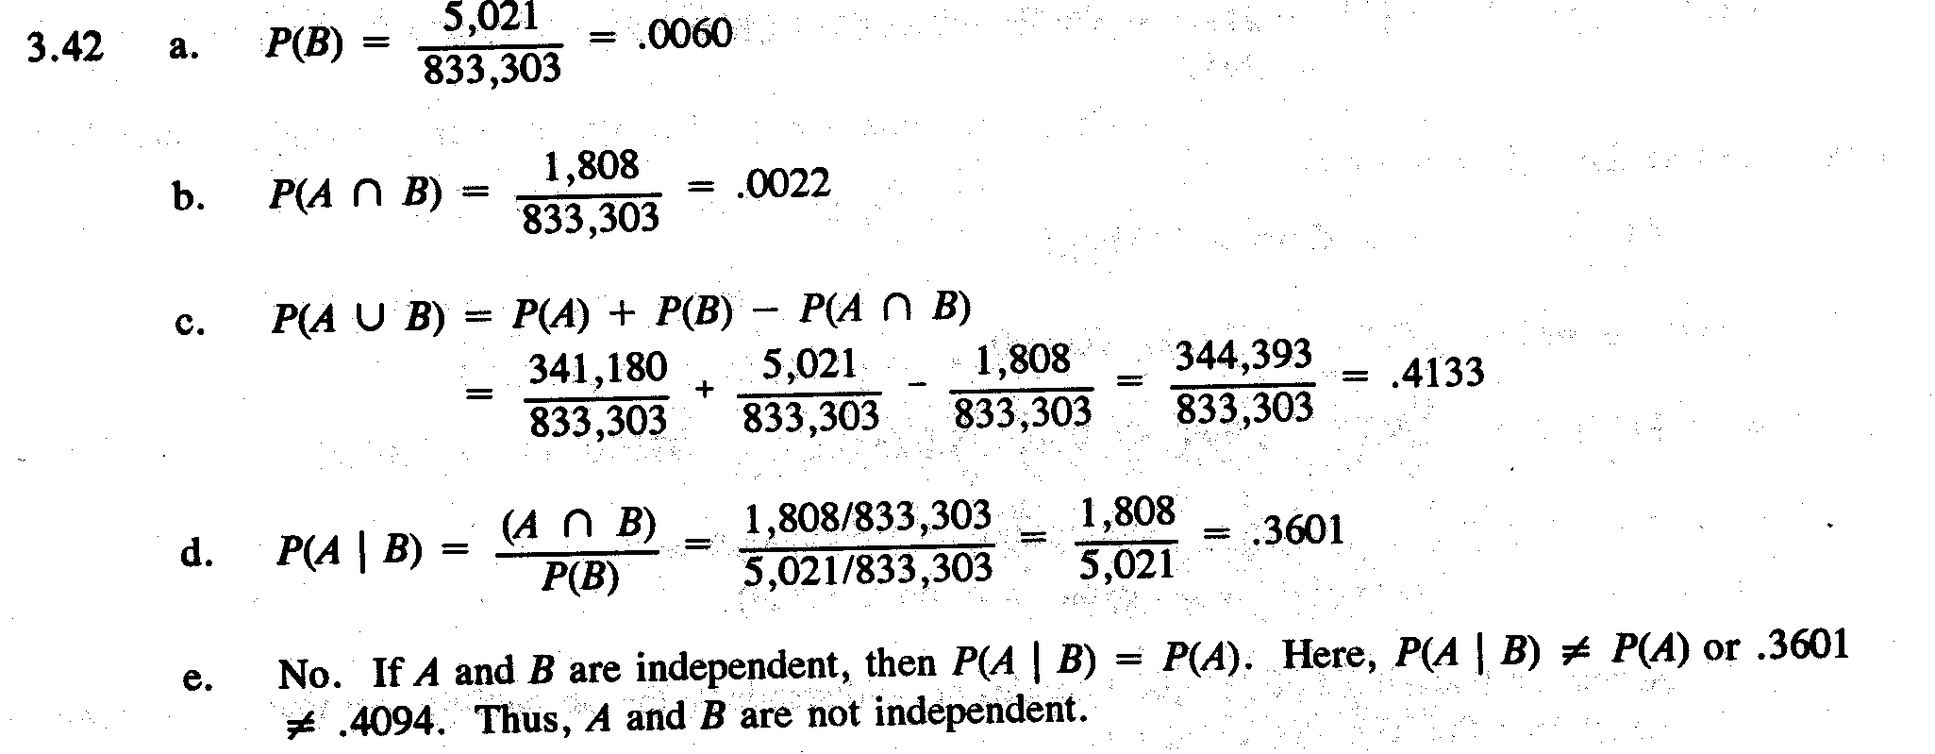

i
n - 1

