MBS

8.37 (20 points)
n=200 x=17.05 $σ$=5.21
- H${}_{o}$: $μ=\text{16}\text{.}5$ H${}_{a}$: $μ>\text{16}\text{.}5$
- Z-stat=$\frac{\overset{⃛}{x}−μ}{s/{\sqrt{n}}}=$$\frac{\text{17}\text{.}\text{05}−\text{16}\text{.}5}{5\text{.}{\text{21}}/{\sqrt{\text{200}}}}$=1.493
p-value=1-P(1.493<=Z-stat)=0.0681
- In this case, out alternative hypothesis is to “greater than”, not “ not equal to”.
So, we only need to test the right side error, the right-tail test is more appropriate.
8.99 (20 points)
a) H${}_{o}$: $μ=\text{12432}$ H${}_{a}$: $μ>\text{12432}$
b) Z-stat=$\frac{\overset{⃛}{x}−μ}{s/{\sqrt{n}}}=$$\frac{\text{13016}−\text{12432}}{{\text{1721}}/{\sqrt{\text{30}}}}$=1.86
If we pick $α=0\text{.}\text{05}$, Z${}_{α}$=1.645, We reject the null hypothesis.
- In this context, the statistical significance level is $α=0\text{.}\text{05}$. The practical significance is the
p-value, which is 0.0314.
9.16 (30 points)
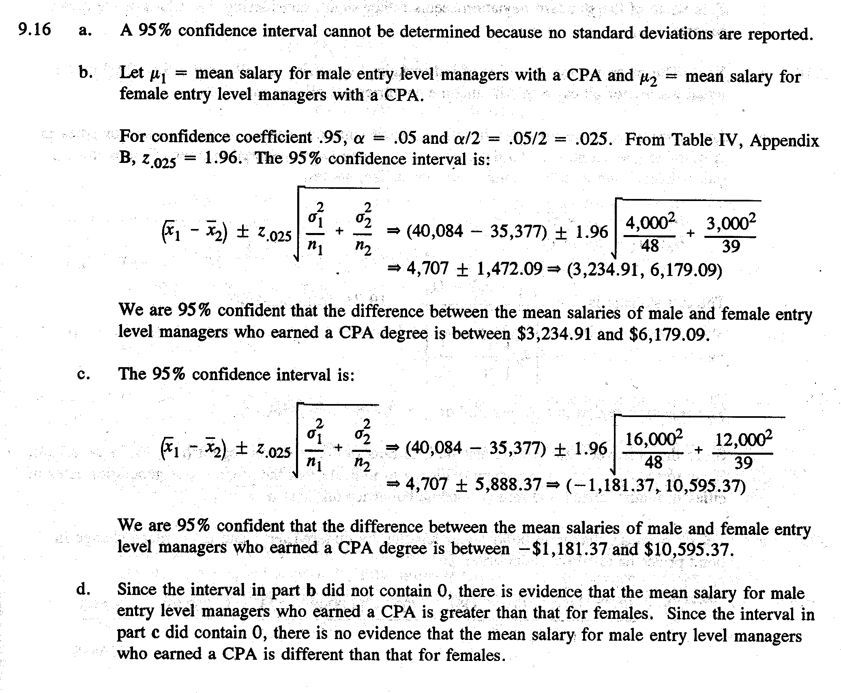
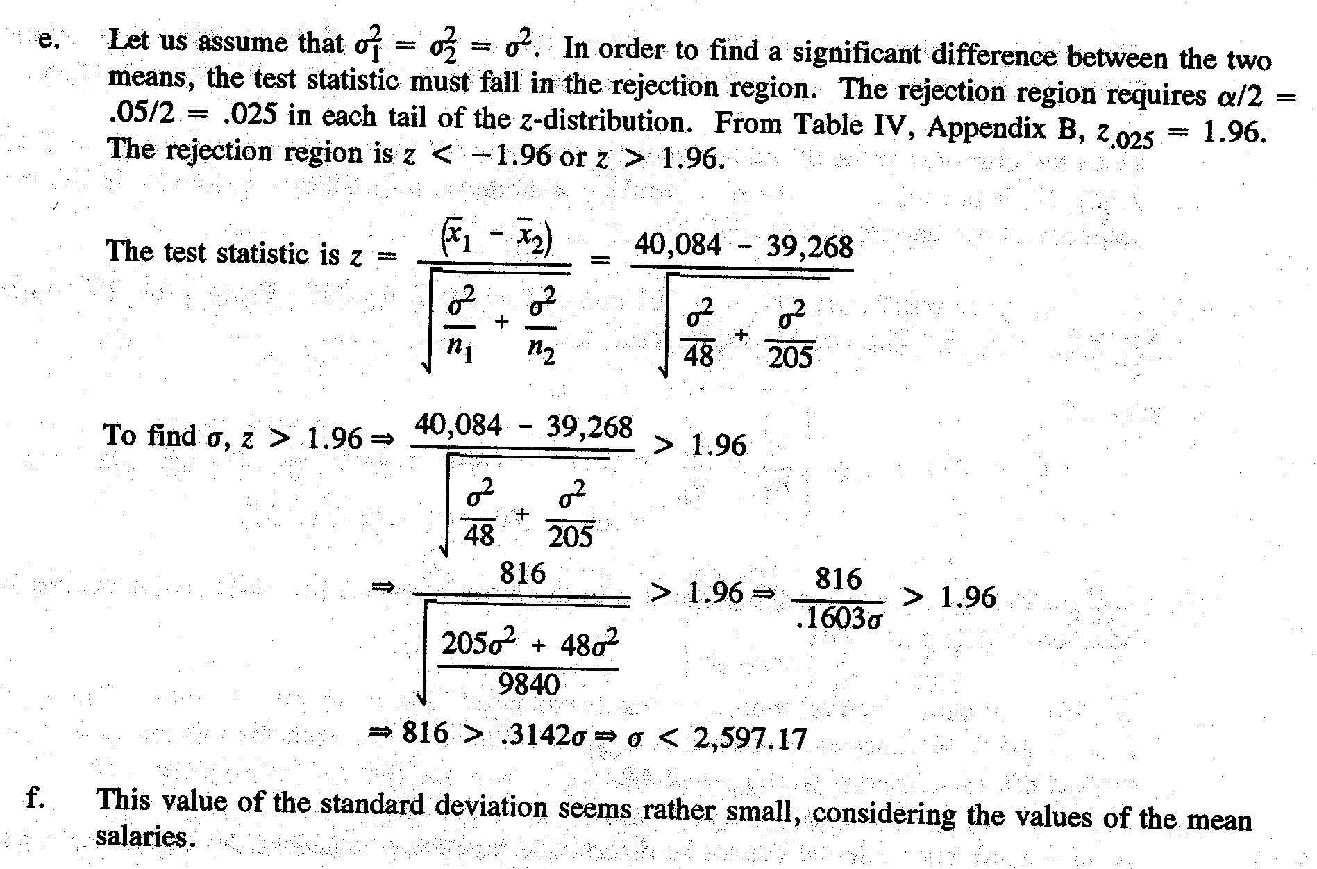
Chatterjee Case Book Question (30 points)

1)
Two Sample T-Test and Confidence Interval

Two sample T for Fixed vs Adjustable

N Mean StDev SE Mean
Fixed 14 7.357 0.404 0.11
Adjustab 6 4.917 0.645 0.26

95% CI for mu Fixed - mu Adjustab: ( 1.74, 3.14)
T-Test mu Fixed = mu Adjustab (vs not =): T = 8.57 P = 0.0001 DF = 6

Apparently, we should reject the null hypothesis.

2)

For the Saracco study:

Sample | Infected Couples | Total Couples | Estimated P
Without using Condom | 8 | 55 | 0.145455
Using condom | 3 | 171 | 0.017544

Z-stat=2.63 P-value=0.008
The tail probability is the p-value.

For European studies:
Sample | Infected Couples | Total Couples | Estimated P
Without using Condom | 12 | 122 | 0.098361
Using condom | 0 | 123 | 0.000000

z-stat=3.65 p-value=0.0002
P-value is just twice as big as the tail probability. It is easy to understand. The tail
Probability is the probability of the two tails, while the p-vale is only the right hand
Side tail probability.

