90-728 Management Information Systems
Advanced Macros for Handling Life Cycle Data
Fall 1999

A copy of the database used below, with all database objects completed, may be found in l:\academic\90728\guns98a.mdb.
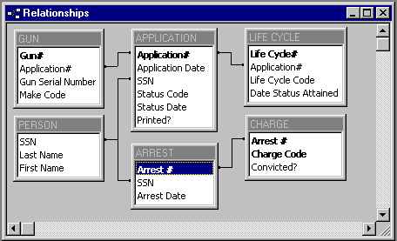

The table APPLICATION has Status Code, which is a slight generalization of Life Cycle Code. Below is the corresponding decision tree with Life Cycle codes on branches and Status Codes in parentheses. The Steelton Police check their own arrest records first to see if the applicant (who wishes to purchase a handgun), has a felony conviction. For those that do not, the police must then login to a national computer system run by the FBI (NCIC) to see if the applicant has a felony conviction elsewhere.

The objective, to be implemented with macros, is to automate input of status codes and life cycle records as spinoffs of other activities. Steps will be as follows:

- At the first node of the decision tree, we open frmApplication. Recall that entering the Status Code control on the form triggers mcrCheckArrest. I have extended this macro in a straightforward way for it to enter Life Cycle table records.
- If the search of Steelton arrest records turns up any felony convictions, then the Status Code is updated to “Refused” and we write a record to the Life Cycle table with code value “Felony: Steelton.” If the search does not turn up any felony arrests, then the Status Code is updated to “Pending.” We write a record to the life cycle table with code “No Felony: Steelton.” Next, the investigator must search NCIC for pending applications.
- To process applications for NCIC checks, we open up frmNeedsProcessing. This form brings up only applications needing further processing, An investigator checks NCIC and then clicks the appropriate button on frmNeedsProcessing, triggering macros in the named macro group mcrNeedsProcessing.
- If the NCIC search does not turn up any felony convictions, then the status code is “Approved” and the Life Cycle Code is “No Felony: NCIC.” The other case is “Refused” and “Felony: NCIC.” Again macros update status code and write Life Cycle table records.
- All application records start out with the attribute Printer?, a yes/no variable, with the default value of no. mcrPrintrptResults prints out results for applications that have a final disposition (Approved or Refused) but have not yet been printed. The macro also sets Printed? to Yes when done printing. The select query qryResults and the update query qryUpdatePrintedFlag do a lot of work for us here.

Suppose that we are entering a new application. When we enter the Status Code control, we trigger mcrCheckArrest.
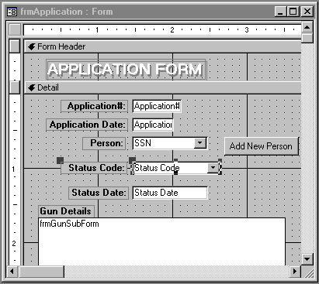

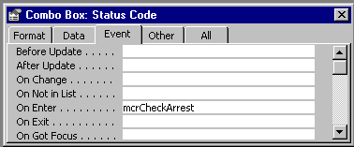

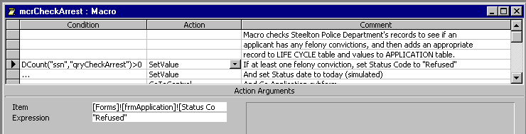

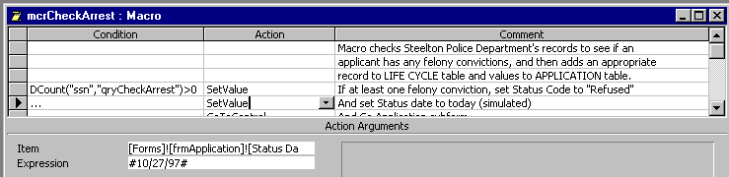

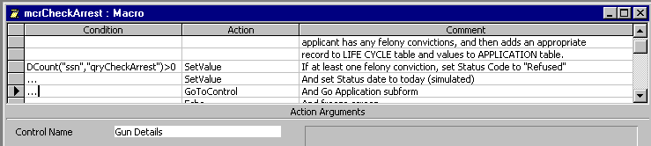

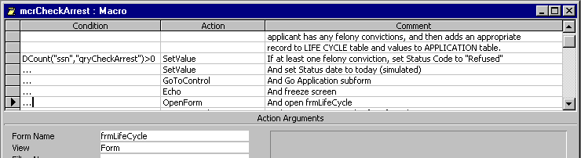

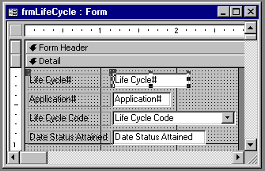

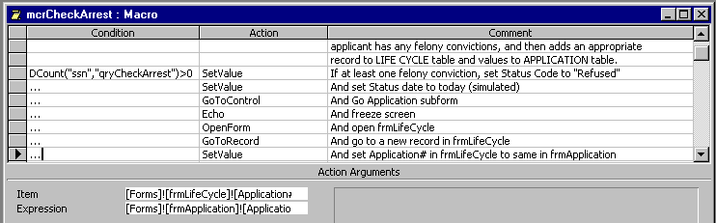

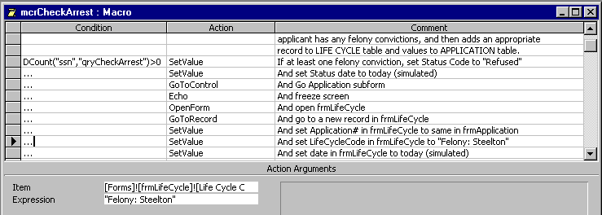

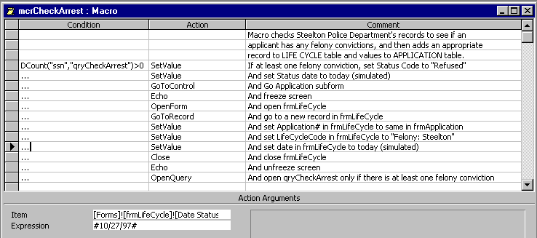

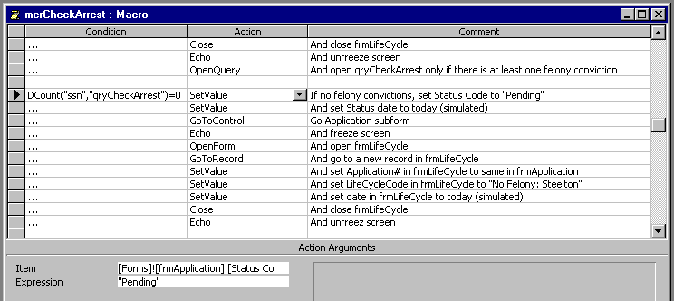

Now to process NCIC checks, we open frmNeedsProcessing, which is based on qryNeedsProcessing.

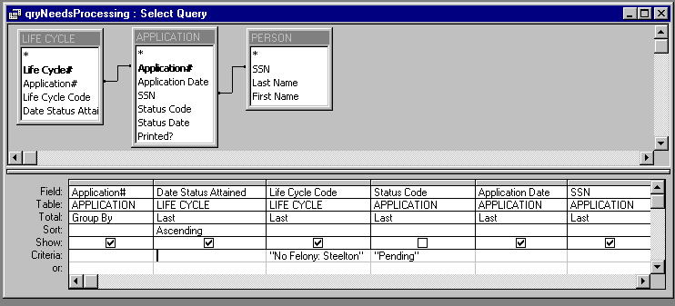

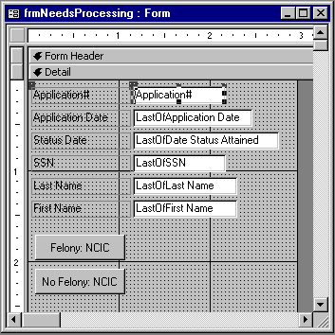

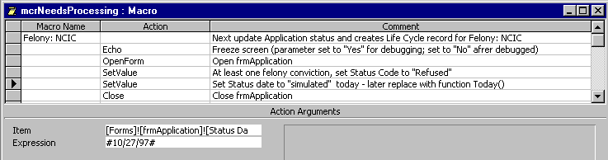

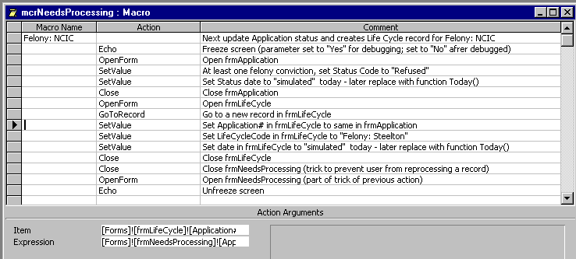

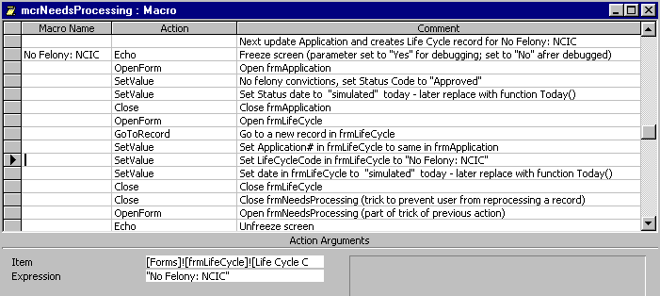

Finally, we need to print results.
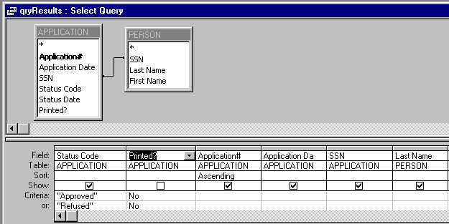

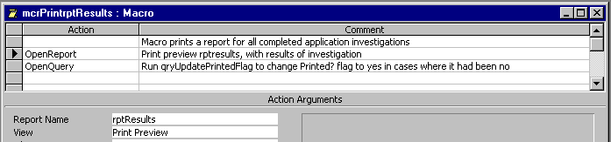

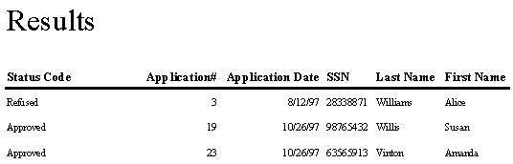

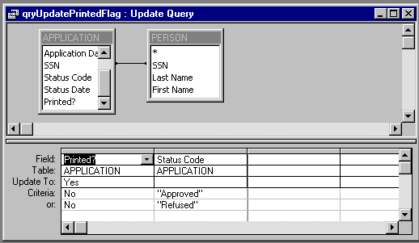

Switchboard Interface

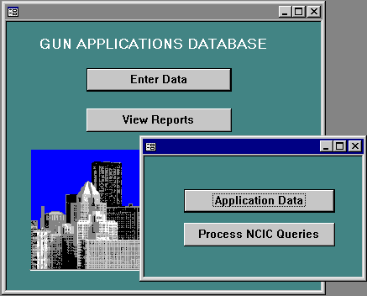
Open frmFormsSwitchboard
Open frmReportsSwitchboard
Run mcrOpenFrmApplication
Open FrmNeedsProcessing
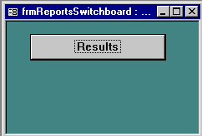
Run mcrPrintrptResults

