90-728 Management Information Systems
Homework #6, Fall 1999: Advanced Queries
Due: Tuesday, October 12, 1999 at 2 PM
[Midterm #1 will cover Problem 1 only]

- Job*Links Summary – 1

An employment and placing program called Job*Links trains clients for various professions and maintains a database for prospective employers. Data for Job*Links is contained in the database Workforce99.mdb. The entity-relationship diagram for Job*Links is represented in the Access Relationships window reproduced below.
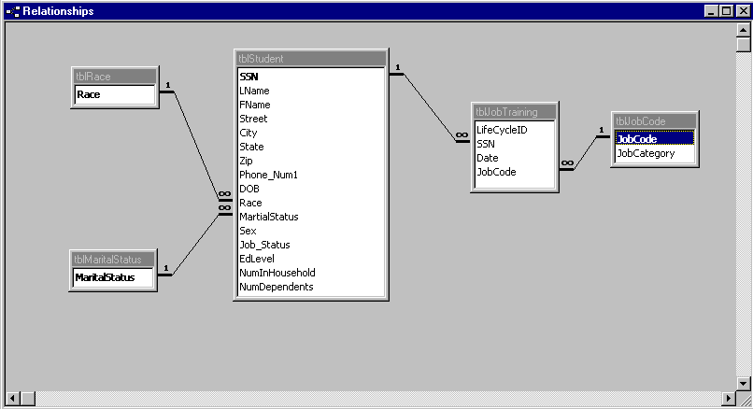

tblRace is a list of race/ethnicity categories for clients.
tblMaritalStatus is a list of marital status categories for clients.
tblStudent is a list of clients enrolled in the program.
tblJobTraining is a list of job titles for which clients have received training.
tblJobCode is a list of general job categories containing specific job titles.

In this question, we wish to summarize job training data across a number of tables.

- Create a view of historical job training data that contains the following fields: SSN, LName, FName, City, Date, JobCode, JobCategory. Order the output first by SSN and then by Date. Call this query qryJobTrainingView. Give the SQL code and the datasheet view of the output.

- (b) Using the query you created in (a), create a cross-tabulation query that contains a Row Heading corresponding to City, a Column Heading corresponding to Job Category and a Value field corresponding to the number of clients living in a specific City with training in a specific Job Category. Call this query qryJobTrainingCityCategoryXTab. Give the SQL code and the datasheet view of the output.

- Job*Links Summary – 2

In this question, we wish to summarize client descriptive data based in race/ethnicity and marital status.

For program reporting purposes, we wish to list the number of clients falling in certain categories defined by race/ethnicity and marital status. However, instead of simply summarizing all clients in tblStudent in various race/ethnicity and marital status categories as they appear in tblStudent, we wish to summarize all clients in tblStudent according to all possible race/ethnicity and marital status categories. That is, we want to capture data such as “no African-American students are divorced.”

- Create a list of all possible race/ethnicity – marital status combinations using a Cartesian Product query. Include a field called “Number” with a value of “0” (zero) for all race/ethnicity – marital status combinations. Call this query qryRaceMaritalStatusCP. Give the SQL code and the datasheet view of the output.

- Save the results in (a) in a new table called tblRaceMaritalStatus using a Make-Table query.

- Create a select query of the number of clients in various race/ethnicity – marital status combinations using tblStudent alone. Call the field representing counts of students NumActual. Call this summary query qryRaceMaritalStatusSum.

- Create an select query that replaces “0” (zero) values for the field “Number” in tblRaceMaritalStatus with the actual value for the corresponding race/ethnicity – marital status combination from qryRaceMaritalStatusSum. NOTE: you will have to redefine the field “Number” so that race/ethnicity – marital status combinations for which there are no students have the value “0” (zero) rather than Null (blank). Give the SQL code and the datasheet view of the output.

- Job*Links Summary – 3

Now we wish to characterize the family composition of program clients according to the gender and marital status of the household head.

- Create a select query that computes the average number of household members and the average number of dependents for each combination of Gender and Marital Status code appearing in tblStudent. Give the SQL code and the datasheet view of the output.

- What trends do you notice for male, single households as compared to female, single households? What might explain this trend?

- Job*Links Summary – 4 [Extra Credit]

Finally, we would like to summarize performance of the Job*Links program over the past eighteen or so months for which we have data. We will use the data ranges 1/1/98 – 6/30/98, 7/1/98 – 12/31/98, 1/1/99 – 6/30/99 and 7/1/99 – 12/31/99.

- Create a select query that assigns each record in tblJobTraining a unique code number corresponding to the date ranges defined above. HINT: use the “iif” and “between” commands. Call this query qryJobTrainingCodeAssign.

- Create a select query that counts the number of training outcomes in each date range for the query you created in (a). Call this query qryJobTrainingDateRangeSummary. HINT: for this summary query, should you summarize on the LifeCycleID field or the Date field? Give the SQL code and the datasheet view of the output.

