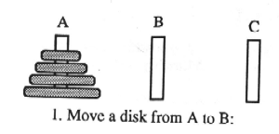

WM

(PEG ^NAME A ^DISK-LIST 1 2 3 4)
(PEG ^NAME B)
(PEG ^NAME C)
(GOAL ^DISK-NAME 1 ^SOURCE A ^DEST B)

WM

(PEG ^NAME A ^DISK-LIST 2 3 4)
(PEG ^NAME B ^DISK-LIST 1)
(PEG ^NAME C)
(GOAL ^DISK-NAME 2 ^SOURCE A ^DEST C)

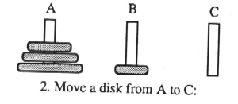

WM

(PEG ^NAME A ^DISK-LIST 3 4)
(PEG ^NAME B ^DISK-LIST 1)
(PEG ^NAME C ^DISK-LIST 2)
(GOAL ^DISK-NAME 1 ^SOURCE A ^DEST B)

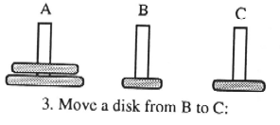
Structure of an OPS5 Program

Initialize Working Memory

(make start)

(make peg ^name A)

(make peg ^name B)

(make peg ^name C)

Object and Attribute Declarations

(literalize peg
name
disk-list)
(vector-attribute disk-list)

(literalize goal
disk-name
source
dest)

Productions

((p startup
(start)
→
(make peg ^name B)
(make peg ^name C)
(write |How many disks?|)
(bind <disk-no> (accept))
(make place-disk <disk-no>)
)

Productions

LHS (If…) (Then) RHS (Do…)

(p rule name
(condition element) → (action)
{<Element-Designator>
(condition) }
)

match against WM create WMEs
modify WMEs (change values)
remove WMEs
print output

Rule Base

(p startup
(start)
→
(make peg ^name B)
(make peg ^name C)
(write |How many disks?|)
(bind <disk-no> (accept))
(make place-disk <disk-no>)
)
.
.
(p place-disks
(place-disk ^number <num>)
→
do something…
)

WM

1: (START)
2: (PEG ^NAME A)

Rule Base

(p startup
(start)
→
(make peg ^name B)
(make peg ^name C)
(write |How many disks?|)
(bind <disk-no> (accept))
(make place-disk <disk-no>)
)
.
.
(p place-disks
(place-disk ^number <num>)
→
do something…
)

WM

1: (START)
2: (PEG ^NAME A)
3: (PEG ^NAME B)
4: (PEG ^NAME C)
5: (PLACE-DISK 3)

VARIABLE BINDING

(p assign-to-empty-room

{ <unplaced-student>
(student ^name <s-name> ^placed-in nil ^sex-is <gender> ^smoker? <s-pref> )
}

(room ^vacancies >0 ^sex-are <gender> ^smokers? <s-pref>)

{<empty-room>
(room ^number <rm-num> ^capacity <max> ^vacancies <max>
}

→

(modify <unplaced student> ^placed-in <rm-num>)
(modify <empty-room> ^occupants <s-name>
sexes-are <gender> ^smokers? <s-pref>
vacancies (compute <max> - 1) )

WM

41: (STUDENT ^NAME DAWN ^SEX-IS FEMALE ^PLACED-IN NIL
^SMOKER? YES)
55: (STUDENT ^NAME PETER ^SEX-IS MALE ^PLACED-IN NIL
^SMOKER? NO)
57: (STUDENT ^NAME WILMA ^SEX-IS FEMALE ^PLACED-IN 234
^SMOKER? YES)

9: (ROOM ^NUMBER 222 ^CAPACITY 3 ^VACANCY 3)
19: (ROOM ^NUMBER 333 ^CAPACITY 3 ^VACANCY 2
^SEXES-ARE MALE ^SMOKERS? NO ^OCCUPANTS JOHN)
22: (ROOM ^NUMBER 123 ^CAPACITY 1 ^VACANCY 1)

INSTANTIATIONS

ASSIGN-TO-EMPTY-ROOM 41 9
ASSIGN-TO-EMPTY-ROOM 41 22
ASSIGN-TO-EMPTY-ROOM 55 9
ASSIGN-TO-EMPTY-ROOM 55 22

Recognize-Act Cycle

