Doing secondary market research is an important part of entrepreneurship, since the results can help you evaluate and refine your business idea. A clear strategy for tunneling through the mountains of data available can help you figure out where to begin finding data relevant to your topic. This handout lists some online sources available through the Carnegie Mellon Libraries that should help you considerably in finding relevant information, as well as offers some advice for refining your searches.

Online Resources
Some very helpful sources available through Carnegie Mellon Libraries are:
Visit the CMU Libraries page at www.library.cmu.edu and look for
“Databases by Subject”
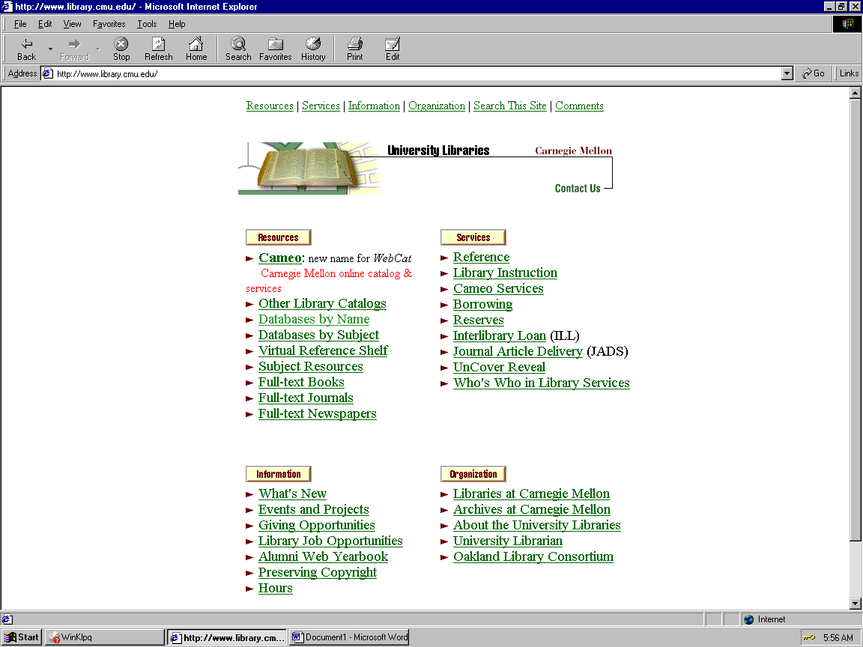
- Cameo, the Carnegie Mellon online catalog
- Online databases Lexis-Nexis, Proquest Direct, and Infotrac
- “Other Library Catalogs,” such as UPitt, the Carnegie Library, and WorldCat

One of the nicest things about these online sources is that you don’t have to physically be in the library to use them – as long as you’re on campus or connected through the CMU modem network, you should have no problems obtaining access to any of these sources. A word of caution - Proquest Direct only works well with Netscape; otherwise, all the other sources work just fine with either Netscape or Internet Explorer.

Keywords and Searches

First and foremost, before doing any online search, one should try to have a clear idea of what to tell the computer to look for. This may sound obvious, but keep in mind that online databases are generally not very intelligent. For example, if you’ve used a search engine on the Web such as Yahoo, think of the last time that you found exactly what you were looking for on the first try. So before you start, make a list of any key words and phrases you know that are specific to the industry you are interested in. Good keywords are words such as the standardized description of your industry, industry acronyms, brand names of competitors and their products, geographical locations, people, industry buzzwords – words or phrases that, particularly when they appear together, would likely appear in a relevant journal article or book.
For example, if my entrepreneurship project required me to do research on America Online, good keywords would be: America Online, Internet Service Provider, ISP, AOL, ICQ (a popular chat program they own), Earthlink and Mindspring (two of AOL’s competitors), Dulles, Virginia (their headquarter’s location), and so on.
As you learn more about your topic, keep adding to your keyword list, so that you can quickly do searches in the future, as well as think of new paths that might uncover more information. In addition, if you find a journal or book that seems to have good articles related to your topic, or references to a journal or book in a bibliography or list of sources, note that down as well. Also, don’t skip over information such as people or organizations cited in an article, or the author of an article – those names often help a great deal. Referencing those sources in the future, or using those sources as keywords in future searches, can often uncover more useful information.
To make the most of your searches, it is also worth taking the time to learn some of the more advanced features of the online databases or search engines you are using. Most online databases allow you to refine your searches using Boolean terms (such as AND, OR, and NOT) and wildcards, usually denoted by a star (so that a search for Mexic*, for example, would return both “Mexico” and “Mexican”). Usually these features are explained in the help section, and they really help a great deal in making your searches faster and more accurate.

Good luck, and happy hunting!

