Theory of zeta potential measurement
Paul J. Sides
Department of Chemical Engineering
Carnegie Mellon University

This document contains a description of the theory behind use of the rotating disk to generate a streaming potential. There are two major sections. In the first one, the theory of the parallel plate capillary is reviewed to provide background for understanding the rotating disk treatment. The second section contains the theory of the disk.

Theory of the parallel plate capillary
Understanding the theory of the parallel plate capillary is helpful for appreciating the somewhat more complicated theory underlying zeta potential measurement with the rotating disk; It is useful, therefore, to review the theory of the classical method for measuring zeta potential. The theory by which measured streaming potential measured in a parallel plate system is converted to zeta potential (neglecting surface conductivity) begins with the equation for flow between two parallel plates where the flow is one-dimensional and laminar. The velocity profile for fluid flow between two parallel plates separated by a distance h is
[1]
and y is a distance variable running from 0 to h. μ is liquid viscosity, ΔP is the pressure difference between outlet and inlet, and L is the length of the flow channel. The surface current is calculated in general by integrating the local velocity with the local unbalanced charge density, according to
[2]
Including both sides of the channel, one uses Poisson's equation and integrates by parts to find
. [3]
For a given value of z, the surface current depends on the pressure gradient, the gap h, and the reciprocal of viscosity. One calculates the total surface current by multiplying the expression for j_{s} by the width W of the cell, so that
[4]
Having an expression for the surface current, one must find next an expression for the potential distribution in the bulk electrolyte along which the streaming current is returned to close the circuit.
The equation expresses the relationship between the normally directed bulk current and the surface divergence of the surface current. Taking the divergence of the surface current, which is a constant, one finds that the normally directed bulk current is zero, which means that all gradients of potential normal to the surface vanish. The consequence of this result is that one is required to solve only a one-dimensional form of Laplace's equation for the electric potential in the bulk solution between the plates.
[5]
where f and g are constants to be determined. Taking φ to be zero when z = 0 at the inlet, one obtains the simple relationship that φ = g z. The total current flowing in the bulk solution parallel to the plates is given by ohm's law as
. [6]
One closes the problem by stating the conservation of charge for this system, I_{bulk} + I_{s} = 0. Inserting the results obtained above for the bulk and streaming currents into the charge conservation equation, one finds that
[7]
and hence the distribution of potential between the plates is given by
[8]
When z = L, one obtains an expression for the streaming potential measured by placing reference electrodes at either end of the flow channel.
. [9]
Again, note that this equation applies only when surface conductivity is negligible. The streaming potential is independent of the length of the channel L and its height h, as long as the length is much greater than the height. Measuring a streaming potential, one can invert this equation to find the zeta potential.

Theory of streaming potential in the vicinity of a rotating disk
A dielectric disk of radius a rotates in an infinite aqueous solution. Rotation of the disk generates radial flow with a velocity proportional to distance from the axis. Radial convection along the disk surface transports mobile ionic charge in the diffuse part of the electrical double layer, thereby creating a sheet of ionic current that flows both concentrically and radially outward along the disk surface. The convected radial current must return through the electrolyte to complete the circuit and conserve charge.
The radial surface current j_{sr} comprises current due to the imposed flow of electrolyte and current due to surface conductivity. In the case of the disk, the effect of surface conductivity is negligible. The derivation of the surface current begins with
[10]
where v_{r} is the local radial velocity and ρ_{e} is the charge density at any point in space. The radial velocity in the immediate vicinity of a rotating disk is given by
[11]
We use this equation, Poisson's equation, and integration by parts to calculate the integral appearing in eq. 10. Only the z component of Poisson's equation is included because the z variation of the electric field in the diffuse layer dominates the radial variation.
[12]
where ε is the dielectric constant, r is radial position, ζ is zeta potential, , Ω is the rotation rate in radians per second, and ν is the kinematic viscosity of the liquid. Here the electric field at infinity and the potential at infinity are both zero. Thus the surface current due to convection of charge in the diffuse layer is proportional to the radial position and to the rotation rate raised to the 3/2 power. The surface current flows radially outward along the disk surface and is contained within a few Debye lengths of the surface. The surface current density is positive for a negative zeta potential.
The streaming potential arises in the bulk electrolyte because this region conducts the radial surface current j_{sr} away from the periphery of the disk and returns it to the diffuse layer. The normal component of the current in the bulk solution at the disk's surface was derived from its relationship to the surface divergence of the surface current, i.e., i_{z} =-∇_{s} ⋅ j_{s} , yielding
i_{z}= 2 ε γ ζ. [13]
Equation 13 indicates that a uniform current density flows between the diffuse layer and the rest of the domain. When the surface current j_{sr} is positive (for negative ζ), the bulk current density to the disk given by eq 13 is negative; current flows toward the disk for 0 < r < a. In summary, a total surface current (for negative ζ ) of magnitude enters the bulk solution at the disk's periphery and returns via the bulk solution to the diffuse layer with a uniform current density i_{z} given by eq 13.
Deriving an expression for the overall electric potential distribution in the bulk solution is the remaining task. According to the mechanism described in the previous paragraph, the potential at an arbitrary location is a superposition of a potential arising from the uniform flow of current to the disk and from a ring source of current at the periphery of the disk. The equation expressing the potential on such a disk, when the current density is a constant equal to the result presented in eq 13, is
, [14]
where J_{i} represents Bessel functions; φ_{d} is the potential due to the disk; κ is the solution conductivity, and the overbars on r and z indicate that the coordinate is scaled by the disk radius, a.
The surface current leaving the disk is a ring source at radius a. Consider a flat ring of radius r' and thickness dr' centered about the axis in the plane of the disk; the ring is a source of current density i_{n} flowing into the semi-infinite domain below the disk. The contribution of this ring to the electric potential is
, [15]
in which K(m) is the complete elliptic integral of the first kind with
. [16]
The variable φ_{r} denotes the potential due to the ring, and the current density on the ring is i_{n} at r'. Here the ring is an infinitesimally thin source of current so that r' → a and i_{n}dr'→ -aεγζ. Furthermore, and . Equation 15 becomes
. [17]
Superimposing eqs 14 and 17, one obtains the overall potential distribution φ in the semi-infinite domain,

. [18]

Equation 18 permits calculation of the potential anywhere in the bulk electrolyte subject to several assumptions: (1) The domain is semi-infinite. (2) The spindle supporting and spinning the disk is taken as infinitesimally thin and frictionless with respect to the flow. (3) The plane z = 0 is a mirror plane, i.e., the upper surface of the disk is equivalent to the lower.
Equipotentials and current lines calculated with the aid of eq 18 appear in Fig. 2. The equipotentials correspond to constant values of κφ/aεγζ at intervals of 0.05. The zero of potential is the surface of rotation extending from r = 0.908a on the disk and flaring out to infinity. Potentials at radii smaller than the radius of this surface are positive, while potentials at radii larger than the radius of this surface are negative. The maximum potential is in the plane of the disk at the axis and the potential diverges to negative infinity in the plane of the disk at r = a where the ring source emits current to the bulk solution. The equipotentials are practically indistinguishable near the edge of the disk. Any two current lines enclose 4% of the total current. Streaming current emerges from the edge of the disk (r = a) and flows through the bulk solution back to the diffuse layer where it is distributed uniformly between r = 0 and r = a.
The potential distribution appearing in Fig. 2 leads to conclusions about placement of reference electrodes. Positioning one reference electrode at the axis near the disk takes advantage of the insensitivity of potential to radial position there. One must, however, know accurately the distance of the reference electrode from the disk for absolute calculation of zeta from measured streaming potentials. In the limit of small z, the streaming potential along the axis takes values approximately equal to
[19]
If one knows the distance between the reference electrode and the sample, this equation can be used to find the correct factor representing the streaming potential at the position of the reference electrode.
Placement of the other reference electrode near the disk at r = a is problematic because of the extreme gradients of potential. The best position for the second reference electrode is far from the disk where the potential is zero and not sensitive to position.

2a
ζ
2a
Figure 1. A rotating disk of diameter 2a in an infinite electrolytic solution. The lower surface of the disk has a zeta potential equal to ζ. (In the analysis it is also assumed that the upper surface has an equivalent ζ.)
0
0
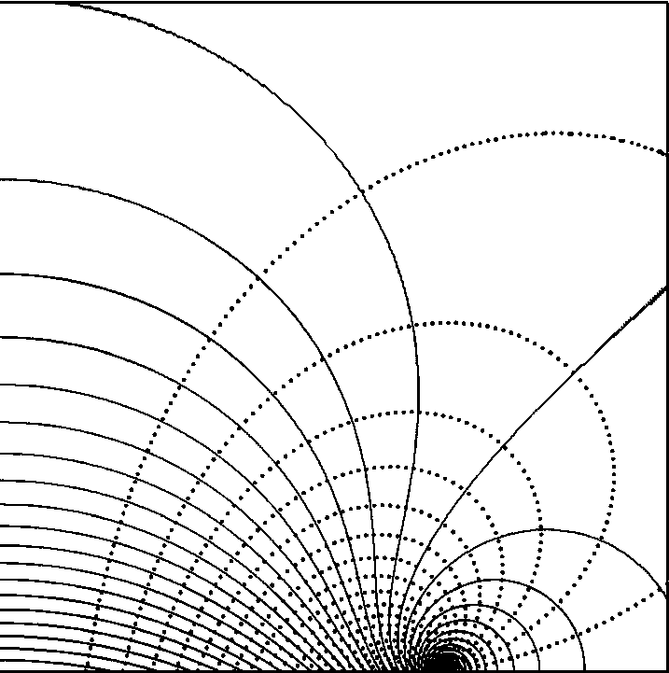
Figure 2. Streaming potential (solid lines) and lines of current (dotted) in the vicinity of the disk. The equipotentials represent constant values of κφ /aεγζ shown at intervals of 0.05. The zero of potential is the surface of rotation extending from 0.908 radii on the surface of the disk out to infinity. Values of κφ /aεγζ at radii smaller than the zero of potential are positive, while this quantity at radii larger than the zero of potential is negative. 4% of the total current flows between each line of current.

(a)
(b)
Figure 3. The dependence of the streaming potential on position with respect to the disk. (a) radial position dependence at constant axial distance in the plane of the disk (z = 0) for the present calculation (solid line) and the previous calculation^{1,2} (dotted line). (b) axial position dependence from the center of the disk. Comparison of the present result with the prior calculation demonstrates the origin of a factor of 2.33 discrepancy on the axis of the disk even though the profiles both cross zero and go through a minimum near the edge of the disk. The streaming potential on the edge of the disk in the present calculation goes to negative infinity compared to a finite value in the previous calculation.

