24-451 | Feedback Control Systems | Fall 2000

Quizz #1

- (20 points.) Use the differentiation theorem for Laplace transforms to derive the expression for F(s)=L[cosh(t)]. Note that the hyperbolic cosine and sine functions have the following properties:
$\text{cosh}(0)=1$, $\text{sinh}(0)=0$, $\frac{d}{\text{dt}}\text{cosh}(t)=\text{sinh}(t)$, and $\frac{d}{\text{dt}}\text{sinh}(t)=\frac{d^{2}}{{\text{dt}}^{2}}\text{cosh}(t)=\text{cosh}(t)$.
- Consider the op-amp circuit shown below.
  - (20 points.) Show that the transfer function for the circuit can be written in the form
$\frac{V_{o}(s)}{V_{i}(s)}=K_{P}+\frac{K_{I}}{s}+K_{D}s$,
and determine K_{P}, K_{I} and K_{D} in terms of R₁, R₂, C₁ and C₂.
  - (10 points.) Can the transfer function $\frac{V_{o}(s)}{V_{i}(s)}=−\frac{s^{2}+s+1}{s}$ be implemented with this circuit with practically realizable resistance and capacitance values? Hint: look at the zeros of the transfer function.
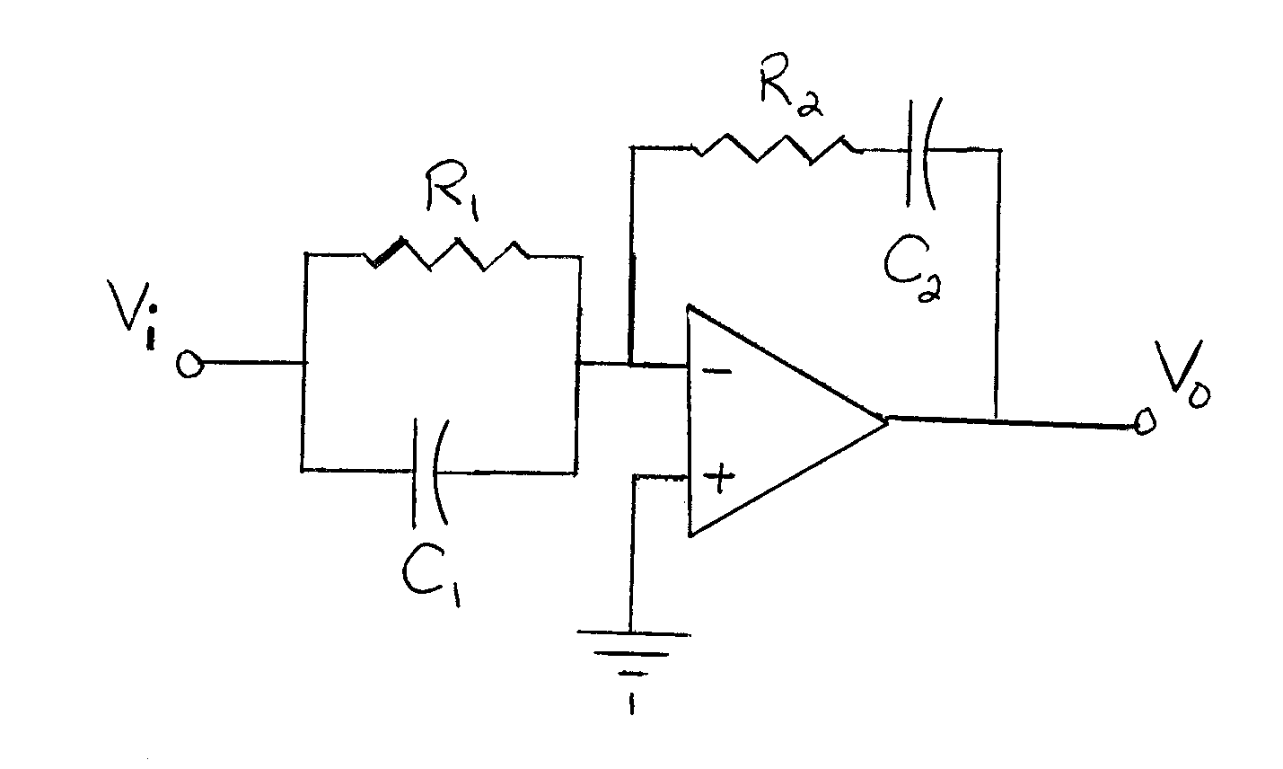
- Consider the translational mechanical system shown below. A mass M=1 is supported on the frictionless surface of a cart. In addition, the mass is attached to a spring K=2 and a damper D=3, which in turn are attached to the cart.
  - (25 points.) Determine the transfer function from the cart displacement R(s) to the mass displacement Y(s). Both displacements are relative to the stationary ground.
  - (25 points.) From the transfer function, compute the time response y(t) for a unit step input r(t)=u(t) (assuming zero initial conditions).
