24-451 | Feedback Control Systems | Fall 2000

Midterm Exam

- The figure below illustrates the automatic breaking control of a train, where U_{r}(s)=L[u_{r}(t)], V(s)=L[v(t)], u_{r} is the input voltage representing a desired train speed, and v is the actual train speed,. The amplifier gain is K=100, and the tachometer (velocity sensor) constant is K_{g}=0.15.
  - (10 points.) Suppose that the braking action can be modeled by a transfer function of the form $G_{B}=\frac{F(s)}{E_{B}(s)}=\frac{C}{s+a}$, where E_{B}(s)=L[e_{B}(t)], F(s)=L[f(t)], e_{B}(t) is the braking input and f(t) is the resulting braking force. If f(t)=100(1-e^{-10t}) is measured with e_{B}=u(t) (the unit step function), determine the constants a and C.
  - (10 points.) The train has mass M=5×10⁴ and is assumed to be subjected to no other force than the braking force. What is the transfer function for the train, $G_{T}=\frac{V(s)}{F(s)}$?
  - (10 points.) Determine the closed-loop transfer function $T_{\text{cl}}=\frac{V(s)}{U_{r}(s)}$.
  - (10 points.) Let the input voltage be a step function u_{r}(t)=Au(t). Determine the value of A if the steady state speed of the train (i.e., at time t → ∞) is to be maintained at 20. (Hint: use the Final Value Theorem of Laplace transforms.)
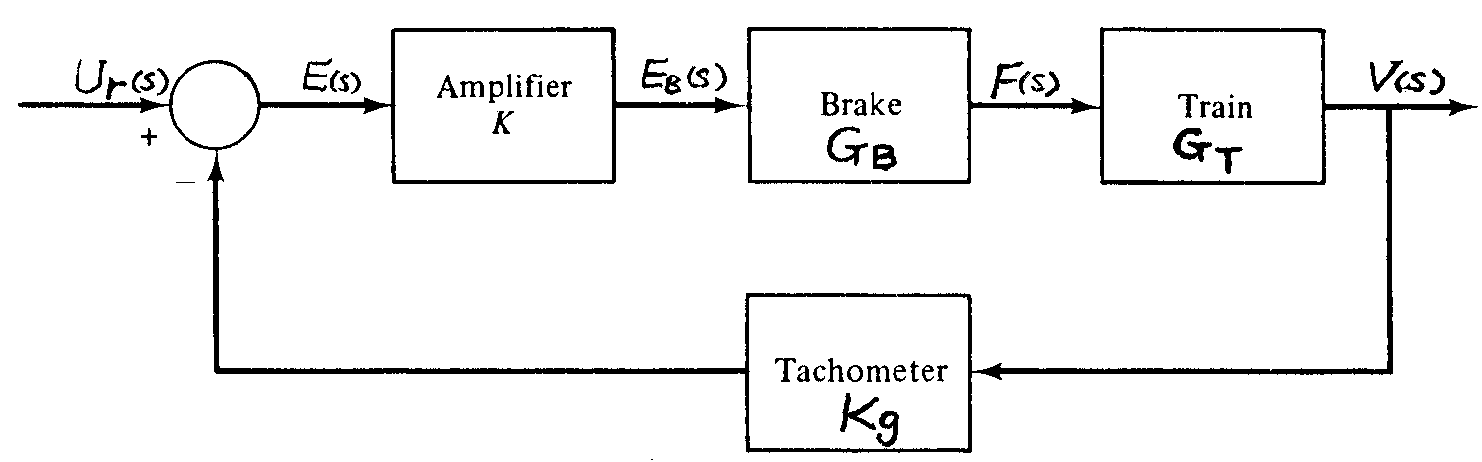
- Servomotor control systems often involve mechanical loads exhibiting significant elastic deformations. As shown in the figure below, the armature of a servomotor has resistance R with negligible inductance, torque constant K_{τ}, and back emf constant K_{b}. (The field circuit for the motor is not shown.) The motor’s rotor, with moment of inertia J_{m}, is connected to a disc of inertia J by a shaft, which is equivalent to a torsional spring K.
  - (20 points.) First consider the mechanical component of this electromechanical system and denote by τ(t) the torque generated from the armature current. Derive the equations of motion for the motor’s rotor and the load disc (in either time domain or Laplace transform domain).
  - (20 points.) Let Θ₁(s)=L[θ₁(t)], Θ₂(s)=L[θ₂(t)], and T(s)=L[τ(t)]. The equations of motion (in the Laplace transform domain) of the rotor and the load disc have a solution of the form Θ₁(s)= G₁(s)T(s) and Θ₂(s)= G₂(s)T(s). Obtain an expression for G₁(s) and G₂(s).
  - (20 points.) Consider the system’s mechancal/electrical componenets together. Determine the transfer function $G=\frac{Θ_{2}(s)}{E_{a}(s)}$, where E_{a}(s)=L[e_{a}(t)], in terms of system parameters as well as G₁(s) and G₂(s).
