24-451 | Feedback Control Systems | Fall 2000

Final Exam
December 15, 2000; 120 Minutes; 100 Points Full Score

Name____________________________ | Score____________________________

- Repetitive Control refers to a class of control methods used to compensate for periodic disturbances or periodic reference inputs. One such system is shown below.

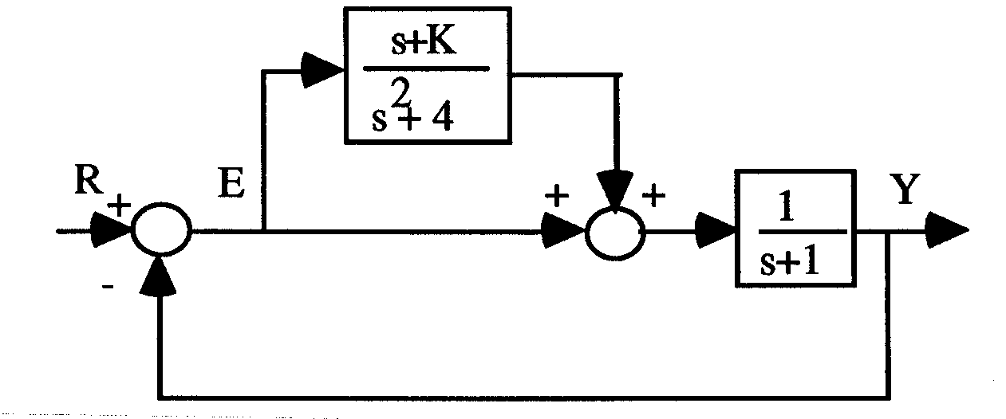
  - (10 points.) Find the input-to-output transfer function $T(s)=\frac{Y(s)}{R(s)}$.
  - (10 points.) Find the input-to-error transfer function $T_{E}(s)=\frac{E(s)}{R(s)}$.
  - (10 points.) Assuming the closed-loop system is stable, show that the steady-state error, $e_{\text{ss}}=\underset{t→∞}{\text{lim}}e(t)$, is zero, if $R(s)=\frac{\text{as}+b}{s^{2}+2^{2}}$, i.e., the reference input is a sinusoid with frequency 2.
  - (20 points.) Determine for what values of K the feedback system is stable. Note that K is not a gain here and in general can be positive, zero, or negative.
- A motor speed control system with PI control is depicted in the block diagram form below. Before the controller was added and the loop was closed, the time response was recorded for a step input of magnitude 0.2 V to the motor-tach system.
  - (10 points.) Determine the parameters τ and K_{m} from the recorded time response as shown on next page. To read the data shown, 0.01 s is an acceptable accuracy for time and 0.5 V is an acceptable accuracy for voltage.
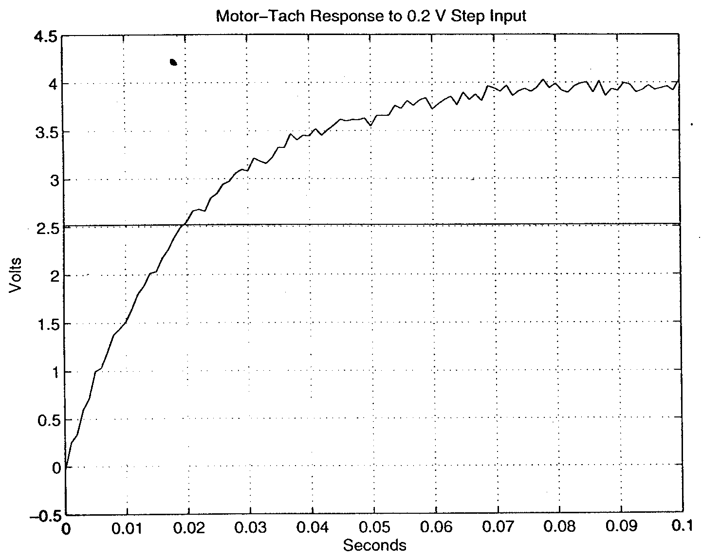
  - (10 points.) Determine the desired closed-loop poles that achieve a damping ratio of 0.707 and a settling time of 0.02 second.
  - (10 points.) Using the angle criterion, determine the location of the controller zero (i.e. the value of a) to obtain the desired closed-loop poles.
  - (5 points.) Determine the gain K to obtain the desired closed-loop poles.
  - (10 points.) Sketch the root locus using the axes provided below. Indicate any open-loop poles and zeros, along with the closed-loop poles obtained in step b, in your sketch. You do not need to calculate the breakaway and break-in points in this step.
  - (5 points.) Calculate the real-axis breakaway and break-in points of the root locus.
