24-451 | Feedback Control Systems | Fall 2000

Homework #9 Solutions

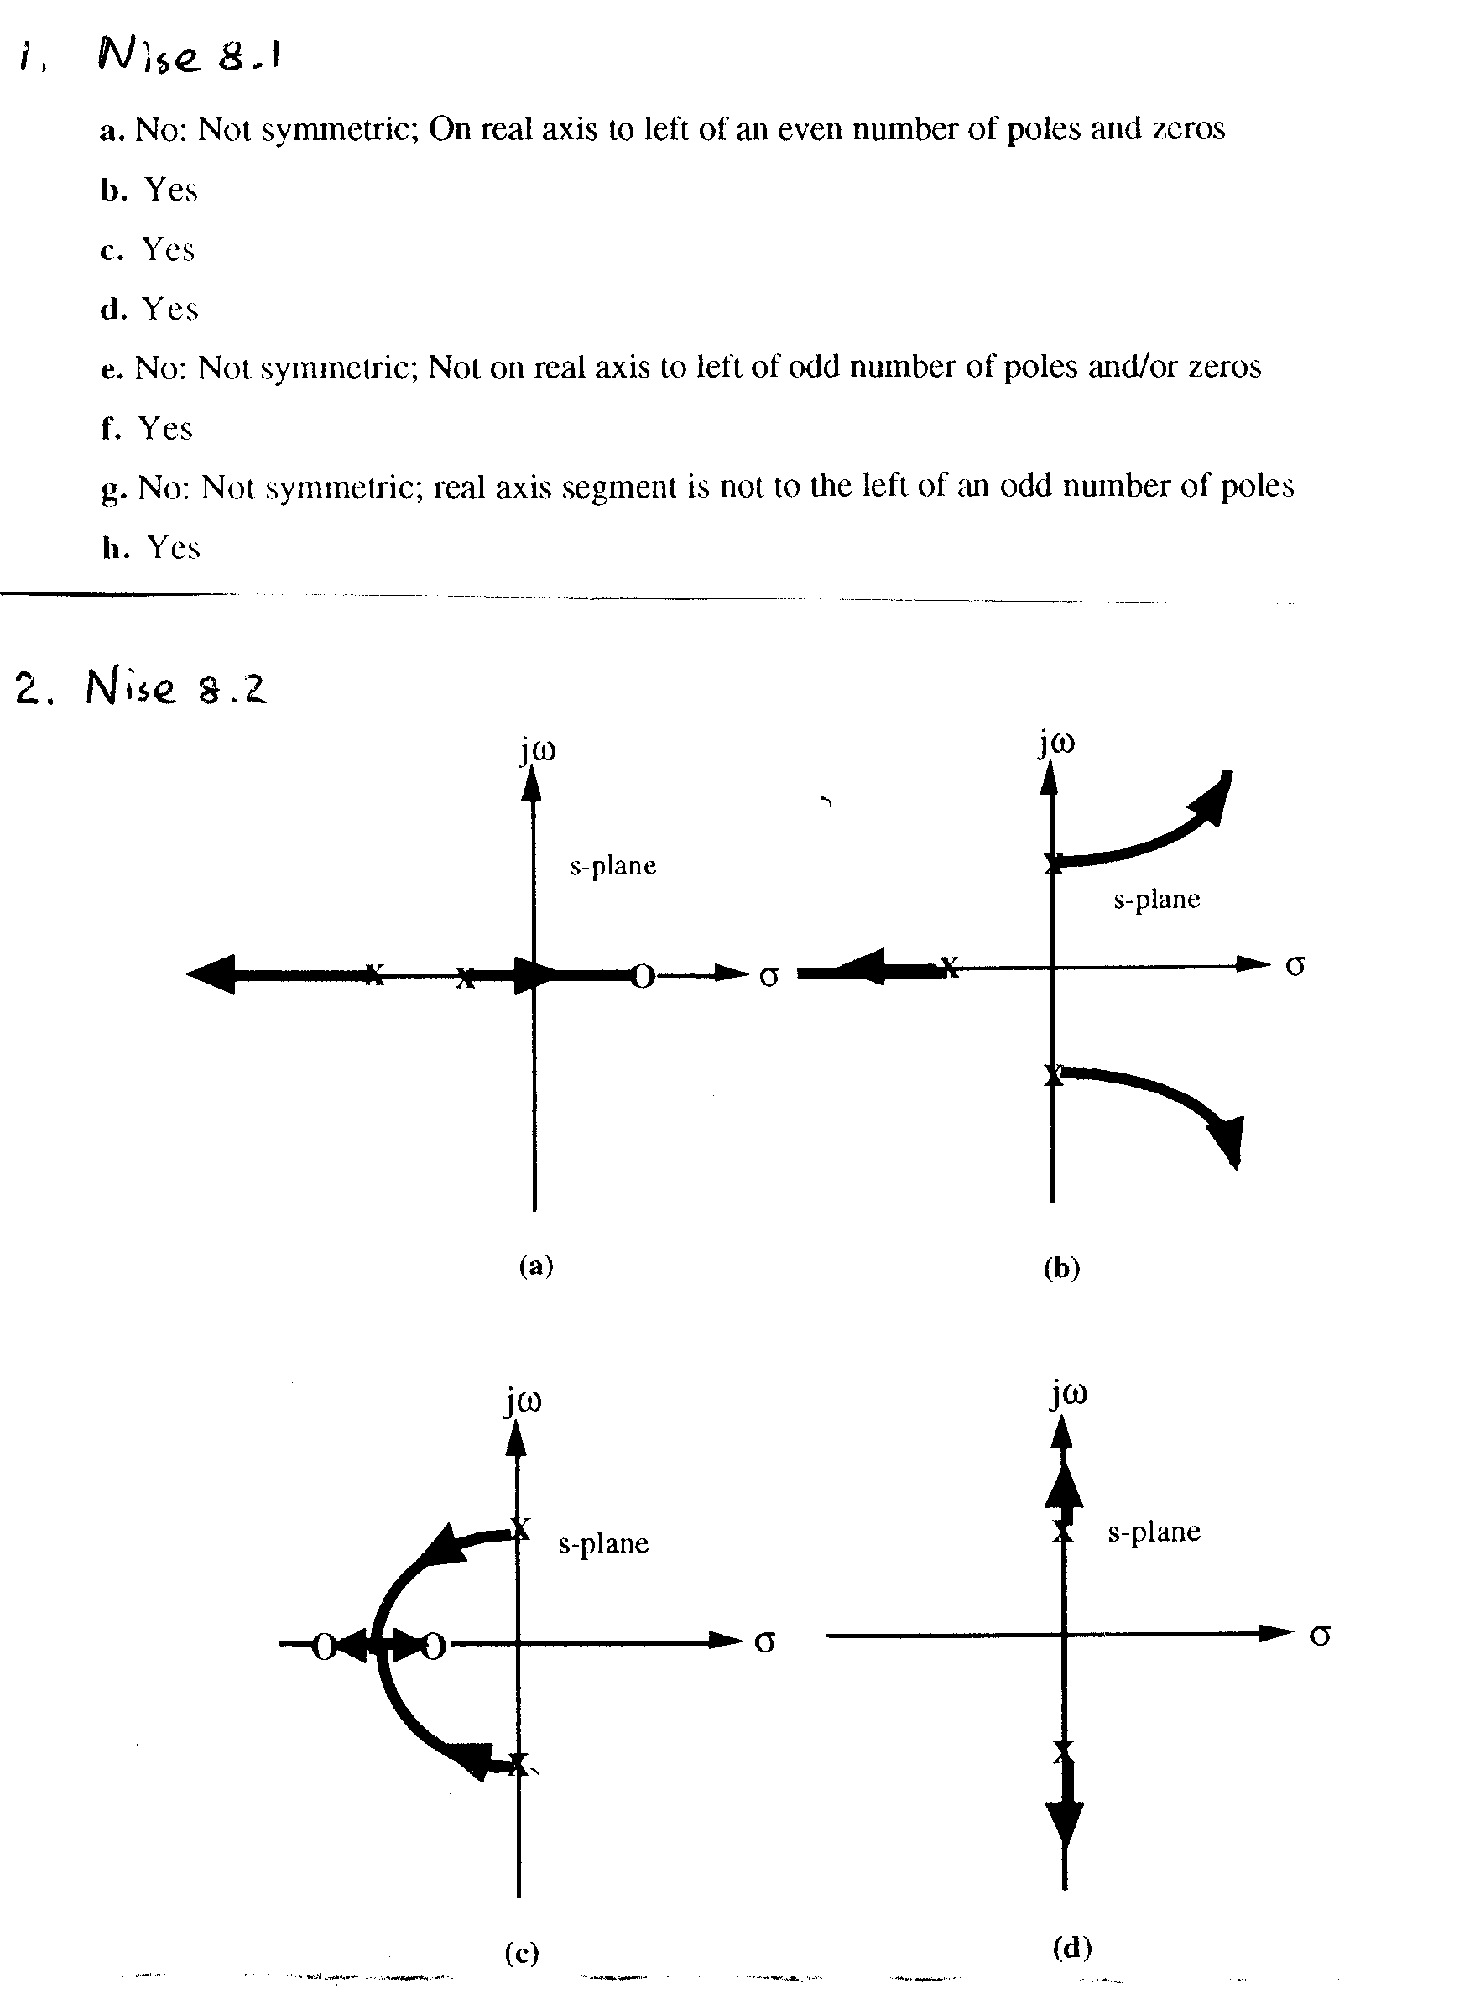
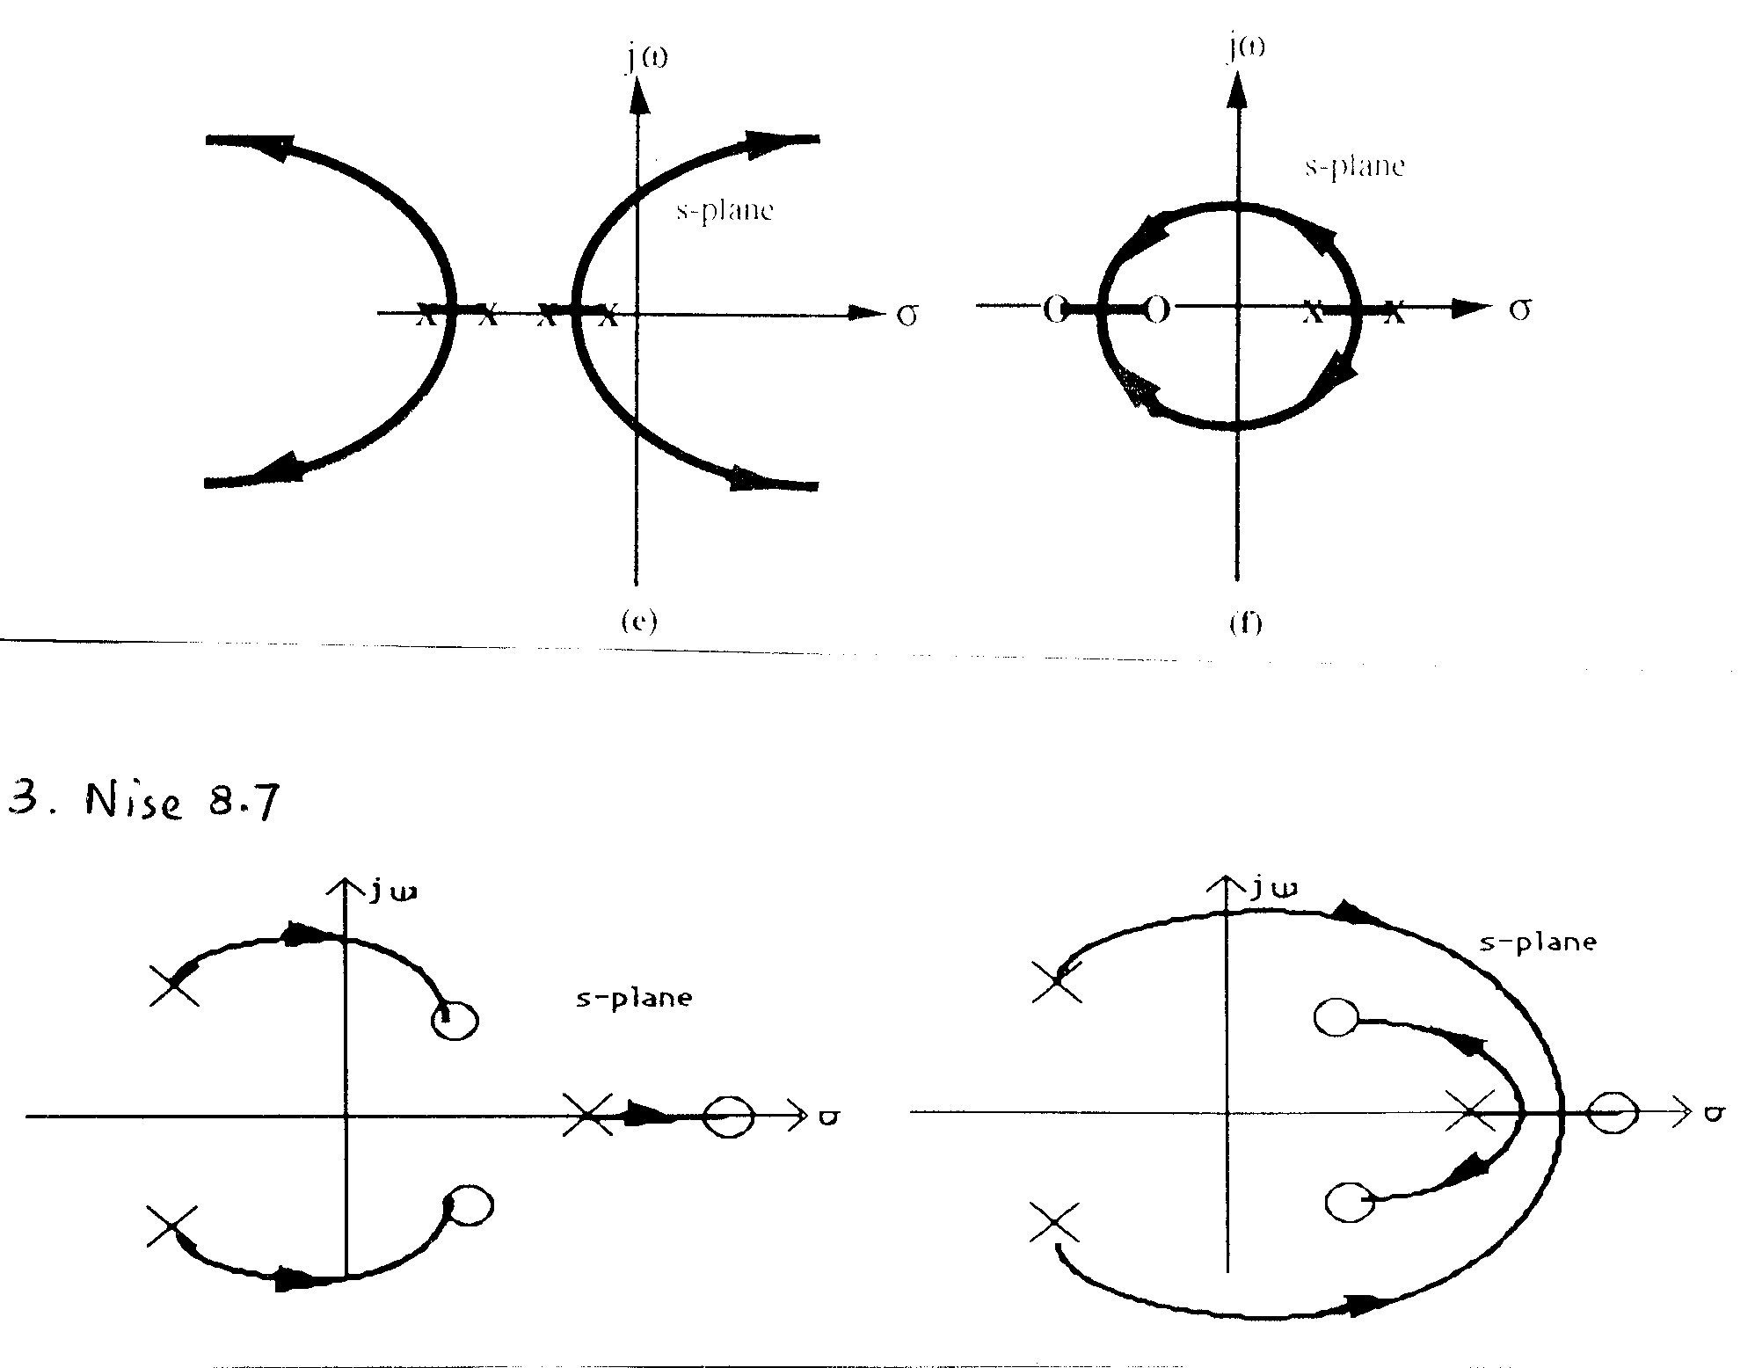
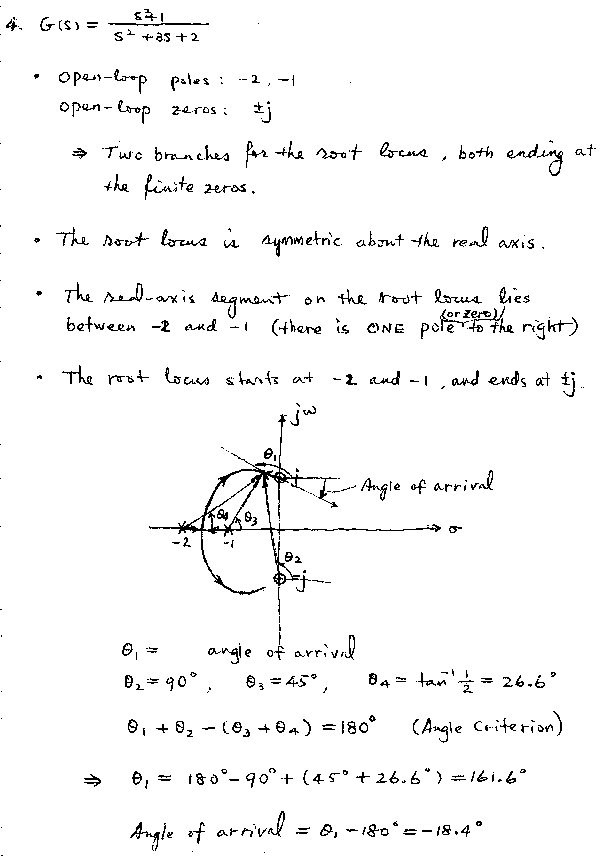
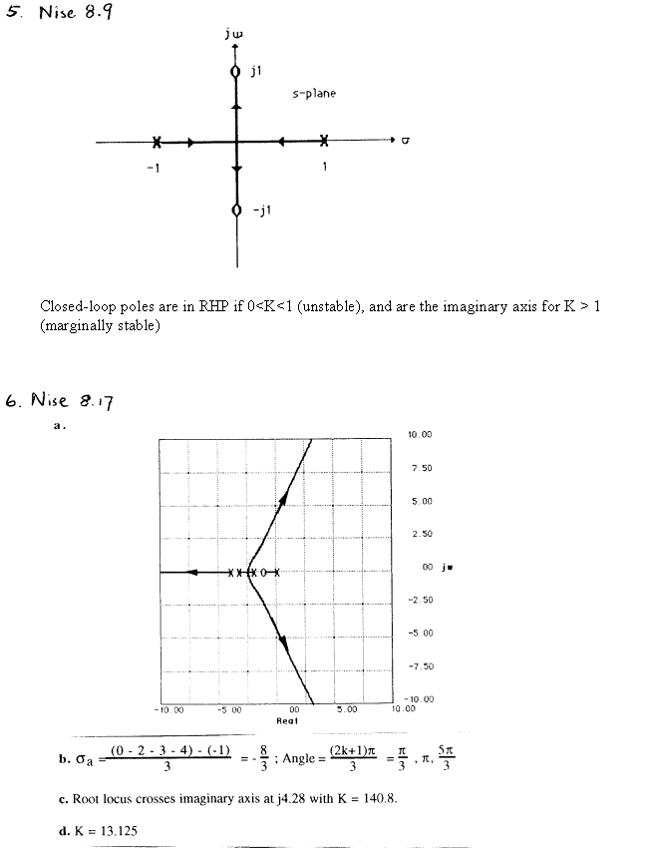

An Additional Example: Sketching the Root Locus and Computing the Angle of Departure

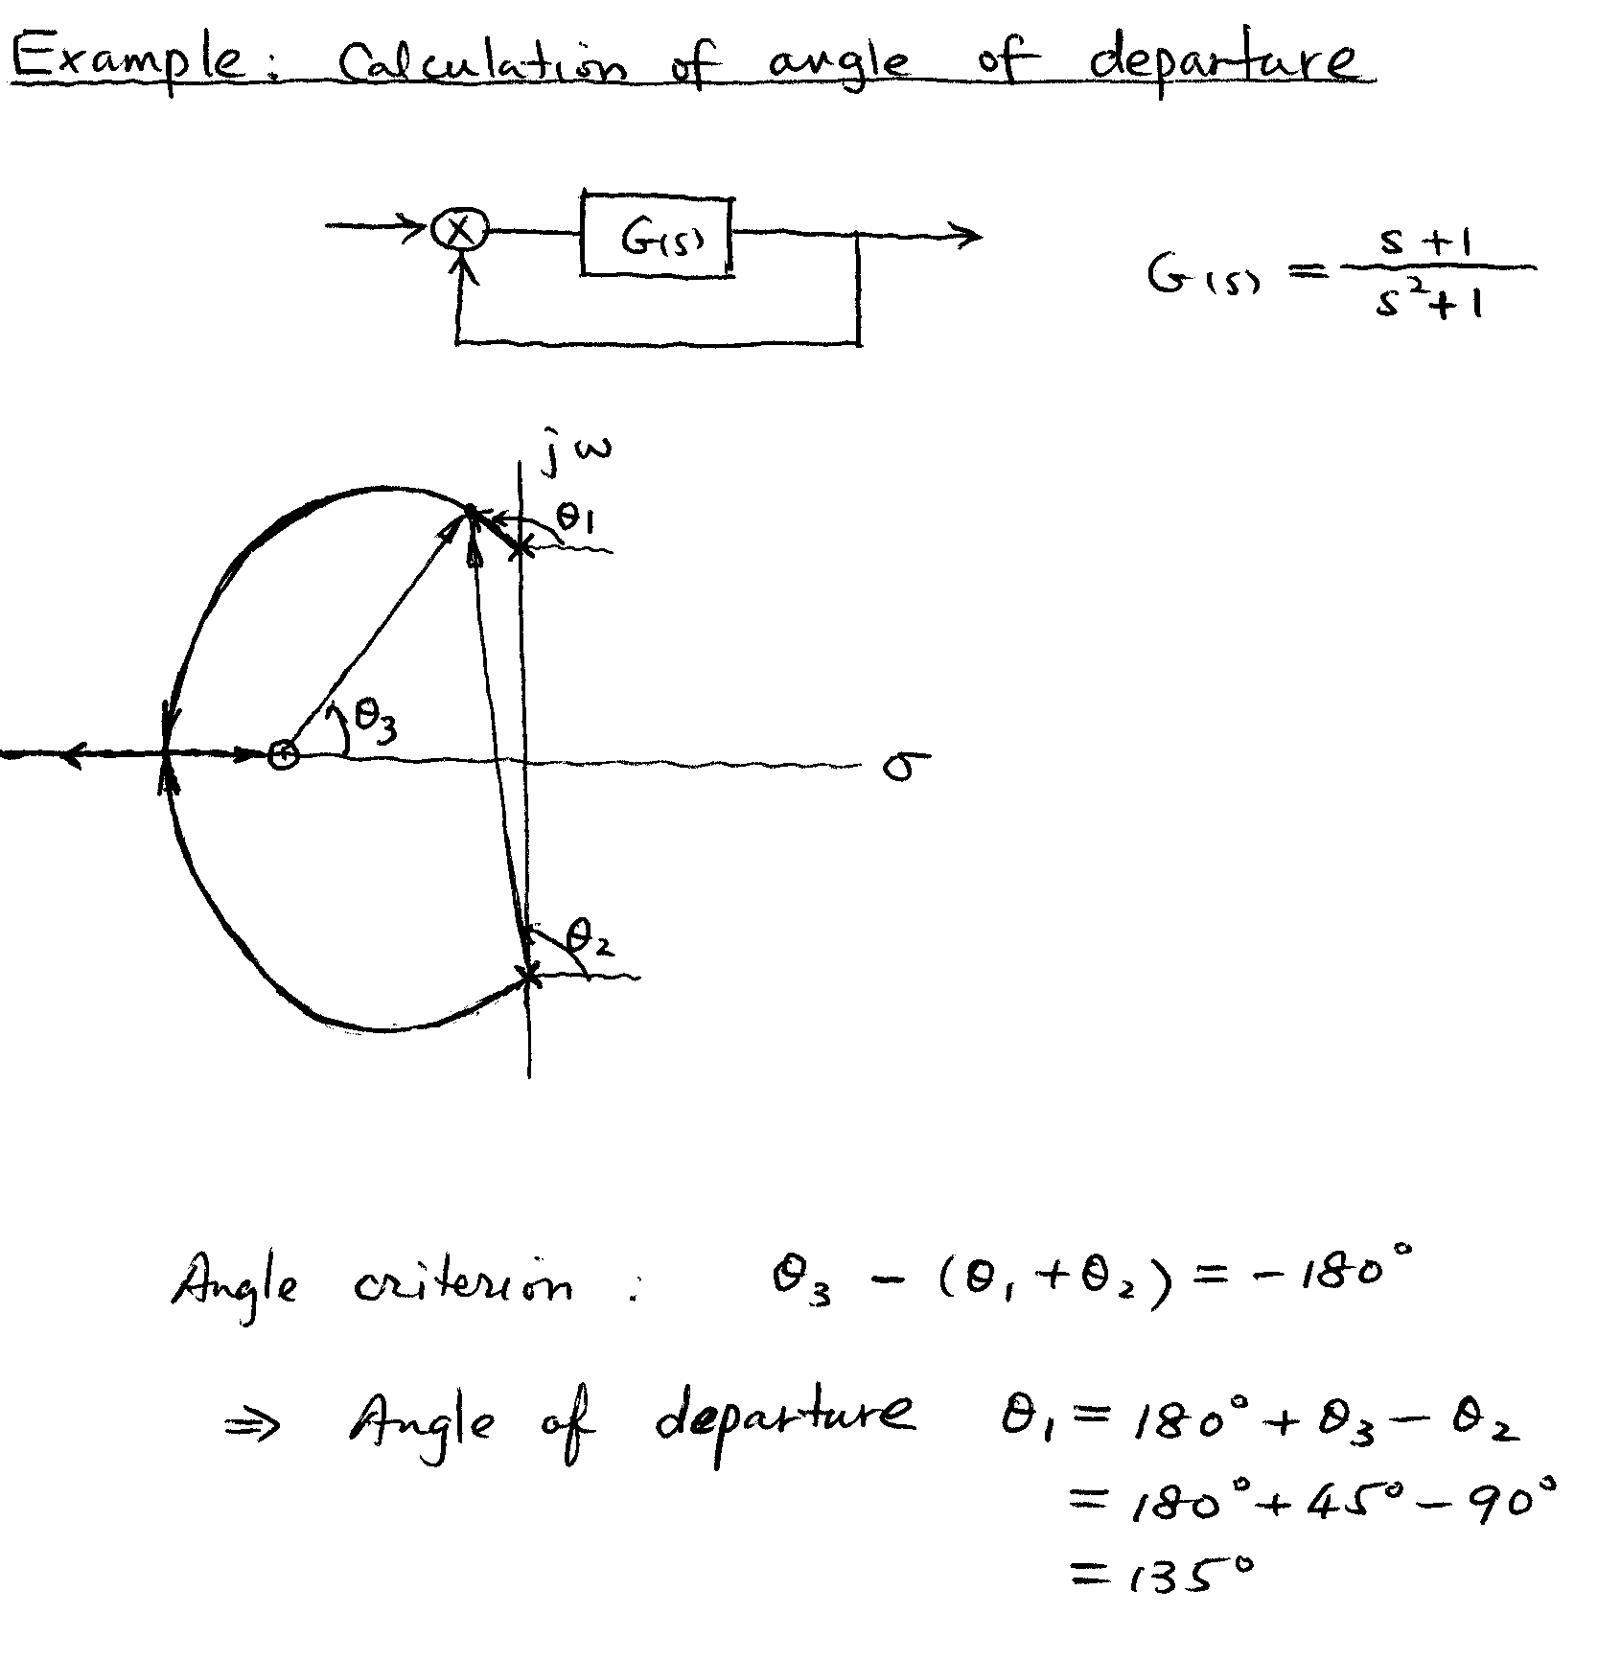
MATLAB root locus plots:

Problem. 4.
» rlocus([1 0 1],[1 3 2])
»

Problem 5.
» rlocus([1 0 1],[1 0 -1])
»
Problem 6.
» num=[1 1];
» den=conv([1 0],conv([1 2],conv([1 3],[1 4])))

den =

1 9 26 24 0

» rlocus(num,den)
»

