24-451 | Feedback Control Systems | Fall 2000

Homework #2 Solutions

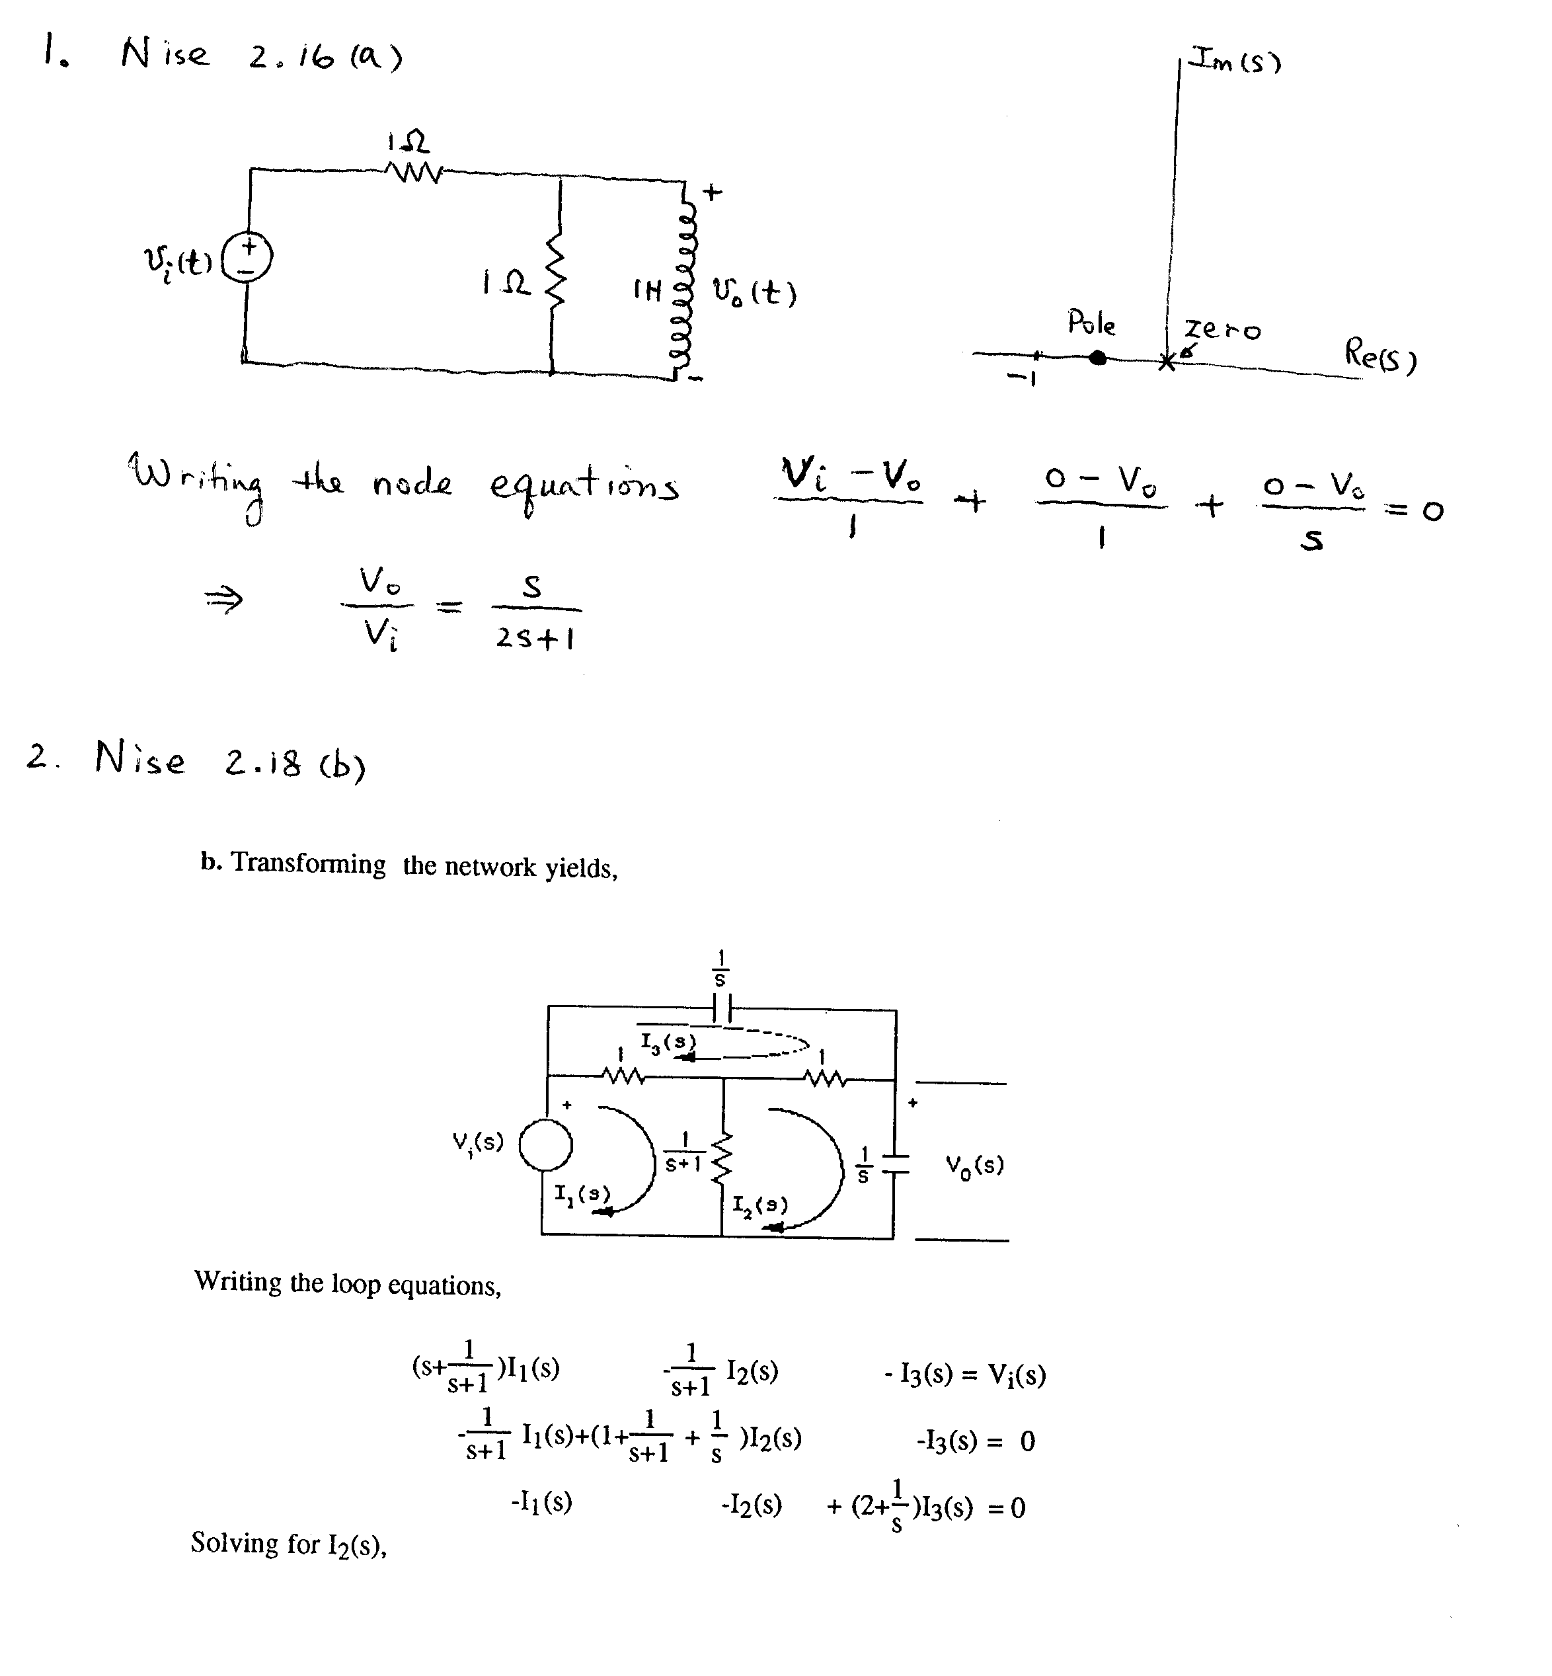

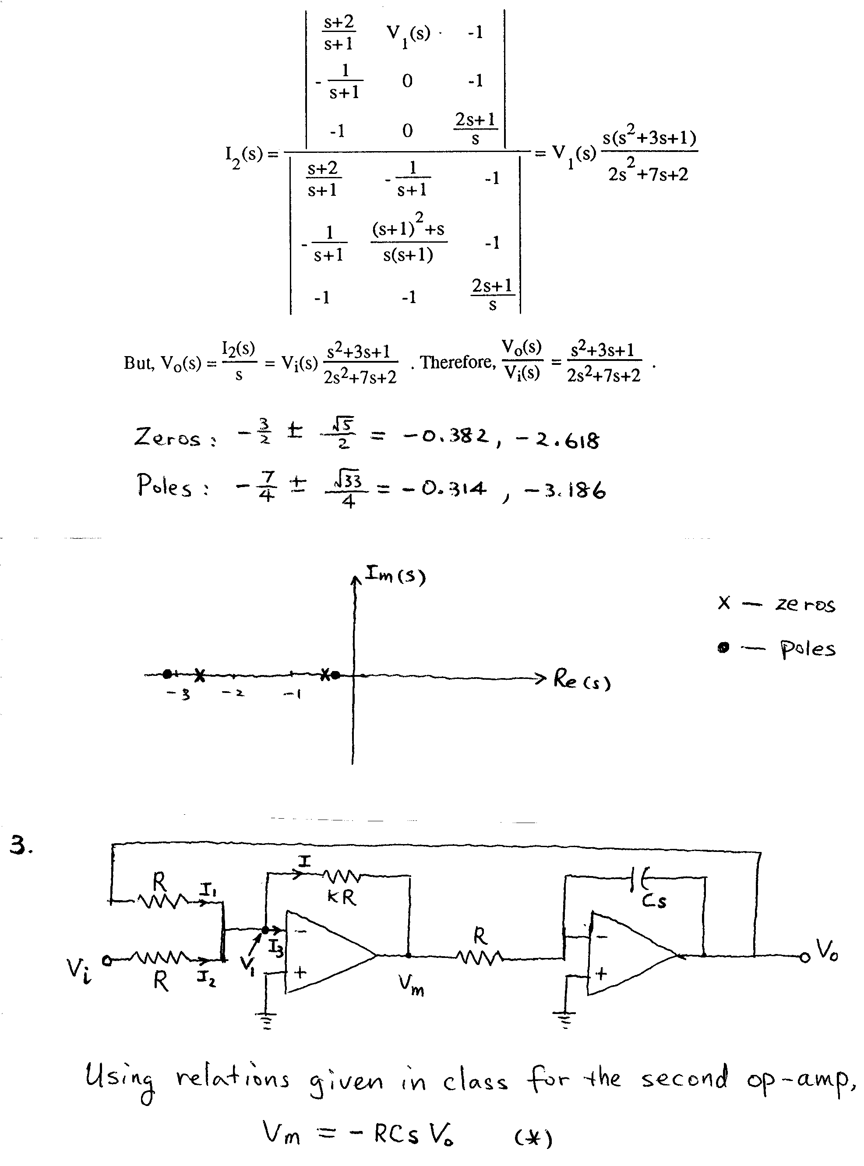

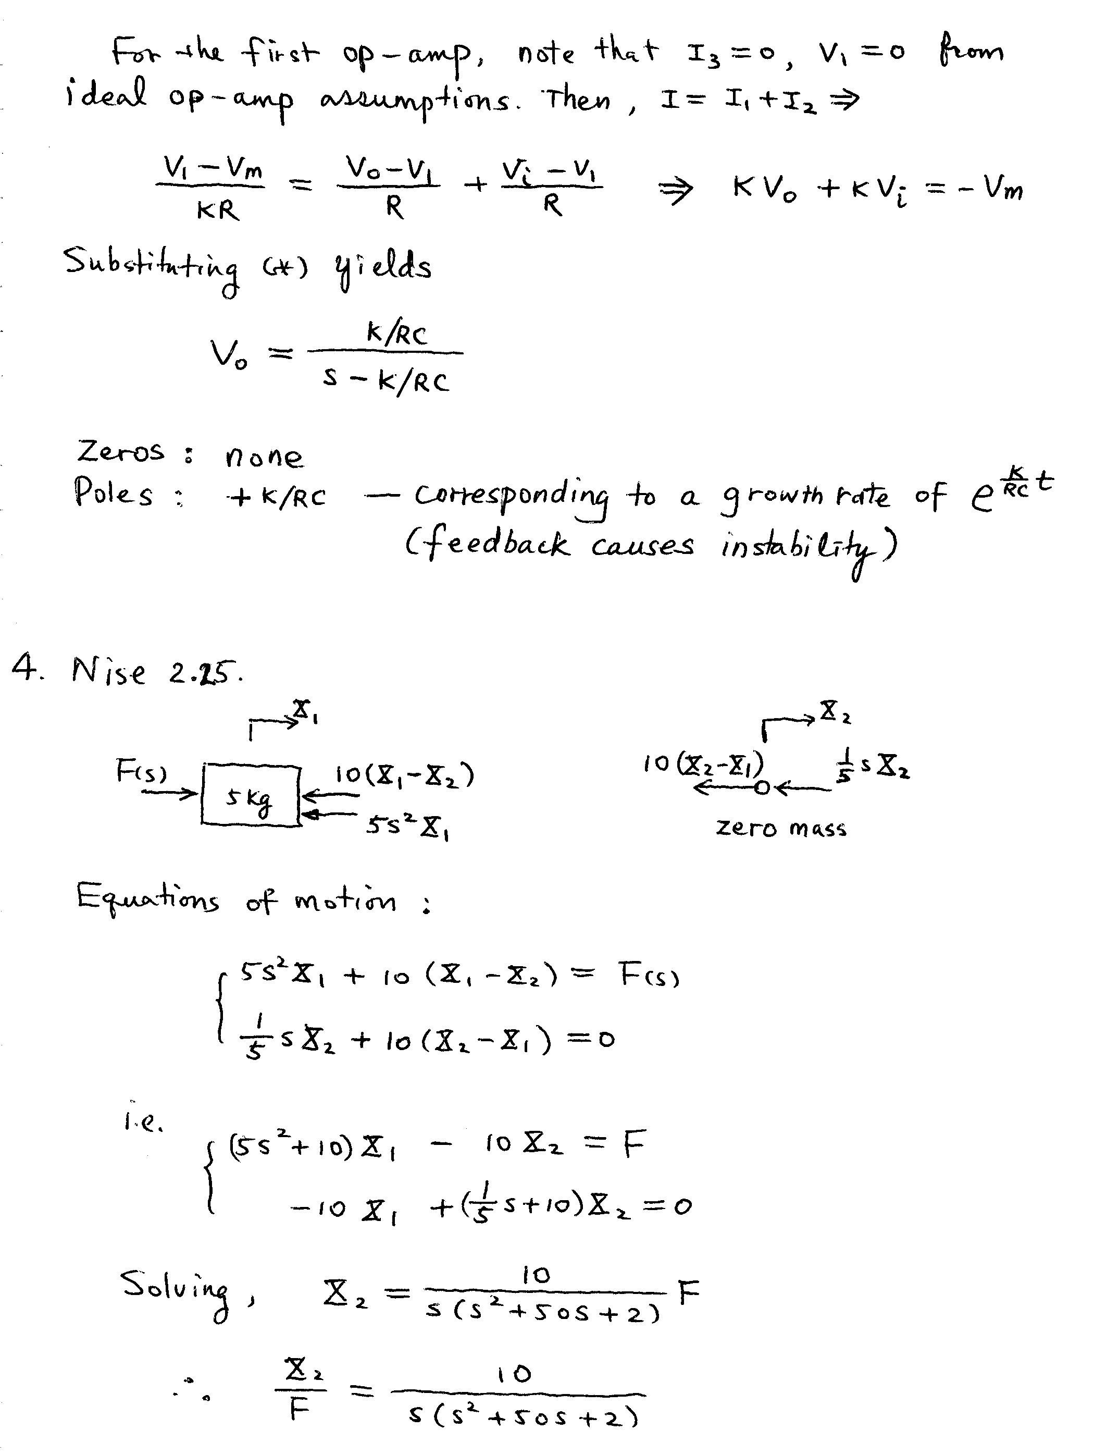
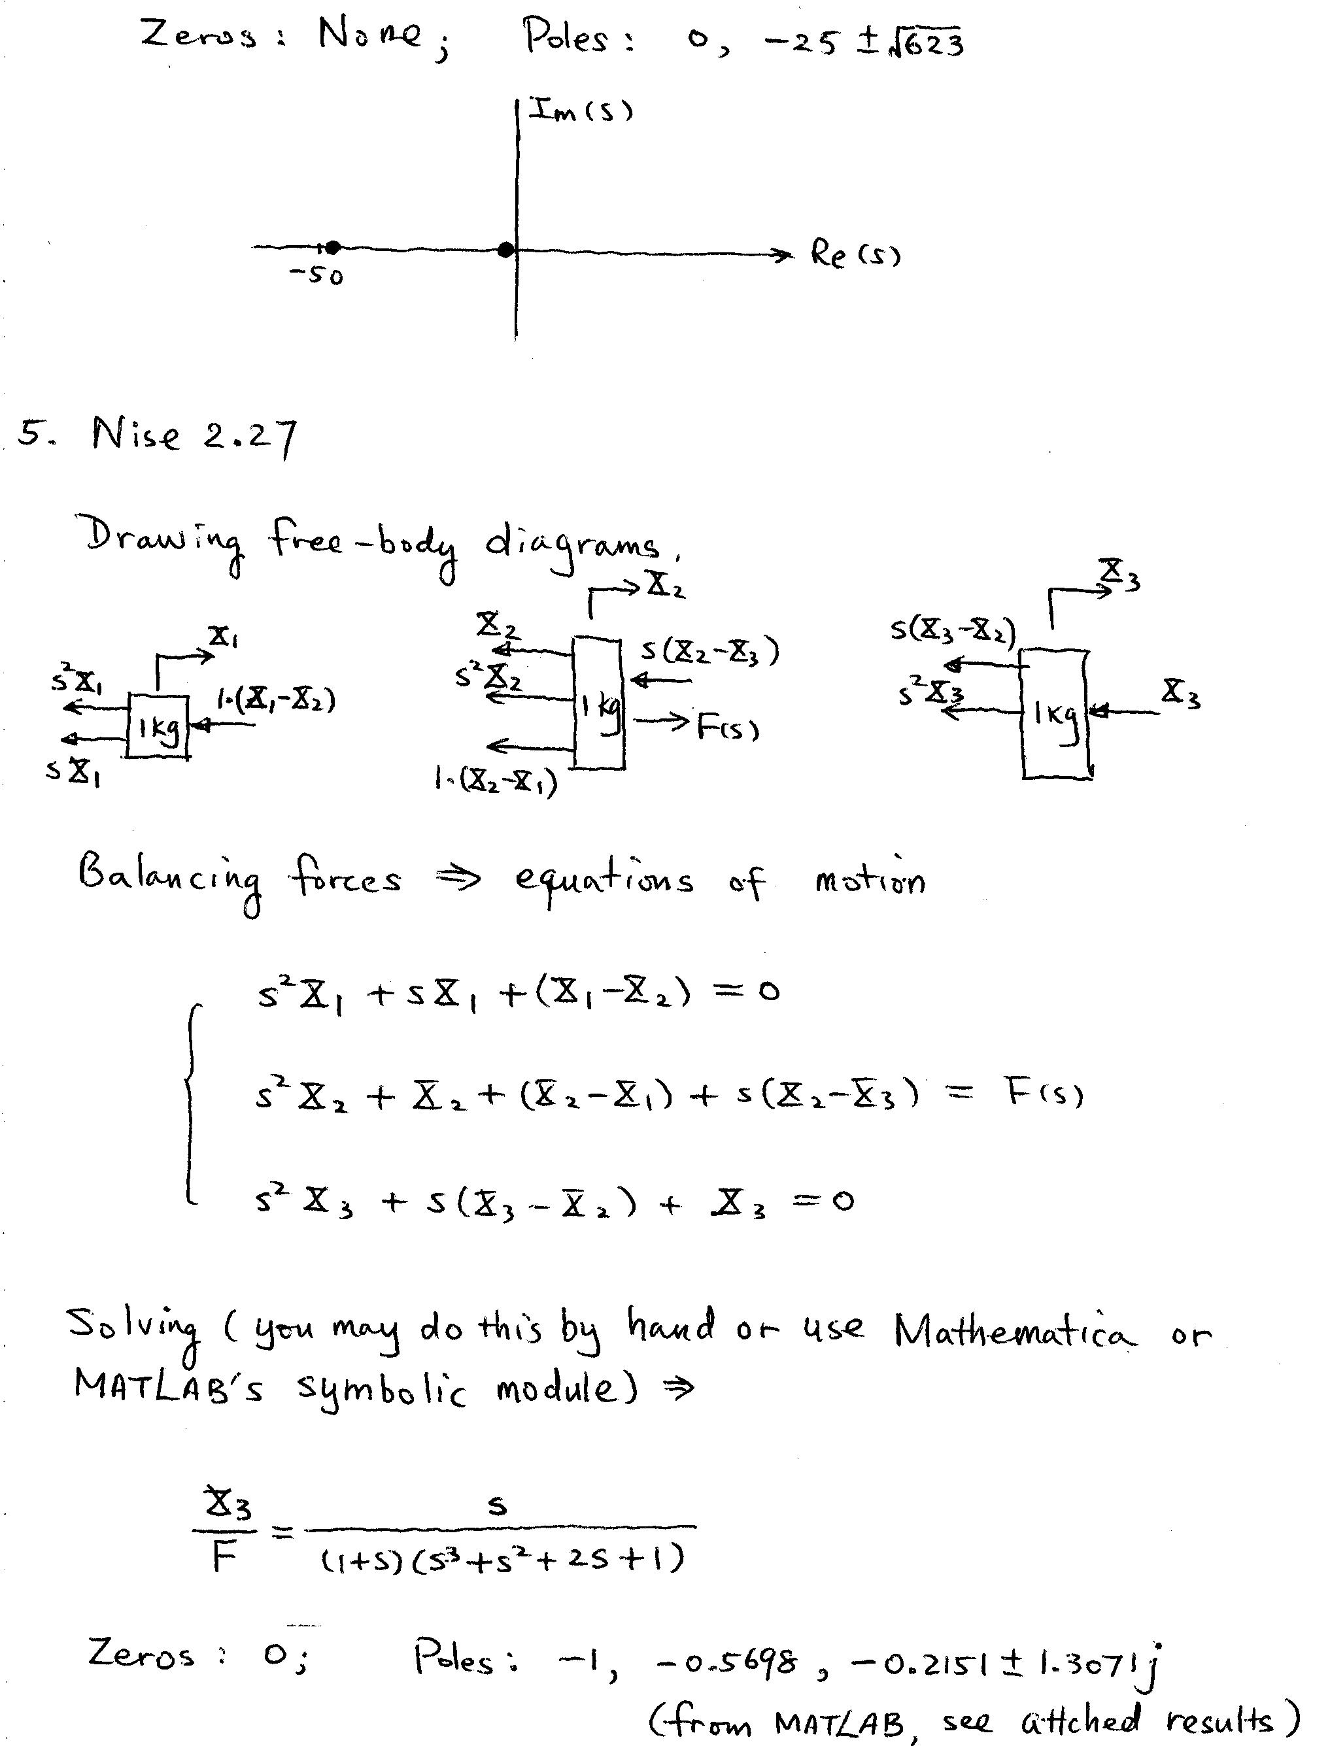

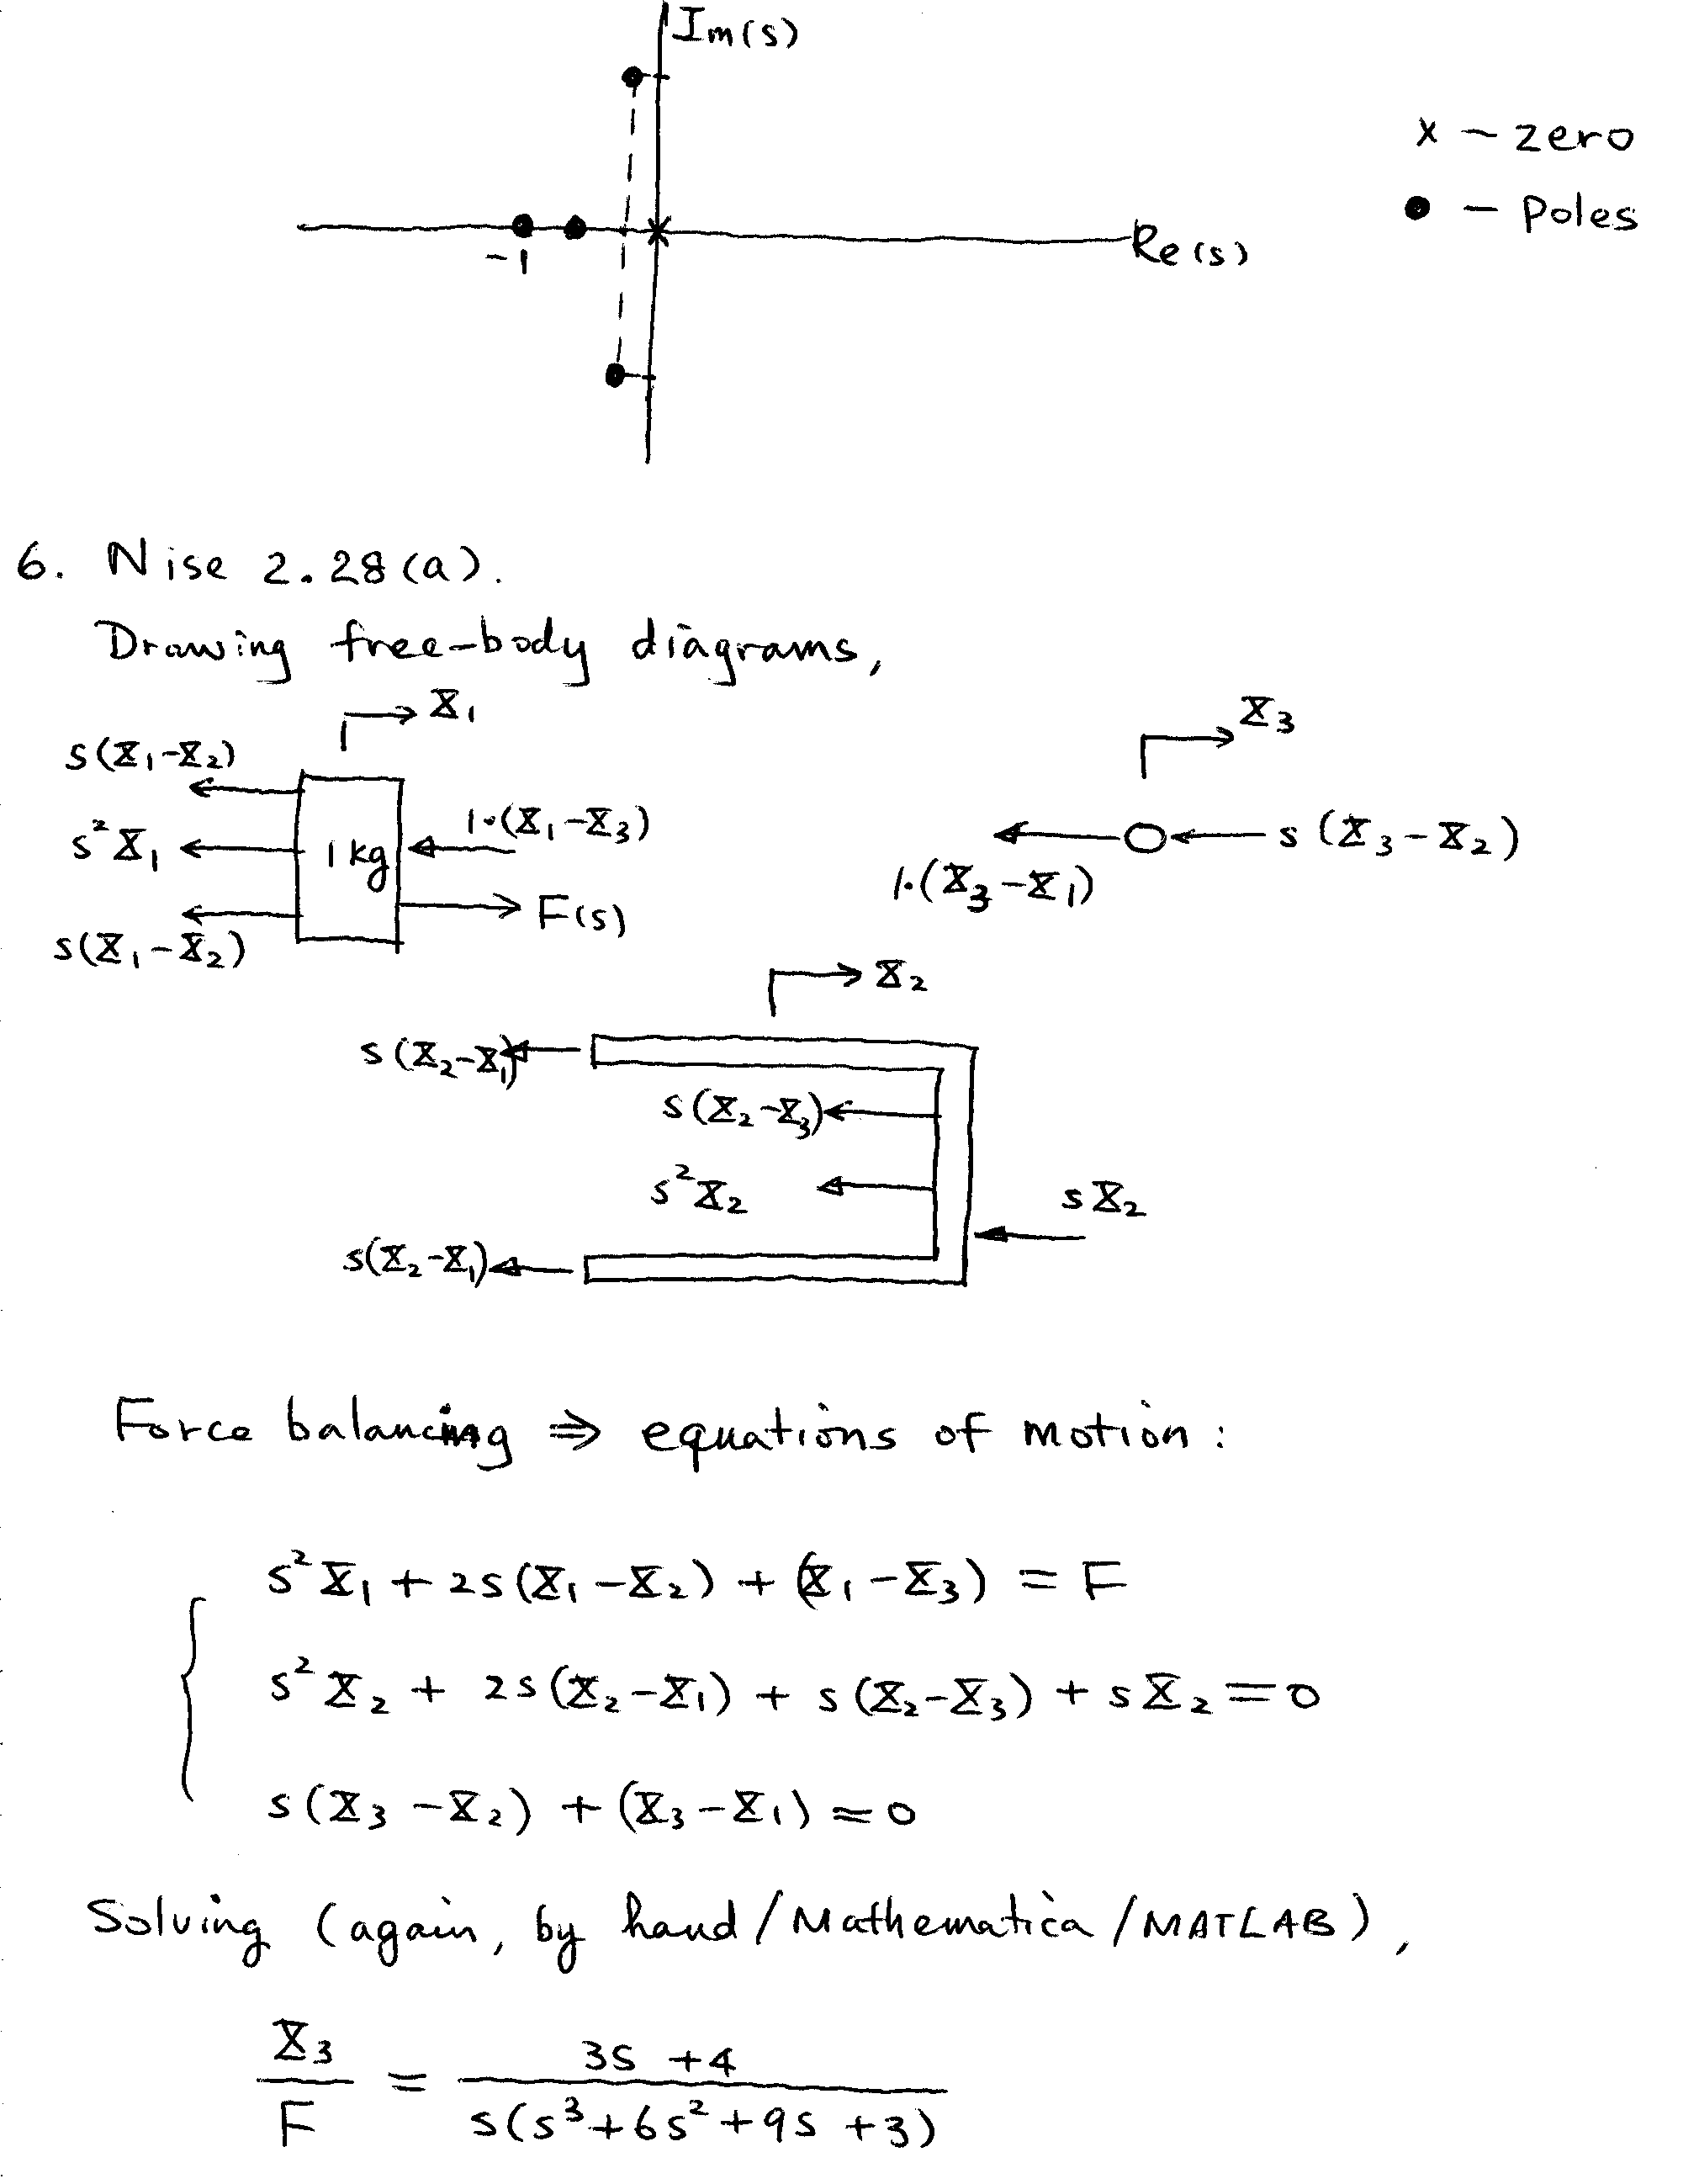

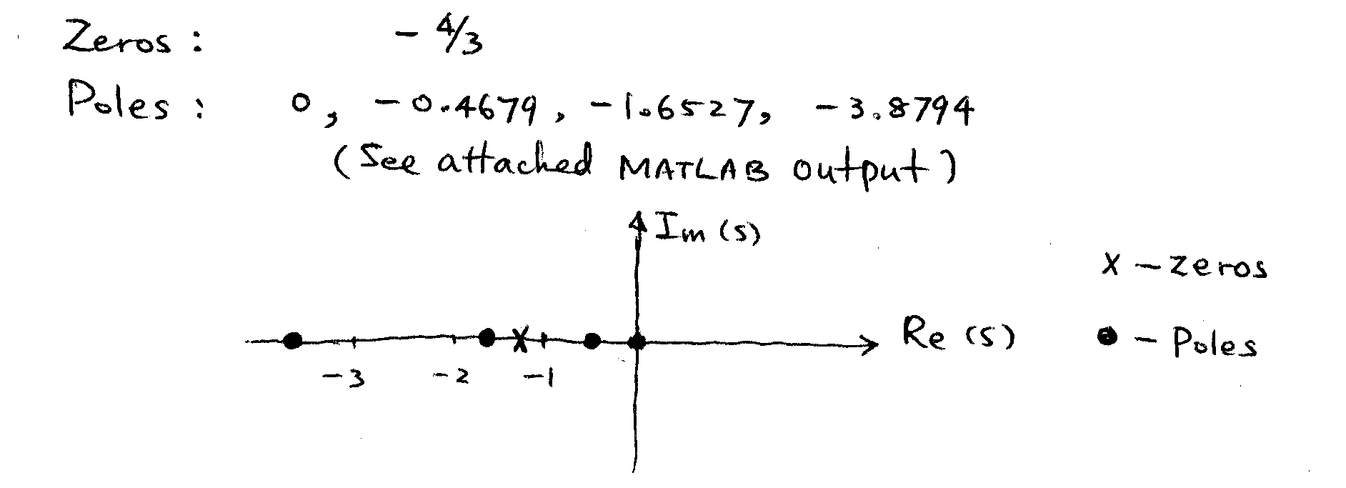

MATLAB Output:

>> %Homwork 2
>> %Prob. 5 - Nise 2.27
>> %Solving s^3 + s^2 + 2s + 1 = 0
>> roots([1 1 2 1])

ans =

-0.2151 + 1.3071i
-0.2151 - 1.3071i
-0.5698

>>
>> %Prob. 6 - Nise 2.28(a)
>> %Solving s^3 + 6s^2 + 9s + 3 = 0
>> roots([1 6 9 3])

ans =

-3.8794
-1.6527
-0.4679

>> diary off

