24-451 | Feedback Control Systems | Fall 2000

Homework #1 Solutions

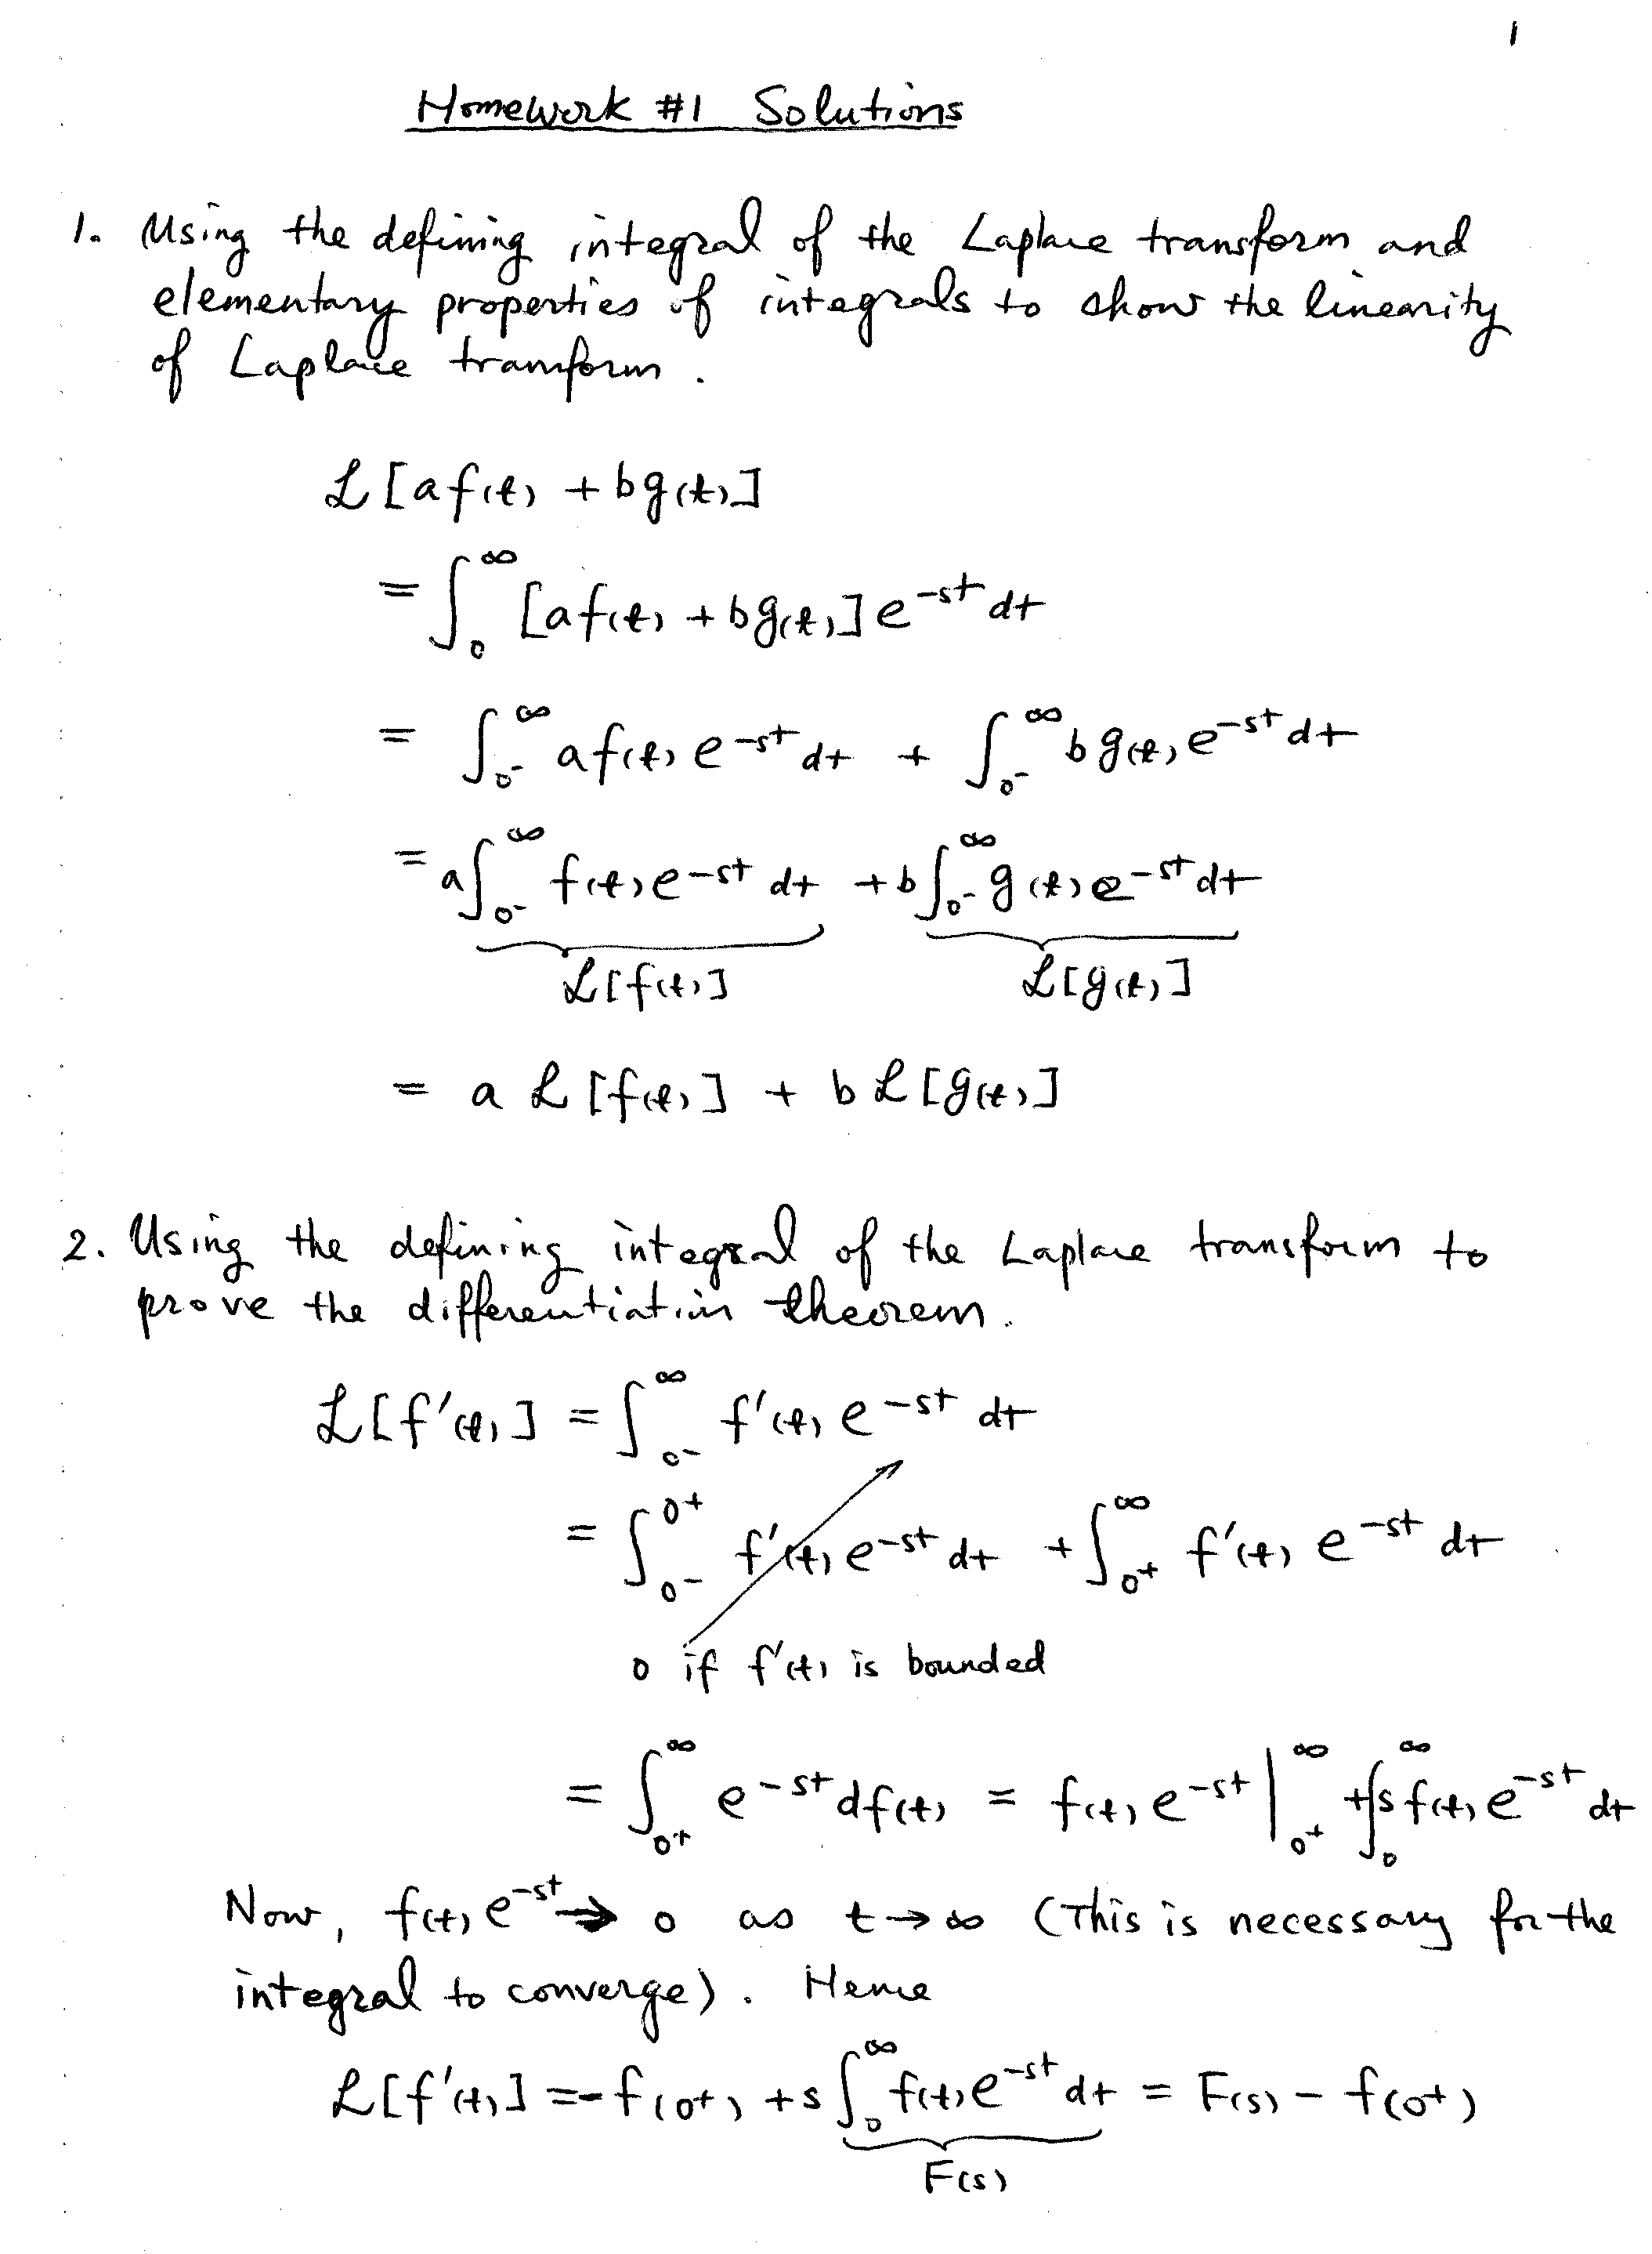

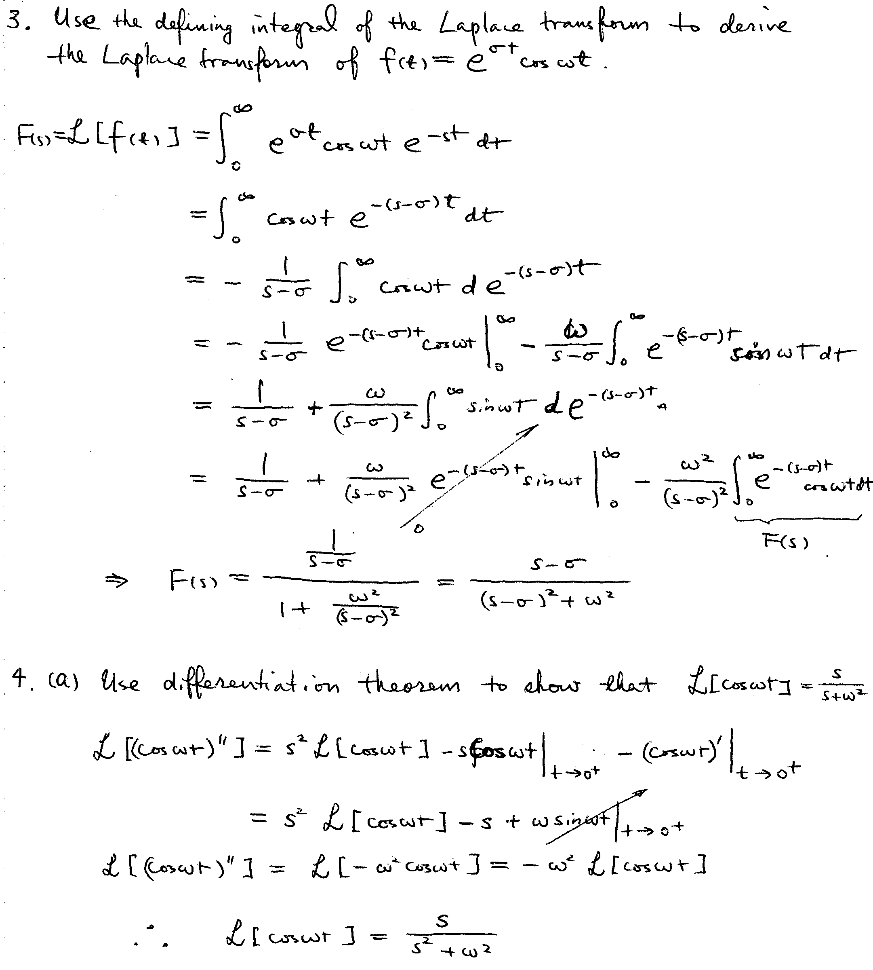

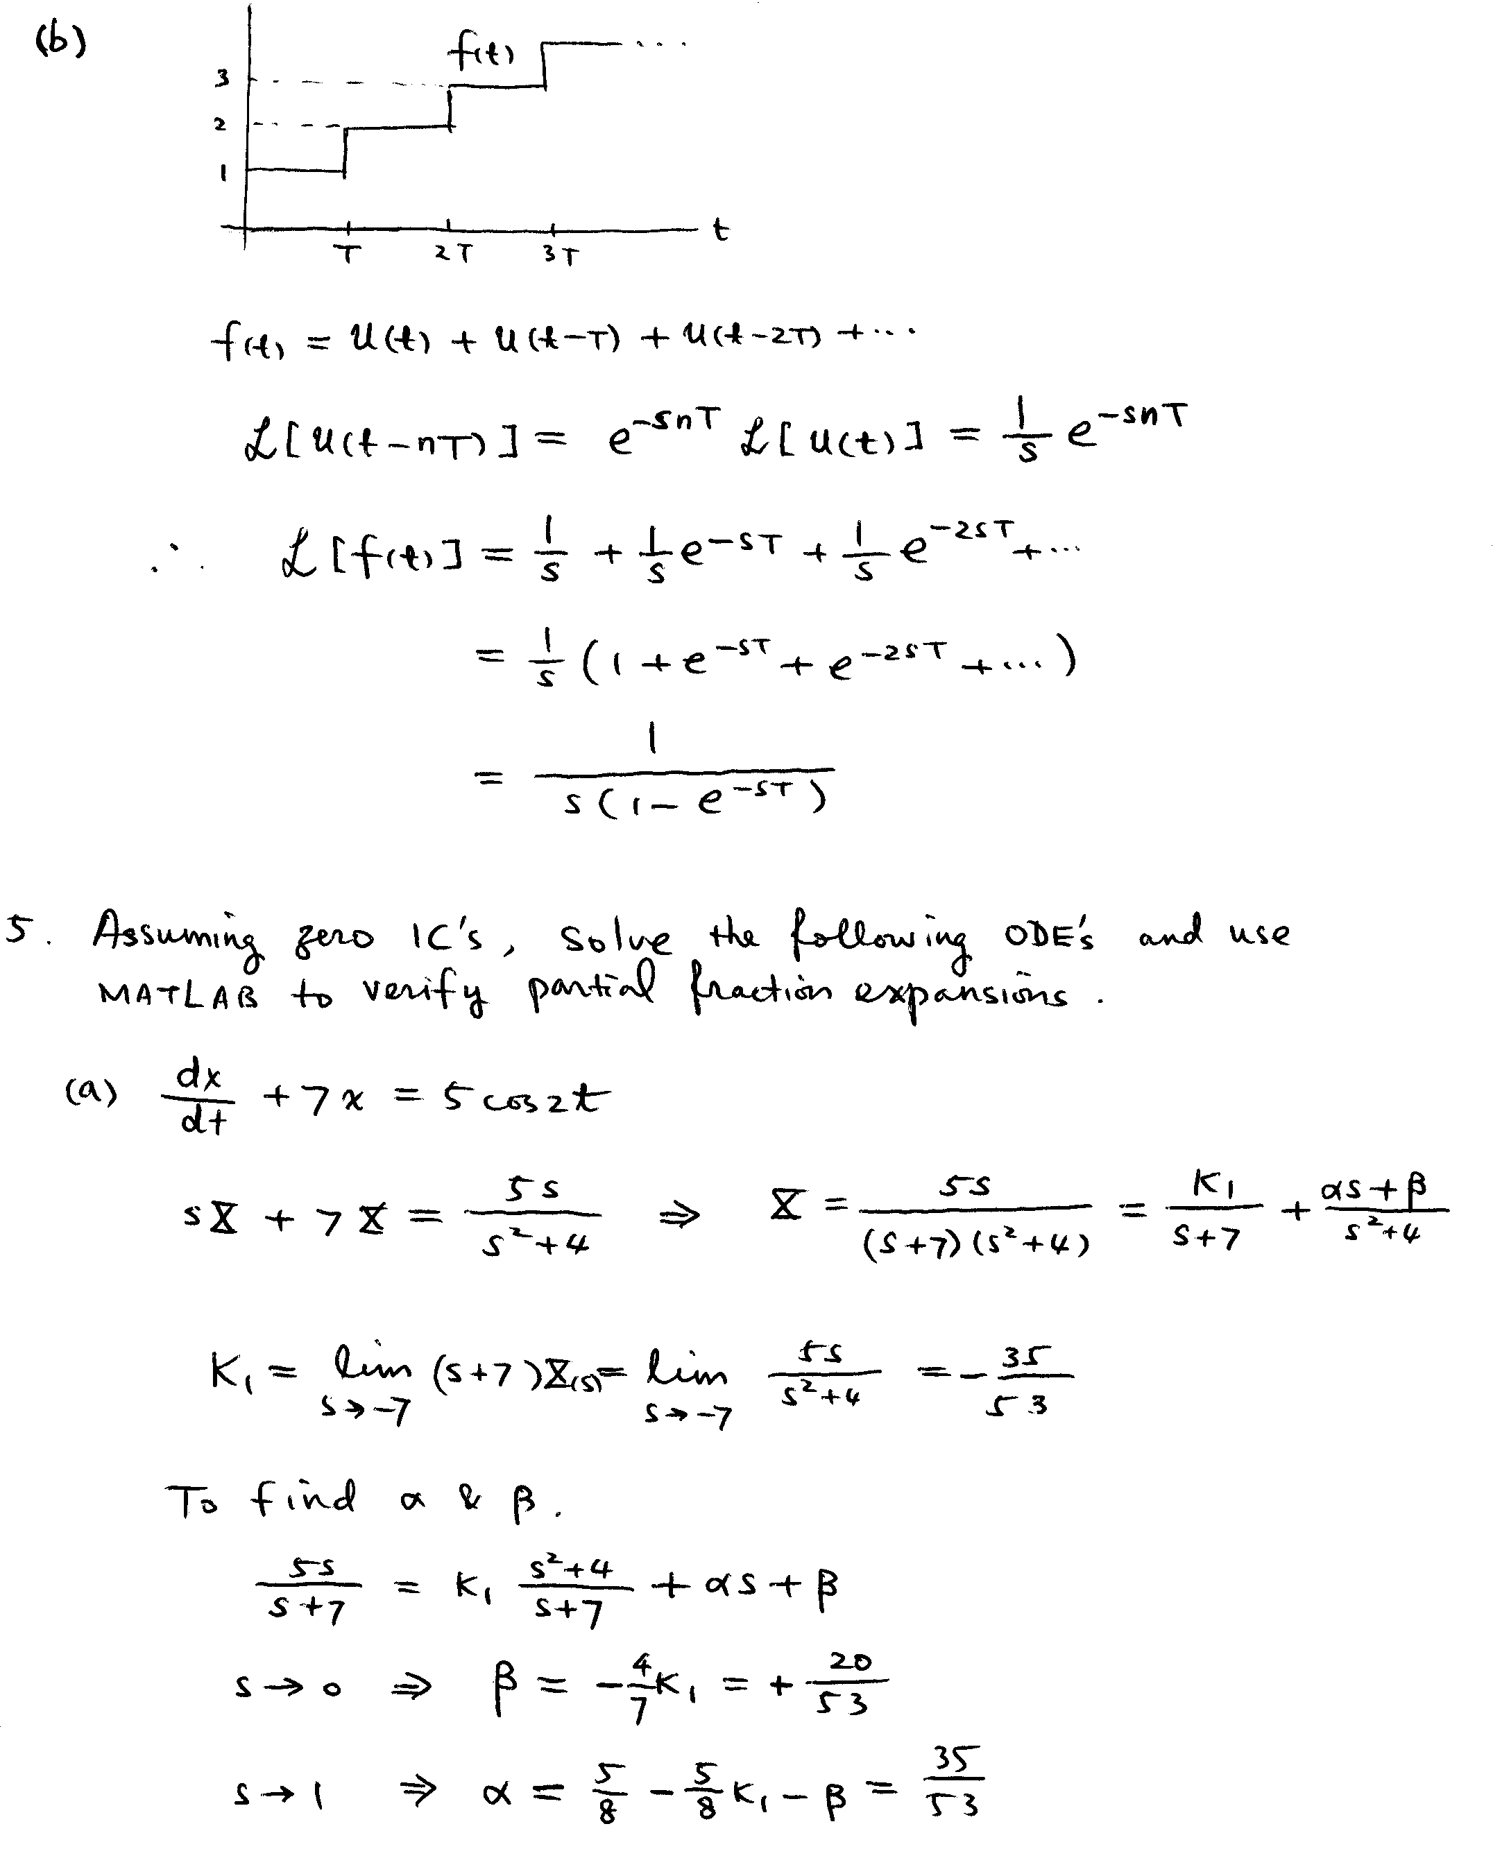

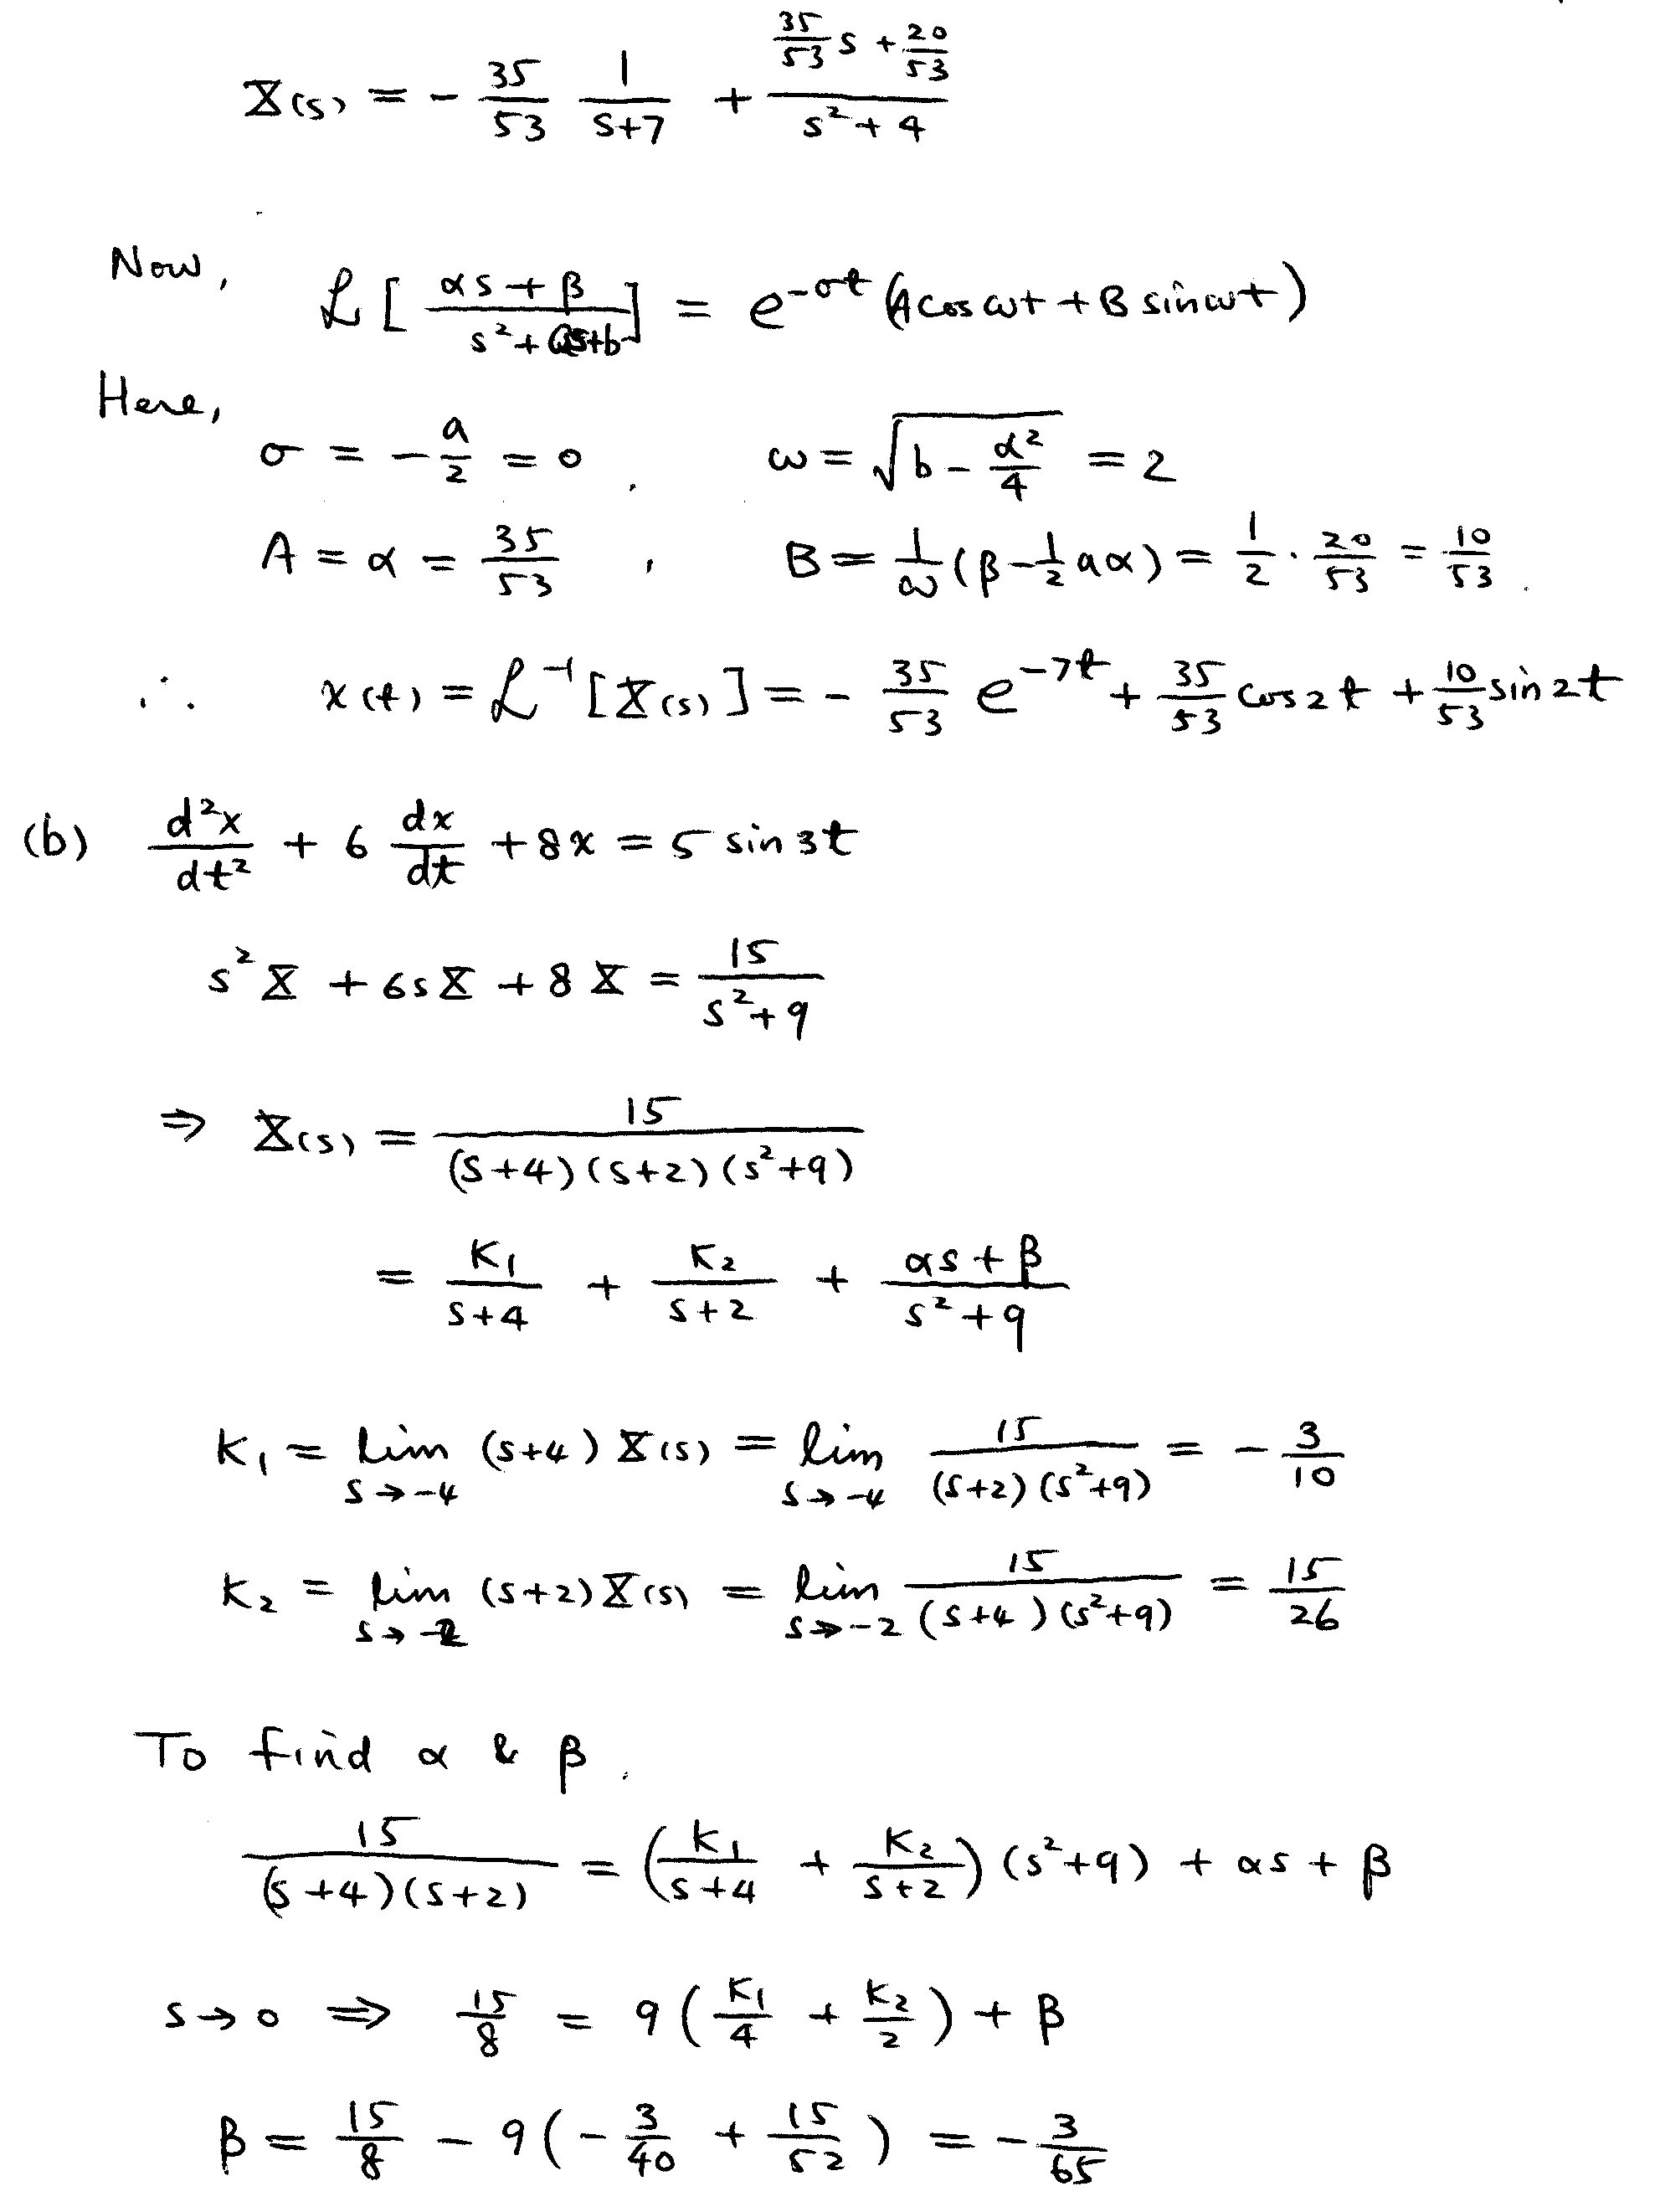
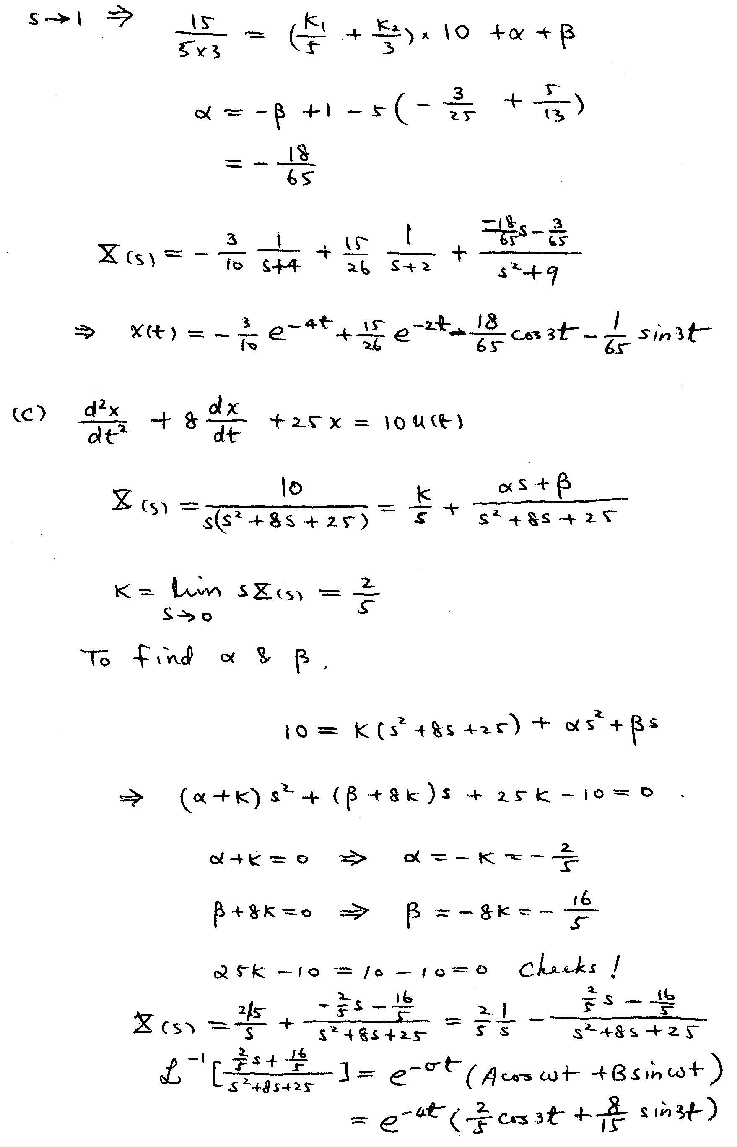
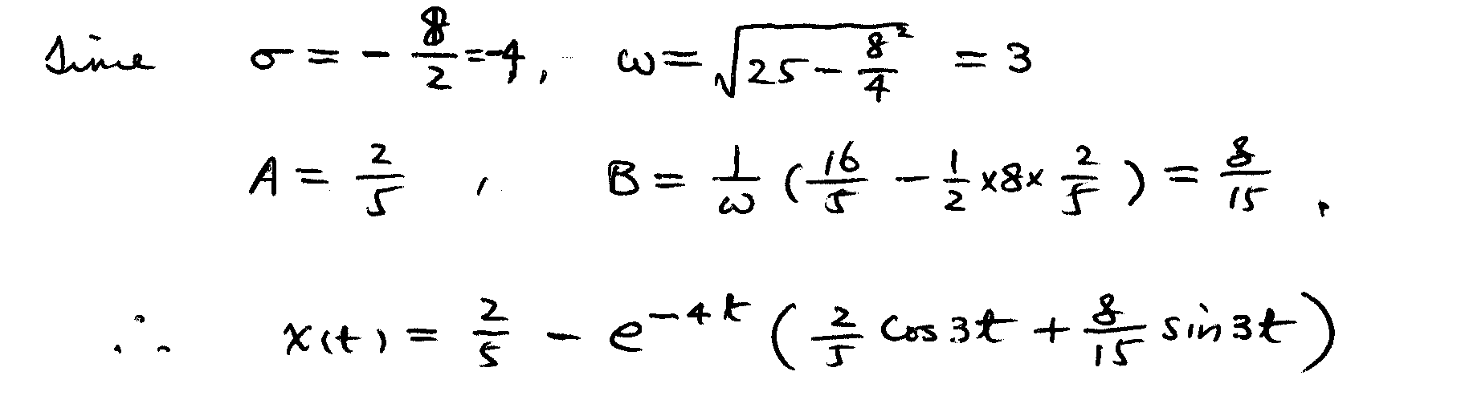

MATLAB Output:

% HW1, Prob. 5(a)
n=[5 0]; % coefficients of numerator polynomial
d=conv([1 7],[1 0 4]) % expand the denominator polynomial

d =

1 7 4 28

[r,p,k]=residue(n,d)

r =

-0.6604
0.3302 - 0.0943i
0.3302 + 0.0943i

p =

-7.0000
0.0000 + 2.0000i
0.0000 - 2.0000i

k =

[]

[n23,d23]=residue(r(2:3),p(2:3),[]) % combining r2/(s-p2)+r3/(s-p3)

n23 =

0.6604 0.3774

d23 =

1.0000 -0.0000 4.0000

% HW1, Prob. 5(b)
n=15; % coefficient of numerator polynomial
d=conv(conv([1 4],[1 2]),[1 0 9]) % expand the denominator polynomial

d =

1 6 17 54 72

[r,p,k]=residue(n,d)

r =

-0.3000
-0.1385 + 0.0077i
-0.1385 - 0.0077i
0.5769

p =

-4.0000
-0.0000 + 3.0000i
-0.0000 - 3.0000i
-2.0000

k =

[]

[n23,d23]=residue(r(2:3),p(2:3),[]) % combining r2/(s-p2)+r3/(s-p3)

n23 =

-0.2769 -0.0462

d23 =

1.0000 0.0000 9.0000

% HW1, Prob. 5(c)
n=10; % coefficient of numerator polynomial
d=conv([1 0],[1 8 25]) % expand the denominator polynomial

d =

1 8 25 0

[r,p,k]=residue(n,d)

r =

-0.2000 + 0.2667i
-0.2000 - 0.2667i
0.4000

p =

-4.0000 + 3.0000i
-4.0000 - 3.0000i
0

k =

[]

[n12,d12]=residue(r(1:2),p(1:2),[]) % combining r1/(s-p1)+r2/(s-p2)

n12 =

-0.4000 -3.2000

d12 =

1 8 25

diary off

