24-451 | Feedback Control Systems | Fall 2000

Homework #3

Due Tuesday 26 September at 3 pm

Reading: Nise Chapter 2, Sections 2.1-2.7.

Problems:
- (15 points.) Nise Chapter 2, Problem 32.
Hint: use the relations r₁/r₂= N₁/Ν₂ and r₃/r₄= N₃/Ν₄, relate the angles and torques associated with each pair of gears, and consider the free-body diagrams of the three shafts.
- (15 points.) Nise Chapter 2, Problem 35. Determine and plot the zeros and poles of the transfer function in the s-plane.
- (30 points.) Consider the tape transport system sketched as follows. The unsupported portion of the tape can be modeled by a translational spring K and damper D (K=Eew/l and D=b_{t}ewl – note the meaning of these formulas) attached to two inextensible strings that lead to the tape packs. The total inertia of the reels can be computed from J₁=J+J_{1p} and J₂=J+J_{2p}, where J is the inertia of the hub, motor and shaft, and J_{1p}=(1/2)πρw(r₁⁴-r_{i}⁴) and J_{2p}=(1/2)πρw(r₂⁴-r_{i}⁴) are the inertia of the tape packs. Additional physical and geometric parameters of the system are listed below. Find the transfer functions from each torque input (with the other torque input set to zero) to the two outputs, tape tension and tape velocity.
Hint: Draw free-body diagrams of the two reels and of a zero mass at one end of the tape spring/damper. Express θ₁ and θ₂ in terms of x₁ and x₂.

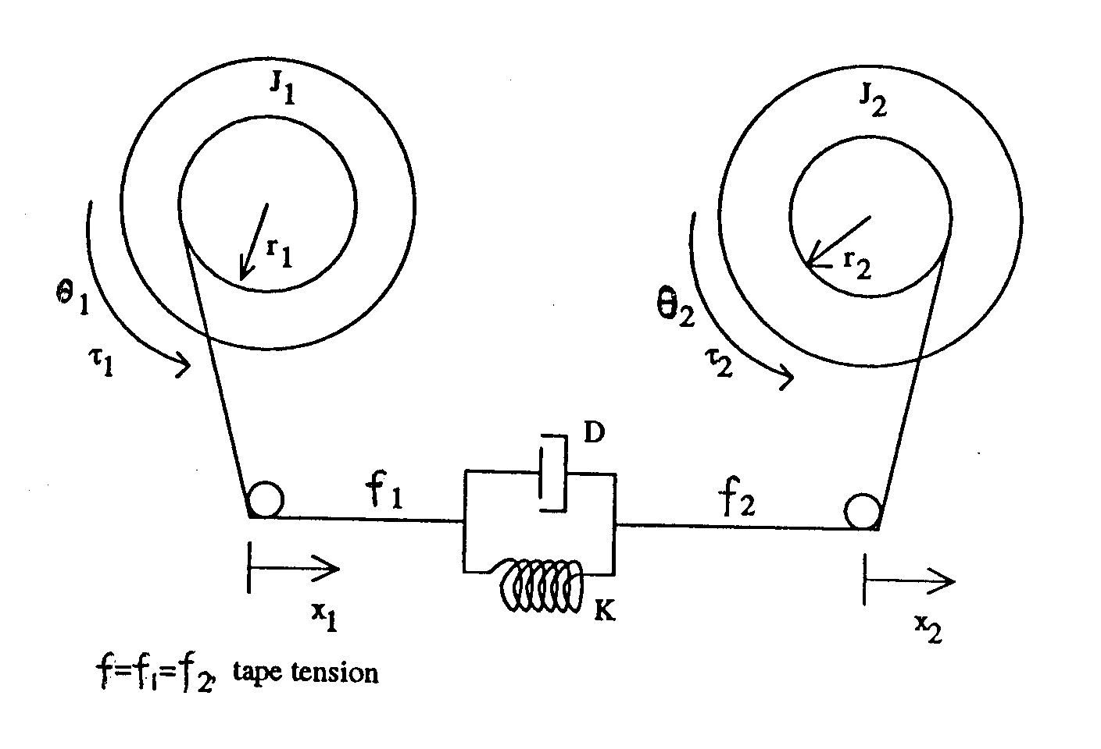

D_{m}: viscous damping coefficient of each motor and shaft
r_{i}: inner radius of each tape pack
r₁ and r₂: radii of reel 1 and reel 2 tape packs
e and w: tape thickness and width
l: unsupported tape length (length of tape from reel to reel)
b_{t}: tape damping per unit volume
E: tape elastic modulus
ρ: tape density
θ₁ and θ₂: angles of rotation of reel 1 and reel 2
x₁ and x₂: linear displacements of the tape at reel 1 and reel 2
τ₁ and τ₂: input torques applied to motor 1 and motor 2

f: tape tension (output)
$v=({\overset{˙}{x}}_{1}+{\overset{˙}{x}}_{2})/2$: tape velocity at mid span (output)

