24-451 | Feedback Control Systems | Fall 2000

Homework #2

Due Tuesday 19 September at 3 pm

Problems: In each of the following problems, find the desired transfer function, and determine and plot the zeros and poles of the transfer function in the s-plane.

- (10 points.) Nise Chapter 2, Problem 16 (a).
- (10 points.) Nise Chapter 2, Problem 18 (b).
- (10 points.) The transfer function from V_{i} to V_{o} in the following circuit.

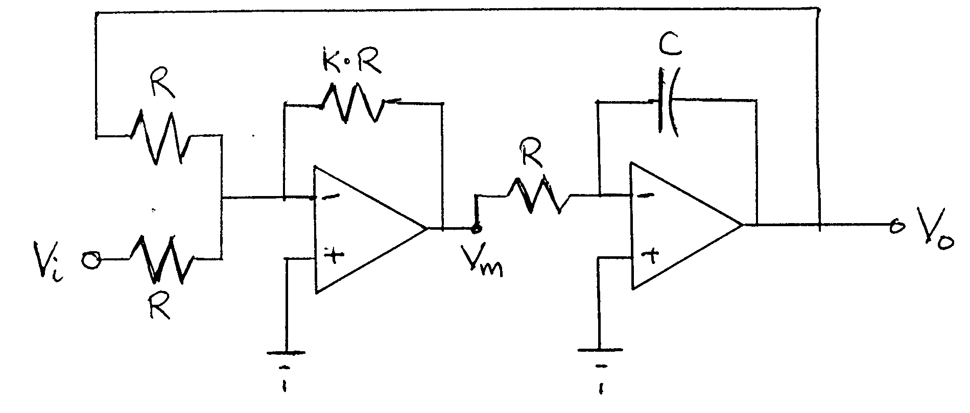

- (10 points.) Nise Chapter 2, Problem 25.
- (10 points.) Nise Chapter 2, Problem 27.
- (10 points.) Nise Chapter 2, Problem 28(a).

