CBLs:
(servers)
ACBpoints:
(users)
Server of user certificates &
Billing register &
Locator

User node
Server of user certificates &
Billing register &
Locator

Server of user certificates &
Billing register &
Locator

Distributed database
Sockets (TCP/IP)

User node
Direct communication (initiated by using the CBLs)
Sockets (TCP/IP)

User node

User node
Sockets
(TCP/IP)
Web Server
(Apache)

Web Site for
advertisement & ACBpoint downloading

User node
(Out of the system)

Administrators
Sockets
(TCP/IP)
Picture 1. The System Model (BIG PICTURE)

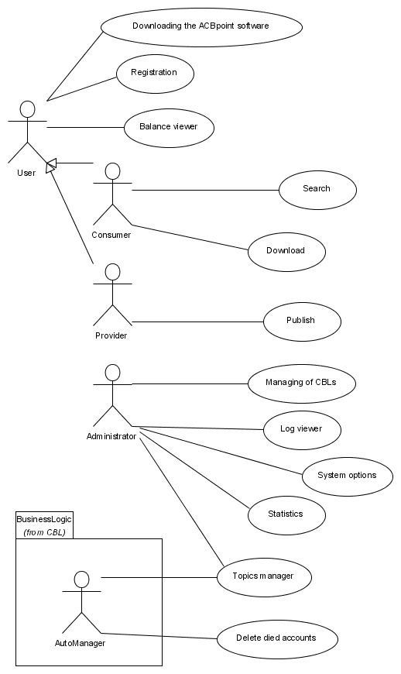
Picture 2. Use cases
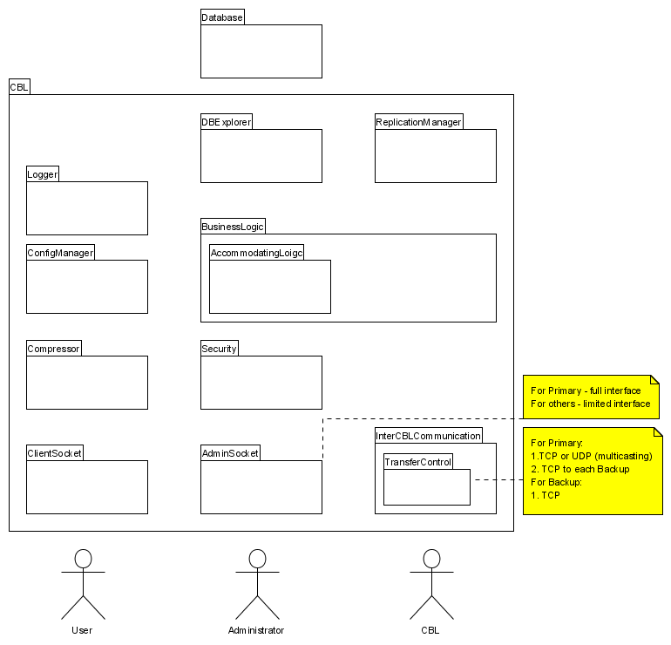
Picture 3. Layers and classes of a CBL server
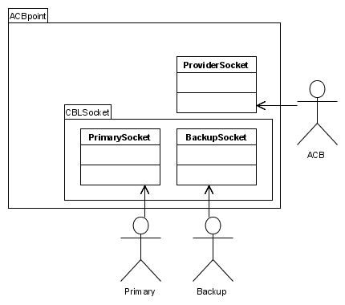
Picture 4. ACBpoint layers and classes

