

18-842 Distributed Systems

Final Report

For Project

Access Control & Billing
In Peer-To-Peer environment


TEAM (CMU/AIT)

Team Members:

- Alexander Stasiv
- Gergana Krumova
- Lazar Adzigogov
- Mariana Marin
Version 1.0. 28/04/04
Table of Contents

Introduction 3
System Environment (Actors) 3
Project Requirements 4
Infrastructural features 5
System Design 6
High-Level Design 6
Package Hierarchies 6
Application Programming Interfaces 6
Class Hierarchy 6
Interface Hierarchy 9
Components / Layer Design 10
Database 10
Common Module 11
CBL module 13
ACBpoint module 14
Implementation 16
Evaluation 18
Demonstrated sequences 18
Quantitative performance results 24
Project Status 24
Summary and Future Work 25

Introduction

Today there is a large explosion of p2p-based systems on internet. P2P networks as communication model connect together a large number of different computers. They provide an efficient way of storing and accessing large amounts of data, as demonstrated by the popularity of music file sharing networks such as KaZaa.

The main goal of our project is to implement features in the p2p environment such as authorization for accessing general type of information, authentication between the up loader-downloader and secure channel for transport of the encrypted information in order the content to be secured even if it is eavesdropped. In addition, our system supports billing/charging of information. The providers state their own prices for a data (music, video, movie, etc) and in order this data to be accessed first the consumer must pay the price of the specific data. Therefore our system supports money transaction from one account to another with all related issues like security, fault tolerance and high availability.

The Project Web site:
http://www.andrew.cmu.edu/course/18-842/index.htm

API documentation:
http://www.andrew.cmu.edu/course/18-842/index.html

Team Members:

Alexander Stativ:
mailto:asta@ait.edu.gr
http://www.ini.cmu.edu/people/AIT/MS15/Alexander_Stasiv.htm

Gergana Krumova:
mailto:gkru@ait.edu.gr
http://www.ini.cmu.edu/people/AIT/MS15/Gergana_Krumova.htm

Lazar Adzigogov:
mailto:ladz@ait.edu.gr
http://www.ini.cmu.edu/people/AIT/MS15/Lazar_Adzigogov.htm

Mariana Marin:
mailto:mmar@ait.edu.gr
http://www.ini.cmu.edu/people/AIT/MS15/Mariana_Marin.htm

System Environment (Actors)

- Owner of the system wants stable or growing profit
- Users (Providers) want securely share information and receive current amount of money from each download
- Users (Consumers) want securely search and download information and pay correct amount of money after each downloading
- Administrators want to be able to maintain the system

Project Requirements

One of the existing problems in information sharing p2p-based system on internet is how to manage secure access and bill the engaging parties. From the perspective of the end-user the system provides mechanism for:

- Publishing and management of their shared information

Each user can easily select which documents he/she is willing to share and define price for each document.

- Efficient search for required documents

We implemented a search engine, efficient and easy to use, which gives report to the user, where the documents can be found/if they exist, which peers have them and their price.

- High-availability

Each user can query the system more then 99% of time. The system provides ‘one-copy’ semantics to the end-user, which means that all failures are masked for the peer and they see the system as one entity.

- Billing

The system makes sure that the engaging parties are satisfied with the transaction. The downloader who pays for the document protected by any misuses from the up loader peer, and vice versa, the up loader, which is paid protected from any misuse from the downloading peer.

- Secured access to the system

Each user have its own pair of login name and password.

- Authentication of engage parties

Parties engaging in transfer of a document know that they communicate to valid person, not an adversary.

- Segmented downloading

When the engaging parties exchange documents, if the transfer is interrupted, the next time they establish connection, the transfer continues where it was interrupted, not from the beginning.

- Document confidentiality

The transfer of the documents between the peers is secured by encryption, in order to provide protection against eavesdropping.

Infrastructural features

- Communication

No Middleware was used. The system has its own protocol for communication between the nodes and among the servers. The protocol is an exchange of messages using Send and Receive.

- High-availability/ Fault Tolerance

The System from the perspective of following functions are highly available and fault tolerant

  - Register
  - Publish
  - Search
  - Bill

The Replication control subsystem takes care for failures such as power failures of any servers, loss of network connection for any server, therefore providing transparent high-availability to the end-user. The system tolerates finite number of failures, which is defined by the owner of the system. Larger number of servers guarantees large number of failures tolerance.

The following functions are not highly available and fault tolerant.

- Download

- Security

By default, Peer-To-Peer networks are open and therefore not immune to security attacks. The system provides three levels of security:

  - authorization of users
  - authentication when peers exchange documents
  - encryption on the transferring document protecting it against eavesdropping.

- Load-balancing

  - Search

The client chooses a random backup server (in time of joining the group) for the search query, in order not to send request only to one server.

System Design

High-Level Design

- ACBpoint – Client software (in user side);

- CBL – chain of server software communicated using Primary-Backup Protocol;

- CBLcc – Administrator software for system maintenance.

Package Hierarchies

dist1.acb.ACBpoint, dist1.acb.ACBpoint.transport, dist1.acb.CBL, dist1.acb.CBL.concretePackets, dist1.acb.CBLcc, dist1.acb.common, dist1.acb.common.database, dist1.acb.common.transport, dist1.acb.common.transport.concretePackets

Application Programming Interfaces

Class Hierarchy
- class java.lang.Object
  - class javax.swing.AbstractCellEditor (implements javax.swing.CellEditor, java.io.Serializable)
    - class javax.swing.DefaultCellEditor (implements javax.swing.table.TableCellEditor, javax.swing.tree.TreeCellEditor)
      - class dist1.acb.ACBpoint.PublishingTableCellEditor
  - class dist1.acb.common.transport.AbstractClientSocket.SocketAndStreams
  - class javax.swing.table.AbstractTableModel (implements java.io.Serializable, javax.swing.table.TableModel)
    - class dist1.acb.ACBpoint.CashFlowsTableModel
    - class dist1.acb.CBLcc.CBLsTableModel (implements java.io.Serializable)
    - class dist1.acb.ACBpoint.DownloadingTable
    - class dist1.acb.CBLcc.LogTableModel (implements java.io.Serializable)
    - class dist1.acb.ACBpoint.PublishingTable (implements java.io.Serializable)
    - class dist1.acb.ACBpoint.SearchResultTableModel
  - class dist1.acb.ACBpoint.BusinessLogic
  - class dist1.acb.CBLcc.BusinessLogic
  - class dist1.acb.CBL.CBL
  - class dist1.acb.common.database.CBL (implements java.lang.Cloneable, java.io.Serializable)
  - class java.awt.Component (implements java.awt.image.ImageObserver, java.awt.MenuContainer, java.io.Serializable)
    - class java.awt.Container
      - class javax.swing.JComponent (implements java.io.Serializable)
        - class javax.swing.JLabel (implements javax.accessibility.Accessible, javax.swing.SwingConstants)
          - class dist1.acb.CBLcc.ActiveCBLRenderer (implements javax.swing.table.TableCellRenderer)
          - class javax.swing.table.DefaultTableCellRenderer (implements java.io.Serializable, javax.swing.table.TableCellRenderer)
            - class dist1.acb.ACBpoint.CurrencyRenderer
          - class dist1.acb.ACBpoint.DirectionRenderer (implements javax.swing.table.TableCellRenderer)
        - class javax.swing.JProgressBar (implements javax.accessibility.Accessible, javax.swing.SwingConstants)
          - class dist1.acb.ACBpoint.ProgressRenderer (implements javax.swing.table.TableCellRenderer)
        - class javax.swing.JTable (implements javax.accessibility.Accessible, javax.swing.event.CellEditorListener, javax.swing.event.ListSelectionListener, javax.swing.Scrollable, javax.swing.event.TableColumnModelListener, javax.swing.event.TableModelListener)
          - class dist1.acb.ACBpoint.DNDTable (implements java.awt.dnd.DragGestureListener, java.awt.dnd.DragSourceListener, java.awt.dnd.DropTargetListener)
        - class javax.swing.JTree (implements javax.accessibility.Accessible, javax.swing.Scrollable)
          - class dist1.acb.ACBpoint.TopicsTree
      - class java.awt.Window (implements javax.accessibility.Accessible)
        - class java.awt.Dialog
          - class javax.swing.JDialog (implements javax.accessibility.Accessible, javax.swing.RootPaneContainer, javax.swing.WindowConstants)
            - class dist1.acb.CBLcc.LoginDialog
            - class dist1.acb.ACBpoint.RegisterDialog
            - class dist1.acb.ACBpoint.SearchResultDialog (implements java.awt.event.MouseListener)
            - class dist1.acb.ACBpoint.ViewCashFlowsDialog
        - class java.awt.Frame (implements java.awt.MenuContainer)
          - class javax.swing.JFrame (implements javax.accessibility.Accessible, javax.swing.RootPaneContainer, javax.swing.WindowConstants)
            - class dist1.acb.ACBpoint.ACBpoint
            - class dist1.acb.CBLcc.CBLcc
            - class dist1.acb.CBLcc.ViewLogFile
  - class dist1.acb.common.ConfigManager
  - class dist1.acb.common.Constant
  - class dist1.acb.CBL.DBExplorer (implements dist1.acb.CBL.UpdatesExecutor)
  - class dist1.acb.ACBpoint.DownloadingTableData (implements java.io.Serializable)
  - class dist1.acb.common.database.File (implements java.io.Serializable)
  - class java.util.logging.Formatter
    - class dist1.acb.common.NiceFormatter
  - class dist1.acb.common.HandlersHive
  - class dist1.acb.common.transport.Id (implements java.io.Serializable)
  - class dist1.acb.common.transport.InetAddressHelper
  - class java.io.InputStream
    - class java.io.FilterInputStream
      - class dist1.acb.common.transport.FlowRateInputStream
  - class java.awt.event.KeyAdapter (implements java.awt.event.KeyListener)
    - class dist1.acb.CBLcc.CBLcc.RefreshKeyListener
    - class dist1.acb.CBLcc.ViewLogFile.RefreshKeyListener
  - class dist1.acb.common.database.Log (implements java.io.Serializable)
  - class dist1.acb.common.LoggerFactory
  - class java.awt.event.MouseAdapter (implements java.awt.event.MouseListener)
    - class dist1.acb.ACBpoint.ACBpoint.PublishTableMouseListener
    - class dist1.acb.CBLcc.CBLcc.MyMouseListener
  - class dist1.acb.common.transport.ObjectReaderWriter
  - class dist1.acb.common.transport.ObjectStreamFactory
  - class dist1.acb.common.transport.Packet (implements java.io.Serializable)
    - class dist1.acb.common.transport.Request
      - class dist1.acb.CBL.concretePackets.RequestForHotJoin
      - class dist1.acb.common.transport.concretePackets.RequestGetBalance
      - class dist1.acb.common.transport.concretePackets.RequestGetCashFlows
      - class dist1.acb.common.transport.concretePackets.RequestGetCBLsInfo
      - class dist1.acb.common.transport.concretePackets.RequestGetEnvironment
      - class dist1.acb.common.transport.concretePackets.RequestGetLog
      - class dist1.acb.common.transport.concretePackets.RequestGetLogFile
      - class dist1.acb.common.transport.concretePackets.RequestGetPeersLocation
      - class dist1.acb.CBL.concretePackets.RequestGetReplicas
      - class dist1.acb.common.transport.concretePackets.RequestGetServersList
      - class dist1.acb.common.transport.concretePackets.RequestGetTopics
      - class dist1.acb.common.transport.concretePackets.RequestLoginComminment
      - class dist1.acb.CBL.concretePackets.RequestReplicasToPrimary
      - class dist1.acb.common.transport.concretePackets.RequestSearch
      - class dist1.acb.common.transport.concretePackets.RequestServersList
      - class dist1.acb.ACBpoint.transport.RequestStartDownload
      - class dist1.acb.CBL.concretePackets.RequestTest
      - class dist1.acb.common.transport.RequestUpdate
        - class dist1.acb.common.transport.concretePackets.RequestBeginSellTransaction
        - class dist1.acb.common.transport.concretePackets.RequestCloseSession
        - class dist1.acb.CBL.concretePackets.RequestDeleteOldUsers
        - class dist1.acb.common.transport.concretePackets.RequestEndSellTransaction
        - class dist1.acb.CBL.concretePackets.RequestExecuteHotJoin
        - class dist1.acb.CBL.concretePackets.RequestExecuteUpdate
        - class dist1.acb.CBL.concretePackets.RequestInitCBLTable
        - class dist1.acb.CBL.concretePackets.RequestInsertLog
        - class dist1.acb.CBL.concretePackets.RequestJoin
        - class dist1.acb.common.transport.concretePackets.RequestLogin
        - class dist1.acb.common.transport.concretePackets.RequestMoneyFromAccount
        - class dist1.acb.common.transport.concretePackets.RequestMoneyToAccount
        - class dist1.acb.common.transport.concretePackets.RequestRegister
        - class dist1.acb.common.transport.concretePackets.RequestRemoveCBL
        - class dist1.acb.common.transport.concretePackets.RequestRemoveFiles
        - class dist1.acb.common.transport.concretePackets.RequestShare
        - class dist1.acb.common.transport.concretePackets.RequestUpdateCBL
        - class dist1.acb.CBL.concretePackets.RequestUpdateUser
      - class dist1.acb.common.transport.RequestWithStringMessage (implements dist1.acb.common.transport.StringMessage)
        - class dist1.acb.common.transport.concretePackets.RequestRejoin
        - class dist1.acb.common.transport.concretePackets.RequestShutdownApplication
    - class dist1.acb.common.transport.Response
      - class dist1.acb.common.transport.concretePackets.ResponseBalance
      - class dist1.acb.common.transport.concretePackets.ResponseCashFlows
      - class dist1.acb.common.transport.concretePackets.ResponseCBLsInfo
      - class dist1.acb.common.transport.concretePackets.ResponseEnvironment
      - class dist1.acb.ACBpoint.transport.ResponseFile
      - class dist1.acb.common.transport.concretePackets.ResponseFileIds
      - class dist1.acb.ACBpoint.transport.ResponseFileSegment
      - class dist1.acb.CBL.concretePackets.ResponseHotJoinInfo
      - class dist1.acb.CBL.concretePackets.ResponseJoinInfo
      - class dist1.acb.common.transport.concretePackets.ResponseKey
      - class dist1.acb.common.transport.concretePackets.ResponseLog
      - class dist1.acb.common.transport.concretePackets.ResponseLogFile
      - class dist1.acb.common.transport.concretePackets.ResponseLoginChallenge
      - class dist1.acb.common.transport.concretePackets.ResponseLoginOk
      - class dist1.acb.common.transport.concretePackets.ResponseOk
      - class dist1.acb.common.transport.concretePackets.ResponsePeersLocation
      - class dist1.acb.common.transport.concretePackets.ResponseRegisterId
      - class dist1.acb.CBL.concretePackets.ResponseReplicas
      - class dist1.acb.common.transport.concretePackets.ResponseSearch
      - class dist1.acb.common.transport.concretePackets.ResponseServersList
      - class dist1.acb.common.transport.concretePackets.ResponseTopics
      - class dist1.acb.common.transport.ResponseWithStringMessage (implements dist1.acb.common.transport.StringMessage)
        - class dist1.acb.common.transport.concretePackets.ResponseCloseSession
        - class dist1.acb.common.transport.ResponseError
          - class dist1.acb.common.transport.concretePackets.ResponseAnError
  - class dist1.acb.ACBpoint.PointDB
  - class dist1.acb.ACBpoint.PublishingTableData (implements java.io.Serializable)
  - class dist1.acb.common.database.Register (implements java.io.Serializable)
  - class dist1.acb.CBL.Replica (implements java.io.Serializable)
  - class dist1.acb.common.transport.concretePackets.RequestShare.File (implements java.io.Serializable)
  - class dist1.acb.common.transport.concretePackets.ResponseCashFlows.FlowInfo (implements java.io.Serializable)
  - class dist1.acb.common.transport.concretePackets.ResponseCBLsInfo.CBLInfo (implements java.io.Serializable)
  - class dist1.acb.common.transport.concretePackets.ResponsePeersLocation.PeerInfo (implements java.io.Serializable)
  - class dist1.acb.common.transport.concretePackets.ResponseSearch.SearchInfo (implements java.io.Serializable)
  - class dist1.acb.common.transport.concretePackets.ResponseTopics.Topic (implements java.io.Serializable)
  - class dist1.acb.common.Security
  - class dist1.acb.ACBpoint.SharedDocument (implements java.io.Serializable)
  - class dist1.acb.common.Signal
  - class dist1.acb.common.transport.SocketFactories
  - class java.lang.Thread (implements java.lang.Runnable)
    - class dist1.acb.common.transport.AbstractClientSocket
      - class dist1.acb.CBLcc.AdminSocket
      - class dist1.acb.CBL.Backup (implements dist1.acb.CBL.Server)
      - class dist1.acb.ACBpoint.transport.ClientSocket
      - class dist1.acb.ACBpoint.transport.DownloadFile
    - class dist1.acb.common.transport.AbstractConnectionServer
      - class dist1.acb.CBL.AdminSocket
      - class dist1.acb.CBL.ClientSocket
      - class dist1.acb.CBL.ControlSocket
      - class dist1.acb.CBL.Primary (implements dist1.acb.CBL.Server)
      - class dist1.acb.ACBpoint.transport.ProviderSocket
    - class dist1.acb.common.transport.AbstractPersonalManager
      - class dist1.acb.CBL.AdminSocket.AdminManager
      - class dist1.acb.CBL.ClientSocket.ClientManager
      - class dist1.acb.CBL.ControlSocket.ClientManager
      - class dist1.acb.CBL.Primary.ClientManager
      - class dist1.acb.ACBpoint.transport.ProviderSocket.ClientManager
    - class dist1.acb.CBL.AutoManager
    - class dist1.acb.CBLcc.Refresher
  - class java.lang.Throwable (implements java.io.Serializable)
    - class java.lang.Exception
      - class java.lang.RuntimeException
        - class dist1.acb.CBL.CBL.TransitiveStateException
        - class dist1.acb.common.NoHandlerException
  - class dist1.acb.ACBpoint.Topic
  - class dist1.acb.common.database.Topic (implements java.io.Serializable)
  - class dist1.acb.common.database.TopicProposal (implements java.io.Serializable)
  - class dist1.acb.ACBpoint.TopicsModel (implements javax.swing.tree.TreeModel)
  - class dist1.acb.CBL.UpdatesExecutorHandlersHive
  - class dist1.acb.common.database.User (implements java.lang.Cloneable, java.io.Serializable)

Interface Hierarchy
- interface dist1.acb.common.transport.StringMessage
- interface dist1.acb.CBL.UpdatesExecutor
  - interface dist1.acb.CBL.Server

Components / Layer Design

Database

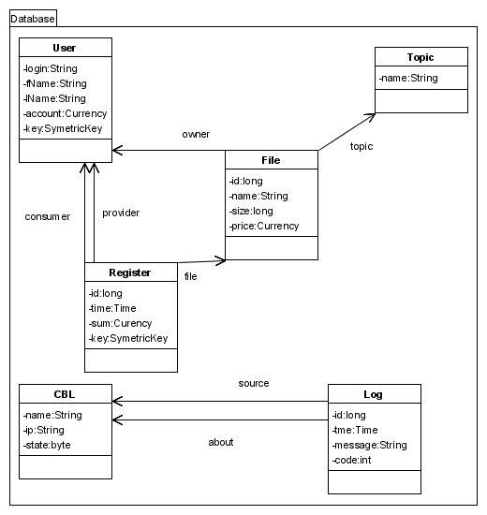
Picture 1. Class diagram of Database

  - User – contains users account.
  - File – contains list of shared files
  - Topic – contains possible topics of files
  - Register – contains performed operations
  - CBL – contains list of CBL’s with all related information like state of a CBL (primary / backup / joining / off-line)
  - Log – contains most important system events (such as crashes of CBL, joining of a CBL, etc)

Common Module

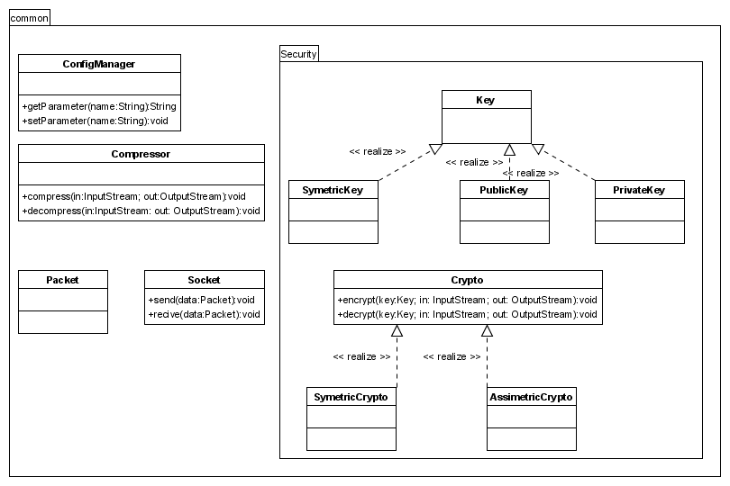
Picture 2. Class diagram of common module

  - ConfigManager – Reads/Sets parameters that control the behavior of CBL. These parameters are stored locally at each CBL node.
  - Compressor – Since there are large messages, in order not to load the network with a lot of traffic, every message before it is sent it is compressed, and each received message is decompressed.
  - Security – Each message after it is compressed it is encrypted, in order to ensure that the any adversary does not do any harm. Upon receiving the message is decrypted.

Transport Layers:

Security (SSL)
Compression (GZIP)
Sockets (TCP/IP)
Object-byte stream conversion
Type resolving and handlers invocation
Handler 1
Handler N
Handler 2
Fails detection and recovering
User layer
Server
side only

Picture 3.Transport layers

CBL module
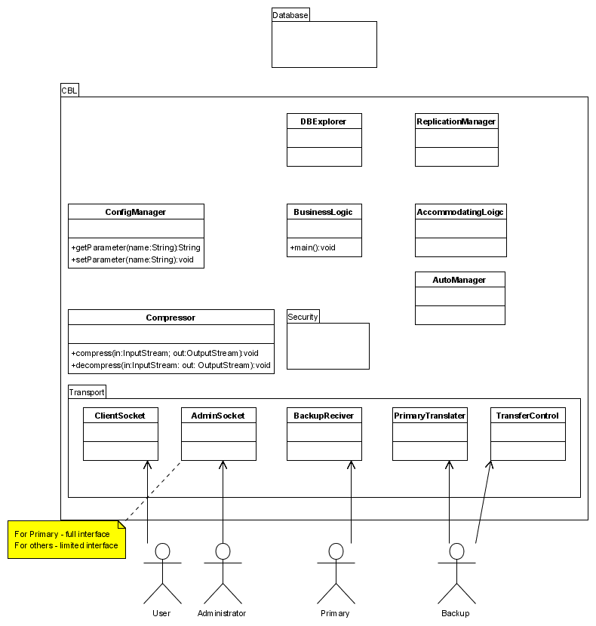

Picture 4. Class diagram of CBL module

  - Replication Manager – Responsible for data replication. Whenever there is a request that results in the change of the database, this component make sure that the changes are updated at the backup’s server.
  - DBExplorer – Provides functions, methods for updating/reading various data that are stored in the database. It is practically an interface between the CBL and the database.
  - Business Logic – It is used to decode the message sent either from a peer or from another CBL node. If it is a message produced as a consequence from a failure of a primary or backup server, it is sent to the subcomponent Accommodating Logic. Otherwise the message is processed by this component.
  - Accommodating Logic – Responsible for making decision after changing of the system state such as joining the group, crashes of the servers and primary backup switch.
  - Transport package – It provides the access interfaces to other entities in the system, to the peers, the Administrators, the Primary, and other backups.

ACBpoint module

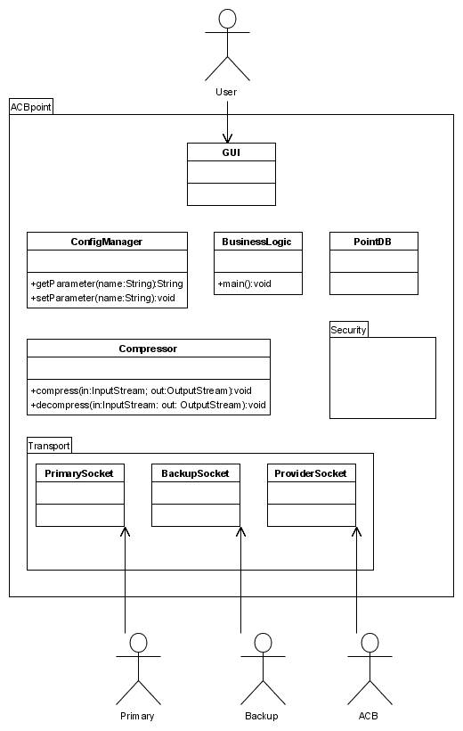
Picture 5. ACBpoint layers and classes

Each client (peer) has ACBpoint installed by Java WebStart. This is a GUI application which provides to the peer all the functionalities.

The layer PrimarySocket is used for sending request to the primary server concerning the following operations:

  - Register
  - Publish/Share
  - Billing

The layer BackupSocket is used only for communication with a random chosen backup server that will be queried for a search result.

  - Search

Therefore we are not loading the primary with a search request, since they require a lot of computational power, and not one specific backup, but randomly chosen in order to achieve load balancing. This is safe, because the search operations do not make changes, they are practically read queries.

The layer ProviderSocket is used between two ACBpoint modules in order to transfer documents.

  - Download

PointDB component provides methods for retrieving data stored locally on the client side.

Implementation

- High-availability

Primary backup approach is used to provide high-availability for the following functions:

  - Register
  - Publish
  - Search
  - Billing

Server (for billing)
2) Encrypt file
3) Begin Sell Transaction
4) Send file (encrypted)
5) End Sell Transaction
6) Charging consumer, adding money to provider (+1% commission)
7) Give the key
8) Decrypt file
1) Request File

Picture 7. Downloading and billing schema

Data is replicated on several backup servers; the number is defined by the owner of the system. More backups mean more fault tolerant system. Heartbeats were used in order backups to know whether the primary is alive or not. When primary is cut off from the network and after that he comes back, since it is not primary any more, it becomes backup and synchronize.

- Communication

Two low level functions take care for the Communication

  - SendRequest, SendResponse

Synchronous function thats sends a message to the specific peer/server

  - ReceiveRequest, ReceiveResponse

Synchronous function that receives a message from specific peer/server

- Security

During registration process public cryptography was used SSL, and for other process such as publishing, downloading and billing symmetric cryptography was used by triple-DES. For Authentication, we used Zero Knowledge protocol.

- Load-balancing

Each client is connected to a random server. Therefore, all requests executed in distributed way. The requests include registration, un/publishing information, and billing executed on Primary. Searching requests (and all other not so complex read-only requests) are executed on the Backups servers. Therefore, load-balancing is achieved.

Evaluation

Demonstrated sequences

The main goal was to show how 30597 lines of code in 141 files serve 1600 users. And the goal was achieved.
The sequence:
- CBLcc – Control Center for administrators.
- Extreme testing: 1600 users exploit the system and the Primary crashes (it is most complex case).
- ACBpoint – client application:
  - Registration;
  - Account Management;
  - Publishing;
  - Searching;
  - Downloading;
  - Billing.
- Free program (Q&A + scenarios on demand).

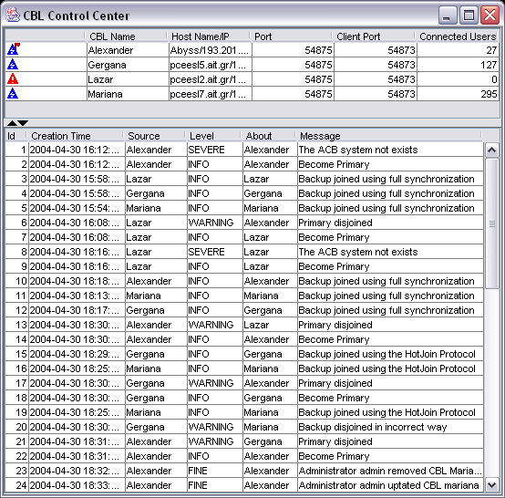

Picture 8. CBLcc – control center in real life

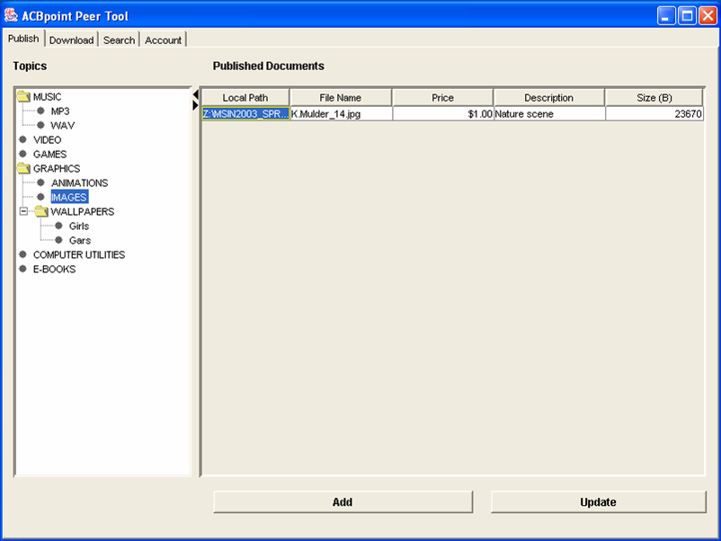

Picture 9. ACBpoint – Sharing

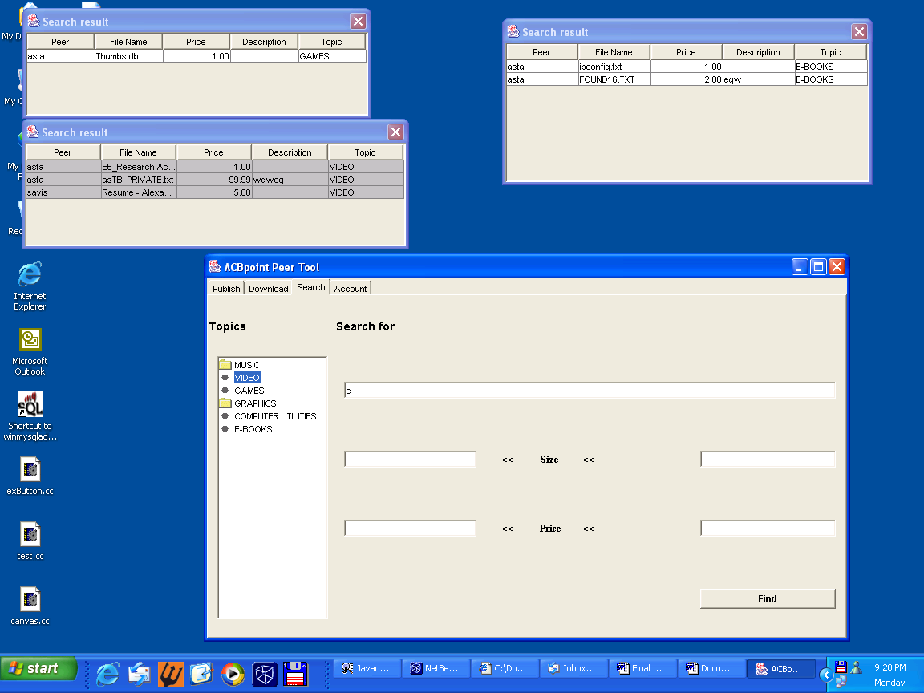

Picture 10. ACBpoint – Searching

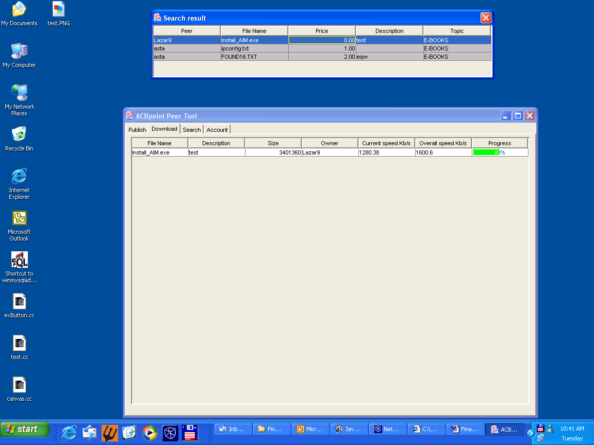

Picture 11. ACBpoint – Downloading

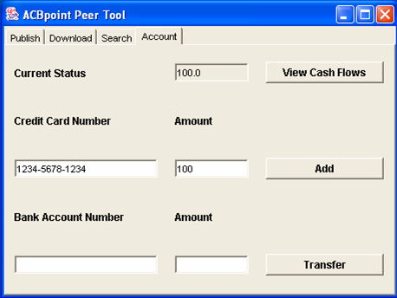

Picture 12. ACBpoint – Account Manager
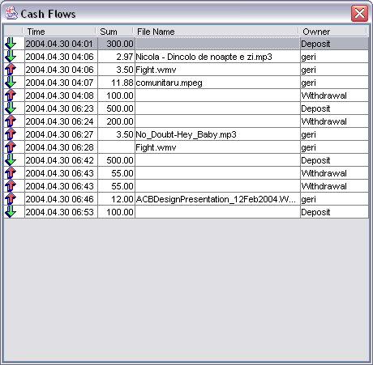
Picture 13. ACBpoint – Account Manager – Cash Flows

Quantitative performance results

The demo showed that four servers (one Primary and three Backups) could serve more then 1500 users, which send requests every 10 seconds. During these operations, links were broken, and the system reorganizes itself, so any loss of users was avoided.

Project Status

30597 lines of code in 141 files!

All planed features were implemented. They are situated inside three jar-files:

- ACBpoint.jar – client application;
- CBL.jar – server;
- CBLcc.jar – control center.

The system behaves robust and stable.

Summary and Future Work

We developed a stable and scalable system as shown from performance results. The system can be deployed any time and up and running without any delay.

We are recommending the following future improvements of the system:

- Changing the underlying database system of MySQL to more robust system, this supports transaction and referential integrity, because the simple MySQL does not support them.
- The communication layer is based on TCP/IP, and SSL. Since SSL is connection oriented, multicast can not be supported. Therefore, we are recommending implementing security layer that will allow multicast feature of the system.
- Adding ownership of the shared and downloaded documents, so the intellectual rights of the owner of the document are preserved. This can be done by watermarking.
- Efficient management of Topics, adding new topics can be approved by voting between the peers.
- Preview of each document. For example, for multimedia data such as video and music, the peer that is willing to buy it, will have an opportunity to see (hear) the first couple of minutes. For other types of documents, such as electronic books, the first couple of pages, or whatever is given by the author.
- Allowing the peers to upload any multimedia file to our servers, therefore adding streaming features to our system, evolving it in distributed multimedia content sharing. In addition, billing for such services will be paid accordingly.
- Playing multimedia data from ACBpoint directly
- Implementing features that will allow the peer to see not only what he is downloading, but also who is uploading from him, pause each transfer, cancel each transfer and set priority among transfers.
- Adding support for multiple money currencies. Now, the billing transactions are done using one currency, but allowing different peers to share documents under different currencies will make the system more flexible and international oriented. The billing process will use some trusted currency converter that will display ratio between currencies up to date.
- Adding additional information about the document, file, depending of the type, for example, for books, authors, style, for movies, directors, actors playing. In other words, depending on the type of documents, the peer enters different additional information, which later can be used during searching process. This way, the searching results will be more detailed.
- Starting with our primary goal of the system, creating market for peers to make money, the prices are set at beginning when a peer is sharing a document. Later the peer can change the price. Additional feature of the system will be bargaining, allowing peers that want to buy document, that can propose a price for the provider, and real market scenario can be supported, when providers and consumer are bargaining for a certain stock (“file”). This will make the system attractable for peers that are willing to buy under their own defined prices, therefore increasing the profit of everybody.

