

18-842 Distributed Systems

Design Document

For Project

Access Control & Billing

In Peer-To-Peer environment

A
C
B

By

TEAM

Team Members:

- Alexander Stasiv
- Gergana Krumova
- Lazar Adzigogov
- Mariana Marin
Version 1.0. 18/02/04
Table of Contents

Project Summary 3
System Environment (Actors) 3
Detected Problems in Peer-To-Peer networks 4
1. Communication 4
2. High Availability 4
3. Security 4
4. Fault Tolerance 5
5. Scalability 5
6. Management and Maintenance 6
6. Priority 6
Project Requirements 7
High-level project specification 7
Infrastructural features 9
System Design 10
High-Level Design 10
System Model (The Big Picture) 11
System Model description 12
Component / Layer Design 13
Database 13
Common Module 14
CBL module 15
ACBpoint module 17
Feature Implementation 19
Task Scenario 20
Unique Innovations 23
Project Demonstration 24
Intermediate Milestones 24
Final Project Milestones 25
Project Partitioning and Schedule 27
Responsibilities for each member 27
Schedule 28

Project Summary

Today there is a large explosion of p2p-based systems on internet. P2P networks as communication model connect together a large number of different computers. They provide an efficient way of storing and accessing large amounts of data, as demonstrated by the popularity of music file sharing networks such as KaZaa.

The main goal of our project is to implement features in the p2p environment such as authorization for accessing general type of information, authentication between the up loader-downloader and secure channel for transport of the encrypted information in order the content to be secured even if it is eavesdropped. In addition, our system will support billing/charging of information. The providers will state their own prices for a data (music, video, movie, etc) and in order this data to be accessed first the consumer must pay the price of the specific data. Therefore our system will support money transaction from one account to another with all related issues like security, fault tolerance and high availability.

The Project Web site:

http://www.andrew.cmu.edu/course/18-842/index.htm

Team Members:

Alexander Stativ:
mailto:asta@ait.edu.gr
http://www.ini.cmu.edu/people/AIT/MS15/Alexander_Stasiv.htm

Gergana Krumova:
mailto:gkru@ait.edu.gr
http://www.ini.cmu.edu/people/AIT/MS15/Gergana_Krumova.htm

Lazar Adzigogov:
mailto:ladz@ait.edu.gr
http://www.ini.cmu.edu/people/AIT/MS15/Lazar_Adzigogov.htm

Mariana Marin:
mailto:mmar@ait.edu.gr
http://www.ini.cmu.edu/people/AIT/MS15/Mariana_Marin.htm

System Environment (Actors)

- Owner of the system wants stable or growing profit
- Users (Providers) want securely share information and receive current amount of money from each download
- Users (Consumers) want securely search and download information and pay correct amount of money after each downloading
- Administrators want to be able to maintain the system

Detected Problems in Peer-To-Peer networks

1. Communication

P2P networks as communication model connect together a large number of different computers, pooling their resources. They provide an efficient way of storing and accessing large amounts of data, as demonstrated by the popularity of music file sharing networks such as KaZaa. One big drawback is that they are de-centralized, i.e. there is no central server that keeps tracks of all the information in the system. This means searching for information on these networks is slow and cannot guarantee to find information.

Proposed solution:

In our distributed systems specific dedicated nodes of the network will play role as storage facilities for keeping index of content of each node (user peer) that are sharing/selling general information.

2. High Availability

Services such as sharing / joining the group / searching must be available during more than 99% of time, in order to make profit of the owner. If one point of service is available, its failure will be the death of the entire system. Therefore, some kind of mechanism must be provided in order to ensure high availability.

Proposed solution:

Providing high availability can be achieved by data replication (Primary-Backup protocol). Our distributed system will have subsystem called “ReplicationManager”, which will expect dedicated node failures and deal with it by making multiple copies of the data, ensuring that end user will not see any node failures and will continue to use the system like nothing happened. Failure of one or more dedicated nodes will be transparent to the end user. We can not control a peer, therefore operation downloading can not be highly available.

3. Security

The distributed systems for sharing information raises the prospect of it being very easy to publish information anonymously, for example, pirated music and video. P2P networks can also allow a user to download and use copyrighted material in a way that violates intellectual property laws, and to share files in a manner that violates an organizations security policies. The notion of authentication, authorization, ownership arises. In addition, there are other threats that exist, such as viruses, worms, malicious programs, that spread very easily on file-sharing distributed systems and can cause malfunctioning of end user system, when they download some document.

Proposed Solution:

Our distributed system will provide authentication, meaning that the user who will download the file, will be assured that he is downloading from the right person, and the user who is giving the information, is assured that he allows copying of document to authenticated person.

In addition, encryption mechanism through authenticated channel will be used while the document is transported over the network, therefore protection against eavesdropping is ensured. Nobody else but the downloading person can be able to decrypt the document.

Features such as ownership of the document (by watermarking it) will not be supported because of long time expectation of developing these features.

4. Fault Tolerance

Failures such as link failures, server or peer crashes occur very frequently in the P2P environment. There is a need to ensure that such failures do not make the system neither malfunctioning neither incorrect.

Proposed Solution:

Fault tolerance will be provided for searching / sharing / managing account and billing operation. We can not control peers behavior, therefore operation downloading can not be tolerated.

5. Scalability

One of the requirements of every system is to be scalable. The performance of the system should not drop, if the number of the users increases and geographically the system expands its distribution.

Proposed Solution:

The system design is scalable. The reasons are that the most common and most difficult request in the system is searching. The system will be able to execute such requests in any server. Therefore if number of users’ increases, we just have to add more servers. The primary server can be hardly overloaded because it process only simple requests.

6. Management and Maintenance

Distributed Systems by definition are harder to maintain, since they are consisted of more than one node. There is a need to diagnose and locate problems very easily.

Proposed Solution:

Special kind of users, Administrators will be responsible for managing the distributed systems. The subsystems, ‘AccommodationLogic’, will be responsible for detecting failures, and reporting to the Administrators, the type of failure occurred and the measures taken, the failures was automatically fixed, or human interaction is required. For the administrators, specific software module will be implemented.

6. Priority

Since there will be many users in the distributed system, the Internet will be loaded with heavy traffic, not only by downloading, but also with control messaging. Should the distributed system support priority among users, in case where one user makes a lot of transactions/spends a lot of money, therefore downloading more documents, than the users that download only one document? Does the user with higher downloads have higher priority then other users?

This feature will not be supported because of long time expectation of developing this feature.

Project Requirements

High-level project specification

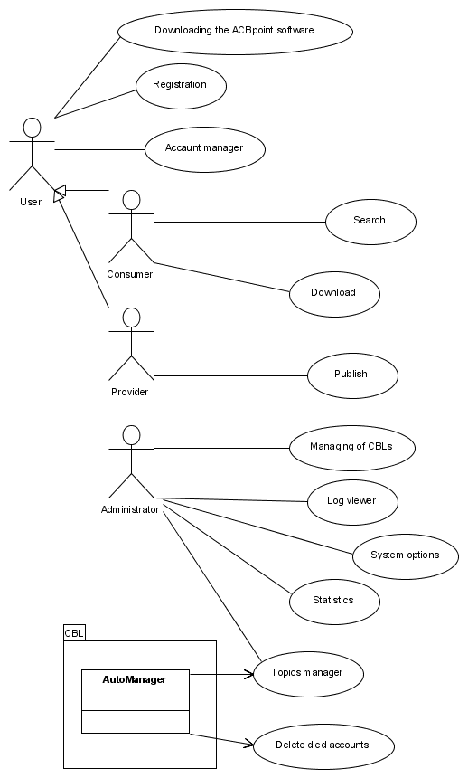
Picture 1. Use cases

One of the existing problems in information sharing p2p-based system on internet is how to manage secure access and bill the engaging parties. From the perspective of the end-user the system provides mechanism for:

- Publishing and management of their shared information

Each user can easily select which documents he/she is willing to share and define price for each document.

- Efficient search for required documents

There will be a search engine, efficient and easy to use, which will give report to the user, where the documents can be found/if they exist, which peers have them and their price.

- High-availability

Each user can query the system more then 99% of time. The system provides ‘one-copy’ semantics to the end-user, which means that all failures are masked for the peer and they see the system as one entity.

- Billing

The system will make sure that the engaging parties are satisfied with the transaction. The downloader which pays for the document will be protected by any misuse from the up loader peer, and vice versa, the up loader which gets paid will be protected from any misuse from the downloading peer.

- Secured access to the system

Each user will have its own pair of login name and password.

- Authentication of engage parties

Parties engaging in transfer of a document will know that they communicate to valid person, not an adversary.

- Segmented downloading

When the engaging parties exchange documents, if the transfer is interrupted, the next time they establish connection, the transfer continues where it was interrupted, not from the beginning.

- Document confidentiality

The transfer of the documents between the peers will be secured by encryption, in order to provide protection against eavesdropping.

Infrastructural features

- Communication

No Middleware will be used. The system will have its own protocol for communication between the nodes and among the servers. The protocol will be messages such as Send and Receive.

- High-availability/ Fault Tolerance

The System from the perspective of following functions will be highly available and fault tolerant

  - Register
  - Publish
  - Search
  - Bill

The Replication control subsystem will take care for failures such as power failures of any servers, loss of network connection for any server, therefore providing transparent high-availability to the end-user. The system will tolerate finite number of failures, which is defined by the owner of the system. Larger number of servers will guarantee large number of failures tolerance.

The following functions will not be highly available and fault tolerant

- Download

- Security

By default, Peer-To-Peer networks are open and therefore not immune to security attacks. The system will provide three levels of security:

  - authorization of users
  - authentication when peers exchange documents
  - Encryption on the transferring document protecting it against eavesdropping.

- Load-balancing

  - Search

The client will choose a random backup server (in time of joining the group) for the search query, in order not to send request only to one server.

System Design

High-Level Design

- ACBPoint – Client software (in user side)

- CBLs – chain of server software communicated using Primary-Backup Protocol

- Admin Tools – Administrator software for system maintenance

Since it is a p2p network, a user at the same time can be Provider/Consumer.

System Model (The Big Picture)
CBLs:
(servers)
ACBpoints:
(users)
Server of user certificates &
Billing register &
Locator

User node
Server of user certificates &
Billing register &
Locator

Server of user certificates &
Billing register &
Locator

Distributed database
Sockets (TCP/IP)

User node
Direct communication (initiated by using the CBLs)
Sockets (TCP/IP)

User node

User node
Sockets
(TCP/IP)
Web Server
(Apache)

Web Site for
advertisement & ACBpoint downloading

User node
(Out of the system)

Administrators
Sockets
(TCP/IP)
Picture 2.
System Model

System Model description

The following solution gives the overall idea and the usage of the system in practice.
The proposed name for the project is ACB (Access Control & Billing).

Our p2p billing system will be used by two types of users: Providers and Consumers. A provider is a user that wants to share (sell) information (music, documents, video, movies, etc) for a given price and for a given speed of downloading. A consumer is a user that searches for particular information and if he/she is willing to buy the found document, he/she pays for it. A user can be a provider/consumer at the same time. A user becomes provider by downloading application called ACBPoint node, which enables the user to specify which documents he/she wants to sell for specified price. This module updates this information to a specific server called CBL (Certificates, Billing, and Locator), where practically the user accounts is created with the information/prices that he offers. The downloaded module also provides confidentiality (encryption mechanism), when a particular consumer wants to download specific document from the provider. A user connects to the system as a consumer in the same way, and after successful authentication (signing in process was successful, here he puts the amount of money he has), the ABC offers to the consumer some kind of search engine in order to help the user to find the requested general information. If the consumer found what he was looking for and is willing to pay for it, it establish secured authenticated channel with the provider and downloads the document. All the information about the users sharing information and completed transaction will be stored in a database.

The system will be managed by special users (Administrators), which will take care for the chain of p2p CBL servers that hold the user’s information’s (configuring and maintenance). There will be special application (GUI) for this purpose.

Component / Layer Design

Database

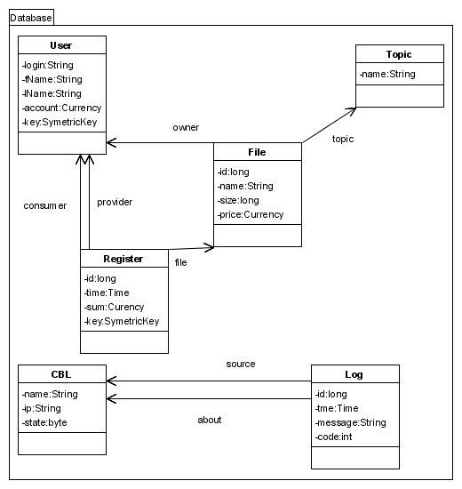
Picture 3. Class diagram of Database

  - User – contains users account.
  - File – contains list of shared files
  - Topic – contains possible topics of files
  - Register – contains performed operations
  - CBL – contains list of CBL’s with all related information like state of a CBL (primary / backup / joining / off-line)
  - Log – contains most important system events (such as crashes of CBL, joining of a CBL, etc)

Common Module

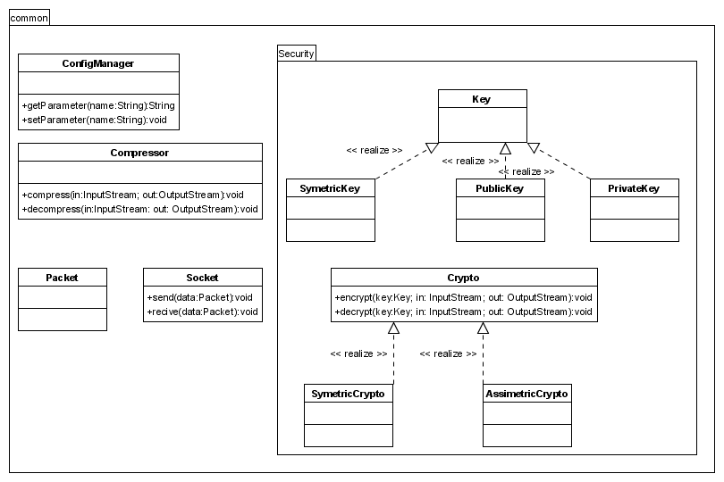
Picture 4. Class diagram of common module

  - ConfigManager – Reads/Sets parameters that control the behavior of CBL. These parameters are stored locally at each CBL node.
  - Compressor – Since there are large messages, in order not to load the network with a lot of traffic, every message before it is sent it is compressed, and each received message is decompressed.
  - Security – Each message after it is compressed it is encrypted, in order to ensure that the any adversary does not do any harm. Upon receiving the message is decrypted.

CBL module
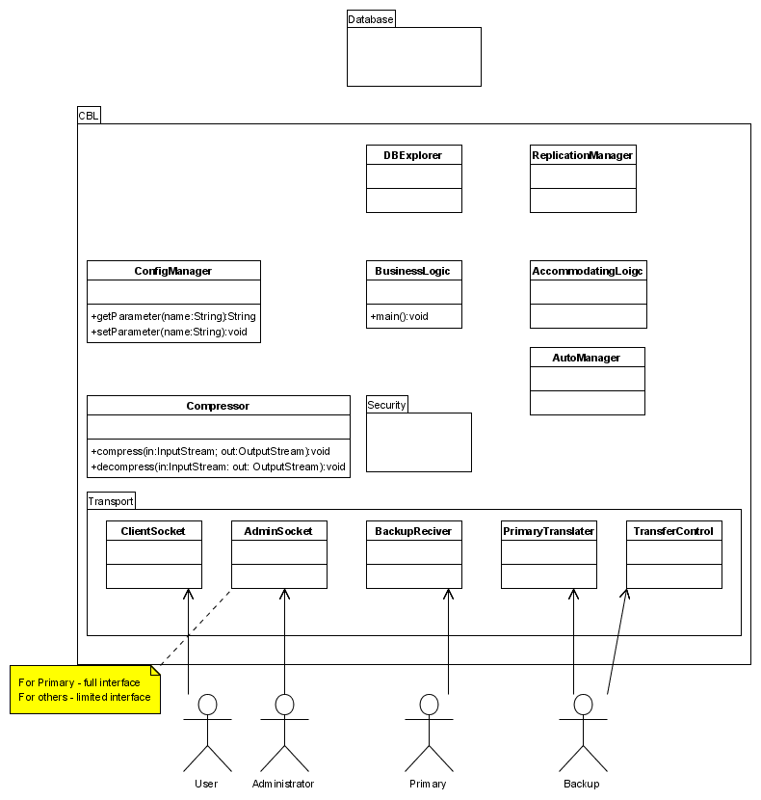

Picture 5. Class diagram of CBL module

  - Replication Manager – Responsible for data replication. Whenever there is a request that results in the change of the database, this component make sure that the changes are updated at the backup’s server.
  - DBExplorer – Provides functions, methods for updating/reading various data that are stored in the database. It is practically an interface between the CBL and the database.
  - Business Logic – It is used to decode the message sent either from a peer or from another CBL node. If it is a message produced as a consequence from a failure of a primary or backup server, it is sent to the subcomponent Accommodating Logic. Otherwise the message is processed by this component.
  - Accommodating Logic – Responsible for making decision after changing of the system state such as joining the group, crashes of the servers and primary backup switch.
  - Transport package – It provides the access interfaces to other entities in the system, to the peers, the Administrators, the Primary, and other backups.

ACBpoint module
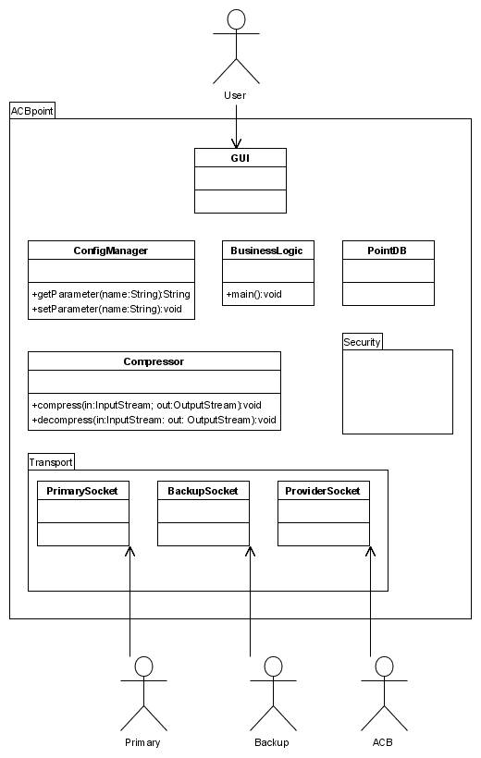
Picture 6. ACBpoint layers and classes

Each client (peer) will have ACBpoint installed. This will be a GUI application that will provide to the peer all the functionalities.

The layer PrimarySocket will be used for sending request to the primary server concerning the following operations:

  - Register
  - Publish/Share
  - Billing

The layer BackupSocket will be used only for communication with a random chosen backup server that will be queried for a search result.

  - Search

Therefore we are not loading the primary with a search request, since they require a lot of computational power, and not one specific backup, but randomly chosen in order to achieve load balancing. This is safe, because the search operations do not make changes, they are practically read queries.

The layer ProviderSocket will be used between two ACBpoint modules in order to transfer documents.

  - Download

PointDB component provides methods for retrieving data stored locally on the client side.

Feature Implementation

- High-availability

Primary backup approach is used to provide high-availability for the following functions:

  - Register
  - Publish
  - Search
  - Billing

Data is replicated on several backup servers; the number is defined by the owner of the system. More backups mean more fault tolerant system. Heartbeats will be used in order backups to know whether the primary is alive or not. When primary is cut off from the network and after that he comes back, since it is not primary any more, it will become backup and synchronize.

- Communication

Two low level functions will take care for the Communication

  - SendPackage

Synchronous function which sends a message to the specific peer/server

  - ReceivePackage

Synchronous function which receives a message from specific peer/server

- Security

During registration process public cryptography will be used using DSA method, and for other process such as publishing, downloading and billing symmetric cryptography will be used by RC4. For Authentication MAC is used.

- Load-balancing

Each client will be connected to two servers, to primary which will be used to handle request that requires updates to the database. These requests include registration, un/publishing information, and billing. Searching requests are sent on the backups servers. Therefore load-balancing is achieved.

Task Scenario

- Registering a new user, publishing new information

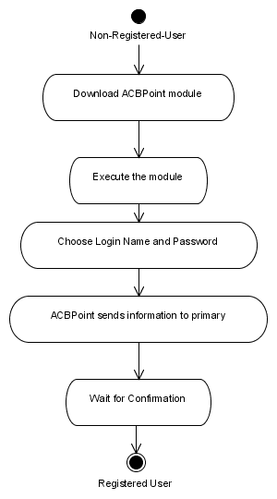
Picture 7. Activity Diagram for registering new user

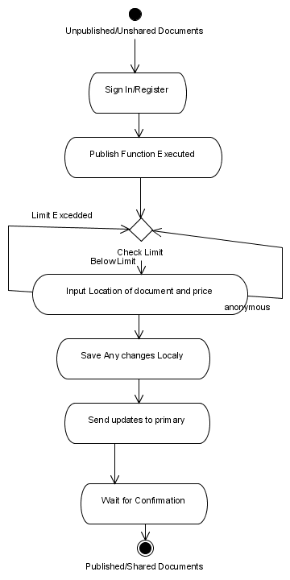
Picture 8. Activity Diagram for sharing information

The new user will download the client module (ACBPoint) from specific web-site. When the module starts, a user chooses its own login name and password. The module connects to the primary server, registers the user. After successfully registering the user, the ACBPoint offers to the user via its GUI, possibility to state which documents he/she wants to share and their price. New dialog is opened for this purpose, where the peer specifies the directory where the document is located and the price. The number of documents that a user can share is limited by the owner of the system, and the peer is not allowed to exceed this limit. This information is locally stored on the peer system and after the peer finishes with sharing, this information is updated to the primary server. The primary by default updates the backups.

- Engaging (Billing) two parties
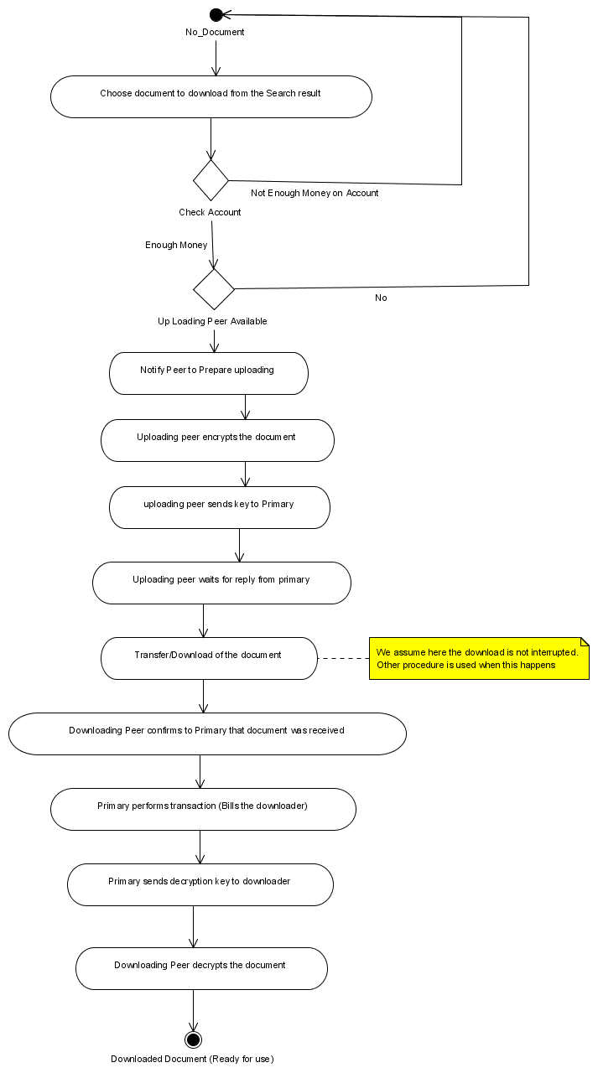
Picture 9. Activity Diagram for Downloading

After successful search operation, if the peer decides that he/she wants to download the desired document the system checks the following precondition before starting the download. If the other peer is active, then communication is established between the two peers only if the calling peer has credit on his account more than it is needed to pay the downloading document. Otherwise the peer is notified to increase the cash on his account and the connection is not established. If preconditions are meet, direct link using TCP/IP is established to the other peer and downloading process starts. The document is encrypted while it is being transferred. If there is a failure, there is no network or the peer disconnects himself from the network, or a link failure occurred, downloading stops. It will continue when both the peers are available. The downloading will continue where it stopped, not from beginning. After downloading is finished, the downloading ACBpoint make a transaction from the downloader account to the up loader account, the billing process, and receives decryption key from the primary. This mechanism is used to avoid any misuse from both engaging parties. In addition, the account of the owner is increased by the appropriate provision per transaction defined by the owner on the account of the downloader.

Unique Innovations

Although our system uses Primary-Backup approach for most of the features, one of the most exhaustive operations that requires a lot of computing power (“Searching”) is not executed on the primary server, but the client ACBpoint chooses random backup server on which the request is sent, therefore achieving load-balancing. This will be safe, from view point of state consistency of the entire system, because searching operations do not affect the state, they do not change anything. As we are not aware of this feature in other systems, we consider it unique feature to our system.

In addition, since we are supporting “Billing”, and these feature is not jet widely available on p2p networks, we consider it also unique capability.

Project Demonstration

Intermediate Milestones

The intermediate demonstration will show the basic functionalities of the system.

- Failure Free scenario

  - Installing the system

Administrator will present setting servers, adjusting system options.

  - Register two new users (peers)

Two users will download the required module and independently will register

  - Publish/Share documents with a given price

Each user will state what type of information he/she is sharing and their price

  - Downloading

One user will download a file from the other peer

- Failure Tolerant

None of these features will be implemented.

Final Project Milestones

The final demonstration will show the fully functional system with all required features implemented

- Failure Free scenario

  - Every scenario from intermediate demo but with more peers

  - Several users will search

One user will search for one type information, another one for different type, third one for something else.

  - Download/Billing initiated by the first user

The peer that was searching initiate download from the other peer

  - One User will manage his Account

How much one peer sold/spent during his life time as a peer in the existing p2p network? Deposit/Withdraw from his account.

  - Administrator maintenance

Viewing Log Viewer, taking maintenance measures, changing system options, viewing statistics

- Failure Tolerant

Failures are masked; the peer does not see them

  - Failure of Primary (disconnecting the network cable) during peer request to Sign In.

The Peer request to Sign In was lost. The Client will not see that the ACBPoint will initiate the same request to another backup server (with lowest IP address), which will become now primary, and will reply successfully. The Peer will not see the failure, it will be masked, but his request will be processed.

  - Failure of Primary (power down) during Publishing request

Similar like previous, the user will not see that the ACBPoint will initiate the same request to another backup server (with lowest IP address), which will become now primary, and will reply successfully.

  - During Billing, failure of the downloading peer

After downloading finishes, the Peer disconnects from network. Because there was no transaction made for billing, the downloading peer does not have the key for decryption; therefore he can not use the downloaded document. The peer must connect again, then the transaction will be made, and the key will be delivered.

Project Partitioning and Schedule

Responsibilities for each member

Module | Package/Class | Member(s)
Common | ConfigManager | Alexander
Common | Compressor | Mariana / Gergana
Common | Packet | Alexander
Common | Security | Mariana
CBL | Database | Gergana
CBL | DBExplorer | Gergana / Mariana
CBL | ReplicationManager | Alexander
CBL | BusinessLogic | Alexander
CBL | AccomodatingLogic | Alexander
CBL | Transport | Alexander
CBL | AutoManager | Alexander
ACBpoint | GUI | Lazar
ACBpoint | BusinessLogic | Lazar
ACBpoint | PointDB | Gergana / Mariana
ACBpoint | Transport | Lazar
AdminTools | GUI | Lazar
AdminTools | BusinessLogic | Lazar / Alexander
AdminTools | Transport | Lazar / Alexander
Site | Design | Alexander
Site | Information | Gergana / Mariana
Documentation |  | Gergana / Mariana / Lazar

Schedule

Week | Period | Iteration | Planed Activities
before 6 | up to Fri 20/02 |  | Design phase / studying development tools
7 | Sat 21/02 – Sun 29/02 | 0 | Building the core and establishing “vertical”:  Common: Packet, Socket, ConfigManager  CBL: Database, DBExplorer, BusinessLogic, ClientSocket  ACBpoint: BusinessLogic, Registration
8 | Mon 01/03 – Sun 07/03 | 0
9 | Mon 08/03 – Sun 14/03 | 1 | Adding main features:  Common: Security  CBL: Primary-Backup (without TransferControl) AccomodationLogic  ACBpoint: Sharing, Downloading
10 | Mon 15/03 – Thu 18/03 | 1
10 | Fri 19/03 | 1 | Intermediate Project Presentation
11 | Sat 20/03 – Sun 28/03 | 2 | Adding features:  CBL: AutoManager, Searching, TransferControl  ACBpoint: Searching, Account manager, PointDB
12 | Mon 29/03 – Sun 4/04 | 2
13 | Mon 5/04 – Sun 11/04 | 3 | Adding final features:  Administrative tools, Site development  Common: Compressor
14 | Mon 12/04 – Sun 18/04 | 3
15 | Mon 19/04 – Sun 25/04 |  | Final testing and documentation
16 | Tue 27/04 |  | Final Project Presentation

