Name:

15-200 Exam #3
Kesden (Sample)

- The following method is taken from the departmental exam pool, please implement it. Assume that you are within the framework of the departmental exam. Should you need instance variables, just declare them above your implementation of the method.

public ExtendedBST cloneTree()

Creates and returns an exact copy of the tree. This copy organizes the same items and has the same structure. It does not duplicate the reference data stored within each Node. Instead, it duplicate only the tree and the nodes it contains
This method does not change any of the items or the structure of the original tree.
In the event of an error, it returns null.
Returns:
an exact copy of the tree. This copy organizes the same items and has the same structure.

- Please show the BST generated by adding the following numbers in the order shown:

5, 2, 7, 9, 11, 12, 4, 1

- What is the problem solved by the topological sort? In other words, what does it do? You may use example applications to illustrate your description – but your description must stand, by itself, without the example applications.

- What is a spanning tree?

- Given the graph below, please draw a minimum spanning tree

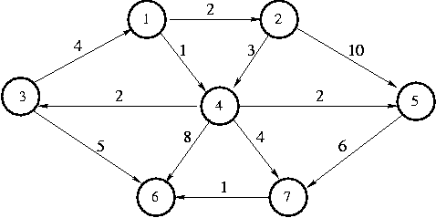

- Given the graph above, please illustrate the finding of any minimum spanning tree by Prim’s algorithm (the one with no table). Please show the critical data structure as the algorithm progresses and label each step.

- Given the graph above, please illustrate the finding of any minimum spanning tree by Dijkstra’s algorithm (the one with the table). Please show the table as the algorithm progresses and label each step.

- What is a greedy algorithm? In other words, what distinguished greedy algorithms from other classes of algorithms?

- Which traversal uses a queue, a depth-first search or a breadth-first search?

- You are given a map of cities and the highways connecting them, as well as a labeling indicating the drive times along each individual highway. Your goal is to build a program that, given a pair of cities, reports the drive time along a directly connecting highway, if any, or “No connecting highway”, none. The program should report as quickly as possible. What representation do you use for the map? We discussed three in class.

- In selecting, above, the data structure that you did, what were the trade-offs, if any, as compared to the other two possibilities?

- Name two methods present in most any applet and explain the role of each

- What is a Listener? What is its role in applet programming?

- Please produce a code segment that creates a TextArea and adds it to the applet.

