Sep. 9, 2005-- CMU Entertainment Technology Center talks about the Interbots Initiative.

The presentation started by questioning something I never had -- “aren’t animatronics boring compared to what they could be?” Animatronics are often poked at in popular culture. Take Tim Burton’s “Charlie and the Chocolate Factory” for example: remember Wonka’s awful animatronics show that eventually caught fire? But I had never wondered if these fiery little bundles of dancing-metal happiness could be improved upon. Animatronics has always been for Chuck E. Cheese’s 3-and-under crowd. ...until Interbots.
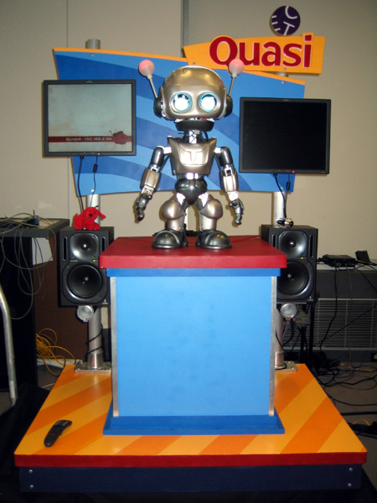
The Interbots Initiative is a program that has a group of grad students work on a single task for an entire semester. Out of a few sequential semesters of this, Quasi was fabricated. Quasi is an animatronic born from a drama mother and an engineer father. He has both a technically sound, cost-effective design and the ability to connect with humans on an emotional level. “CMU is all about interdisciplinary study blah blah blah.” Hey whaddya know? It’s true! The grad students working on the project range from computer scientists to entertainers to drama students to cognitive scientists. The professor of computer science that was co-heading the operation noted that he shared an office with the drama professor also working on the project for (I think it was) 10 years. When, a few years ago, a group of students approached these professors with the idea of making a better, more cost-effective animatronic, CMU had its work cut out for it.
They identified two major problems with animatronics as they are currently known. Not only do they cost a LOT of money (Disney spending some millions of dollars on them every year), but they are also ...well...robotic. They can say funny things, but they can’t truly connect with the audience. Quasi would change all of this. The main drama professor gave the students an initial challenge: their “robot” had to be mute. It had to get information across to its audience without making a sound.
Quasi is able to display five main emotions: angry, happy, sad, confused, and lonely [I believe]. And he displays them amazingly well, without any noise. He is able to change the color of his antennae and eyes, change his body position and antennae position, and change the shape of his eyes (using two covers, one on top, one on bottom...like eye lids). When he’s angry, he looks angry. It’s enough to scare a young child...and perhaps enough to one day take over the world... Anyhow, in order for Quasi to be able to display these emotions so well, his creators spent months researching animal facial behavior and fine-tuning him.
There are two versions of Quasi. The first sits in an interactive booth, and is completely autonomous. He will hold conversations (basic ones) with people, sing with them, and give them candy. The second version is the one that was displayed at the presentation. He is controlled by a “puppeteer,” who holds a touch screen and is able to move and shake Quasi at the touch of a stylus pen. Quasi also has a voice-changer equipped, so the puppeteer can speak into a headset and Quasi will speak (and his mouth will move correctly) with the voice of a 12-year-old robot.
The main thing that attracts people to Quasi? He is darn cute. Even when powered down, Quasi seems like a nice guy that you would want to have a conversation with. This is where the drama and design departments came in -- creating a shell that was both visually attractive and emotionally stimulating. When Quasi is powered on (and yes, I deliberately avoided saying “turned on”), he is able to move and interact with people in a very non-mechanical way. This was the work of the engineers and the computer scientists. When this is all put together, Quasi is the best animatronic character known today. At one presentation, the guys who did the animatronics for Jurassic Park spent several hours in Quasi’s booth. The soon-to-be-famous robot was asked to be the mascot for The World’s Fair for Kids. When Quasi is displayed, people will come up and talk to him, and then to the researchers and the puppeteer controlling him. But when they leave the booth, after saying good bye to the creators, almost everyone turns around and bids good bye to Quasi, the pile of metal, plastic, and cables that can connect on an emotional level with humans.

