Fibrous proteins - highly elongated molecules whose secondary structures are their dominant structural motifs. Collagen is an example of a fibrous protein that plays a key connective and supportive role in all multi-cellular animals. In vertebrates, it is the major protein component of connective tissue and constitutes 25% of total protein.

Pro-Collagen Triple Helix

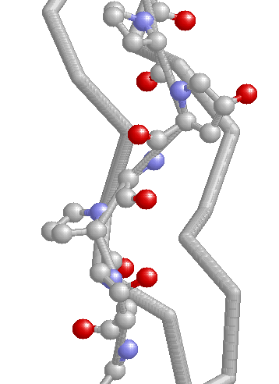

The stability of the collagen fiber, consisting of Gly-X-Y, depends on inter-chain H-bonds. In addition, Y is often an hydroxylated Pro residue. Hydroxylation (vitamin C dependent) is also critical for stability of the collagen helix. In absence of vitamin C, scurvy results. Symptoms include skin lesions, fragile blood vessels, loss of teeth and bleeding gums.
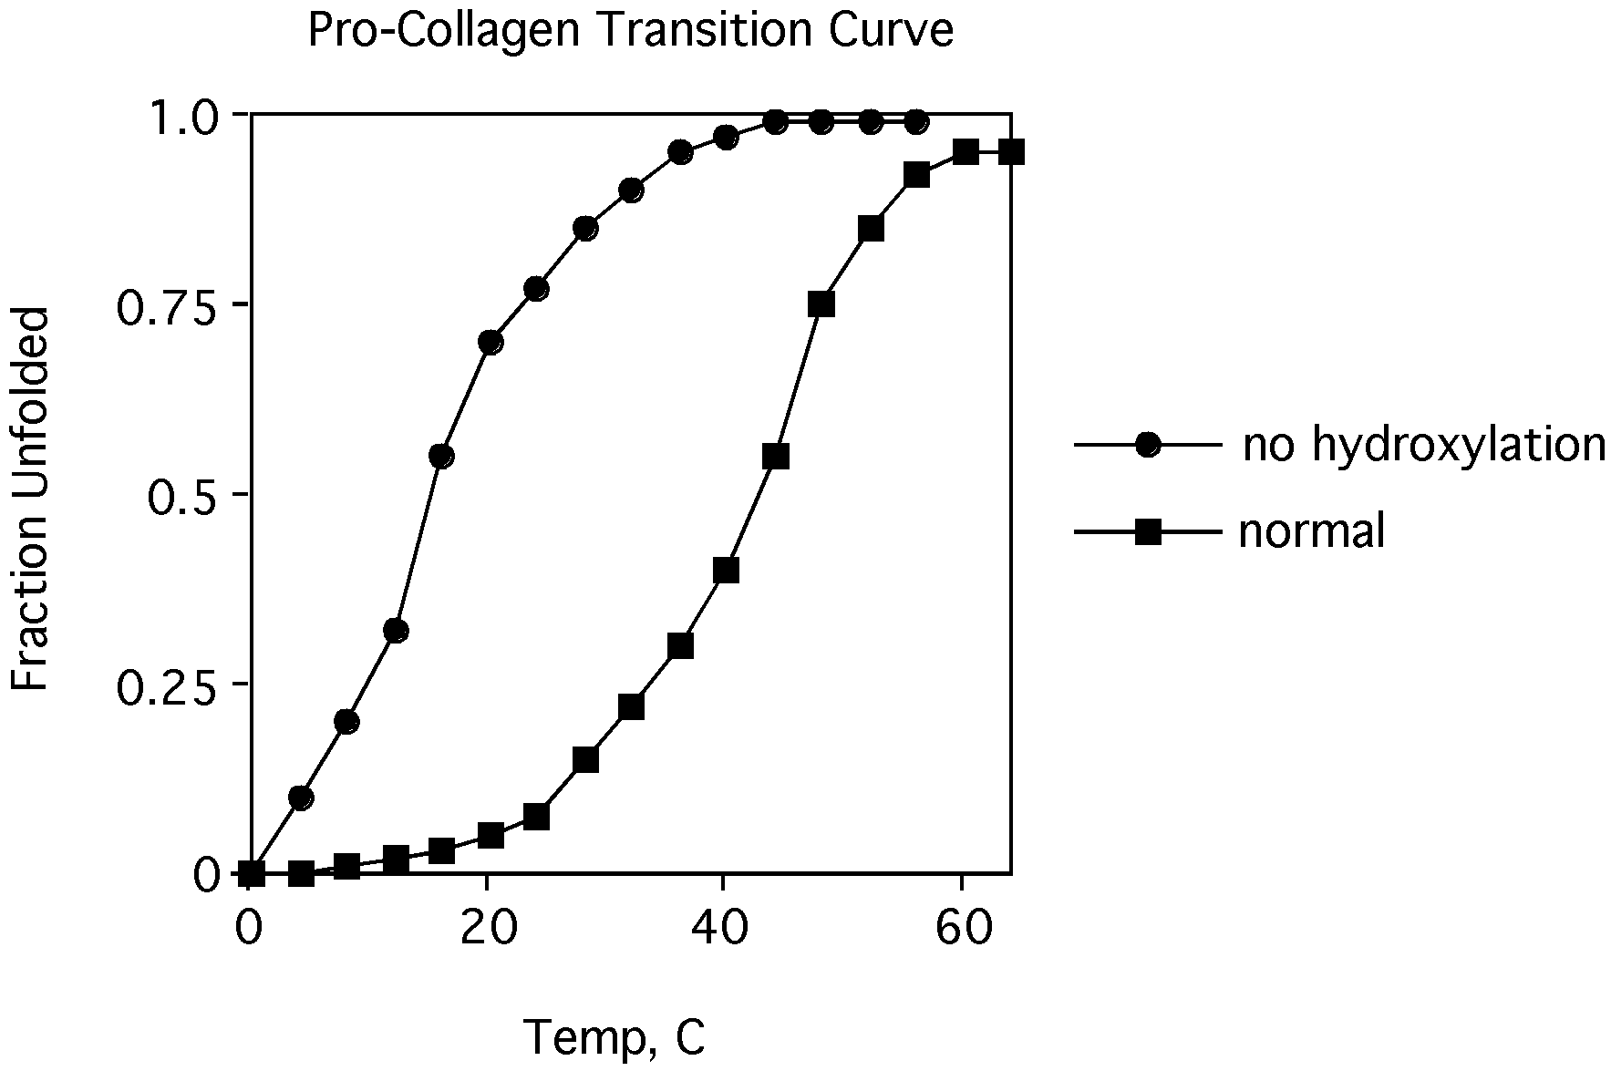

Is loss of protein stability in absence of Pro hydroxylation due to a change in ΔH or ΔS?

