Unit 1 – Forces in 1D (Student Sheet)

Engineering Statics in Physics Project
Carnegie Mellon University and Pittsburgh Area Schools

Paul S. Steif, Carnegie Mellon University
Janet R. Waldeck, Pittsburgh Allderdice High School

© July 8, 2013 Paul S. Steif and Janet R. Waldeck. All rights reserved.

1.1.1. Use two fingers to hold a bungee cord. Keep the right finger stationary and move the left finger to stretch the cord.
Right
finger
Left
finger
Cord initially unstretched

Cord stretched by left finger

Draw arrows to represent the forces on the fingers and the hooks.

1.1.2. Use two fingers to hold a bungee cord vertically. Keeping the top finger stationary, move the bottom finger downward to stretch the cord.

Top
finger

Cord initially unstretched

Cord stretched by bottom finger

Bottom
finger

Draw arrows to represent the forces on fingers and hooks.

1.2.1. A bowling ball is rolling to the right. Can the palm of this hand slow it down?
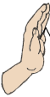
Yes____ No ____

1.2.2. A bowling ball is rolling to the right. Can the palm of this hand speed it up?
Yes____ No ____

1.2.3. A bowling ball is rolling to the left. Can the palm of this hand speed it up?
Yes____ No ____

1.2.4. A bowling ball is rolling to the right. Can the palm of this hand speed it up?
Yes____ No ____

1.2.5. A bowling ball is rolling to the right. The two palms briefly press against the ball and it slows down.

Draw (on the figure shown below) all of the forces between the ball and the palms while they were in contact. The hands have been separated from the ball in this image to make it easier for you to draw the forces on each body separately.

Which of the forces on the ball was greater?

Due to palm at the left _____ Due to palm at the right _____ Cannot determine_____

1.3. Rest a block on your hand.

Draw arrows to represent all of the forces that involve the block and provide each arrow with a label (such as “block” or “hand”) that identifies the cause of the force.

Have you included all of the forces that act on the block?
Yes_____
No _____
If no, name other bodies exerting forces on the block _________________________

Have you included all of the forces that act on the hand?
Yes_____
No _____
If no, name other bodies exerting forces on the hand _________________________

1.4.1. Hold a small bucket stationary by resting it on the palm of a hand while pulling up slightly on the handle.

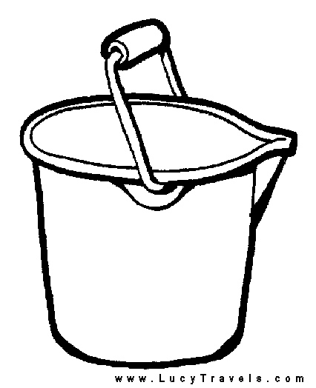

Draw arrows to represent all of the forces involving the bucket and give each an appropriate label.

Because the forces on the stationary bucket must sum to zero,

- the largest force is ______________ or check if you cannot determine____
- the smallest force is______________ or check if you cannot determine____
- Explain your answers to a) and b): _________________
1.4.2. Hold a block stationary by squeezing it between two hands as shown.

Upper hand

Lower hand

Draw arrows to represent all of the forces involving the block and give each an appropriate label.

Because the forces on the stationary block must sum to zero,

- the largest force is ______________ or check if you cannot determine____
- the smallest force is______________ or check if you cannot determine____
- Explain your answers to a) and b): _________________

1.5.1 Stand on a bathroom scale and record the reading. What does the scale measure?
Scale 1

Scale Reading = __________

The scale measures ___________

__________________________________

__________________________________

Stand on one scale and press down with your hands on a second scale. Press hard enough so that Scale 2 steadily reads at least 20 lbs. Record the two readings and use them to draw an FBD on the person’s outline shown below. Write down the summation of vertical forces, with positive sign for upward forces and negative sign for downward forces.

Scale 2

Scale 1 Reading = __________

Scale 2 Reading = __________

Scale 1

Sum of vertical forces on you =
How can you use your recorded observations to show that the person is in static equilibrium?

In this situation, what does the first scale measure?

What does the second scale measure?

1.5.2 Place a weighted bucket on a food scale. Record the bucket’s weight in the table below. Attach a spring scale to the bucket’s handle and pull upwards gently to reduce the food scale’s reading slightly. Record the readings from the spring scale and the food scale in the second row of the table below. Repeat this four additional times, pulling a little harder on the spring scale each time and recording the readings from both scales in the table below.

Record forces (in Newtons) in the first three columns for several levels of spring scale.

Bucket weight | Spring Scale Force | Food Scale Force | Sum of vertical forces

Draw an FBD of bucket. Label the forces as follows: bucket weight W, spring scale F_{spring}, and food scale F_{scale}.

Write down the summation of vertical forces, with positive sign for upward and negative sign for downward, in terms of the force labels above.

Evaluate the summation of vertical forces for each row in the table above and enter in the final column. Is the summation close enough to zero that it is due to uncertainties in the scale measurements or did you make an error?

1.5.3: Blocks hanging from scales

In the sketches below, an oval represents a spring scale and a square represents a block. Using the arrangement of one scale and one block, determine the block’s weight.

A

For each of the arrangements of blocks and scales shown below, record the forces in each scale. Then, in each case, draw a separate FBD of the scales and blocks indicated by the arrows. Use the measured scale force for each scale and the measured weight of the block. Show how the system in each FBD is in equilibrium.
A
B
C
Case 1
Case 1
FBD’s
C
Scale C : _____ N
Scale B : _____ N
Scale A : _____ N
B
A
FBD’s
Scale C : _____ N
Scale A : _____ N
Scale B : _____ N
C
B
A
Case 2
A
B
C
Case 2
FBD’s
C
A
Case 3
A
B
C
Case 3
Scale C : _____ N
Scale B : _____ N
Scale A : _____ N
B

