Problem Set 8 - Due Tuesday November 12 Time required ~ 70 min.
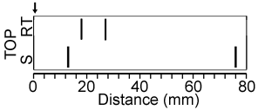
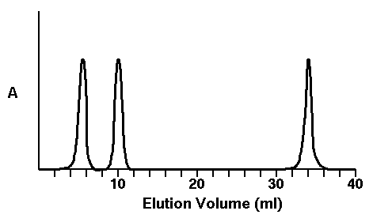
1. (17 pts, 25 min) Two experiments were performed to determine the quaternary structure of HIV reverse transcriptase. In these experiments, HIV reverse transcriptase was mixed with equal masses of two proteins with known molecular weights of 10 KDa and 80 KDa (i.e. molecular weight standards). Both of the standard proteins consisted of a single polypeptide chain. This mixture was then separated by size exclusion or by SDS-PAGE electrophoresis. Note that molecular weights determined by either technique are generally accurate to within ~10%.
Size Exclusion Column: The absorption at 280 nm, as a function of the elution volume, is shown to the right. The 1st peak is the HIV reverse transcriptase. This was determined by incubating that fraction with RNA and the building blocks for DNA and detecting the production of DNA.
SDS-PAGE. The SDS-PAGE gel is shown on the right (turned sideways). The bands indicate regions of the gel that are stained with a stain for protein. The thicker the band, the more protein. The arrow marks the top of the gel (where the mixture of proteins would be applied to the gel before the electric field would be turned on). The lower scale gives the distance from the starting point. The lane marked S contains the standards. The same pattern was seen whether BME was present or not.
i) Would the assay that was used on the size exclusion column work to determine which bands are reverse transcriptase in the SDS-PAGE gel? Why or why not? (2 pts)
ii) Use the SDS-PAGE gel to determine the molecular weight(s) of the polypeptide chains that are present in this enzyme. Be sure to show your work (5 pts).
iii) Use the elution profile from the size exclusion column to determine the native molecular weight of reverse transcriptase (5 pts).
iv) Determine the quaternary structure of HIV reverse transcriptase by combining the information from the size exclusion data with that from SDS-PAGE. Indicate the presence of any disulfide bonds. Please show your work (5 pts).
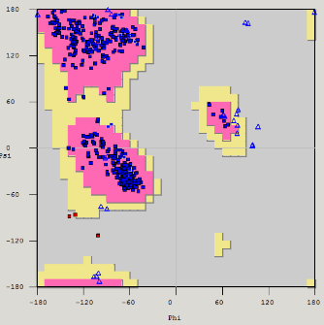
2. (5 pts, 10 min) An electron density map can be viewed on a Jmol page by selecting the link to jmol_xray on the Jmol link page. The buttons on this page will trace the main-chain through this electron density as well as give you some choices regarding the sidechain of the residue. Determine the amino acid sequence that best fits the experimental electron density. Briefly justify your answer.
3. (5 pts, 5 min) We recently determined the structure of a protein in our lab and the Ramachandran plot for the final fitted structure is shown on the right. Is our model of the structure likely correct, or not? Briefly justify your answer.
4. (5 pts, 5 min) Draw the reduced Haworth representation for the L form of the monosaccharide sugar shown on the extreme right. Assume the configuration of the anomeric carbon is α.
5. (5 pts, 5 min) Name the disaccharide shown to the right.
6. (5 pts, 5 min) Corn oil is a triglyceride with a high concentration of linoleic acid (C18:2 cis,cis-Δ⁹,Δ¹²) as the fatty acid component. Draw the triglyceride and explain why corn oil is a liquid at 20 C.
7. (5 pts, 5 min) Corn oil margarine, a substitute for butter, can be made by chemically altering corn oil. The reaction does not change the number of carbons, but raises the melting temperature so that margarine is a solid at 20 C. What is the chemical alteration?

8. (8 pts, 15 min) View the Jmol page that displays the membrane protein bacteriorhodopsin by following the link to jmol_br. The following is the polypeptide sequence of part of one of the α-helices in this protein.
Trp₇₉-Ala₈₀-Arg₈₁-Tyr₈₂-Ala₈₃-Asp₈₄-Trp₈₅-Leu₈₆-Phe₈₇-Thr₈₈-Thr₈₉-Pro₉₀-Leu₉₁
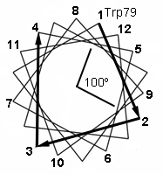
i) Beginning with Ala₈₀ as the second residue, write the name of the amino acid on the ‘helical wheel’ that is shown on the right (Trp₇₉ has been done for you). The helical wheel represents a “top view” and shows the projection of amino acid sidechains from the helix with a line connecting sequential residues.
ii) The angle between successive spokes or positions on this wheel is 100º. Why? (Hint: Consider the geometric properties of an alpha helix.)
iii) View the Jmol page and circle the residues names on the wheel that point outward from the protein towards the lipid and indicate whether they are predominately polar (p) or non-polar (np).
iv) In what way does the pattern of polar and non-polar residues on the helical wheel relate to the orientation of the helix with respect to the lipid acyl chains? Why is this arrangement energetically favorable?
9. (8 pts, 15 min) A peptide that is 20 residues in length is mixed with pure lipid bilayers in aqueous solution. The concentration of the peptide in the membrane and in solution is measured. From this measurement it is possible to calculate an equilibrium constant for the transfer of peptide from the solvent to the membrane (this type of equilibrium constant is often called a partition coefficient): K_{EQ} = [P_{Membrane}]/[P_{H2O}]. Note that the peptide is either completely in solution or completely buried in the membrane, as indicated in the diagram on the right that shows the equilibrium for Phe₆ (part ii assumes a different composition, i.e. Ala+Phe).
i) What secondary structure will a 20 residue peptide most likely assume in the membrane? (Hint: what is the relationship between the length of a helix or strand and the width of a typical biolayer?) (2 pts).
ii) Assume that the 20 residue peptide contains n alanine residues and (20-n) Phe residues. Calculate the number of Ala and Phe residues in this peptide such that an approximately equal amount of the peptide will be found in solution and in the membrane (i.e. K_{EQ} = 1). You should find the value of n that is closest to giving a K_{eq} of 1. You should use the values of free energy of transfer for Ala and Phe residues that are given in lecture 26 (6 pts).
10. (10 pts, 10 min) View the Jmol page on the potassium channel by selecting the link jmol_k_channel on the Jmol links page. Please answer the following questions.
i) Potassium ions can be seen at three sites, site A, site B, and site C. Site B is within the selectively filter of the channel while A and C are at the entry and exit to the filter. Briefly describe how the ligands (groups and/or molecules) that interact with the potassium ion differ in these three environments, i.e. what happens to the K⁺ as it goes through the channel?
ii) A series of buttons allow you to change the ion in the central channel, at site B. Based on the interactions between the metal ion and the groups in the central channel briefly explain, in terms of molecular interactions, why the channel is selective for potassium ions, while smaller ions cannot go through the channel.
11. (6 pt, 10 min) The rate of transfer of potassium ions as a function of [K⁺] is shown on the right for a solution of 1 nmol of channels (in membranes of course).
i) Calculate K_{CAT} for this “enzyme” (3 pts).
ii) How would this plot differ if Rb ions were also present in solution? Would K_{M} or V_{MAX} change? (3 pts).

