**Lecture 34: Nucleic Acids.**

**1. Monomeric Units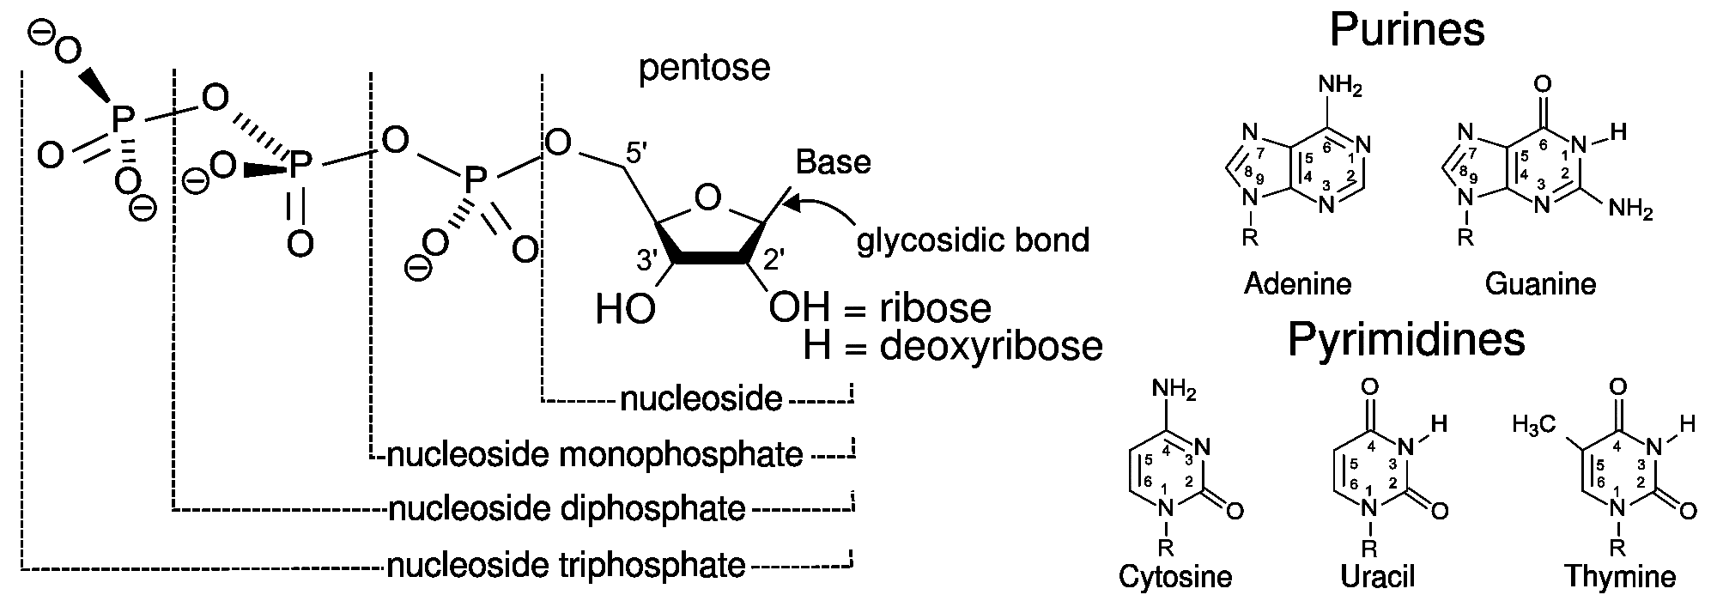**

1. Nucleoside triphosphates are the building blocks of nucleic acids.



1. The base ("sidechain") is connected to the C1' of the sugar ("mainchain") by an **N-linked glycosidic** bond.

Base + sugar = **nucleoside**.

Base + sugar + 1 phosphate=**nucleotide**

1. The carbon atoms on the sugar are numbered 1' to 5'. The primes distinguish the atoms on the sugar from those on the base.
2. DNA differs from RNA in the sugar as well in one base.
3. Four different monomers, A, G, C, T in DNA. U replaces T in RNA.

|  |  |  |  |  |
| --- | --- | --- | --- | --- |
|  | **Nitrogenous Base** | **Nucleoside** | **Deoxynucleoside** | **Deoxynucleoside Triphosphate** |
| A | Adenine | Adenosine | Deoxyadenosine (dA) | dATP |
| G | Guanine | Guanosine | Deoxyguanosine (dG) | dGTP |
| C | Cytosine | Cytidine | Deoxycytidine (dC) | dCTP |
| T | Thymine | 5-methyluridine | Thymidine (dT) | dTTP |
| U | Uracil | Uridine | Deoxyuridine (dU) | dUTP |

1. Aromatic rings of bases absorb light at ~260 nm.

**2. DNA and RNA are Polynucleotides**



a) The **phosphodiester** backbone is comprised of deoxyribose (DNA) or ribose (RNA) sugars bridged by phosphates between the **3' and 5'** positions of the sugars.

i) The phosphates are always ionized (pKa~1), therefore nucleic acids are **polyanions**.

ii) Note that the polarity, i.e. 5' → 3', be able to identify the 5’ and 3’ ends.

b) The sequence of nucleotides encodes the information in DNA.

**Sequence of nucleotide bases is written in the 5'-3' direction**.

**3. Chemical Stability.**

a) DNA is stable to acids and bases.



b) RNA is hydrolyzed at high pH (alkaline hydrolysis).

**4. Double Helical Structures: B-DNA**

 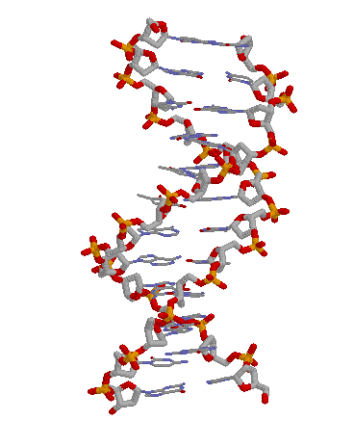

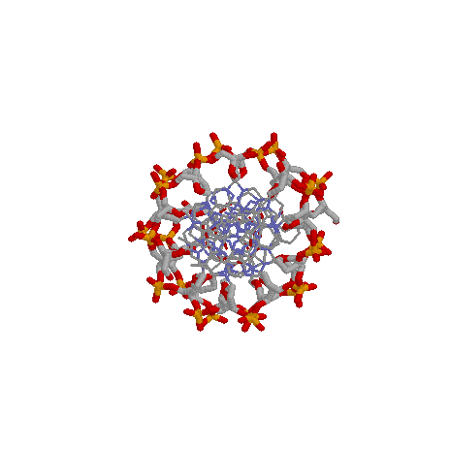a) The helix is right-handed; the chains are **antiparallel**.

b) Rise 3.4Å/base pair; **10 bp/turn**.

c) The spacing between the two phosphate chains in the direction of the helix is not uniform. There is a wider groove (**major groove**) and a narrower groove (**minor groove).**

d) The grooves are filled with water and ions (e.g. Na+)

e) The helix interior is filled with stacked base.

f) T pairs with A via two "Watson-Crick H-bonds"

g) C pairs with G via three "Watson-Crick hydrogen bonds"



**5. Hydrogen Bond Donors and Acceptors in Major and Minor DNA Grooves:**

(WC Hbonds shown as lines)

**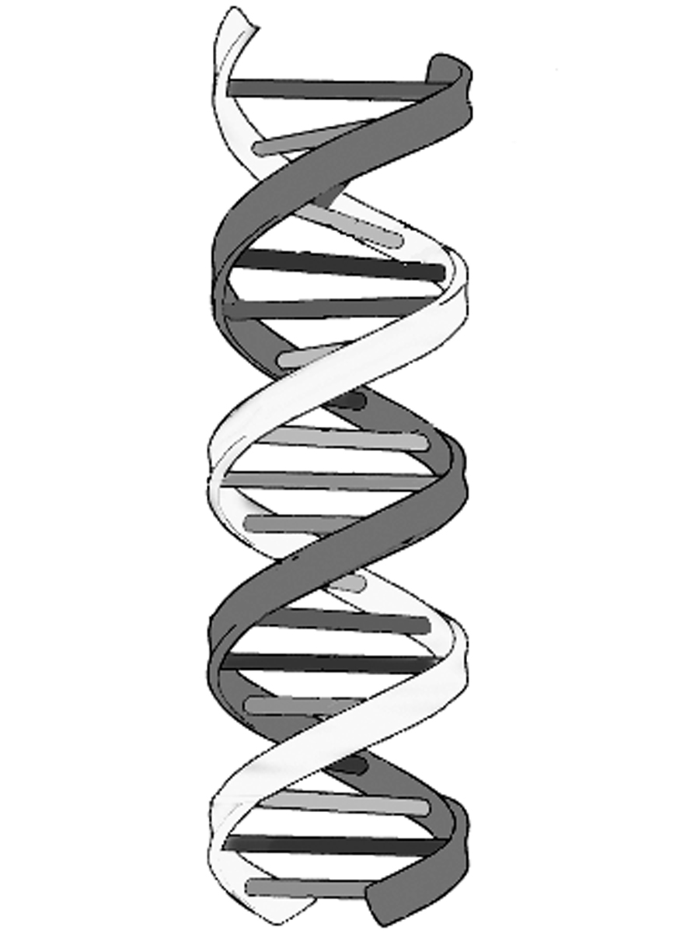6. DNA Topology:**Taking a linear double stranded segment of DNA and joining the two ends will make circular DNA. This is referred to as **closed circular,** **relaxed DNA**.

**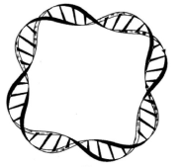**

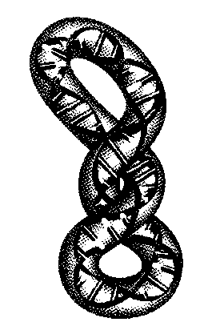**Supercoiled DNA** is made by:



i) breaking the phosphodiester bonds,

ii) rotate the DNA 360 degrees,

iii) rejoin the broken strands.

This induces stress in the DNA (poor vdw contacts between bases) that is relieved by introducing a twist, or supercoil in the circular DNA, restoring good vdw between the bases.

**7. RNA versus DNA Helical Structure:**

|  |  |
| --- | --- |
| **RNA** | **DNA** |
| rna_helix_side |  |
| rna_top | dna_top |

i) DNA and double-helical RNA. Same right-handed anti-parallel structure.

ii) RNA cannot adopt exactly the same -form as DNA (the presence of the 2'-OH interferes).

a) Spacing of phosphates chains is more uniform.

b) The depth of the grooves alternate between shallow and deep in RNA versus narrow (minor) and wide (major) in DNA.

c) Bases are displaced from helical axis in RNA.

iii) U pairs with A.

**8. Other Structural Features of RNA.**

