**Lecture 22: Quaternary & Tertiary Structure Determination.**



Cox & Nelson: Section 3-3 and Box 4-4 (4e) or 4.3 (5e). Horton Fig 3.19, sec 3.7

**Electrophoresis:**

**Denatured Molecular Weight: SDS-PAGE (SDS-polyacrylamide gel electrophoresis).**

* Routinely used to assess purity.
* Measure **molecular weight of** **denatured** proteins.



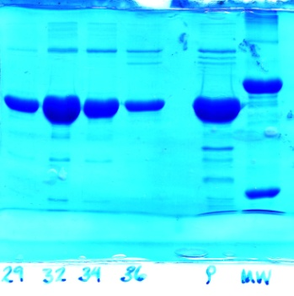a) In the presence of an electric field proteins will migrate at a velocity that is proportional to their *intrinsic* charge-mass-ratio.

Top view

b) **Denaturation** and coating of proteins by SDS gives them a *uniform* charge-to-mass ratio.

c) Forcing the protein-SDS complexes through a polyacrylamide gel causes separation of the proteins according to size.

d) Distance, *d*, migrated down the gel during electrophoresis depends on molecular weight. **Smaller proteins move faster.**

e) Gels are calibrated using known molecular weights.

**Disulfide Bonds:** If proteins are crosslinked by disulfide bonds, and it is desirable to obtain the sizes of the subunits, then the S-S bonds have to be broken using β-mercaptoethanol (BME) or Dithiothreitol **(**DTT) before the electrophoretic separation. BME and DTT reduce the disulfide bond generating free –SH groups on the Cysteine residues.



**Native MW: Gel filtration (size exclusion).**

The matrix or beads in the gel-filtration column contains pores that allow smaller molecules to enter but exclude larger molecules. Gel filtration is usually performed under conditions where the quaternary structure of the protein is preserved, giving the **native molecular weight.**

The volume that a particular protein elutes from a column is called the elution volume, Ve. For example, if a protein was contained in the 69th mL of liquid that dripped from the column then its elution volume would be 69 mL. The relationship between the molecular weight of the protein and its elution volume is given by the following equation. ***log (MW) = α VE + β***

Where α and β are constants obtained by measuring the elution volume of proteins with *known* sizes, giving a calibration line.

**Example Determination of Quaternary Structure:**

An enzyme consists of four polypeptide chains. Two chains are 20 kDa in size (α-chain) and two are 30 kDa in size (β-chain). There is a single disulfide bond between the α and β subunits. The four chains associate as indicated in the diagram to form a hetero-tetramer, (αβ)2. The following two experiments were performed:



**1. Gel filtration chromatography**, using three known standards (IgG, Hb, Myo).

|  |  |  |
| --- | --- | --- |
| **Protein** | **MW (gm/mole (Da))** | **Log MW** |
| Antibody (IgG) | 150,000 | 5.17 |
| Unknown |  |  |
| Hemoglobin | 64,000 | 4.8 |
| Myoglobin | 16,000 | 4.2 |

**2. SDS-PAGE** in the *absence* and *presence* of β-mercaptoethanol.

For calibration purposes, two proteins with known molecular weights, one with a molecular weight of 10 kDa and the other with a molecular weight of 160 kDa, were also included in this experiment. These two *standards* consist of a single polypeptide chain and will therefore give a single species in all experiments. Images of the two gels, as well as a plot of distance migrated versus log MW are shown.



**Atomic Resolution Structures:**  **X-ray Diffraction**

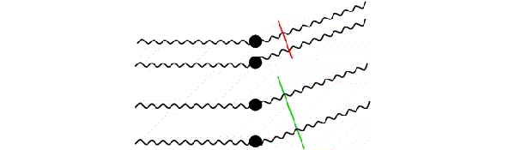**X-Ray Crystallography:**

1. Proteins must be crystallized in a regular lattice, just like NaCl.
2. No real limitations as to the size of the structure that can be determined.
3. X-rays are scattered by electrons – the amount of scattering is proportional to the *number of electrons.*
4. Interference between X-rays that are scattered from atoms in different locations changes the amplitude and the phase of the scattered X-rays. Therefore, scattered X-rays can be used to determine the position of atoms.
5. Intensities can be measured directly, phases have to be obtained indirectly. One common method of obtaining phases is called molecular replacement, where a homologous known structure is used to calculate the phases.
6. Fourier transform of the intensity and phases of the scattered X-rays produces an ‘electron density map’, or the number of electrons at each point in space in the crystal (ρ(x,y,z)). The crystallographer must figure out how to place, or "fit", the known primary structure of the protein into this map.



