**21: Protein Purification: Required reading -** Nelson 4e & 5e Sec 3-3

**Goals:**

* Calculate specific activity
* Calculate net yield
* Select purification step based on properties of the protein
* Determine molecular weight (denatured) by SDS-PAGE.

**Protein purification:**

**How to monitor purity:** It is essential to have some method to evaluate purity, otherwise how do you know whether a specific step in the purification scheme has been successful in increasing the purity of the desired protein? To do so, we need to obtain two experimental measurements:

*i) Amount of target enzyme*: It is essential to have some method of determining the amount of the *desired* enzyme at any given step of the purification scheme. Consequently, the most critical step in any purification scheme is to develop a suitable assay for the enzyme that is being purified. This is usually done using enzymatic assays that produce colored products – allowing a spectrophotometric assay.

ii) *Amount of total protein in the sample:* Simply measuring the absorbance at λ = 280 nm will often suffice.

The purity of the enzyme during the purification scheme is generally monitored by measuring the specific activity:

**Specific Activity:** The velocity of the enzyme catalyzed reaction for the desired enzyme divided by the total amount of *all* protein species in the sample. Typical units would be μmol/sec/mg total protein, where the μmol/sec refers to the amount of product produced (μmol) per unit time.

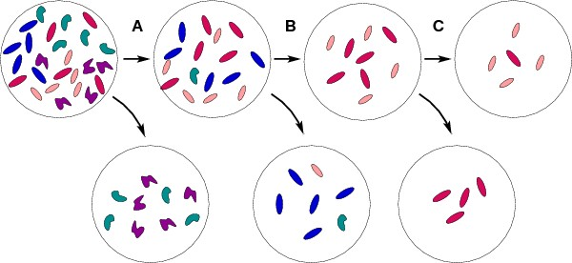

|  |  |  |  |  |
| --- | --- | --- | --- | --- |
| **Sample** | **Separation method** | **Units of Activity** | **Total Protein** | **Specific Activity** |
| Lysate |  | 50 | 25 | 2.0 |
| Step A | By shape | 50 | 16 | 3.1 |
| Step B | Not blue (=red/pink) | 40 | 9 | 4.4 |
| Step C | Pink | 40 | 5 | 8.0 |

**Net yield** (final amount of target/starting amount of target):

**Increase in purity** (final specific activity/initial specific activity):

**Separation by Solubility.** High concentrations of ammonium sulfate can precipitate proteins by reducing the ability of water to interact with the protein. Different proteins have different levels of solubility at any given concentration of ammonium sulfate. The precipitated proteins usually remain active and can be redissolved in buffer.

**Separation using Column Chromatography:** In most cases chromatography is performed in long glass tubes filled with a matrix or resin (particle size similar to a fine sand) that is completely immersed in a buffered salt solution. The mixture of proteins is added to the top of this column and buffer is allowed to flow through the column. As the buffer flows through the column the mixture of proteins is drawn down through the column and interacts with the matrix or resin. The actual mode of separation depends on the nature of the resin. Usually several different chromatographic steps are performed with different resins during a purification scheme. The actual order of separation methods will depend on the protein being purified.



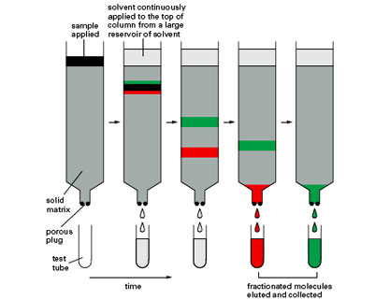

There are four common methods of separation.

1. Gel Filtration – separation by size

2. Anion exchange – separation by charge

3. Cation exchange. – separation by charge



4. Affinity chromatography – separation by affinity

**Effect of pH on net Charge of Protein** – ion exchange.

**pI** (Isoelectic pH)- pH at which proteins have no *net* charge:

* Proteins become positively charged for pH < pI
* Proteins have a negative charged if pH > pI.

Therefore the charge on a protein can be changed by altering the pH, increasing or decreasing the binding to ion exchange resins.

**Evaluating Final Purity:**

After the protein is pure, its purity can be monitored by

a) SDS-page gel electrophoresis.

b) Mass spectrometry.

c) Amino terminal sequencing.

d) Isoelectric focusing (separation by pI).

**SDS-polyacrylamide gel electrophoresis).**



a) In the presence of an electric field proteins will migrate at a velocity that is proportional to their *intrinsic* charge-mass-ratio.



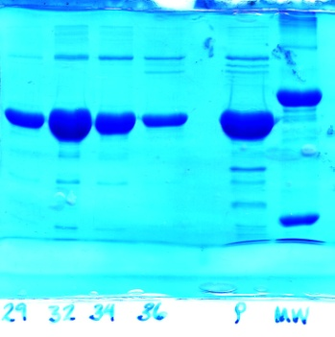b) **Denaturation** and coating of proteins by SDS gives them a *uniform* charge-to-mass ratio.



Top view of stained gel

c) Forcing the protein-SDS complexes through a polyacrylamide gel causes separation of the proteins according to size.

d) Gels are stained with a stain that is specific for protein.

e) Distance, *d*, migrated down the gel during electrophoresis depends on molecular weight. **Smaller proteins move faster.**

**Determining Subunit Molecular Weight with SDS Page.**



i) Load molecular weight standards on one lane (right lane in above gel)

ii) load unknown in another lane.

iii) Electrophorese proteins through gel.

iv) Measure the distance migrated of each band.

v) Plot log MW versus d for standards, generating a calibration curve.

vi) Use calibration curve to get logMW of unknown.

**Disulfide Bonds:** If proteins are crosslinked by disulfide bonds, and it is desirable to obtain the sizes of the subunits, then the S-S bonds have to be broken using β-mercaptoethanol (BME) or Dithiothreitol **(**DTT) before the electrophoretic separation. BME and DTT reduce the disulfide bond generating free –SH groups on the Cysteine residues.

