**Lecture 20: Retroviruses & Inhibitors - HIV Protease.**

**Suggested Reading:** OLI Page, 20, Nelson: 4e Sec 26.3, 5e 218-219.

Goals:

* Identify potential drug targets based on viral life cycle.
* Compare and contrast serine to aspartyl proteases
* Measure inhibitor binding to characterize drug efficiency.

**Mixed Inhibitors:** Term comes from the fact that they affect both Km and Vmax.

There are two special cases of mixed inhibitors that are often used to confuse students:

|  |  |  |
| --- | --- | --- |
|  | **Binds to (E)** | **Binds to (ES)** |
| **Mixed type** | **yes** | **yes** |
| Uncompetitive | no | yes |
| Noncompetitive | Same affinity | Same affinity |

**Suicide Inhibitors**



* Inhibitor binds and forms a covalent bond with the enzyme, inactivating it.
* Nerve gas sarin modifies the active site serine in the serine esterase acetylcholine esterase

**Human Immunodeficiency Virus (HIV)**

The normal flow of information in cells is: DNA → mRNA → protein

In retroviruses, the genetic information is stored in RNA (vRNA) which must be first be copied into DNA. The flow of information in retroviruses is: vRNA → DNA → mRNA → protein

→ vRNA

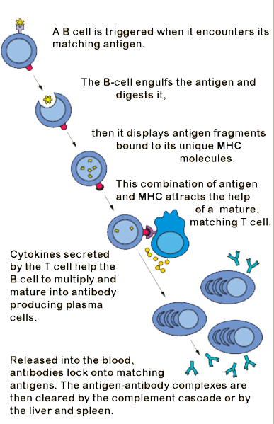**Central Role of T-helper (TH) Cells in Immunity:**

* Activate B-cells so that they can differentiate into plasma cells → secrete antibodies that inactivate pathogens (bacteria, viruses).
* Infection of the TH cells by HIV results in loss of TH cells.
* HIV infected individuals cannot make antibodies against relatively harmless pathogens and will die from common infections or rare cancers.

**HIV Viral Infection of T-Helper Cells:**

1. Viruses bind to molecules displayed on the TH cell surface.

2. The virus then fuses with the cell membrane and releases its RNA genome from its lipid envelope.

3. The enzyme **reverse transcriptase** first makes a double-stranded DNA copy of the viral RNA molecule. This process is error prone, leading to mutations in the virus. *These mutations cause drug resistant strains of the virus to arise.*

4. The DNA is integrated into the host cell’s DNA by an enzyme called **integrase**.

5. Integrated DNA produces vRNA, the genetic material for new virus particles. mRNA is also made from this DNA, to produce proteins for new particles.

6. Immature (extra long) viral proteins are made from mRNA.

7. **HIV protease** required for maturation of viral proteins , by cleaving them into smaller proteins that form the mature virus.

The virus particle contains reverse transcriptase, integrase, and HIV protease (in addition to the vRNA genetic material).

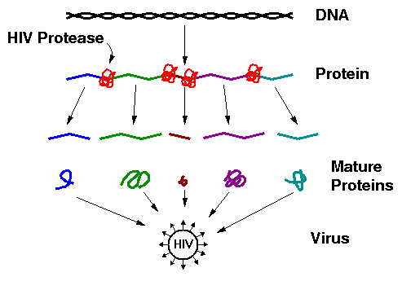

**Potential Drug Targets & Their Features:**

**Drug Resistance:**

* Reverse transcriptase, which copies vRNA to DNA is error prone.
* Errors lead to changes in the amino acid sequence of drug targets, interfering with drug binding
* Resultant mutant viruses can grow in the presence of the drug.

**HIV Protease (Aspartyl protease)**

1. An essential enzyme in the maturation of the HIV virus. If inhibited, the virus cannot replicate.

2. The HIV protease is a homo-dimeric protein, containing two catalytic Asp residues, Asp25 and Asp25', the same residue on each chain. However, the pKa values of these two differ widely, one is about 4.0 and the other about 6.0. It is a member of the general class of ***Aspartate proteases.***

3. One of the Asp residues must be protonated the other must be deprotated for full activity.

4. Water is the activated nucleophile, no acyl-intermediate.

5. Prefers hydrophobic substrates due to Val82 plus other non-polar residues in its active site.

**Mechanism:**



1. Activation of H2Oby Asp25’

2. Nucleophilic attack on C=O of substrate

3. Tetrahedral transition state

4. Peptide bond cleavage

5. Protonation of new NH2 by Asp25

**Inhibition of HIV Protease (HIV Drugs):**

* Most drugs are small peptide-like analogs with non-cleavable bonds that resemble peptide bonds.



* Unfortunately, viruses containing mutations in their HIV protease arise. These mutants are resistant to current HIV drugs.

**Drug Design:** Compounds A and B (see next page) are candidates for HIV protease inhibitors. Which of the two drugs will be more effective at inhibiting the wild-type protease?

**Answer:** We will assume that these are competitive inhibitors. Therefore**,** we need to compare the KI values for each inhibitor binding to the protease, using the following steps.

1. Select a suitable substrate for steady-state assays. The kinetics of HIV protease can be measured using this substrate, producing a bright yellow nitrophenolate ion.



2. Measuring KI for both Drugs:

a) Acquire velocity versus substrate, no inhibitor.

b) Acquire velocity versus substrate, fixed inhibitor.

c) Plot double reciprocal plots.

d) Obtain α from ratio of slopes

e) KI = [I]/(α-1)

|  |  |  |  |
| --- | --- | --- | --- |
| **[S] μM** | **v**  **(I=0)** | **v**  **([A]=10 nM)** | **v**  **([B]=10 nM)** |
| 10 | 7.3 | 3.8 | 0.7 |
| 50 | 26.7 | 16.0 | 3.2 |
| **1/[S]** | **1/V**  **(I=0)** | **1/V**  **([A]=10nM)** | **1/V**  **([B]=10nM)** |
| 0.10 | 0.138 | 0.263 | 1.513 |
| 0.02 | 0.038 | 0.063 | 0.313 |

The units of velocity are μmoles product/sec.

|  |  |  |
| --- | --- | --- |
|  | **Slope** | **α = slope(I>0)/slope(I=0)** |
| **No Inh.** | 1.25 |  |
| **Inhibitor A** | 2.50 | α = 2.50/1.25 = 2 |
| **Inhibitor B** | 15.00 | α = 15.00/1.25= 12 |

**α** is obtained from the ratio of the slopes in the double reciprocal plot.

Once the α values are found, we can calculate the KI for each inhibitor using the formula: **KI=[I]/(α-1).**





**Mutations in HIV Protease** → Drug Resistance: