**Lecture 20: HIV Drugs - HIV Protease (Aspartate Protease) & Reverse Transcriptase Inhibitors.**

**Suggested Reading:** OLI Page, 20, Nelson: 4e Sec 26.3, 5e 218-219.

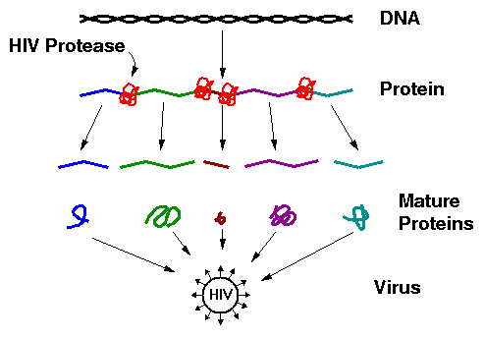**HIV Life Cycle:**

**Potential Drug Targets & Their Features.**

**Drug Resistance:**

* Reverse trascriptase, which copies vRNA to DNA is error prone.
* Errors lead to changes in the amino acid sequence of drug targets, interfering with drug binding
* Resultant mutant viruses can grow in the presence of the drug.

**HIV Protease**

1. An essential enzyme in the maturation of the HIV virus. If inhibited, the virus cannot replicate.

2. The HIV protease is a homo-dimeric protein, containing two catalytic Asp residues, Asp25 and Asp25', the same residue on each chain. However, the pKa values of these two differ widely, one is about 4.0 and the other about 6.0. It is a member of the general class of ***Aspartate proteases.***

3. One of the Asp residues must be protonated the other must be deprotated for full activity.

4. Water is the activated nucleophile, no acyl-intermediate.

5. Prefers hydrophobic substrates due to Val82 plus other non-polar residues.

**Inhibition of HIV Protease (HIV Drugs):**

* Most drugs are small peptide-like analogs with non-cleavable bonds that resemble peptide bonds.



* Unfortunately, viruses containing mutations in their HIV protease arise. These mutants are resistant to current HIV drugs.

**Drug Design:** Compounds A and B are candidates for HIV protease inhibitors. Which of the two drugs will be more effective at inhibiting the wild-type protease?

**Answer:** We will assume that these are competitive inhibitors. Therefore**,** we need to compare the KI values for each inhibitor binding to the protease, using the following three steps.

1. Obtain the initial reaction velocity at various substrate concentrations in the absence of the inhibitor and in the presence of a known amount of *each* inhibitor. The kinetics of HIV protease can be measured using this substrate:



|  |  |  |  |
| --- | --- | --- | --- |
| **[S] μM** | **v**  **(I=0)** | **v**  **([A]=10 nM)** | **v**  **([B]=10 nM)** |
| 10 | 7.3 | 3.8 | 0.7 |
| 50 | 26.7 | 16.0 | 3.2 |
| **1/[S]** | **1/V**  **(I=0)** | **1/V**  **([A]=10nM)** | **1/V**  **([B]=10nM)** |
| 0.10 | 0.138 | 0.263 | 1.513 |
| 0.02 | 0.038 | 0.063 | 0.313 |

The units of velocity are μmoles product/sec.

2. Since **α=(1+[I]/KI)**, we need to determine α, from which we can determine KI. α is obtained from the ratio of the slopes in the double reciprocal plot.

|  |  |  |
| --- | --- | --- |
|  | **Slope** | **α = slope(I>0)/slope(I=0)** |
| **No Inhibitor** | 1.25 |  |
| **Inhibitor A** | 2.50 | α = 2.50/1.25 = 2 |
| **Inhibitor B** | 15.00 | α = 15.00/1.25= 12 |

3. Once the α values are found, we can calculate the KI for each inhibitor using the formula: **KI=[I]/(α-1).**

Inhibitor A: Inhibitor B: