**Lecture 8: Helices, Sheets & Stability of the Tertiary Structure**

Suggested reading in Horton: 4.9, 4.10. Nelson 4e & 5e : 4.2, 4.3, 4.4.



**Goals:**

* Relate molecular interactions to stability of proteins.
* Consider enthalpic and entropic effects.
* Understand marginal stability of folded proteins.

**αR-Helix Structure** (Φ = -60°, Ψ = -45°)

* Dimensions, geometry, & H-bonds

3.6 residues/turn

pitch = 5.4 Å/turn

rise/residue = 1.5 Å

* H-bonds || to helix axis.
* Sidechains point outwards
* Right handed

**β Structures** (Φ = -120°, Ψ = 125°)



1. β-Hairpins (two strands connected by a sharp turn)

2. β-Sheets

a. parallel

b. antiparallel

* H-bonds perpendicular to direction of strands.
* Sidechains point up and down, above and below the sheet.

**Location of Helix and Sheet residues in Ramachandran Plots:**

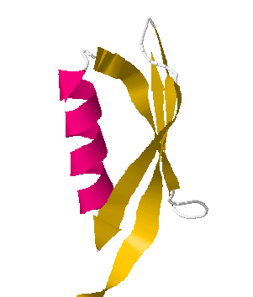 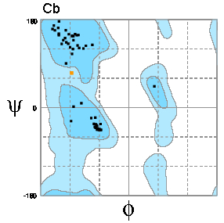



**Non-regular secondary structures:** Sharp turns in proteins, particularly at the ends of beta-strands (beta hairpins) have a characteristic geometry and sequence. These turns are also stabilized by hydrogen bonding. These turns often contain Glycine at position 3, because of its unique conformational properties.

**Features of the Folded State of Globular Proteins:**

|  |  |  |  |  |  |
| --- | --- | --- | --- | --- | --- |
| **Amino Acid Distribution** | **Location** | |  | **Folded (Native) State**  **(Tertiary Structure)** | **Denatured or Unfolded State** |
| Inside | Surface |
| Charged |  |  | * Compact |  |
| Polar |  |  | * Single Conformation |  |
| Non-polar |  |  | * Extensive Secondary Structure (H-bonds) |  |
| Amphipathic (e.g. Lys) | | | * Reduced exposure to solvent |  |

**Thermodynamic Factors that affect the Stability of the Native State:**

**ΔGo:** Change in the energy of the system when one mole of reactant(s) are converted to one mole of product(s).

ΔGo = Go Products – Go Reactants

ΔGo defines the equilibrium position of a reaction through the relationship: ΔG0 = -RT ln KEQ.

We will consider the direction of the reaction to be Folded (native) ↔ Unfolded

Both the enthalpy and entropy contribute to the overall Gibbs energy of the system as follows:

ΔGo = ΔHo - T ΔSo

**Enthalpy (ΔHo)** is the amount of heat generated/consumed by the reaction when 1 mole of reactants are converted to one mole of products.

ΔHo = Ho Products – Ho Reactants

The enthalpy is related to changes in molecular interactions (i.e. hydrogen bonds, van der Waals, etc.). In biochemistry, these interactions usually involve non-covalent changes.



ΔH0 > 0

ΔH0 < 0

**1. Hydrogen bonds:**

* ΔHo associated with hydrogen bonding is *unfavorable* for unfolding. Hydrogen bonds are more stable in the native form of the protein by about 1 kJ/mol.
* Hydrogen bonds that are broken during folding and then **not** reformed in the folded state cost about 20 kJ/mol.

2. ΔHo associated with **Van der Waals** forces is unfavorable for unfolding. Van der Waals interactions are more stable in the native form of the protein.



**3. Electrostatic forces**:

* **Surface charges:** Although these forces can contribute to ΔHo changes in many biochemical interactions, they are generally not important for protein folding because the charged residues remain on the surface and therefore interact with water equally well in both the native and the denatured state.
* **Buried charges:** The energetic cost of burying a single charge in the core of a protein is extremely high, largely due to desolvation of the ion during the folding process. Note that in some proteins *charge-pairs* are buried. These are stable because the loss of energy due to desolvation is regained by favorable electrostatic interactions in a low dielectric media (E ∝ 1/D).

**ΔSo :** Change in entropy when 1 mole of reactant(s) are converted to one mole of product(s).

ΔSo = So Products – So Reactants

A positive entropy change is favorable since the disorder in the system is increased.

The entropy is related to the change in the number of possible configurations (W) of the system when the reaction occurs. The entropy can be calculated from Boltzmann’s equation:

S = R *ln* W

W is the number of conformations, and R is the gas constant.

**1. Conformational Entropy:** When a protein unfolds the entropy of the molecule increases dramatically due to a change in the conformational freedom of the Φ and Ψ angles of the mainchain, as well as disordering of the sidechain. Note that the increase in entropy would be much larger, except for the fact that the presence of the sidechain groups restricts the Φ and Ψ angles to three possible conformations, instead of the 9 possibilities associated with two freely rotatable bonds.



|  |  |
| --- | --- |
| The number of conformations in a 50 residue folded protein is: |  |
| Giving an entropy of : |  |
| The number of conformations of a 50 residue unfolded protein is: |  |
| Giving an entropy of: |  |
| **The net change in entropy**, due to unfolding of a 50 res. protein: |  |

**2. Hydrophobic effect - Entropy Changes of the Solvent:** The hydrophobic effect is due to the entropy of the *water* in the system. When a non-polar side chain is exposed to water it orders, or decreases the entropy, of the water molecules. However, when the non-polar residue become buried in the non-polar center of the protein it releases all of the water which coated it. The released water can now freely diffuse in the solvent, resulting in an increase in entropy of the water.



The **hydrophobicity**, or entropy change when a non-polar group is buried in a non-polar environment (e.g, during protein folding) depends on the non-polar surface area. Glycine is set to zero on this plot to account for the contribution of the mainchain. Note that amino acids with larger non-polar sidechains cause a larger decrease in the entropy of the water when they become exposed.

**Energy Balance:** An *estimate* of the contribution of the entropy (-TΔSo) and enthalpy to the stability of a 50 residue protein is illustrated below:

