# Lecture 5: Amino Acids:



# A. Structure and Properties:

* An amino acid is a carboxylic acid with an amino group. Most biological amino acids are α-amino acids because the amino group is attached to the α-carbon.
* The "mainchain" or "backbone" atoms (N, Cα, C=O) are the same in each of the 20 commonly found amino acids.
* The sidechain atoms are unique to each amino acid and give rise to the unique properties of that amino acid.
* The sidechain atoms are designated with Greek letters, based on the nomenclature for carboxylic acids.
* The pKa of the carboxylate is ~2.0 and that of the amino group is ~9.0. Sidechain ionizable groups are also found on some amino acids, see next page.
* Amino acids are joined together to form linear polymers by the formation of a **peptide** **bond** between the carboxyl of one amino acids and the amino group of the next. This reaction releases water and is thus **dehydration** reaction. It is also referred to as a condensation reaction because two amino acids are condensed into one.
* The peptide bond can be broken by the addition of water, a reaction called **hydrolysis** *(hydro-lysis)*.

**Expectations:**

* Full name of each (20) amino acid
* 3 Letter name of each amino acid
* Structure of each amino acid
* Properties of the side chains:

i) Ionization of groups (pKa)

ii) H-bonding capability

iii) Functional groups (polar/nonpolar)

* UV absorbance, calculation of protein concentration (lecture 6).



**Flash card examples**

**B. Chirality & Optical Activity:** In all amino acids (except glycine) the α-carbon is chiral. In some amino acids, additional chiral centers are present. These are chiral centers because all four groups attached to the carbon are different. This means that the mirror images of these compounds cannot be superimposed. The two mirror images are called ***enantiomers***.

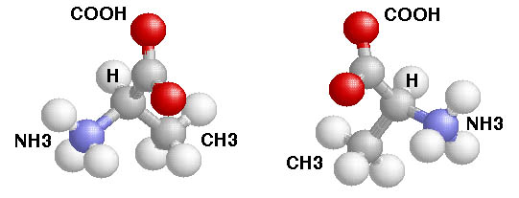



Enantiomers have the following attributes:

* *Identical* physical properties (except rotation of polarized light).
* Markedly *different* biological properties.
* Most common amino acids have an S configuration. An older, but very much used, notation is D and L. This notation is based on the chirality of a reference compound and **all amino acids that are found in proteins are L.**

**Importance of chirality in Biology:** Usually only one enantiomer is active in biological systems. As indicated above, only L-amino acids are used to make proteins. Amino acids of the other enantiomer (D) are generally harmless. This is not always the case for other compounds with chiral centers.



**Thalidomide**. This drug was prescribed as a sedative in the late 50s and early 60s. It was withdrawn because it causes birth defects by interfering with the development of the baby (**teratogens)**. This activity is associated with only one enantiomer. The other enantiomer is safe.

**C. Ionization Properties of Amino Acids.**

Other sidechain ionizations that are less important:



* Tyr-OH pKa=10, Cys-SH, pKa=8.

Which groups don’t ionize at physiological pH ranges?

**Amino acids with unique properties:**

