

**Buffers:**

* 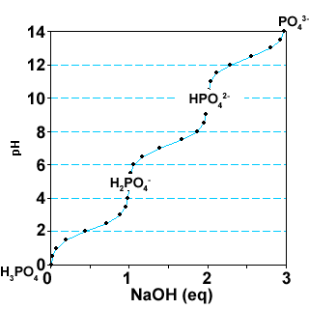**To make a solution at a desired pH**
* **That acts as a buffer, pH=pKa +/- 1**

**Polyprotic Buffers:**

1. Select weak acid based on *any* of its pKa values.

2. Use pKa closest to desired pH to calculate *fHA*and *fA-.*

3. How to make the buffer, select one of the following three methods:

i) Use chemical forms of “(HA)” and “(A-)” that represent the species present at the pKa you choose, e.g. NaH2PO4/Na2HPO4 if the middle ionization was used.

ii) Starting from completely protonated form (e.g. H3PO4). Add sufficient whole equivalents (*n*) to reach the buffer region you are using, add (*n + fA-)* equivalents *of* strong base, or (*n + fA-)* [AT] moles of strong base.

iii) Starting from completely ionized form (e.g. Na3PO4). Add sufficient whole equivalents (*n*) to reach the buffer region you are using, add (*n + fAH)* equivalents *of* acid, or (*n + fAH)* [AT] moles of strong acid.

**Diprotic buffer example:**

The diprotic acid shown on the right has pKa values of 3 and 6.



How would you make 0.5 L of a 0.5 M buffer solution at pH=2.5, using only the disodium salt (Na2A) of this acid?

**Step 1**: Pick the ionization whose pKa is closest to the desired pH, thus defining the pKa value to use for your calculations.

**Step 2**: Use that pKa to calculate the fraction of each species, fHA and fA- that will give the desired pH of 2.5:

**Step 3**: Construct buffer using method (iii) from lecture 4 notes. The titration of the sodium salt with a strong acid.

i) Determine the number of equivalents of strong acid (HCl) to use to reach the correct pH, starting from the fully deprotonated weak acid. For a monoprotic buffer this would simply be *fHA*.



In this case, because it is a diprotic buffer, and we are starting from the fully deprotonated form, we have to add one full equivalent of HCl to reach the buffer region that is being used. Therefore:

**eq. of HCl = 1 + 0.75 = 1.75 eq**

ii)The number of moles of the strong acid to use is:

#eq × mol weak acid × vol = **1.75** ×**[AT]**×**V = 1.75** × **0.5 mol/L** × **0.5 L = 0.438 mol**

# Lecture 5: Amino Acids Reading: Horton 3.1, 3.2, 3.4. Nelson 3.1-3.2

**Key Terms**

* **Mainchain atoms**
* **Sidechain atoms**
* **Chiral center**
* **Acidic Residues**
* **Basic Residues**
* **Charge Calculations**

**5A. Structure and Properties:**



* An amino acid is a carboxylic acid with an amino group. Most biological amino acids are α-amino acids because the amino group is attached to the α-carbon.
* The "mainchain" or "backbone" atoms (N, Cα, C=O) are the same in each of the 20 commonly found amino acids.
* The sidechain atoms are unique to each amino acid and give rise to the unique properties of that amino acid.
* The sidechain atoms are designated with Greek letters, base on the nomenclature for carboxylic acids.
* The pKa of the carboxylate is ~2.0 and that of the amino group is ~9.0. Sidechain ionizable groups are also found on some amino acids.
* Amino acids are joined together to form linear polymers by the formation of a **peptide** **bond** between the carboxyl of one amino acids and the amino group of the next. This reaction releases water and is thus **dehydration** reaction. The peptide bond can be broken by the addition of water, a reaction called **hydrolysis** *(hydro-lysis)*.

**Expectations:**

* Full name of each (20) amino acid
* 3 Letter name of each amino acid
* Structure of each amino acid
* Properties of the side chains:

i) Ionization of groups (pKa)

ii) H-bonding capability

iii) Functional groups (polar/nonpolar)

* UV absorbance, calculation of protein concentration.

**5B. Chirality & Optical Activity:**

In all amino acids (except glycine) the α-carbon is chiral. In some amino acids, additional chiral centers are present. These are chiral centers because all four groups attached to the carbon are different. This means that the mirror images of these compounds cannot be superimposed. The two mirror images are called ***enantiomers***.

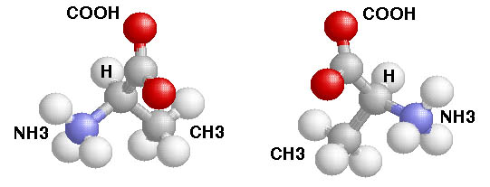



* Enantiomers have the following attributes:
* *Identical* physical properties (except rotation of polarized light).
* Markedly *different* biological properties.
* Most common amino acids have an S configuration. An older, but very much used, notation is D and L. This notation is based on the chirality of a reference compound and **all amino acids that are found in proteins are L.**

**Importance of chirality in Biology:** Usually only one enantiomer is active in biological systems. As indicated above, only L-amino acids are used to make proteins. Amino acids of the other enantiomer (D) are generally harmless. This is not always the case for other compounds with chiral centerss:



**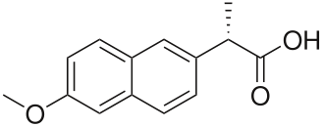Thalidomide**. This drug was prescribed as a sedative in the late 50s and early 60s. It was withdrawn because it causes birth defects by interfering with the development of the baby (**teratogens)**. This activity is associated with only one enantiomer. The other enantiomer is safe.



**Naproxen (Aleve):** One enantiomer relieves pain, the other causes liver damage.

Other sidechain ionizations that are less important: Tyr-OH pKa=10, Cys-SH, pKa=8.

Which groups don’t ionize at physiological pH ranges?



**Zwitterions & Charge Calculation:**

**Zwitterion**: a compound that is ionized, but has no *net* charge**.**

The overall charge on a molecule as a function of pH can be calculated by:

i) Identify all ionizable groups on the molecule & their charge when protonated and deprotonated.



ii) Use the known pKa of each group to determine the fraction protonated (fHA) and deprotonated (fA-) at the required pH.

iii) Calculate the overall charge by summing the contribution of each group.

**Example**: What is the net charge on glycine at pH=8?



|  |  |  |  |
| --- | --- | --- | --- |
| **Functional Group** | **Structure** | **Amino Acids** | **Function.** |
| Non-polar, non aromatic | -CH3 (Ala) | Alanine, Valine, Isoleucine, Leucine | Protein folding – hydrophobic effect. Binding non-polar drugs. |
| Non-polar, aromatic | C:\Users\oli\Desktop\bio_two\quiz_image\fg_benzyl.png | Phenylalanine | Protein folding – hydrophobic effect. Binding non-polar drugs. |
| Alcohol | -OH | Serine, Threonine, Tyrosine | H-bond formation to drugs, other sidechains. |
| Carboxylate | C:\Users\oli\Desktop\bio_two\quiz_image\fg_carboxylate.png | Aspartic acid  Glutamic acid | Usually ionized, neg. charge |
| Amide | amide.png | Aspargine Glutamine | H-bond formation, donor (NH) and acceptor (C=O). Note the NH cannot accept a H-bond. |
| Amino | C:\Users\oli\Desktop\bio_two\quiz_image\fg_amino.png | Lysine | Usually protonated, pos. charge. |
| Thiol (sulfhydral) | -SH | Cysteine | Forms disulfide bonds |