**Lecture 4: Charge Calculations, Environment & pKa, Titration curves & Monoprotic Buffers.**

**Goals:**

* Calculate charges on molecules, given pKas
* Predict environmental effect on pKa.
* Obtain pKa from a titration curve.
* Understand the molecular nature of buffers.
* Buffer construction, monoprotic.

**A. Charge Calculations:**

****The overall charge on a molecule as a function of pH can be calculated by summing the contribution from each ionizable group, as indicated in the equation on the right.

**Approach:**

i) Identify all ionizable groups on the molecule & their charge when protonated and deprotonated.

ii) Use the known pKa of each group to determine the fraction protonated (fHA) and deprotonated (fA-) at the required pH.

iii) Calculate the overall charge by summing the contribution of each group.

**Example**: What is the net (average) charge on glycine at pH=8?



**Short cuts:**

i) if pH << pKa, fully protonated, fHA =1

ii) if pH >> pKa, fully deprotonated, fA=1

iii) ignore neutral species.

**Zwitterion**: a compound that is ionized but has no *net* charge**.**

**Isoelectric pH** (pI) pH where the net charge is zero.

**B. Effects on pKa Values:**

**1. Chemical**

|  |  |  |
| --- | --- | --- |
|  | Acetic Acid pKa ~ 4.0  (Glu,Asp sidechain) | *Negative charge delocalized over C=O, lower in energy, therefore a carboxylate is a stronger acid.* |
|  | Carboxy pKa ~ 2.0  group on an amino acid. | *Electronegative N withdraws charge from the neg. carboxylate, giving a stronger acid.* |

**2. Environmental Effects due to near-by Charges.**

**Analysis by Energy:** The relative populations (*na, nb*) of two states depends on the energy difference between them, ∆E (Boltzmann)

The electrostatic environment of an ionizable group can change the pKa of that group, by affecting the energy of either the protonated or deprotonated states - it is the **relative** energy difference between the HA and A- states that determines the equilibrium constant: *KEQ=nb/na.*

**Approach:**

i) Set the pH = pKa of the free acid, at this pH the energy of HA and A are equal (making comparisons easier).

ii) Determine which state will be affected by electrostatics in the new environment, i.e. is the protonated (HA) charged, or is the deprotonated (A) charged. For example, in the case of a carboyxylate (COOH), HA has no charge while A has a negative charge.

iii) The energy level of the uncharged state remains the same as the free acid in solution.

iv) The energy of the charged state is:

* Lowered if the environment is opposite to its charge (favorable electrostatics)
* Raised if the environment has the same charge (electrostatic repulsion)

v) Evaluate ∆E:

* If the energy of A is now higher than HA, then the deprotonated state is less favorable, therefore the acid is weaker (left system).
* If the energy of A is now lower than HA, then the deprotonated state is more favorable, therefore the acid is stronger (right system).

**Example**: How will a positively charged environment affect the pKa of histidine (pKa of free His =6.0)

****The left shows the relative energy of the protonated and deprotonated group for the free weak acid (made equal by setting the pH=pKa)

****The right shows the relative energy of the same group, but within the context of a local positive charge from other groups (e.g. lysine) on the protein, *at the same pH.*

**Alternative approach - Analysis by Chemical Kinetics:** KA = *kOFF/kON*

If the environment is positive (e.g. lysine) proton collisions will ____________,

∴ kON _______________, ∴KA ___________,∴ -logKA (pKa) ______________.

**C. Titration Curves:**

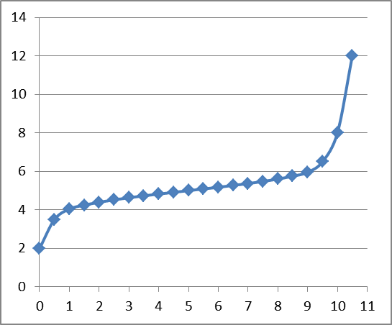Ka values, or acidity constants, must be measured by direct experiment, usually with a pH titration. Known amounts of a strong base (NaOH) are added to a solution of **weak acid.** The effect of the added base can be measured by two ways:

i) Changes in the pH of the solution, this is appropriate for a solution with only one weak acid. As the base is added it removes the proton from the acid.

ii) In complex mixtures of acids, a spectroscopic signal (e.g. NMR) can be used to determine the pKa of individual groups.

**Key features of titration curves:**

***Equivalents****:* the ratio of the moles of the strong base to the weak acid:

varies from 0 to 1 for an acid that releases one proton (monoprotic), from 0 to 2 for a diprotic acid, etc.. This scale is useful since it removes the concentration of the weak acid.

It is also possible to define equivalents in terms of an HCl If you started the titration with the salt (e.g. NaA), and add HCl. In this case the scale is reversed.

* ***The number of NaOH equivalents added = fA***
* ***The number of HCl equivalents added = fHA .***

***pKa Determination (Inflection point):*** There is an infection point at the point where the weak acid is ½ deprotonated. Since the two forms of the acid (HA, A) are equal, the pH=pKa at this point. For multi-protic buffers there would be multiple infection points, one at each pKa.

***Equivalence Point*:** Complete deprotonation of the weak acid occurs when the amount of added base is equal to, or *equivalent*, to the total number of ionizable protons that were originally on the weak acid. This point in the titration is referred to as the *equivalence* point. The equivalence point can be used to determine the concentration of the acid. Multi-protic buffers have multiple equivalence points.

**D. Buffers:** A pH buffer is an acid that resists changes in the solution pH by absorbing or releasing protons. Buffers play an important role in cellular processes because they maintain the pH at an optimal level for biological processes. They are also widely used to control pH in laboratory processes.

Reaction occuring in region A & C:

Reactions occuring in region B:

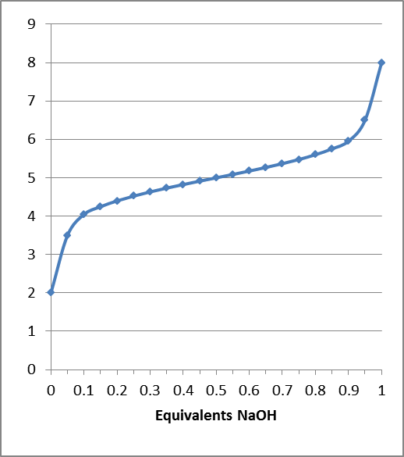

**A B C**

**C B A**

**Buffering range/region:**

**Buffering capacity:** Total moles of a strong acid or base that can be absorbed by a buffer solution and keep the pH within the buffer region. It depends on the concentration of the weak acid, and where the pH is relative to the edges of the buffer region. The higher concentration of weak acid, the higher the capacity.

**E. Buffers Construction:** Need to determine the ratio of [A-] to [HA] (=R) to give desired pH of the solution.

**Typical Problems - Monoprotic Buffer:**

* concentration [AT] , [AT] = [HA] + [A]
* volume V, pH
* List of weak acids and their pKa values.

**Method:**

1. Select a weak acid whose pKa is within one pH unit of the desired pH.

2. Determine the fraction protonated and deprotonated at the desired pH, *fHA*&*fA-*.

3. Obtain this ratio of [HA] to [A-] in solution by one of the following methods:

i) Mix the indicated concentration of the weak acid (HA) and its conjugate base (NaA) to give the desired pH:

moles (HA)= *fHA* ×[AT]× V moles (A-) = *fA-* ×[AT] × V

ii) Use [AT] amount of the *acid form* of the weak acid and add sufficient *strong base* (e.g. NaOH) to make the required concentration of [A-] to attain the desired pH. You are titrating starting from the left side and converting enough of the fully protonated acid to give the correct amount of the deprotonated acid. The added base converts HA to A-.

***The amount of strong base to add is fA- equivalents****. moles NaOH = fA- × [AT] × V*

iii) Use [AT] amount of the *conjugate base* form of the weak acid and add sufficient *strong acid* (e.g. HCl) to make the required concentration of [HA] to attain the desired pH. You are protonated the fully deprotonated acid by just the right amount to give the correct amount of the protonated acid. The added acid converts A- to HA.

***The amount of strong acid to add is fHA equivalents.*** *moles HCl = fHA × [AT] × V*

**Example:**  Make 1L of 1 M buffer solution at pH 5.0 using either imidazole (pKa~6), or pyruvate (pKa~2.5). You have both the protonated and deprotonated species (e.g. Na salt) in hand.

1. Which buffer would you use, why?

2. Determine fraction protonated and deprotonated at the desired pH:

R = 10(pH-pKa)



3. Since we have both forms (HA), (A) we can use any of the three methods to make the buffer:

*Questions on buffer Capacity:*

*1. What is the capacity of this buffer to the addition of acid? How many equivalents of acid could be added and the pH would still be within the buffer region?*

*2. What is the capacity of this buffer to the addition of base? How many equivalents of base could be added and the pH would still be within the buffer region?*