Entropy of Mixing:
One thermodynamic effect that favors high solubility of solutes in water (or any other solvent) is the increase in entropy when two pure compounds are mixed. The entropy of a system (S) can be calculated using the relationship derived by Boltzmann, which relates the number of conformations of a system (W) to the entropy of the system:
- Crystals have an entropy of zero because all of the atoms are fixed in position and there is only one way to arrange the atoms.
- Solutions of pure substances have low entropy because all of the molecules are identical. Since there can be a slight variation in the positon of the molecules, as well as their orientation, the entropy is not quite zero. If we make the assumption that all molecules in solution are in the same orientation and their positon is fixed to defined points in space, then the entropy of the liquid is also zero because all of the particles are interchangeable with each other.
When two pure substances are mixed, there is an increase in entropy because we now have a mixture of two different molecules and there are many ways to arrange the molecules because the molecules are different. This is referred to as the entropy of mixing.
In the following simple example, let’s look at the entropy of a bowl of fruit. If we have three oranges in the bowl, all of the oranges are identical and there is only one distinguishable way to organize the oranges, so the entropy of pure oranges is zero. If we interchange the position of two identical oranges, the system still looks the same.
Similarly, if we have three plums in a bowl the entropy of the plums is zero as well.
Now if we mix the oranges and plums, there are many different distinguishable ways to organize the oranges and plums. In this example, there are exactly 20 different ways to organize the six pieces of fruit, as shown below. Thus the entropy of the mixture is: S_{MIX}=Rln20 = 24 J/mol-K. This is also equal to the overall entropy changes, since the entropy of the reactants (unmixed fruit) was zero: ∆S = S_{Products}-S_{Reactants} = (24-0) =24 J/mol-K.
We can calculate the number of possible configuration of the mixed fruit using combinatorial theory:
The number of ways of arranging n things is n!, which is 6x5x4x3x2x1 in this case.
However, the three oranges and three plums are identical, so this reduces the number of possible arrangements by (3!)², since there are 3x2x1 ways of arranging three objects. The total number of ways of arranging the three oranges and three plums is: 6!/(3! 3!) = 20.
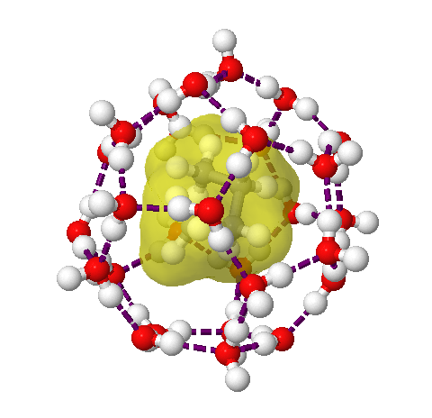Entropy and the Hydrophobic Effect:
Non-polar compound are not very water soluble. The low solubility is due to the entropy changes of the water. If we add a non-polar liquid (e.g. butane), the entropy of the dissolved butane is positive and favorable because it is no longer in pure butane. However, the water interacts with the dissolved butane by forming a cage of organized hydrogen bonded water around the butane, as illustrated on the right. This causes a large decrease in the entropy of the water, much more than the entropy of mixing, so the overall entropy change is negative, or unfavorable.

