**Lecture 1: Introduction to Biochemistry**

Dr. Gordon Rule - [rule@andrew.cmu.edu](mailto:rule@andrew.cmu.edu) Dr. Salini Konikkat – skonikka@andrew.cmu.edu

OLI course can be found at: *http://oli.web.cmu.edu*or *via* Blackboard. **OLI Course Key:**

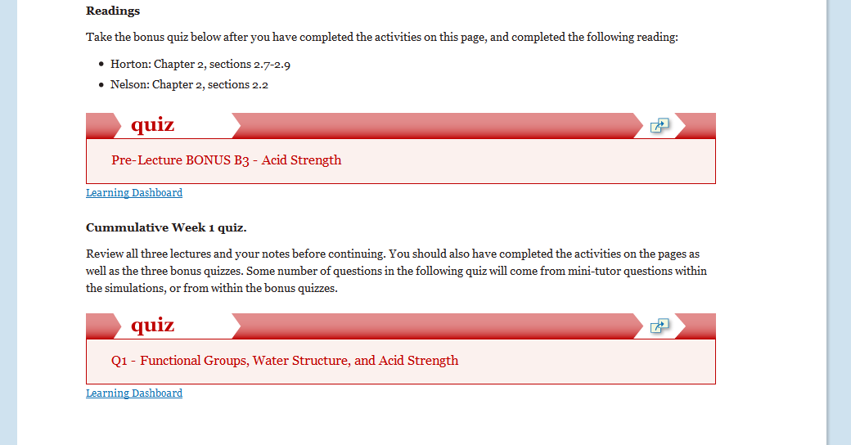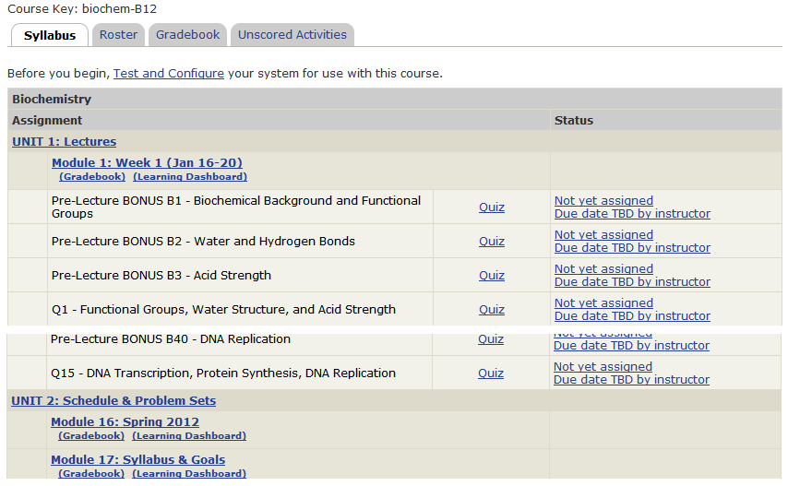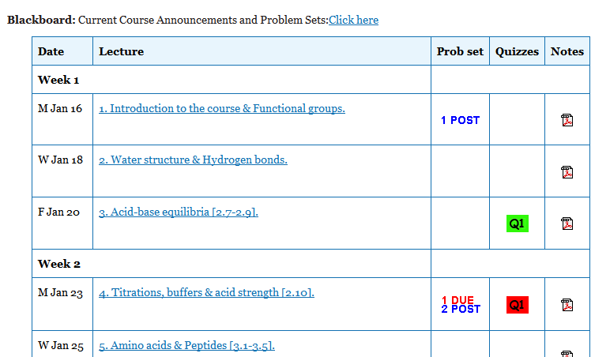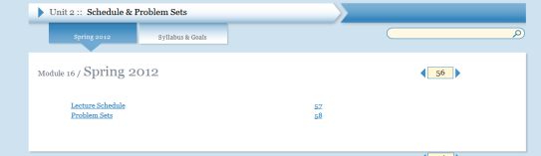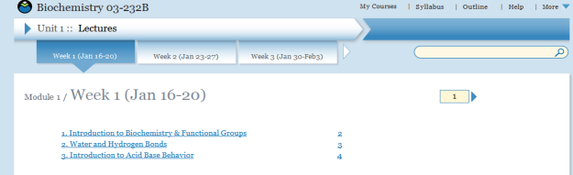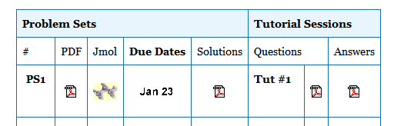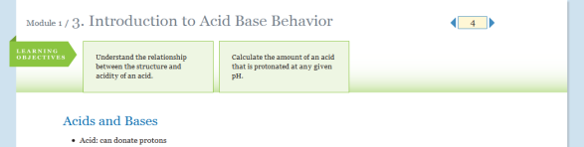

|  |  |
| --- | --- |
| check | Checkpoint: Test prior knowledge |
| lbd | Learn by doing: Learn a concept by performing the activity. |
| digt | Did I get this?: Test your understanding after activity. Test major concepts on a page. |
| quiz | Grades recorded:   * Bonus quiz (39) * Weekly quiz (15) |

**Course Grading**

|  |  |  |
| --- | --- | --- |
| Problem sets (11) | 10% | Lowest three dropped, typically due Monday by 3:30 PM (DH 1321) |
| OLI quizzes (15) | 10% | Lowest 5 of 15 dropped. Due Monday by 11:59 PM. |
| Bonus quizzes (OLI/Bb) | 3.5% | OLI quizzes close 2 AM day of lecture, Bb quiz in recitation. |
| In-class exams (3) | 50/45/40% | Half of lowest one dropped (e.g. 2 x20%, 10%) |
| Final exam (comprehensive) | 30/35/40% |  |

**Tentative letter grades**: A>90, B>80, C>70, D>50.

**Problem Sets:** Any material that is submitted for grading should be your own work.

**Your Weekly Schedule:**

* Bonus OLI quiz before each lecture.
* Review notes after lecture in preparation for recitation, and the weekly OLI quiz.
* Weekly OLI quiz on weekend, due Monday.
* Problem set on weekend, due Monday.

**General Advice:***Do your best to maintain a healthy lifestyle this semester by eating well, exercising, getting enough sleep and taking some time to relax. This will help you achieve your goals and cope with stress.*

*All of us benefit from support during times of struggle. You are not alone. There are many helpful resources available on campus and an important part of the college experience is learning how to ask for help. Asking for support sooner rather than later is often helpful.* ***Please feel comfortable approaching me in requesting extensions for problem sets and to adjust exam schedules depending on demands in your other courses or other issues in your life.***

**Advice for this course:**

1. Time spent learning structures and concepts in the first 4 weeks of class will be *very well* spent.

2. Do the OLI activities. This allows you to assess your understanding of the material well before the exams.

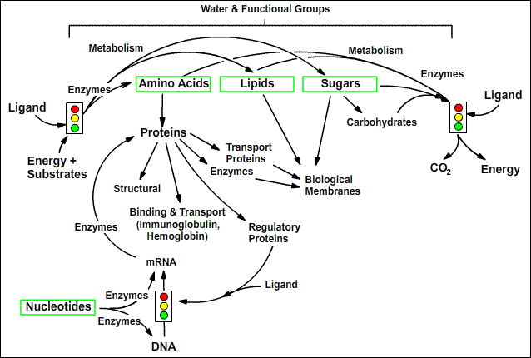**Course Overview (see syllabus on OLI for more details)**

**Lecture 1 learning goals:**

* Predict the formation of ions and their charge from electronic configuration.
* Infer orbital hybridization from molecular geometry.
* Identify non-polar and polar functional groups.

**Chemistry Review:**

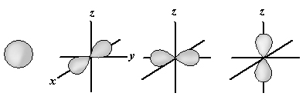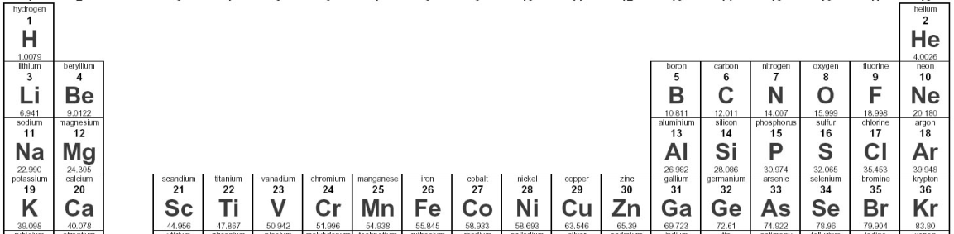**Atomic Orbitals:** All orbitals hold at most 2 electrons. The *s* orbital is spherically symmetric. The three *p* orbitals (*px, py, pz)* are bi-lobed and hold a total of 6 electrons (2x3).

**Order of filling:** 1s, 2s, 2p, 3s, 3p. When orbitals of equal (or near equal) energy are filled (e.g. 2p) the electrons fill the orbitals with one electron/orbital first. *Why?*

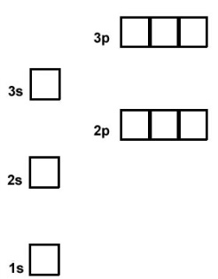**Shells:** 1st = 1s, 2nd = 2s + 2p, 3rd = 3s + 3p

**Na+**

**Ne**



**Stable electronic configuration -** Filled shells due to interaction between electrons and shielded nuclear charges.

* Nobel gasses (e.g. He/Ne/Ar)
* Ions (e.g. Na/Mg/Cl)

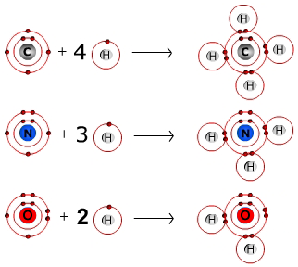**Covalent bonds** occur due to the sharing of electrons between atoms. Two half-filled orbitals combine to form the bond, *lowering the energy of the system.*

**H: 1 bond**

**C: 4 bonds**

**N: 3 or 4* bonds**

**O: 2 or 3* bonds**

**S: 2 bonds**

**P: 5 bonds**

*When protonated; the proton is added to a full orbital.

Why does carbon (6 e) form four bonds? 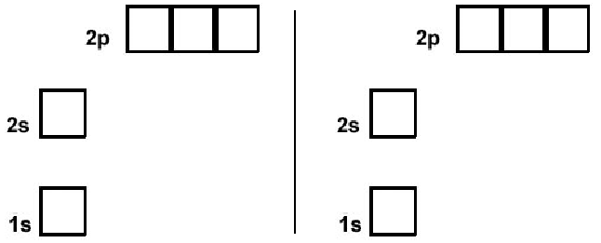



Why do carbon compounds have different geometries?

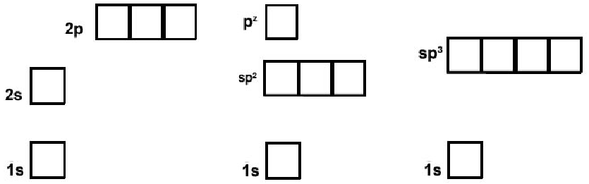

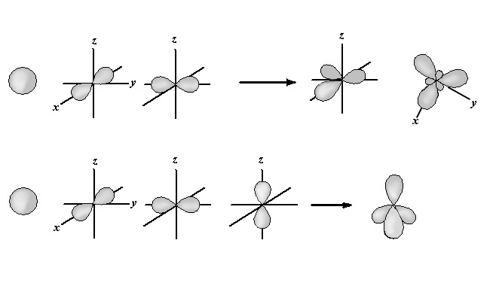**Hybrid Orbitals**: Carbon (and nitrogen, and oxygen) usually form *hybrid* orbitals, which show a mixture of *s* and *p* character.

**sp2:** The s and two of the p-orbitals combine, giving three (3) sp2 orbitals that are equal in energy. **Note**, one of the p orbitals is still present.

**sp3:** The s and all three of the p-orbitals combine, giving four equivalent (4) sp3 orbitals.

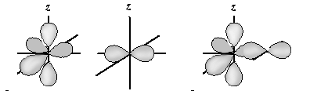**Double bonds** occur when two atoms share two pairs of electrons, e.g. C=O

* bond directly between the atoms is called a sigma (σ) bond.
* 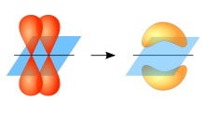the bond formed by the pz orbitals is called a pi (π) bond. It is formed by overlap of two pz oribitals.

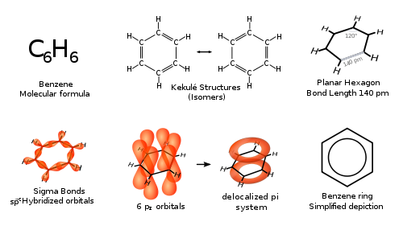**Aromatic Compounds**

* Ring formation - can contain carbon and nitrogen.
* Atoms in ring are sp2 hybridized = planer, sp2 orbitals used to form single bonds.
* Remaining pz orbitals form a delocalized ring of electrons, giving rise to a “partial” double bond between adjacent atoms.



* Absorb UV/visible light

**Organic molecules and Functional Groups:** A functional group is a subset of atoms within a larger molecule, e.g. methyl group, ethyl group. Functional groups have unique properties.

* Representation of molecules in biochemistry – typically hydrogens on carbon are omitted.



**Non-Polar:**

**Polar:**



**Identify the functional groups on these amino acids:**

