1. Cystic fibrosis is a genetic disease that is caused by a single mutation in a chloride ion transporter (CFTR). The transporter is necessary to move Cl ions across mucus membranes. The chloride then causes water to move across the membrane to reduce the viscosity of mucus. When the transporter is defective the mucus is very thick, causing difficulty in breathing.
The gene for the CFTR protein is very long (over 180,000 bases). A segment of the DNA that codes for the middle section of the protein, with the codon for Phe507 highlighted in grey, is shown below. The DNA sequencing primer is highlighted in cyan. The translation of this sequence gives the following protein sequence for this region of the protein (these are one letter codes for the amino acids, e.g. F=Phe)
tgg att atg cct ggc acc att aaa gaa aat atc atc ttt ggt gtt tcc tat gat gaa tat
W I M P G T I K E N I I F G V S Y D E Y
The disease is recessive, meaning that an affected individual must have two copies of the mutation to have the disease. Heterozygous individuals do not have the disease but are carriers. There is a one-in-four chance that a child produced from two carriers will have the disease. Therefore, genetic testing for heterozygotes is very important if there is a family history of the disease.
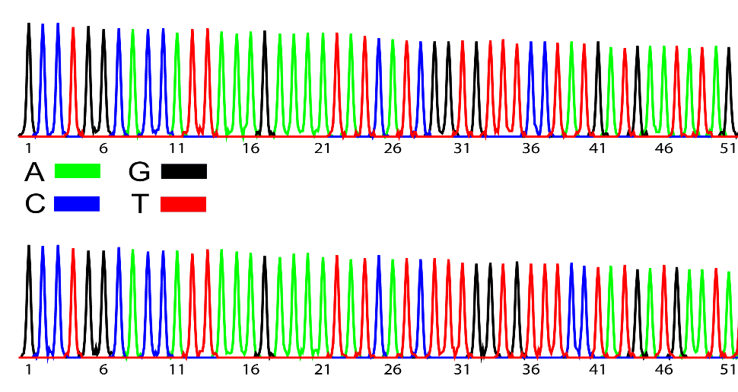
You sequence DNA samples from a heterozygous individual, each sequence corresponds to the gene on one of their chromosomes. One of these sequences corresponds to the normal gene sequence and the other corresponds to the mutation that is responsible for cystic fibrosis. The DNA sequencing data is given to the right.
i) Briefly describe how the 2nd blue peak was generated, give its DNA sequence.
ii) What is the change in DNA sequence (mutation) associated with this disease?
iii) How might this change affect the structure of the protein?
Note, when converting the above DNA sequences to codons, skip the first base, i.e. the first codon is CCT, coding for proline (P). Your translation of the DNA sequence should produce the correct protein sequence.
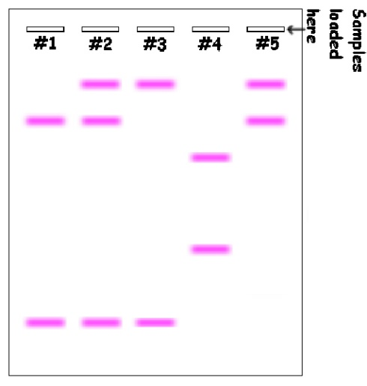
2. Solve the following forensic case. DNA was isolated from the victim, collected from the crime scene, and from three suspects. The DNA was subjected to PCR using primers that amplify a region of the chromosome that is known to contain tandem repeats, which are sequences that are repeated multiple times on the same chromosome. The number of tandem repeats differs from one individual to another, causing the length of the PCR product to differ. For example, one chromosome could look like this, with three tandem repeat (see above), while a chromosome might have four, giving a larger PCR product. Note that since we have two copies of each chromosome there are two possible PCR products, one from each chromosome. It is possible to have the same number of tandem repeats on each chromosome.
After PCR the DNA was separated by size and stained to visualize the DNA fragments. In the image on the right shows the sizes of DNA fragments for each of the following samples:
- Lane 1 – Victim’s blood
- Lane 2 – Blood at crime scene (victim+criminal)
- Lane 3 - Suspect #1
- Lane 4 - Suspect #2
- Lane 5 - Suspect #3

Bands towards the bottom of the diagram are smaller. Bands at the same position have the same size. The circled band will be used for the next problem.

i) Who is no longer a suspect? Please justify your answer.

ii) On the basis of the above data, who is still a suspect for the crime? Please justify your answer.

iii) Is the individual identified in part ii) definitely guilty?
3. The smallest PCR product (circled in the above image) was sequenced, giving the following (top strand only):
GCTGTAGCCATTGGGCCCTTTAAAGGGCCCTTTAAAGGGCCCTTTAAACCGCGTGAGTCA
i) What is the sequence of the tandem repeat?
ii) How many tandem repeats are present in this DNA?
iii) Give the sequence of the left and right PCR primers that would have been used to produce this PCR product. Assume that the PCR primers are 8 bases long.
4. Someone was exposed to Covid19 and shows all of the symptoms of a Covid19 infection. However, when you run a PCR reaction to verify the infection you find that you obtain no PCR product. Explain this result (you should assume that the person is indeed infected with Covid19).
5. The human immunodeficiency virus (HIV) infects and kills T_{H} cells. Why would this lead to an acquired immunodeficiency? Please do not use the web for this question.
6. What disease is the drug Trastuzumab used to treat? Briefly describe how it works to cure the patient (please use the web and provide the appropriate citation).
7. There are two antigens found on red blood cells, type-A or type-B. A person can be type-A (only have the A antigen), type-B (only have the B-antigen), type AB (have both antigens), or type O (neither A or B). An incompatible blood transfusion occurs if a patient is given blood that has a different antigen than theirs due to the presence of pre-existing antibodies against the antigen. For example, type A blood cannot be given to a type B person, because the type-B person will have pre-existing antibodies against the type A-blood. Hint: You want to consider the process of antibody generation in the bone marrow.
i) Explain why a person with type B blood cannot make antibodies that recognize B-antigen.
ii) Explain why a person with type B blood can accept blood from a type O person.
iii) Explain why a person who is AB can accept blood from anyone.

