Problem Set 2:
1. The chemical formula and bonding of the drugs Dexedrine and Benzedrine are the same, and shown on the right. Both of these drugs have the identical physical properties, such as melting point, molecular weight, etc. The dose of Dexedrine is 5mg/day, but the dose of Benzedrine is 10 mg/day. Additional side effects are seen when patients take Benzedrine. Please answer the following questions: [Hint: Is there a chiral center in this compound?]
i) Why is twice as much Benzedrine required for the same biological effect.
ii) Why are there reduced side effects with Dexedrine?
2. Benzedrine is absorbed more readily in the small intestine, where the pH=8, than in the stomach, where the pH=2.0. Why? Hint. Identify the ionizable group on Benzedrine, consider how its ionization state and charge would differ at the different pH values. Only uncharged molecules can move across the non-polar cell membrane.
Problem 3 requires you to view a small protein using graphic software called JSmol. There is a tutorial on the software that can be found at:
http://www.andrew.cmu.edu/user/rule/jsmol/jsmol_tutorial.html
Clicking on “Summary” will give you information on how the mouse works.
3. A link to a JSmol page can be found on the course page. Navigate to that page and answer the following questions:
i) Give the primary structure (amino acid sequence of the protein, N to C). Note that you need to identify the amino acid on the basis of its sidechain atoms.
ii) What is the secondary structure of this peptide, α-helical or β-strand? Justify your answer.
iii) What is the geometry of the atoms associated with the peptide bond (N, HN, C, O)? Do these lie in the same plane or are they tetrahydral?
(Note that there are checkboxes below the image to help you understand the structure, click them!)
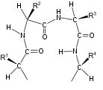
4. Beta strands are connected by turns in the protein backbone that are called tight or reverse turns. The diagram of a reverse turn is shown on the right. What favorable interaction would stabilize the geometry of the turn?
5. Proteins that regulate the expression of DNA in cells generally bind to the DNA by either hydrogen bonding, electrostatic (charge-charge) interactions, or both. These proteins contain a large number of lysine residues. In answering the following, assume that the pKa of the lysine sidechain is 9 and the pKa of the phosphate group in DNA is 2.0. A partial structure of DNA is shown on the right. The structure and ionization properties of lysine are found in lecture 1.
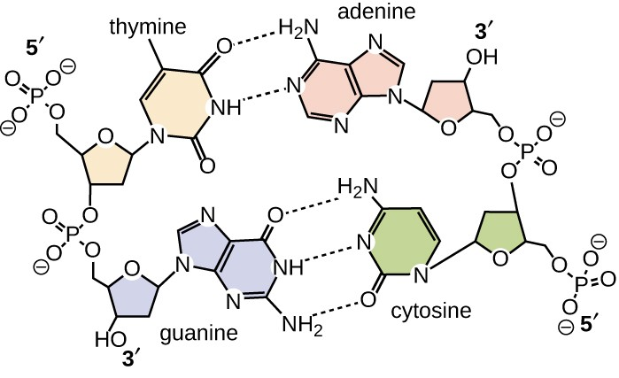
i) Explain how the presence of lysine residues would enhance the interaction (binding) of the protein to the DNA by hydrogen bonding. Which groups on the DNA would be involved?
ii) Explain how the presence of lysine residues would enhance the interaction (binding) of the protein to the DNA by electrostatics. Which groups on the DNA would be involved?
iii) Mutations occur such that some of the lysine residues on the protein are changed to glutamic acid. Predict how the DNA binding would change, would it get better, worse, or stay the same. Justify your answer.

6. A protein contains a valine that is found in its central core. Please discuss how the following mutations would affect the structure of the protein. You should discuss possible changes in van der Waals, hydrogen bonding, and the hydrophobic effect and whether the mutant would be more stable or less stable.
i) Valine changed to alanine.
ii) Valine changed to threonine.

