1. (5 pts) Two pea plants were bred to each other. The peas from the first generation (F1) were 50% smooth and 50% wrinkled. What are all of the possible genotypes of the parent plants? Which genotype gives the observed data? (This is the correct wording of the problem from the previous problem set).

2. (5 pts) A test cross involves crossing an organism that has an unknown genotype with a purebred organism that is recessive at both alleles. Briefly describe how the test cross could have been used to determine the genotype of the plants in question 1.

3. (10 pts) The following pedigree was obtained for several generations of a family.

i) What pattern(s) of inheritance (e.g. autosomal/X-linked, dominant/recessive) are consistent with this pedigree? Briefly justify your answer.

ii) What are the possibilities for Susan’s genotype. Briefly justify your answer.

4. (5 pts) The following pedigree was obtained for a family for an autosomal recessive gene. Could this pattern of inheritance be consistent with an X-linked gene? Justify your answer.



5. (15 pts) A homozygous fruit fly with white eyes and wrinkled wings was mated with a homozygous fruit fly with red eyes and smooth wings. The F1 were all red eyed with smooth wings. The numbers of flies in the F2 generation with different phenotypes were counted and the following were obtained:

|  |  |
| --- | --- |
| **Phenotype** | **Number of Flies** |
| Red eyes, smooth wings | 300 |
| White eyes, wrinkled wings | 100 |
| Red eyes, wrinkled wings | 1 |
| White eyes, smooth wings | 1 |

i) What are the traits and phenotypes in this experiment? (2 pts)

ii) Which alleles are dominant? (2 pts)

iii) Use a Punnett square to determine the expected frequency of each possible type of fly after crossing the F1 flies with each other, assuming the following two conditions (6 pts)

a) unlinked

b) linked

iv) Based on the F2 data and, are these two traits linked or not? Justify your answer (2 pts).

v) Explain how the flies with the rare phenotypes (last two rows of table) were generated (2 pts).

vi) Can you determine whether these traits are sex-linked or not based on this data? Why or why not?(1 pt)

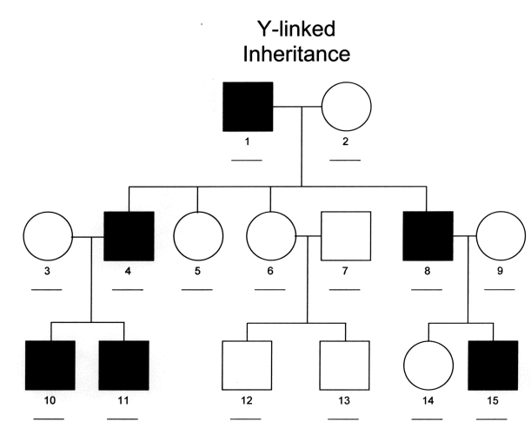6. (5 pts) The inheritance pattern for Retinitis pigmentosa is shown on the right. What is the most likely mode of inheritance? Briefly justify your answer.

7. (5 pts) Plants with red flowers are mated with plants with blue flowers. Both the red and blue flowering plants are pure breeding (homozygous). The F1 plants all have purple flowers. What is the mode of inheritance?

8. (5 pts) Rhogam is given to Rh- mothers at childbirth to prevent complications if she has an Rh+ child in the future. What is rhogam and why does it prevent the Rh- mother from developing antibodies against the Rh factor? Please use the web and cite your source.