1. (5 pts) Write a short essay on Hers’ disease. Your essay should discuss:

i) The normal function of the enzyme that is affected by this genetic disease, and how this enzyme is regulated in a normal individual. This is a glycogen storage disease where the individual is missing glycogen phosphorylase, the enzyme that releases glucose from glycogen. It is normally regulated by the hormone glucagon, which phosphorylates the enzyme.

ii) The consequence of loss of function to the individual. Surprisingly, this deficiency is relative benign, with an enlarged liver and some growth retardation.

iii) Whether males or females will be more likely to inherit this disease.

It is an autosomal recessive disease, so males and females would be equally affected. Some forms are sex-linked as well. The enzyme contains multiple subunits, some on autosomal chromosomes and some on the X-chromosome.



2. (5 pts) What compound will generate more energy from oxidation in metabolism, a 6 carbon sugar (e.g. glucose) or a six carbon fatty acid? Remember that all the carbons in either molecule will be converted to CO2 during oxidation so you want to think about the relative energy of the starting compounds.

Glucose is more oxidized than the fatty acid, carbons 2-5 have an OH group. Since oxidation releases energy, glucose must be lower in energy than the fatty acid because the glucose has already been partially oxidized. Therefore the fatty acid will produce more energy when it is oxidized to CO2. (see lecture 28, pg2)

3. (5 pts) A liver cell initially has high ATP levels. However, due to cellular activity its ATP is converted to ADP. How is glycolysis regulated during these events? Why is this regulation sensible?

Initially, glycolysis will be inhibited by ATP. The actual enzyme that is inhibited is PFK, or phosphofructokinase. This makes sense because glycolysis produces ATP, so the cell should turn off glycolysis when it has lots of ATP.

When the ATP is converted to ADP, PFK becomes active, turning on glycolysis. This also makes sense because the cell needs to replenish its ATP levels by oxidizing glucose in glycolysis.

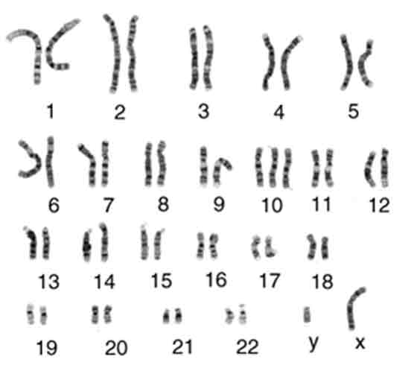4. (5 pts) The image to the right shows a human karyotype.

i) Is this individual a male or female?

Male, since there is an x and a y chromosome (green circle).

ii) Was the image of these chromosome acquired just before mitosis begins, or from the daughter cells? Why? Daughter cells, because there is only one chromatid, if it were before mitosis, you would see sister chromatids.

iii) Does this individual have the normal complement of human chromosomes? If not, how do they differ?

This individual has trisomy 10, three copies of chromosome 10. (blue circle).

5. (5 pts) A cell that recently divided acquired a mutation that inactivated cyclin B. What happens the next time the cell attempts to undergo mitosis?

Cyclin B is the cyclin that is expressed during mitosis, so the cell will go through G1, S, and G2 correctly, duplicating its DNA and preparing for mitosis. But it will be stuck at the end of G2 and not divide. The cell will likely die.

6. (5 pts) Taxol is used to treat a number of cancers. It works by stabilizing microtubules, i.e. making it difficult for the αβ-tubulin subunits to leave the microtubule. Where was taxol first isolated (cite your source)? Why do you think it is effective at treating cancer? It was first isolated from the pacific yew tree. In order for the chromosomes to move to the centrosomes it is necessary to shorten the microtubules by loss of subunits from the centromere area. This could not happen when Taxol is present, so the cancer cells would not be able to divide.

7. (5 pts) One histone modification is acetylation of lysine residues, the structure of lysine and acetylated lysine are shown on the right. Why might lysine acetylation reduce the binding of histones to the DNA?



The sidechain of lysine is positively charged and would bind to the negative charges on the DNA. Once the lysine is acetylated, it would no longer have a positive charge, so it would bind less well to DNA.

8. (10 pts) Two pea plants with smooth peas were bred to each other. The peas from the first generation (F1) were 50% smooth and 50% wrinkled. What are the possible genotypes of the parent plants that would account for the observed data?

This question had a typo – it should have read: “Two pea plants were bred to each other.” See the solution on problem set 10.

9. (10 pts, **bonus**) Complete the metabolism puzzle on the next page. After your puzzle is complete you can either tape the pieces to a sheet of paper and submit that or take a picture of the assembled puzzle.



**Key Points:**

* Glucose is brought into cell (extra glucose and transport protein not in puzzle pieces), converted to pyruvate by glycolysis in the cytoplasm (label not in puzzle pieces).
* Pyruvate goes to ethanol if there is no O2 (in cytoplasm), otherwise brought into mitochondria matrix and oxidizes to CO2 (not in puzzle pieces), producing lots of NADH and some FADH2.
* NADH and FADH give electrons to electron transport chain where they finally are given to O2 to make H2O.
* Electron transport makes an H+ gradient across the inner membrane, higher proton concentration outside the matrix.
* ATP synthase uses the energy stored in this gradient to make ATP from ADP and Pi.